Development of a Propeller Driven Long Range Autonomous Underwater Vehicle (LRAUV) for Under-Ice Mapping of Oil Spills and Environmental Hazards
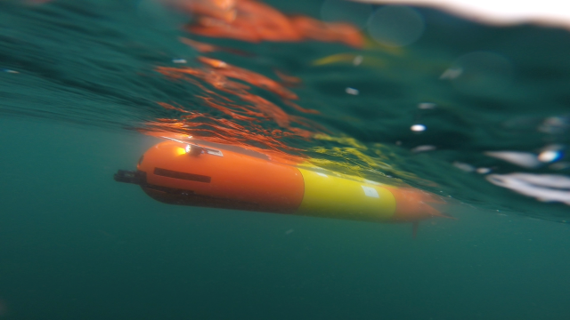
PI Amy L. Kukulya, Noa Yoder, Sean Whelan, Daniel Gomez-Ibanez, PI Jim Bellingham, Woods Hole Oceanographic Institution, Applied Ocean Physics & Engineering, Bigelow 304, Mailstop 10, Woods Hole, MA 02543 Tel: 508-289-3689, Fax: 508-457-2104, Email: akukulya@whoi.edu
PI Brett Hobson, Brian Kieft, Ben Raanan, Monterey Bay Aquarium Research Institute (MBARI)

Field Report for Santa Barbara Seeps Polaris LRAUV Experiments, 2019

Introduction and Background
The Long Range Autonomous Underwater Vehicle (LRAUV), Polaris, has been developed by MBARI and WHOI as part of an Arctic Domain Center of Awareness (ADAC) project, to provide rapid response detection and mapping of oil spills in Arctic environments. In the summer of 2019 a team of WHOI and MBARI engineers conducted two successful Polaris deployments, which provided comprehensive open-water testing in a real-world, oil spill response environment.
The LRAUV was developed at MBARI under PI Jim Bellingham, as a propeller powered vehicle with the range approaching that of a slow buoyancy glider. The capability to both drift in the water column and propel itself in situations where more refined control is necessary, made this base vehicle ideal for long, unsupervised missions in remote locations such as the Arctic. This base LRAUV has since been updated in a collaboration between MBARI and WHOI to include customized hardware and software which allows the vehicle to operate under ice and send data to shore without surfacing. These modifications include a WHOI designed acoustic homing and line capture docking module to allow for safe, low-power parking between missions, and WHOI’s Arctic Gateway Buoys which will serve as a dock, relay acoustic data to the surface, and provide navigation through long-baseline or ultrashort baseline modes. Additionally, the vehicle was equipped with a suite of sensors that allow Polaris to detect and map dissolved hydrocarbons. These sensors include a SeaOWL-UV-A optical sensor that measures dissolved hydrocarbons through florescence and optical backscatter.
These modifications were originally tested in a dye demonstration in Monterey Bay, CA in 2018. The Santa Barbara Channel, between the coast of California and the Channel Islands, provided an excellent location for the next stage of vehicle testing, as the channel is home to upward of eight active, naturally occurring oil seeps, as well as the retired oil rig, Platform Holly. Natural faulting and rupturing of the earth causes subterranean reservoirs of oil in this area to release oil and methane bubbles which lead to surface slicks as large as a few kilometers long. This phenomenon provides a natural environment for the vehicle sensors to be tested in characterizing both slick and suspended oil.
Figure 1. Oil and methane bubbles (left) escape from underground reservoirs, seeping up through the seafloor and releasing into the ocean (right).
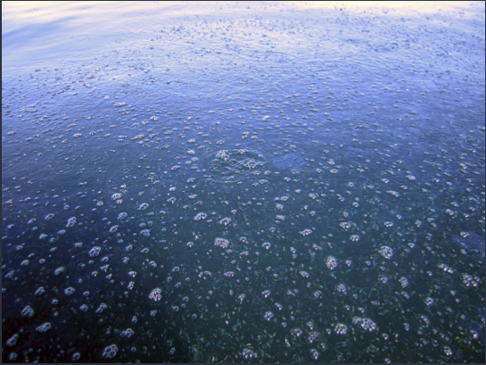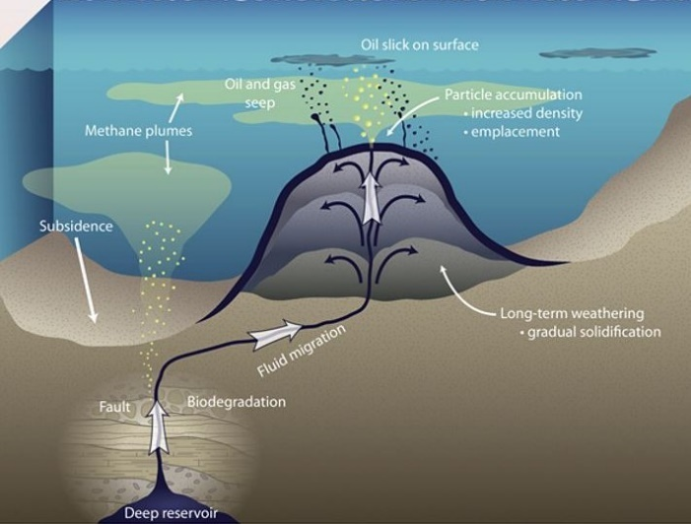

Objectives
The overall objective of these two deployments, was to thoroughly test the vehicle Polaris in an open-water, oil spill environment. High level focus was on understanding detection capabilities of the SeaOWL; Testing the ability of the LRAUV to acoustically communicate to the Arctic buoy while simulating an under-ice environment; and sending near-real time heat maps of oil detection sensor data back to the shore-side command-control center in order to both react to and understand the seeps environment. Both deployments would be an opportunity to train personnel and exercise communications between the subsurface vehicle and command control. Specific objectives of the separate deployments are detailed below.

June Deployment Objectives
The June deployment would consist of the first end-to-end communications field test from the vehicle, through the Arctic gateway buoy and on to the shore-side command control, where the data packets would be unpacked and displayed on the MBARI dashboard. This communication system would simulate an under-ice environment where the vehicle would need to send scientific and technical data without being able to surface. To begin with, all systems of the Arctic buoy would be tested, identifying any areas that could use improvement, and creating a standard for energy configurations to maximize buoy battery life. The vehicle would then be launched, testing a new center lifting bail which will allow for more versatility in the way that the vehicle can be deployed (from a ship or shoreside crane). Once in the water, the vehicle communications to the MABRI dashboard would be tested, using both the traditional direct method from the vehicle antenna using Iridium, Argos, Wi-Fi or cellular radios, and the acoustic method using the acoustic modem to the Arctic buoy, and then from the buoy antenna to the MBARI dashboard via line-of-sight through radio waves. Successful communication allows the operators to view data in near real-time on the dashboard, accessible from any browser, and make informed decisions on how to update missions or redirect the vehicle, but most importantly, on how to respond to an active spill.
Following the Arctic buoy testing, Polaris would then be sent on plume tracking missions, exercising its new algorithms for detection of dissolved hydrocarbons. Plume tracking algorithms must be developed to perform specific behaviors beyond simply reading and processing the data from onboard sensors. The algorithm can be intended to map out the scope of the oil spill, to find areas of high or low concentration for sampling, or to track the spill to its source. Each one of these intended uses cases requires a different search approach. For the purpose of these two Seeps experiments, we focused on finding areas of highest concentrations which might lead to its source. The primary sensor for oil detection onboard the LRAUV which would be informing these plume-tracking missions is the SeaOWL-UV-A sensor. The sensitivity of this sensor would be tested by conducting a comparison to a second sensor aboard a second AUV, a Remote Environmental Monitoring Unit (REMUS 100) in order to test the utility of LRAUV to survey a large area and inform other assets. Operating both vehicles in the same area would give the team a chance to test multi-vehicle operations with the LRAUV, as well as to determine thresholds for the LRAUV to respond to when performing its oil tracking behaviors. The more assets that are deployed, the larger area we can cover, therefore minimizing damages and speeding up the response efforts.
Finally, the Polaris docking system would be tested, first by testing the vehicle homing to a stand-alone transponder. Pinging the custom transponder would allow for easier troubleshooting to continue to refine the docking algorithms. This is the first step of testing a very important vehicle behavior that will allow the LRAUV to either dock to a buoy where it can be safely stored in-between missions, or to return to an ice-hole for retrieval. Following successful tracking of the stand-alone transponder, vehicle homing to the buoy itself could be tested. Other modes of buoy operations include a drifting buoy concept and an anchorage to an ice sheet. Future tests are planned for all three concepts.
All of these tests would be conducted over the course of a single Polaris deployment that would last six days. The LRAUV has a far greater duration capability than any other propeller driven AUV, and the six-day deployment would test these capabilities, and test vehicle reliability over that time.

August Deployment Objectives
The second Santa Barbara Seeps deployment would be funded in part by the Bureau of Safety and Environmental Enforcement (BSEE) as part of a separate project for three-dimensional mapping of dissolved hydrocarbons and oil droplets in collaboration with the US Coast Guard (USCG), National Oceanic and Atmospheric Administration (NOAA) and the Environmental Protection Agency (EPA). This deployment would be part of a larger vehicle effort that would center around two REMUS-AUVs and would involve personnel from the EPA, NOAA, and USCG headquarters. Combining the efforts of these two projects would allow for a unique opportunity to provide further exposure to the USCG and to demonstrate the value of the LRAUV in multi-vehicle operations while operating in tangent with the USCG buoy tender, George Cobb.
Polaris would be deployed from shore where it would conduct yo-yo lawnmower missions up and down the Santa Barbara Channel, mapping out areas known to be near source points. These search and mapping missions would be conducted around the clock for 24/7 operations. Data would be sent every two hours to shore (duty cycle is changeable). The REMUS-AUVs would be loaded out on the USCG George Cobb each day for field operations. The REMUS-AUVs, with shorter battery lives, would be most effective when deployed directly into oil hot spots and areas of interest, allowing them to maximize their time gathering useful data and oil samples with their higher-powered instruments. The LRAUV, with the ability to operate constantly over the course of the nine-day deployment would determine the launch locations for the other two vehicles. In the event of an actual oil spill this information from the LRAUV as to the location of the oil would be critical in saving time and helping first responders optimize their efforts. This highly collaborative mission, allowed the LRAUV to continue reliability testing of communications, navigation and oil detection with the Arctic buoy and operations in the oil seep environment.

Vehicles and Components

LRAUV
The LRAUV is a propeller driven AUV which has been developed and refined over the past ten years at MBARI. The main components that make this base vehicle unique from other propeller driven AUVs are the variable buoyancy system and the mass shifter which allow the vehicle to glide in low power modes for extended periods of time. The 12-inch diameter, 300-meter depth-rated vehicle contains 6kWh internal rechargeable lithium-ion batteries capable of powering the vehicle for up to 15 days while traveling at its standard 0.8 m/s (3km/hr) with its current payload, although it is capable of speeds between 0m/s and 1.2m/s.
In the Polaris docking and oil detection configuration the vehicle is outfitted with the following Commercial Off-the-Shelf (COTS) instrument capabilities: Iridium; low-frequency (10 kHz) WHOI micromodem acoustic communications; RDI 600 kHz up/down ADCP (Acoustic Doppler Current Profiler); NBOSI CTD (Conductivity Temperature-Depth); AADI dissolved oxygen probe; Sea-Bird/Wet Labs, Inc. SeaOWL-UV-A (Sea Oil-in-Water locator) optical sensor (configured with three wavelength pairs to simultaneously measure dissolved hydrocarbons using fluorescence and oil droplets using optical backscatter); and a GoPro camera. This configuration also holds the LRAUV docking payload which consists of a 25kHz DUSBL homing array and a WHOI Dynamic Docking Capture System. All together this configuration is approximately 9ft in length and weighs approximately 255lbs.
Figure 2. Polaris in its docking and oil detection configuration is shown through Computer Animated Design (top) and on its cart before deployment (bottom).
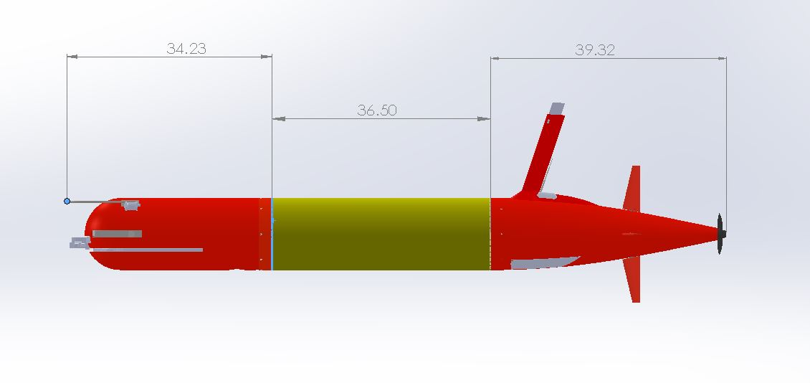
Sensors: DVL/ADCP, NBOSI CTD, PAR, O2, DUSBL, SeaOWL-UV-A
6 kWh rechargeable,
11 kWh expendable
Shifting Mass allows controlled angle of attack during flight
Iridium, GPS, WiFi and Cellular in mast
Backup Argos and VHF
1-liter Buoyancy Engine allows neutral drift in water column
WHOI Dynamic Docking Whisker System

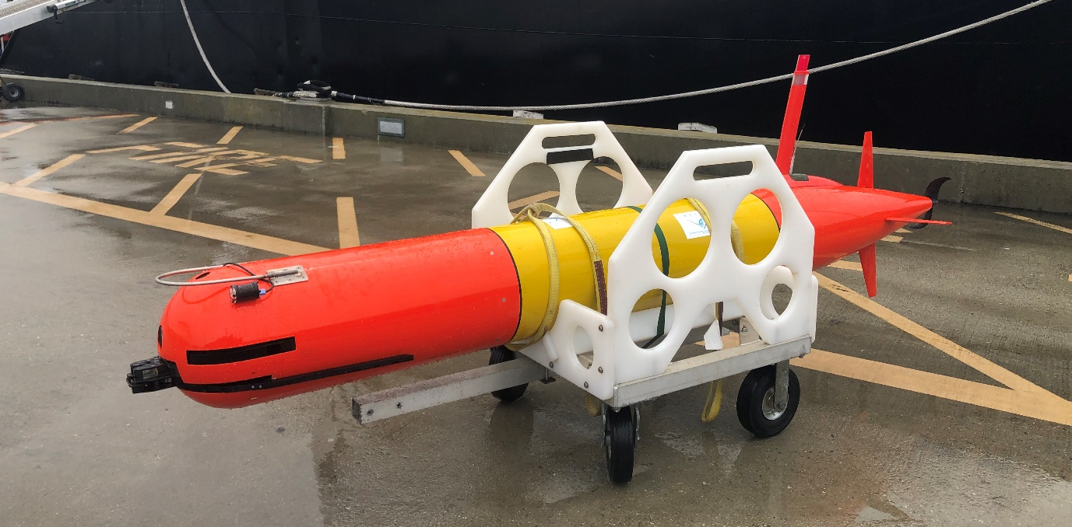

Vehicle Software
The LRAUV employs a layered control system of which the fundamental unit is a behavior. A behavior drives the system to react with the world in a defined way (e.g. waypoint control, yo-yo, attach to dock, go to surface) and can be combined to execute in a parallel and prioritized way via a mission script. Missions are written in XML and combine safety behaviors (e.g. depth envelope, proximity to shore envelope, etc) with behaviors having varying levels of autonomy depending on the task at hand. All missions are carried onboard the vehicle and can be adjusted over the horizon to alter variables such as depth, waypoint, durations, etc. Command of the vehicle and situational awareness occur through the aforementioned web based dashboard. The vehicle operates autonomously and alerts operators via text message if human intervention is ever needed. Examples include mission timeout, or an unexpected failure. Low level software abstracts hardware control of the vehicle’s subsystems away from the mission/behavior level and provides additional safety and reliability monitoring including built in test software that checks basic vehicle health and attempts to troubleshoot failed components. The software runs in Linux application space on a COTS low power ARM processor that is interfaced to the LRAUV’s custom motherboard. Like the rest of the vehicle, the software is designed to conserve energy and has control of each individual power load (up to 21) within the vehicle. Loads are powered as needed when requested by a behavior.
To provide further control and computing power, the LRAUV is equipped with a backseat interface for vehicle control. A higher powered backseat processor can be installed and used when desired to ingest data, and command the vehicle from various behaviors exposed over the network interface. This allows users to develop sophisticated and more computationally intensive algorithms on their own platforms without using up resources on the main CPU or risking changes to the main application codebase.

Arctic Gateway Buoys
The Arctic Buoys act as a gateway between the submerged vehicle and command control. The buoy can receive acoustic messages from the vehicle, which it then packages as short data burst (sbd) messages and sends via either iridium or Freewave radio transmissions to the MBARI dashboard which is a data portal accessible from any browser. The dashboard unpacks these messages and displays them providing near real time updates of the vehicle position and data collection. Commands can also be sent to the vehicle following the same data path in reverse. The purpose of the system is to allow for the LRAUV to stay underwater or ice maximizing its survey time while using the buoy network as its navigation and data relay. This handshaking allows for two-way communications between the deployed assets and operators on shore.
In order to accomplish its required tasks, the Arctic Buoys are equipped with the following capabilities: Iridium; Freewave/RF; WIFI; WHOI micromodem; cellular; emergency flasher; USBL and LBL capabilities; 10kHz or 25 kHz transponders for acoustic transmissions. One buoy is required for docking and USBL functionality and two or more are needed for triangulation via a long-baseline navigation network.
Figure 3 Arctic Gateway Buoy and peripherals (left) were launched off the side of the George Cobb during the second Santa Barbara Seeps deployment (right).
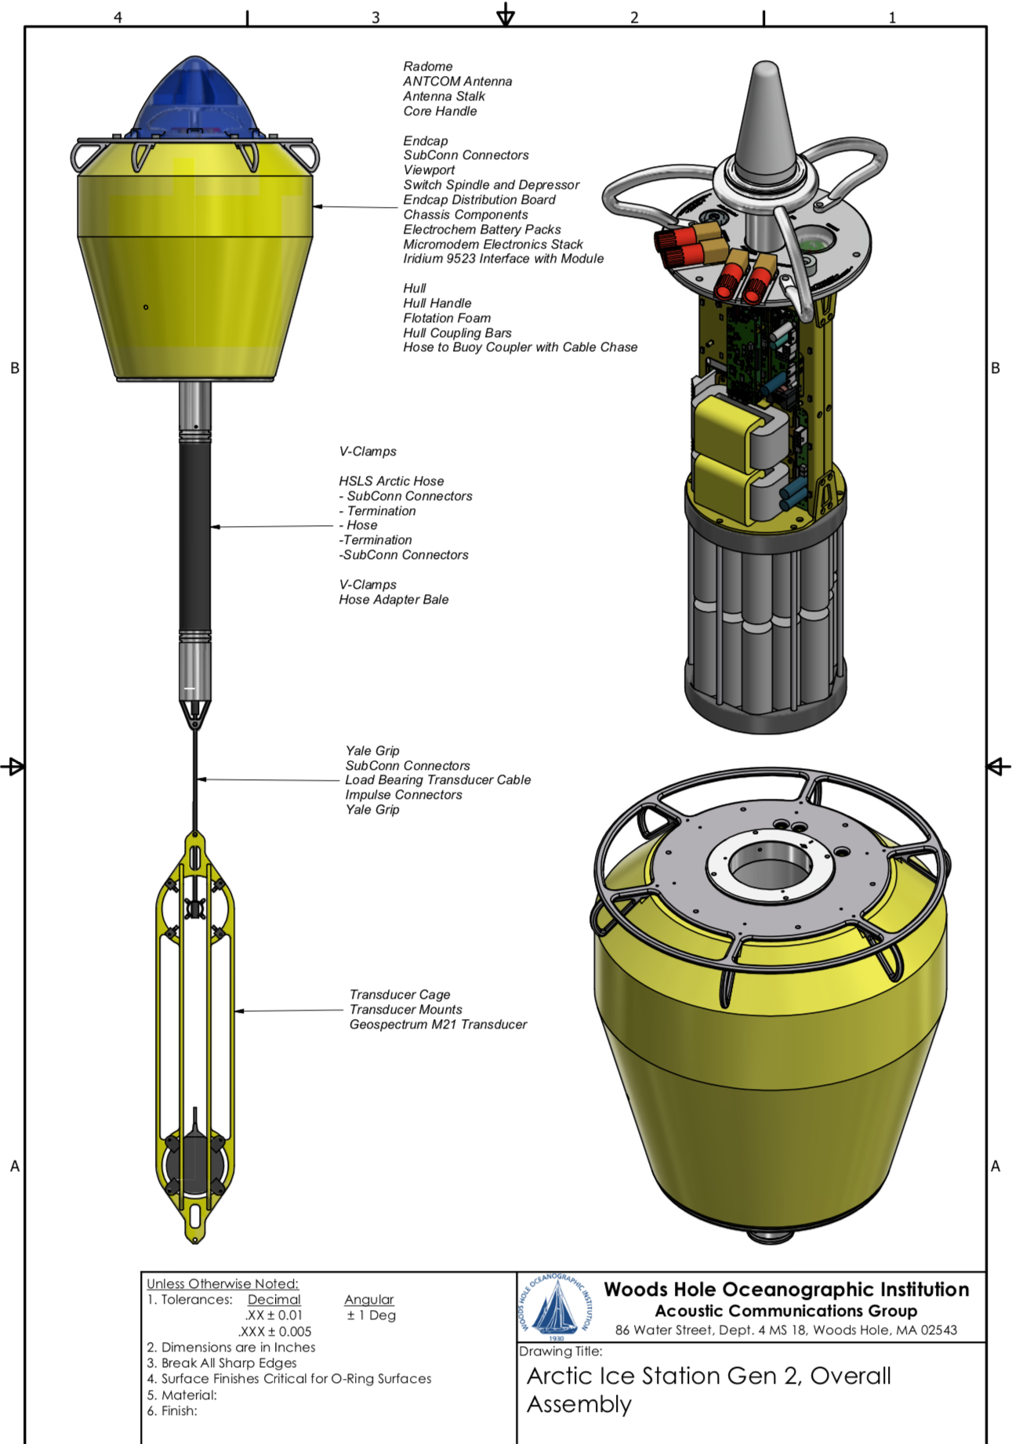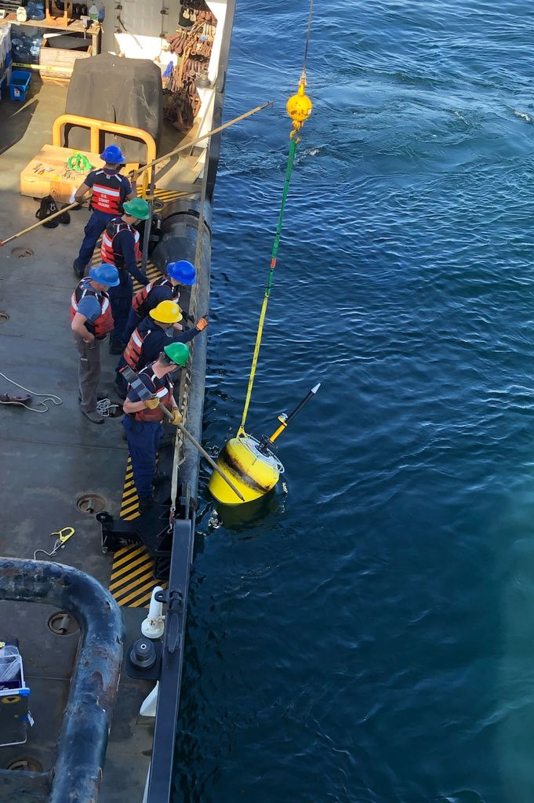

REMUS-100
In both the first and second Santa Barbara Seeps deployments, the REMUS 100 served as a secondary autonomous sensing platform to provide complementary sensing data. The REMUS-100 was outfitted with the following off-the-shelf instruments: Iridium antenna; WHOI micromodem; 1200kHz up/down Acoustic Doppler Current Profiler; PHINS inertial navigation system; NBOSI Conductivity Temperature Depth Sensor; AADI dissolved oxygen probe; SeaOWL-UV-A optical sensor; Suna nitrate sensor; Simrad EK80 splitbeam sonar; Marinesonics sidescan sonar; and a GoPro camera.
Figure 4. The REMUS 100 in its Santa Barbara, oil detection configuration. The EK80 can be seen mounted at the front, and the sidescan sonar in the aft along the side. In between are numerous other sensors including the SeaOWL-UV-A sensor, a NBOSI CTD, an ADCP and a GoPro camera.
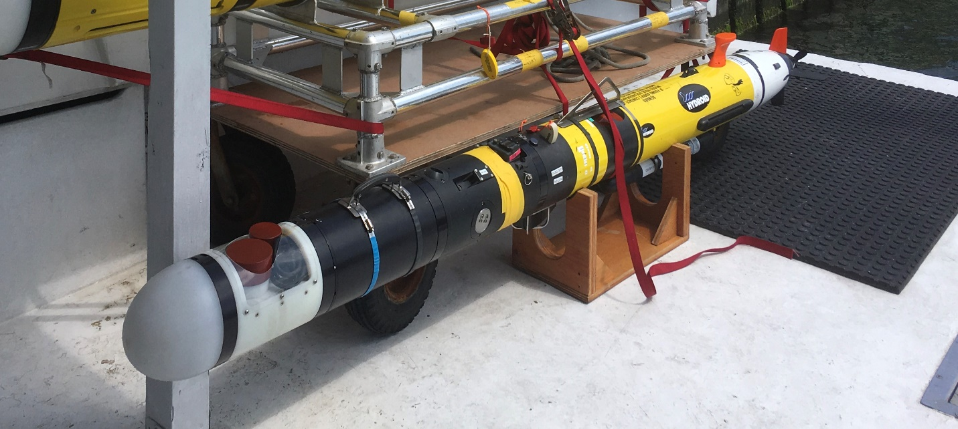
The Simrad EK80 sonar and Marinesonics sidescan sonar in particular provided another method of viewing plumes of oil or methane bubbles as they rose through the water column. The SeaOWL optical sensor, was the same instrument as the one aboard the LRAUV and provided a comparative dataset to determine thresholds for plume tracking.

Blue ROV
The Blue ROV was used in the June Santa Barbara Seeps deployment as a platform for two imaging systems. The first was the standard camera that is a part of the Blue ROV platform, and allowed real time imaging to visually confirm oil or methane bubbles that were sensed by other platforms.

Figure 5 The Blue ROV with the mounted Holographic Imaging System (left) was able to capture holograms and video footage of methane bubbles rising from the seafloor (right).
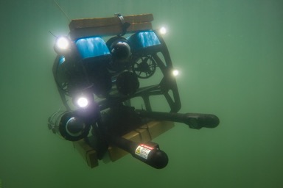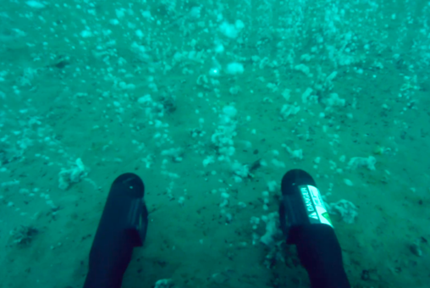
The second, far more advanced camera system, was the Holographic Imaging System (holocam) which captures 3D images of a sample volume. A laser beam is emitted from the holocam, part of which is scattered by particles suspended in the water. This creates an interference pattern or hologram which can later be processed to recreate the 3D image. Analysis of the recreated image will determine the shape and volume of the suspended particles. In the case of an actual oil spill, the holocam has the potential to be a very useful tool in analyzing the volume of oil emitting from a leak, and subsequently determining the appropriate level of response and mitigation.

REMUS-600
The REMUS-600 was one of the primary vehicles used in the August Santa Barbara Seeps deployment. In addition to the normal operational sensors aboard a REMUS-600, this particular vehicle was equipped with another SeaOWL-UV-A sensor to inform its autonomy missions and provide a comparison dataset for the REMUS-100 and the LRAUV. It also carried the holocam used in the previous Santa Barbara deployment, expanding the dataset of holograms of oil droplets, and providing a more versatile platform to implement the holocam more effectively.
Additionally, the REMUS-600 was equipped with the WHOI Gulper, a specialized instrument designed to gather multiple 1 liter samples that could be tested for volatile organic compounds. For many oil tracking missions, it is critical that there be physical samples that back up sensor data, and this sampler allows an AUV to collect those samples along its sensing path. The Gulper was designed to pump water into 1 liter glass bottles through short fluoropolymer inlet tubes and 316 stainless steel inlet valves, minimizing hydrocarbon contamination of the samples. The vehicle determined the location at which to sample using a newly developed autonomy behavior. The vehicle would begin driving in a yo-yo lawnmower path over a pre-determined area. When it encounters sensor readings of hydrocarbon levels above a certain threshold, the vehicle would initiate a circle-spiral-gulp behavior without user input. The vehicle would circle downward from the point at which the high reading was taken, determining the depth at which sensor levels were the highest. At that fixed depth, the vehicle would spiral outward and determine the radius at which the sensor levels were the highest. At this point the REMUS-600 would initiate a gulp and pump seawater into one of the liter bottles, while simultaneously pumping out the distilled water that was pre-filled to keep vehicle buoyancy constant. The REMUS carried two 6-packs onboard for a total of 12-liter sipping capacity. This sensor has been engineered to be an eDNA system and has been deployed on other AUVs at WHOI to support ocean science.
Figure 6. The REMUS 600 on deck of the USCG George Cobb with the Holographic Imaging System mounted on the bow, and two full Gulper assemblies with output straws (left). The foam skids can be removed to access the gulpers inside (right).
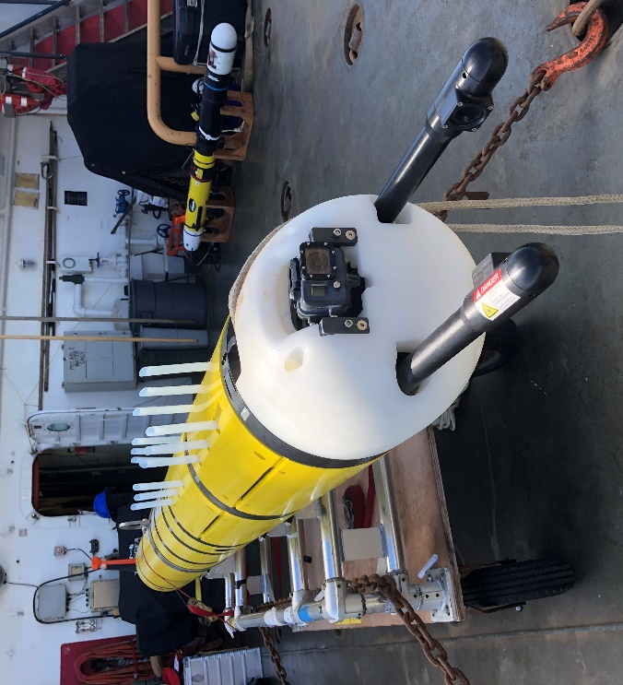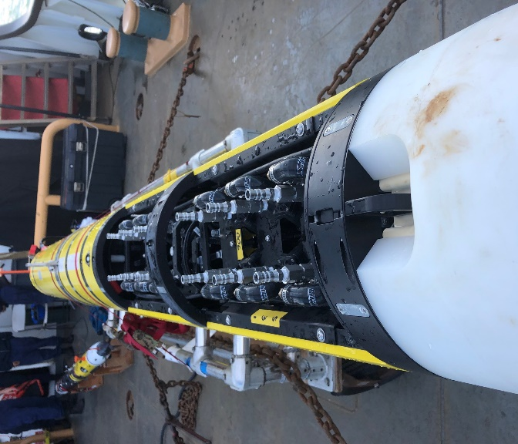
The threshold that triggers the gulping behavior is determined dynamically based on the surrounding dissolved hydrocarbon levels, and with only 12 bottles aboard the vehicle at a time (some of which needed to be blanks to act as controls) the location where the REMUS-600 was deployed for these missions was important. Deploying in hot spots determined by the LRAUV, would allow the sensors aboard the REMUS-600 to be used to their maximum potential, only sampling in high concentration areas. Again, LRAUV was used effectively here in the context of informing first responders where to deploy other sampling assets.

Methods

Area of Operation
Both the June and August deployments were focused within 10km of shore off the coast of Coal Oil Point in the Santa Barbara Channel. This channel, separating the California mainland from the Channel Islands, was chosen for operation as it is a known location of several active oil seeps that have been studied over several past decades although not with an AUV. The University of California Santa Barbara served as a base during these deployments where the LRAUV could be prepped and inspected. The vehicle was then launched from a crane located at Goleta Pier.
Figure 7. All LRAUV missions for both the June and August deployments were conducted off the coast of Goleta Point and Coal Oil point, where there are numerous active natural oil seeps. The LRAUV was prepped in a lab at UCSB and launched from Goleta Pier.
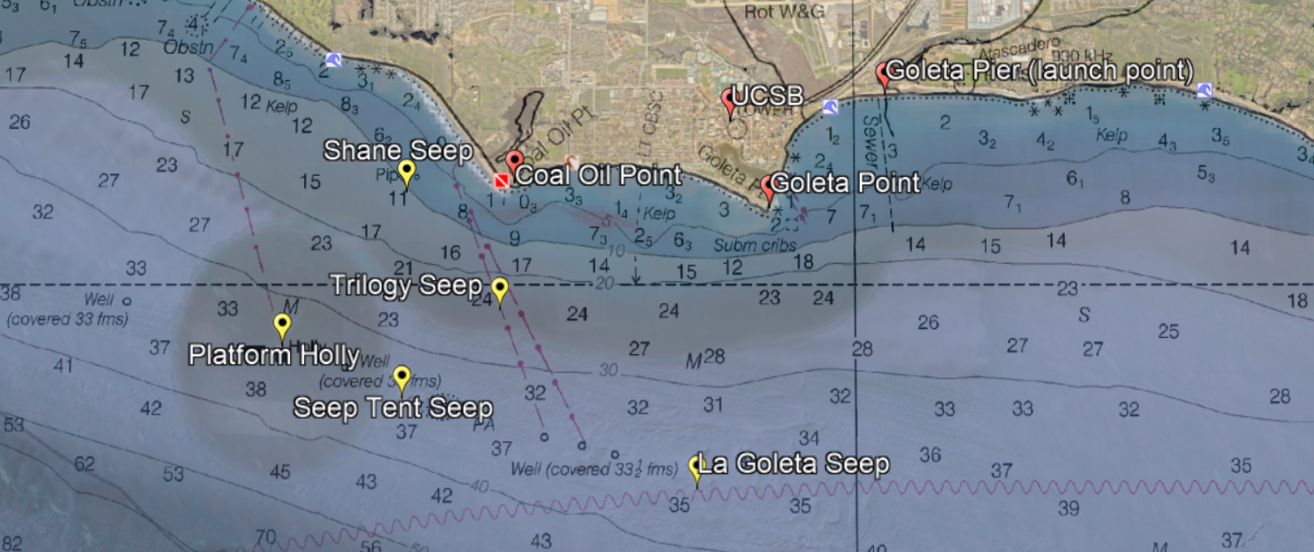
The University of California Santa Barbara (among other institutes) has conducted numerous previous expeditions studying these natural seeps. It has been determined that the oil and natural gas originates from a petroleum reservoir 1500m below the seafloor. The oil and gas seeps through the seafloor in 20m to 60m of water where it then creates slicks on the surface within a few kilometers of shore. These seeps and surface slicks are ideal for testing in an environment that can, to some degree, simulate an oil spill. Initial tests at these seeps determined the seepage to be highly variable from tide to tide and our AUVs determined that surface slicks to not readily correlate with subsurface detection levels.
Figure 8. Sediment isopach, geologic structure and seep distribution off Coal Oil Point where LRAUV operations were located.
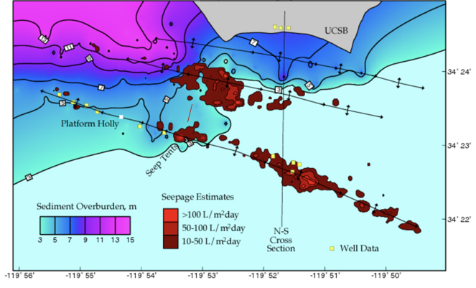

Launch and Recovery
For both deployments the LRAUV was launched directly into the water using a crane located at Goleta Pier. In one instance, Polaris was then towed out of the harbor using a UCSB 22ft pocket cruiser, the Resonance, however for the second deployment the vehicle was commanded out of the harbor under its own propulsion, closely monitored by its operators to avoid boat traffic.
For the June deployment the complementary vehicles, the REMUS-100 and Blue ROV, were launched from the Resonance at various points throughout the LRAUV deployment. The dynamic vessel allowed operators to recover and re-launch the supplementary vehicles numerous times in updated locations based on the LRAUV sensor data.
During the August deployment, the complementary vehicles, the REMUS-100 and REMUS-600, were both loaded aboard the USCG buoy tender, the George Cobb. The crane onboard, usually used for buoy launch and recoveries, was used to deploy both vehicles. Again, these vehicles could be launched and recovered multiple times during a day of operations, to update locations, or to remove samples from the REMUS-600.

June Deployment Results
The June deployment served as an excellent opportunity to test and troubleshoot the Polaris LRAUV development in a real-world oil environment. In particular, several significant advancements were taken with the communication systems between the LRAUV, the Arctic Buoy, and command control. This deployment marked the first time that Polaris was able to send data back to the MBARI dashboard without surfacing, a very important step in order to be able to operate in an Arctic environment where ice coverage would prevent surfacing. The LRAUV’s constant communication with command control, whether or not it is was able to surface, allowed it to provide operators with sensor data in near real time. This actively informed operators as to where to deploy the other assets.

Figure 9. Detections of petroleum hydrocarbons from the SeaOwl onboard the LRAUV are displayed on the dashboard, informing operators on the location of oil hot spots. The dashboard shows the heat map of dissolved petroleum hydrocarbons with the LRAUV depth over time (top), which is georeferenced to the vehicle path (bottom), providing specific coordinates.
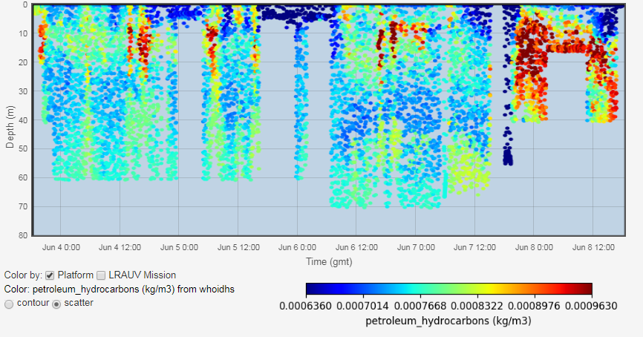
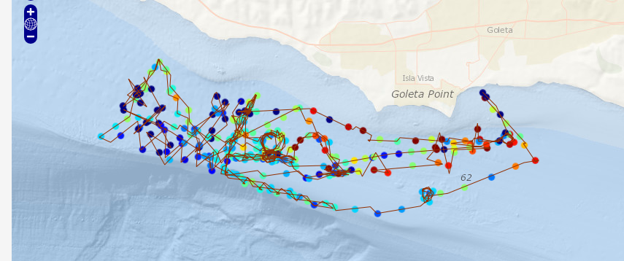

This also marked the first time that Polaris reset its navigation without surfacing for a GPS fix, instead updating its location based on the known position of the Arctic Buoy transponder system. Further adjustments would need to be made to the buoys, however, in order to use them for homing, as the 25kHz DUSBL aboard the vehicle had trouble consistently detecting the 10kHz transponder on the Arctic Buoy. This prevented homing tests to the buoy from being completed in the six-day deployment. However, Polaris was able to successfully home to a hybrid 10kHz/25kHz standalone transponder which was prepared for testing purposes, proving that the vehicle homing systems are sufficient to recall the vehicle to an ice hole for recovery, and showing promise for future docking tests.
Multiday testing confirmed the LRAUV’s reliability over the course of more than a week-long mission, however one of the Arctic buoys died on day three of the deployment, and had to be replaced with another charged buoy. Possible buoy power configurations were considered to determine which subsystems could be shut down for prolonged battery life in future deployments. This problem was later tracked down and the buoy system currently is rated to last at least seven days on a single charge with rechargeable lithium batteries. For Arctic deployments, we secured a battery design to incorporate Li-Primary (disposable) packs which is expected to allow for three weeks of operations. Further R&D is required for energy harvesting to power the buoy system for extended periods of time.
The multi-vehicle operations with the REMUS-100 and the Blue ROV, determined that the SeaOWL sensor is reliable and can detect low signals and decipher against the environmental baseline. The LRAUV oil tracking algorithms, will require further development in order to successfully trace an oil seep back to its source. However, Polaris, remains an extremely useful tool in mapping out the presence of oil over large areas in an open ocean environment. Its ability to run for extended periods of time, gives a fuller picture with far more data than any other propeller driven AUV can achieve. We anticipate the same level of effectiveness of dissolved hydrocarbon detection in under-ice environments.

August Deployment Results
The August Santa Barbara Seeps deployment demonstrated the value of the LRAUV in a multi-vehicle and institution/governmental oil response operation. The LRAUV’s unique ability to run around-the-clock over multiple days, allowed for consistent data collection that informed the operators of where to deploy the REMUS-100 and REMUS-600 in order to maximize their utility. The LRAUV was sent on a broad search of the area, conducting yo-yos between 1m and 50m in order to find areas of elevated SeaOWL detection and create a priority map for the other two vehicles. The LRAUV was reprogrammed to minimize its yo-yo depths when oil was not detected in shallow or deep depths.
The team aboard the George Cobb deployed the Arctic gateway buoy, providing another opportunity to test the LRAUV and Arctic buoy communication system in an open ocean environment. Polaris continued to successfully send data back to shore through both communication methods, via radio and acoustically through the gateway buoy. The data was unpacked and plotted on the MBARI dashboard, providing heat maps of the dissolved petroleum hydrocarbons detected by the SeaOwl. As anticipated, these plots identified hot spots in real time.

Figure 10. Again, during this deployment, the LRAUV provided near-real time sensor data on the presence of dissolved hydrocarbons. This data was displayed as heat maps, with each data point georeferenced with the vehicle’s location so the hot spots could be identified for deploying other assets.
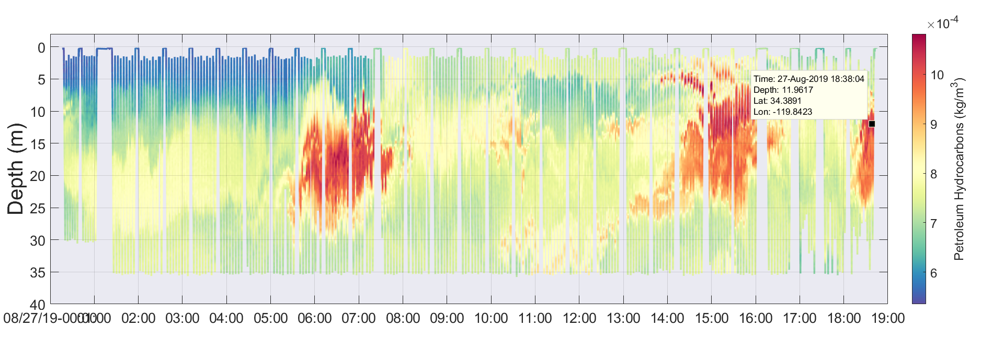
Once a hot spot had been determined, the REMUS-600 and REMUS-100 were deployed in that area. The REMUS-100 conducted fine-scale surveys, and the REMUS-600 conducted its autonomous gulping missions while imaging with the holographic camera. Below is an example LRAUV track from a typical mission. The yellow track indicates hot spots of high petroleum hydrocarbon readings. The track of one of the REMUS600 missions is also plotted, showing that it was deployed near the high readings, indicating hot spots, collected by the LRAUV, slightly south to account for drift.
Figure 10. The LRAUV made searching tracks up and down the coast, recording dissolved petroleum hydrocarbon readings. The REMUS 600 was then deployed in the area of higher readings, and proceeded to take six, 1 liter water samples.
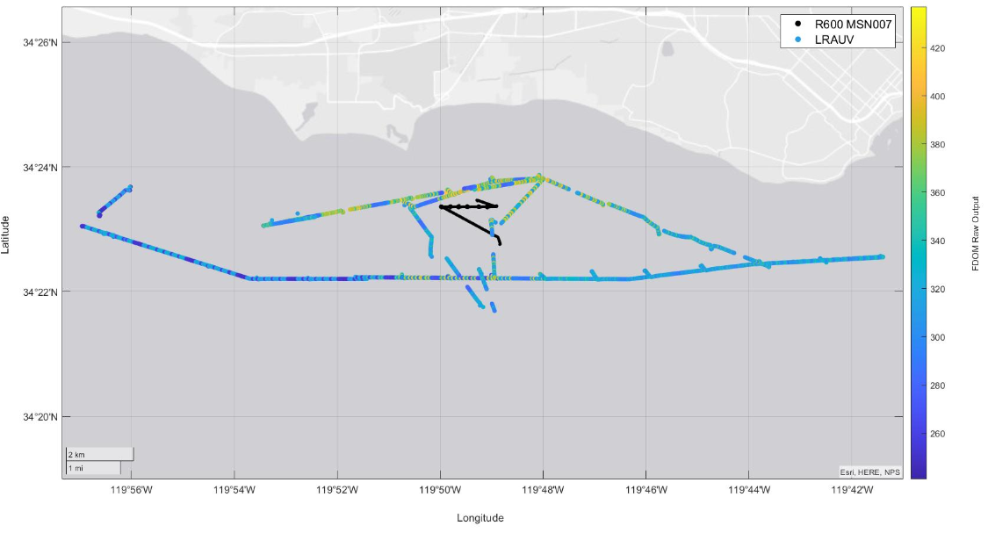
Over the course of the REMUS-600 mission plotted above, the vehicle collected six, 1 liter water samples with the gulper. It also constantly recorded holograms with the holographic camera, which were reconstructed in order to analyze the shape and volume of suspended droplets.
Figure 11. A reconstructed hologram (left) from the REMUS-600 shows numerous droplets marked in red. This is coupled with the exact location of that the hologram was taken along the REMUS-600 path and the corresponding FDOM readings from the SeaOWL (center). The reconstructed hologram is analyzed for droplet count, size and volume (right).
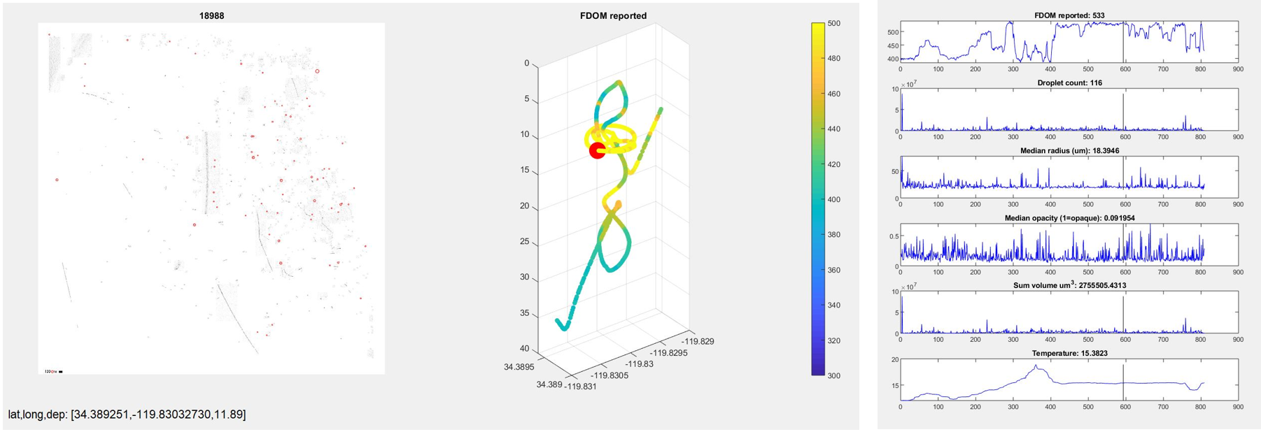
The Holocam and WHOI Gulper are two instruments that have great potential to help quantify and analyze oil in the event of a spill. Both, however, only gather useful data when situated in an oil hot spot, and are most effective when they do not have to spend time searching for these hot spots on their own. During this deployment, the LRAUV served an important role in determining the sampling locations to optimize the efforts of the engineers, operators, partners and scientists aboard the George Cobb. The LRAUV also provided large scale maps of dissolved hydrocarbons in the area, created by a level of data collection that could not have been achieved by any other AUV.

Conclusions
The two Polaris deployments in the summer of 2019 were a crucial step forward in the development of the under-ice oil detection and mapping LRAUV. Exercising the vehicle in an actual oil environment provided insight into what aspects of vehicle performance were successful and which ones required further development. It also provided the opportunity to prove the vehicle’s value as part of a multi-vehicle team, in an environment similar to that of an actual oil spill. The vehicle communication through the Arctic buoy was an important step in preparing the vehicle for under-ice missions, and development has continued to allow the vehicle to conduct prolonged missions without surfacing. The plume tracking algorithms will continue to be refined, however with the SeaOWL-UV-A Sensor, the LRAUV has shown its usefulness in mapping out dissolved hydrocarbons. The Polaris vehicle has the potential to be a vital and effective tool for oil response in remote locations.

