Development of a Propeller-Driven Long Range Autonomous Underwater Vehicle (LRAUV) for Under-Ice Mapping of Oil Spills and Environmental Hazards
An Arctic Domain Center of Awareness Project (ADAC)
PI Amy L. Kukulya¹, Noa Yoder¹, Sean Whelan¹, Daniel Gomez-Ibanez¹, Avery Munoz¹, Jeff Pietro¹, PI Jim Bellingham^{1,} PI Brett Hobson², Brian Kieft², Ben Raanan^{2,} Woods Hole Oceanographic Institution¹ , Applied Ocean Physics & Engineering, Bigelow 304, Mailstop 10, Woods Hole, MA 02543 Tel: 508-289-3689, Fax: 508-457-2104, Email: akukulya@whoi.edu, Monterey Bay Aquarium Research Institute², Moss Landing, CA 95039

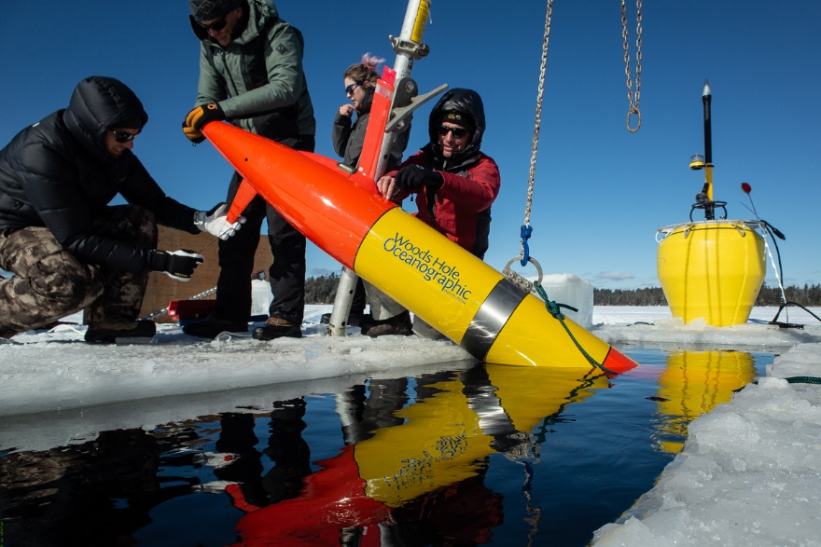

Field Report Document for Polaris LRAUV Under-Ice New England Tests, February 4th-12th, 2020

Introduction and Background
The Long-Range Autonomous Underwater Vehicle (LRAUV), Polaris, successfully completed its first under-ice deployment in February 2020 in New England, advancing USCG RDC AUV capabilities and preparing for a more dynamic mission in the Arctic. This DHS/ADAC funded vehicle was developed to allow for rapid response to oil spills in Arctic environments, while providing situational awareness and damage mitigation for first responders and USCG. The LRAUV was originally developed at MBARI, and in collaboration with WHOI, has been updated to include an innovative set of capabilities. The customized set of hardware and software developed by the WHOI/MBARI team allows Polaris to operate and communicate under-ice, and detect and map dissolved hydrocarbons. The MBARI base vehicle, developed under project PI, Jim Bellingham, was chosen for this project as the desired vehicle for unattended missions in hard to reach regions—such as the Arctic—due to its unique ability to both ‘drive’ itself and operate in a ‘drift’ mode with minimal operator interaction. Both vehicle states have added controls such as low power mode for long transits, as well as maximizing propulsion using an onboard mass shifter and variable buoyancy system. Many added features have been implemented including WHOI’s line capture hydrophone array and docking module, and WHOI Arctic gateway buoys for both communications and navigation, including long-baseline and ultrashort baseline navigation modes for mission versatility. The vehicle and scientific modifications were field tested in a 2018 dye demonstration in Monterey Bay, CA, as well as in the naturally occurring oil seeps in Santa Barbara, CA, in June and August 2019. Polaris was delivered to WHOI in early February 2020 after four-years of collaborative engineering between both MBARI and WHOI to proceed with field testing in an under-ice environment.
During the first week of February, the core LRAUV team consisting of both WHOI and MBARI personnel conducted an end to end test of the LRAUV in the WHOI lab facility. Initial tests are considered a ‘handover’ of operational support of Polaris from MBARI to WHOI, contingent on continual technical support and R&D from MBARI as the platform matures to higher TRLs. Training included an overview and discussions of hardware, software, peripherals, and operational capabilities of the vehicle systems. The team bench tested three Arctic gateway buoys with Polaris, confirming two-way communications of mission performance statistics, data, and navigation homing compatibility. The team had three days to fully check out and water test the Polaris system before embarking on its first under-ice mission field trial. An open water exercise was conducted in Buzzard’s Bay, Woods Hole by deploying one Arctic buoy and mooring in 40 feet of water (the average depth in Buzzard’s Bay). The team was able to successfully validate communications and docking/undocking to the cabled buoy via remote command control.
The next objective was to pack up the kit in Woods Hole and set up an under-ice mission test in Bog Lake, Northfield Maine. The original under-ice test was slated to take place in Lake Winnipesaukee, NH, however, due to an unseasonably warm winter in New England, these tests needed to be moved further north. The New England test site allowed the team the opportunity to conduct high risk tests in a controlled lake environment, and validate the vehicle’s onboard under-ice mission schemes and control logic, as well as identify any items that need refinement. These tests allowed the team to compile a list of lessons learned, calculate hardware and software reliability and repeatability statistics, and demonstrate the current capability for LRAUV to stay under-ice without human intervention for multiple days.
Ultimately, these initial ice tests advanced our LRAUV mission capabilities and conducted platform testing in an under-ice environment, identifying areas for improvement prior to embarking on higher-risk missions. Lessons learned will help minimize future risk in more complex environments such as the Alaskan Arctic.

Test Objectives
The primary objectives of our efforts from the 2nd through the 12th of February 2020 were to deliver the Polaris LRAUV to WHOI, for MBARI to provide training to WHOI personnel, and for the team to conduct the first ever under-ice tests of the LRAUV vehicle. While shipment delays and a winter storm affected the planned schedule, most objectives were still met in the constrained operational window. More granular details to the weeklong tests are outlined below.

Buzzard’s Bay Test Objectives
The first priority on vehicle arrival was for the MBARI team to demonstrate a post-shipment checkout of the vehicle systems and vehicle reassembly for the WHOI team. The MBARI team would train WHOI personnel on the ballast and trim configuration and test tank protocol. Before the ballast and trim could be completed, an avalanche beacon was added to the nose payload as a backup safety device for under ice missions. During the set-up process, the MBARI team would also overview the operator’s dashboard, which documents the vehicle checkouts and mission planning, and serves as remote command control.
Following these training sessions, the next objective was to set up the equipment necessary to water test the Polaris vehicle. This consisted of the Arctic gateway buoys, configured for 14m of water, with the strongback, which houses the transponder at 11m off the bottom. In addition, a second, backup docking transponder would also be deployed a meter below, to test functionality of the system prior to commencing at our under-ice test site. The secondary transponder, known as Sellers, was used as a test proxy prior to the gateway buoys being completed at WHOI in order to fast-track developmental testing. Sellers had been successfully used in the Arctic during a 2010 under-ice scientific expedition in Barrow, Alaska. If the buoys were delayed or had any technical issues, the Sellers transponders could be temporarily used in place of the buoy system. In order for the buoy to communicate with the dashboard, two Freewave radios (one omni, one yagi) would be set up on the roof of the WHOI facility for remote line of sight to the LRAUV and buoy operations area. When the buoy receives data from the vehicle, it transmits that data over the Freewave to a local WHOI server. That server runs a set of Python scripts which convert the serial stream from the buoy into Short Burst Data (SBD) messages. These messages are emailed to the dashboard where they are automatically unpacked and displayed. Commands from the dashboard are sent through the same process, in reverse. After setting up the Freewave, this data path would be thoroughly tested, to ensure communications between the dashboard and Polaris. Once communications had been established the buoy and vehicle could both be manually deployed from the WHOI Hurricane RHIB without special rigging.
Once the vehicle was deployed, it would first run a standard ballast and trim mission in the open water, followed by a series of missions to test the under-ice capabilities. The goal of these missions was to test acoustic communications (ACCOMS), dock ranges, and docking to both the gateway buoy and the Sellers transponder. The vehicle would also test USBL navigation resets based off the buoy’s position. The missions chosen to test these capabilities included Profile Station, a station keeping mission with science sensors engaged, and Sci2, a straight-line science mission, both of which would be followed by the vehicle returning to the dock. The Sci2 mission was also intended to be used to test the range to the dock, and the vehicle’s ability to return to the dock even after traveling out of range. These missions would be looped for 24 hours to confirm repeatability of docking.
Finally, all equipment would be recovered, the mooring would be reconfigured for an on-ice deployment, and the vehicle re-ballasted for fresh water in an outdoor ballast tank. All equipment would be packed into vans for the drive to Northfield, Maine.
Figure 1 Unpackd data sent from the LRAUV to the Dash for quick data assessment and viewing.
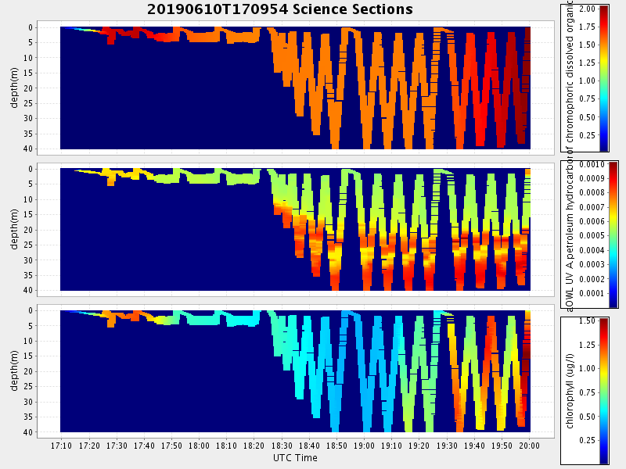

Bog Lake Test Objectives
The first objective at Bog Lake was to re-establish the buoy/dashboard communication by mounting the Freewave radio and configuring a local machine to run the necessary Python scripts that package and email data to the dashboard, as well as to prepare the launch site for the vehicle deployment. Preparing the launch site consisted of setting up a gantry over the deposit/docking site, cutting an ice hole of approximately 3ft by 9ft, and pulling out the ice blocks so they could not cause interference with the vehicle once deployed. Pre-mission checkouts would be completed, including a thorough test of the vehicle’s backup locating equipment (avalanche beacon and self-contained Benthos transponder) and the buoy transponder would be deployed from the gateway buoy fixed to the ice, into the ice hole.
The vehicle would then be attached to the mooring to start in a “docked” state, and lowered into the ice hole using the gantry. Acoustic tests would be conducted prior to sending the vehicle on a mission. Once the checkouts were satisfied, the first mission would be a circle around the dock site to confirm ACCOMS and data transmission between the vehicle and the dashboard command control. Emergency behaviors would be tested and then the vehicle would be sent on repetitive station keeping and docking missions to confirm reliable docking and undocking behaviors. In the original test plan, a second buoy relay was intended to be deployed to demonstrate long range acoustic communications and homing beyond 1km, but with the change from Lake Winnipesaukee to Bog Lake, there was not enough space to carry out the multi-buoy missions.
Figure 2. Bathymetry of Bog Lake, Northfield Maine test site. The test site was not large enough to conduct multiple buoy deployments, but it allowed the team to test under-ice mission behaviors related to finding and docking/undocking to the hole, as well as sending remote comms without surfacing.
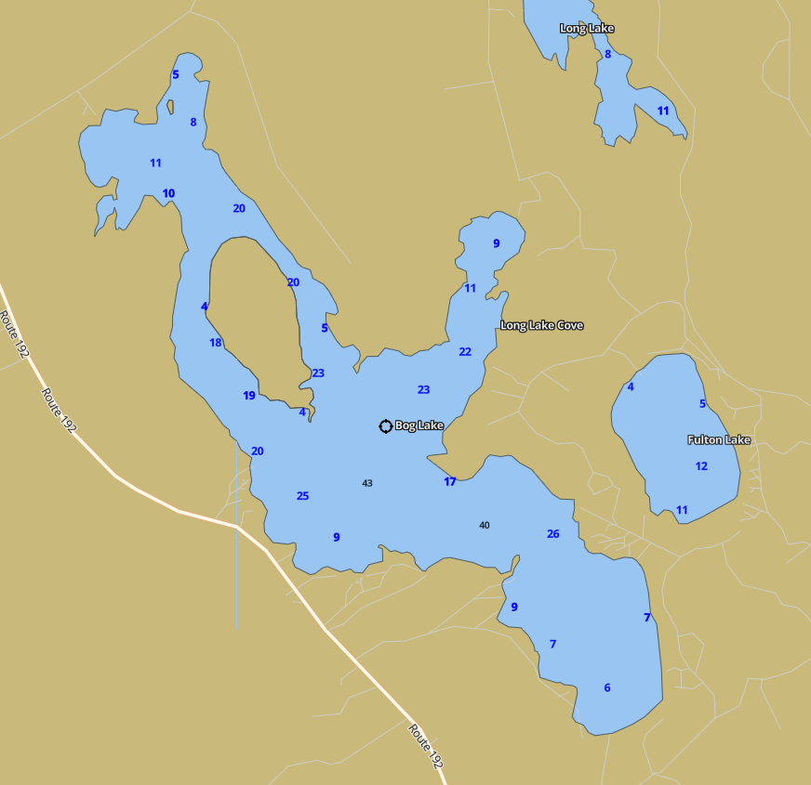
Source: ERMA Southwest
On the final day, the vehicle would be recovered with the gantry and the equipment would be packed up to move back to the WHOI facilities.

Project Components and Equipment

Vehicle and Payload
The LRAUV (300-m depth rating) is a an AUV with over ten years of development history. The Polaris under-ice version with docking nose assembly is approximately 255 lbs./115 kg and 9 ft/2.4 m long. The 12-inch diameter vehicle contains a 6 kWh, internal rechargeable lithium-ion battery capable of up to 15 days while traveling at 3 km/hr or .83 m/sec. with its current payload. The LRAUV is a propeller-driven vehicle capable of speeds between 0.6 and 1.5 m/sec.
The Polaris LRAUV oil detection vehicle has been outfitted with the following COTS instrument capabilities: Iridium; low-frequency (10 kHz) WHOI micromodem acoustic communications; RDI 600 kHz up/down ADCP (Acoustic Doppler Current Profiler); NBOSI CTD (Conductivity Temperature-Depth); AADI dissolved oxygen probe; Sea-Bird/Wet Labs, Inc. SeaOWL-UV-A (Sea Oil-in-Water locator) optical sensor (configured with three wavelength pairs to simultaneously measure dissolved hydrocarbons using fluorescence and oil droplets using optical backscatter); and a GoPro camera. In addition, the LRAUV docking payload contains a 25 kHz DUSBL, and a WHOI Dynamic Docking Whisker System.

Figure 3. Polaris in its Whisker Box long nose configuration is nine feet long.
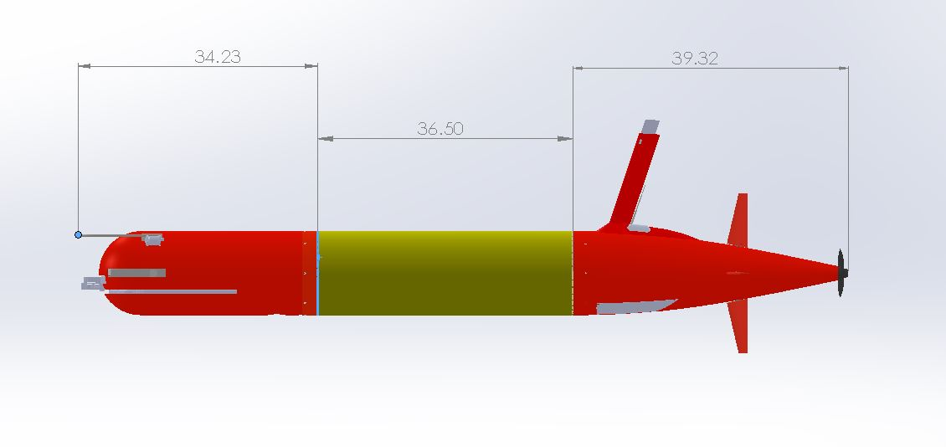
Core sensors: DVL/ADCP, NBOSI CTD, PAR, O2, DUSBL
6 kWh rechargeable,
11 kWh expendable
Shifting Mass allows controlled angle of attack during flight
Iridium, GPS, WiFi and Cellular in mast
Backup Argos and VHF
1-liter Buoyancy Engine allows neutral drift in water column
WHOI Dynamic Docking Whisker System

Vehicle Software
In the original software developed by MBARI, when the vehicle completes a mission or when it experiences a critical failure, it reverts to a “default mission” in which the vehicle returns to the surface. This allows for cellular or iridium communication to diagnose the problem, or simply command another mission. Naturally, in order to operate under the ice, where surfacing the vehicle is not an option, a new “default mission” needed to be put in place. In the under-ice default mission, the vehicle returns to the dock instead, so the vehicle will be in range for strong ACOMMS, and latched in a known location.

Figure 4: Software decision tree for the default under ice mission.
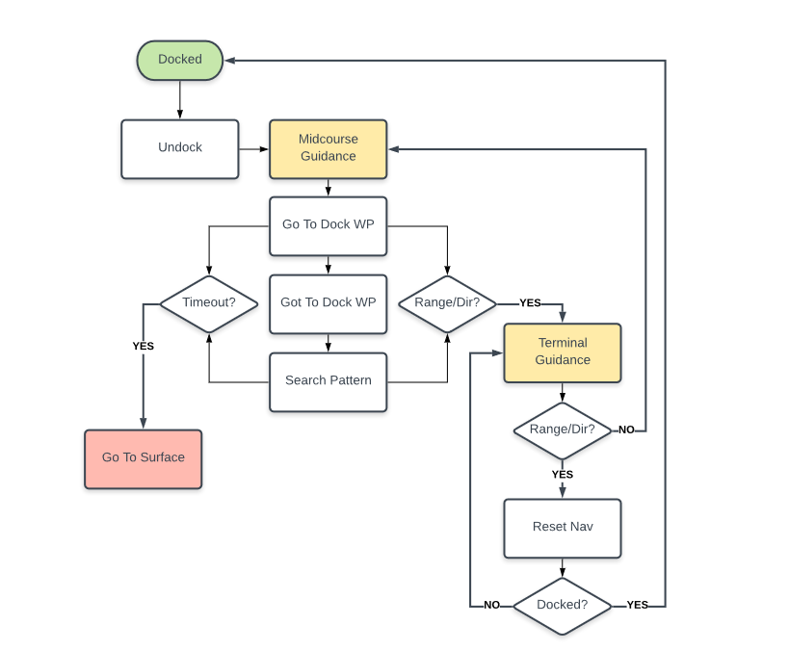
In addition, all the science and behavior missions were updated to include an undocking sequence, so the vehicle would never try to operate on the dock, as well as to include ACCOMS rather than direct comms intervals, where the vehicle surfaced for cellular/Iridium signal.

Arctic Gateway Buoys
Two of the three WHOI hybrid Arctic buoys for WHOI micromodem acoustic communications as well as homing, docking and radio communications, along with their complete housings and mooring systems, were brought to Bog Lake. The third buoy core was also brought to be swapped out with one of the fully-equipped buoys if necessary.

Figure 5. Arctic gateway buoy and peripherals
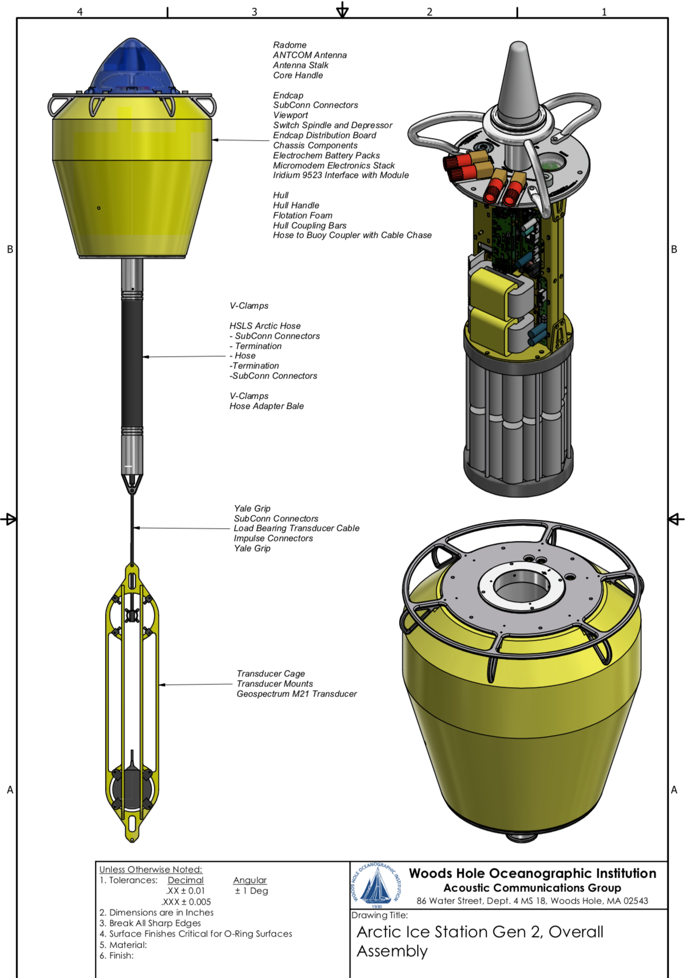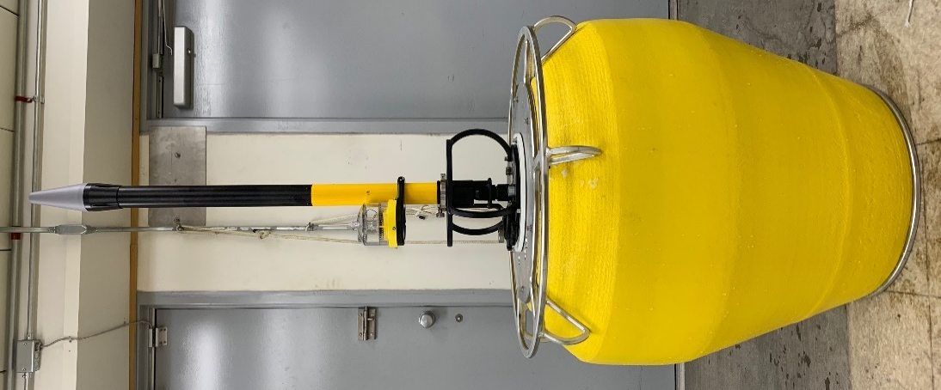
The “Sellers” backup transponders were also brought, to be attached to the buoy mooring system if necessary.

Additional Equipment
In order to safely deploy the vehicle through the ice, an ice and auxiliary gear kit were assembled including tracking gear (acoustic and radios), sleds, a gantry with rigging, ladders, augers, saws, chainsaws, heaters, generators and fuel tanks. An ATV was trailered to the site to be used for transporting the sleds full of gear out to the launch site on the frozen lake.
Other equipment included a WHOI UAS for aerial video and outreach, as well as WHOI’s Blue ROV for underwater video, and rescue recovery if necessary.

Sampling Methods
The LRAUV, Polaris, was run on three deployments, two in Buzzard’s Bay and one in Bog Lake, for a total of approximately 105 hrs.
Date | Event
Monday, February 3nd | MBARI team and Polaris vehicle arrive in Woods Hole
Monday, February 3nd | End to end check of vehicle and assembly
Monday, February 3nd | Freewave set-up and buoy scripts tested
Thursday, February 4th | Gateway buoy deployed and comms tested
Thursday, February 4th | Tank ballast and trim
Thursday, February 4th | Dashboard training for WHOI team
Thursday, February 4th | Vehicle deployed
Thursday, February 4th | Vehicle runs standard calibration missions
Thursday, February 4th | Vehicle sent on Line Capture missions
Wednesday, February 5th | Line capture missions continue, successfully docking
Wednesday, February 5th | Under-ice default test mission
Wednesday, February 5th | Under-ice Sci2 mission
Thursday, February 6th | Vehicle recovered to replace drop weight
Thursday, February 6th | Vehicle deployed for a second time
Thursday, February 6th | Mission default set to under ice default
Friday, February 7th | Vehicle recovered and reballasted for fresh water
Friday, February 7th | Equipment packed and team drives to Portland, Maine
Saturday, February 8th | Team arrives at Bog Lake, Maine, equipment unpacked
Saturday, February 8th | Gateway buoy deployed and comms tested
Saturday, February 8th | Vehicle deployment ice-hole cut
Sunday, February 9th | Vehicle deployed
Sunday, February 9th | Ballast adjusted on dock, ACCOMS tested on dock
Sunday, February 9th | Vehicle runs default under ice and successfully docks
Monday, February 10th | New undock behavior developed
Monday, February 10th | Vehicle runs profile station under mission
Monday, February 10th | New undock behavior tested
Monday, February 10th | Vehicle becomes trapped in shallows, located using acoustic ranging, RDF and avalanche beacon
Tuesday, February 11th | New ice-hole cut and vehicle recovered
Tuesday, February 11th | Ice holes filled in following Lake guidelines and equipment packed
Wednesday, February 12th | Vehicle and equipment returned to Woods Hole

Buzzard’s Bay Deployment

Area of Operation
While in Woods Hole, the team worked out of the Oceanographic Systems Lab, and field testing was conducted in Buzzard’s Bay.
Figure 6. Buzzard's Bay and Woods Hole test sites.
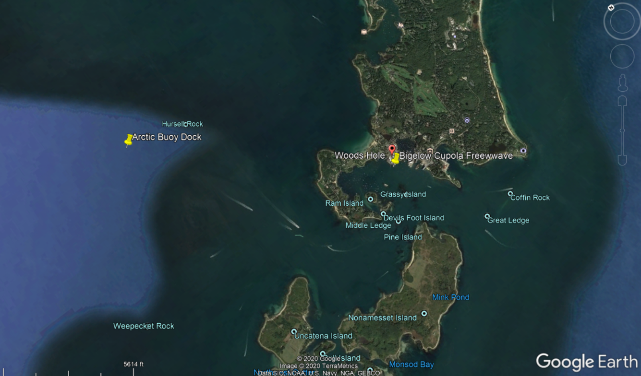
Source: Google Earth

Missions
While in Woods Hole the LRAUV, Polaris, conducted two deployments. Both times the vehicle was deployed and recovered off of the WHOI Hurricane RHIB, a 7-meter vessel. The pontoon sides of this vessel allowed the vehicle to be slid easily in and out of the water with two or three persons either holding the vehicle, or holding lifting straps through the bail on the front of the vehicle to protecting the fins and prop from getting hung up.
Deployment 1 – Buzzard’s Bay
The first deployment began in the evening of February 4th, after the vehicle had been assembled, fully checked out, and ballasted and trimmed in a saltwater tank. One of the Arctic gateway buoys had been deployed earlier that day with both the HF uModem and the Sellars transponder. When the vehicle was deployed it first performed the standard Ballast and Trim and Compass Calibration missions. The vehicle was then sent on repetitive Line Capture missions to practice homing and docking to the uModem Arctic buoy. The whiskers failed to extend for docking and around 2am, the Dynamic Docking Mechanism (DDM) was disabled and the vehicle was commanded to station keep for the rest of the night via the WHOI dashboard.
The following morning the current limit to the DDM was increased and the vehicle was able to open its whiskers and dock successfully. The line capture mission was repeated throughout the day with only a 20% success rate. This was initially thought to be due to the high uModems communications rate interfering with the homing pings, but upon recovery, it was discovered that the Sellers transponder was also responding to the vehicle interrogations (despite the address not being used) and this may have contributed to interference in the homing. The vehicle successfully received commands and returned data acoustically throughout these missions.
Following these successful Line Capture missions, the vehicle was sent to test the under-ice Default mission (which also includes docking). The vehicle was set to loop between the Under-Ice default mission and the straight-line science mission, Sci2. During these missions the vehicle began to have trouble getting off the surface (after surfacing for cellular communications). On recovery, Polaris was found to be missing a whisker. The vehicle still managed to dock with one whisker, but failed to undock due to a software issue in the vehicle’s initialization routine. The vehicle prematurely considered itself undocked and floated to the surface while still attached to the mooring. Unable to reach the surface, it released its drop weight. The vehicle was recovered on the morning of the 6th of February so the drop weight could be replaced and the software issue addressed.
Deployment 2 – Buzzard’s Bay
Polaris was redeployed during the afternoon of February 6th, where it ran another ballast and trim mission. Following the successful testing of the vehicle’s under-ice default mission, the vehicle was configured to actually use that mission as its new default. Testing continued with the vehicle no longer configured to return to the surface unless specifically commanded to do so via the WHOI dashboard. Multiple missions were sent to Polaris acoustically via the dashboard, although not all messages were parsed. The whiskers again experienced difficultly opening, and the DDM current limits were increased to the maximum for future operations. Consulting with other DDM operators confirmed that this is a normal mode of operation. The vehicle was recovered the morning of February 7th, due to incoming weather. The vehicle was re-ballasted for fresh water, and all equipment was packed into vans for the drive to Northfield, Maine.

Bog Lake Deployment

Area of Operation
Bog Lake is in Northfield, Maine, 45 minutes from the Canadian border. The town is remote with about 10 year-round residents. The nearest town is Machias located 12 miles or 25 minutes away and contains minimal commercial enterprises. While the remote location ensured that the lake was sufficiently frozen for operations to take place on the surface without risk to personnel, it also meant that there would be little opportunity to resupply.
Figure 7. Google Earth Image of Bog Lake. Waypoint CC is our main house for working and command control. Waypoint Avery is Avery’s camp for sleep accommodations. The proposed buoy location is 750 meters from CC. Waypoint Boat Ramp is 250 meters from the Buoy location.
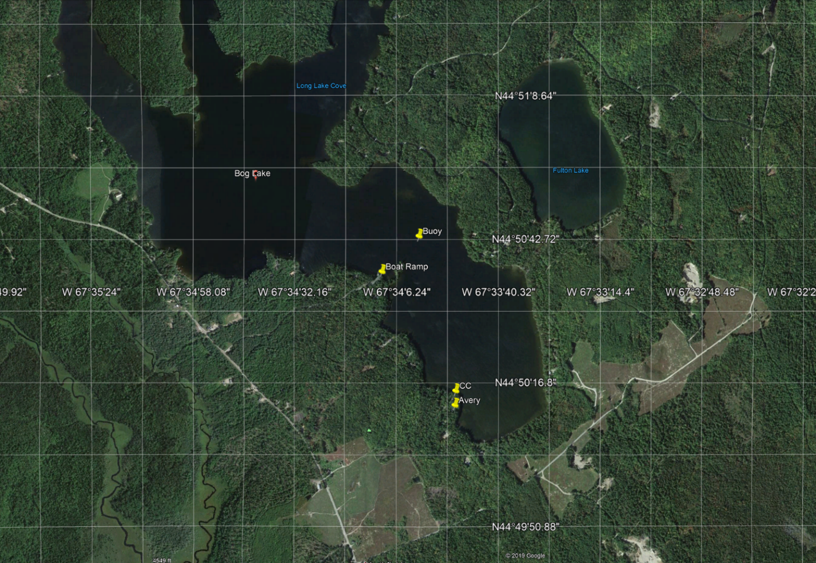
The MBARI/WHOI team traveled up to Bog Lake over two days, since the winter storm on February 6th made night driving on the remote roads of Northfield with all the equipment somewhat hazardous. The team left the afternoon of the 7th, stopping for the night in Portland, Maine and continuing on to Northfield the following morning.

Vehicle Deployment
On arrival at Northfield, Maine, gear was unloaded and the Freewave radio was set up on the deck of the house which served as command control. The buoy was brought out to the desired position on the lake using the ATV and sleds, and communications were tested between the buoy and command control. On the evening of the 8th, a subgroup of the WHOI/MBARI team brought the necessary equipment out to the launch site to cut the hole for the vehicle deployment the following day. For this process, and all operations on the lake thereafter, personnel on the lake were equipped with safety kits consisting of lights, whistles, flares, and radios. Once at the launch site, the deployment hole was measured out and the gantry erected over it. A 24 inch chainsaw was used to cut out the hole in sections, and each ice block was removed from the hole using rigging affixed to the gantry. The buoy was anchored to the ice on one end of the deployment hole, where the transponder could easily hang at the desired depth and the vehicle could be latched onto the dock when deployed. The light on the buoy, along with orange traffic cones, reflectors, and the gantry itself, were used to mark the hole.

Missions
Deployment 3 – Bog Lake
The following morning (the 9th of February) the vehicle was pulled onto the ice using a sled and the ATV, and was lifted into the deployment hole, while already attached to the buoy dock, using the gantry. The freshwater tank at WHOI did not completely match the density of the water in the lake as verify with a CTD cast, so ballast was changed slightly while the vehicle was still attached to the dock. ACCOMS were also tested while the vehicle was still on the dock and is always carried out prior mission releases.
The vehicle was acoustically commanded off the dock, however, it required manual assistance to complete the undocking process. The vehicle normally undocks by adjusting its mass position and buoyancy to either float or sink off the dock, assisted by open ocean water currents. With no water current in the lake, and little depth available in the shallow lake for LRAUV to undock using the vertical maneuvering of its standard undocking behavior, the vehicle was unable to detach on its own, and the line was manually moved around it. Once off the dock, the vehicle ran a profile station mission and when the mission completed, it reverted to its under-ice default mission as intended and docked successfully.
Figure 8. The plot of the vehicle's acoustic ranges to the dock show it making a few passes before finally docking. When in range of the dock the vehicle activates its go pro camera, capturing footage of its whiskers and the mooring line as it docks.
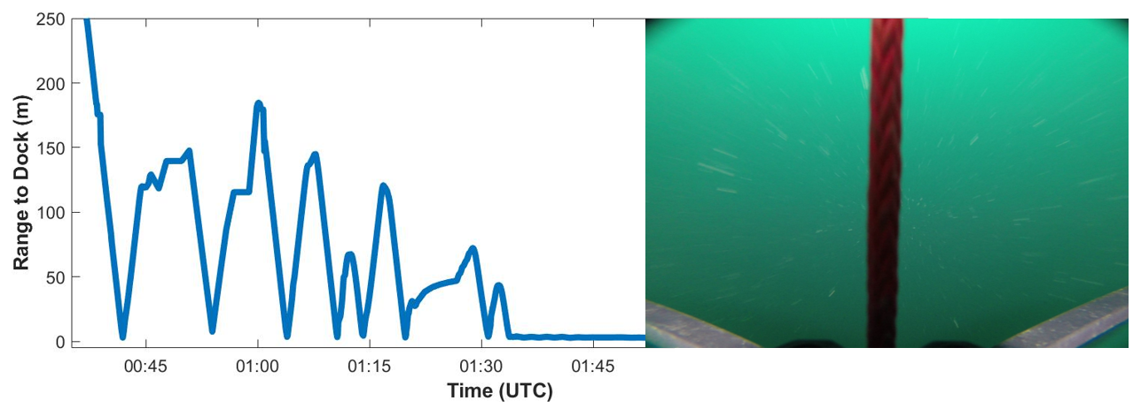
The following day (February 10th) the MBARI team on site worked to develop a “Catapult” undock behavior where the vehicle would drive forward while still attached to the line, and then drift backward off the dock. This was tested unsuccessfully and the vehicle was manually detached, after which it ran another profile station mission and returned to the dock. The vehicle made it to the deployment hole, however an altitude envelope activation earlier in the mission had caused it to drive along the underside of the ice, and the vehicle was caught by hand when it reached the hole, rather than docking. The vehicle’s approach was tracked by acoustic ranges as well as ranging from the avalanche receiver used by someone walking on the ice. Polaris was reattached to the dock, and the catapult behavior continued to be developed. Later that evening the behavior was tested again, and Polaris detached from the dock on its own, however after drifting backward the vehicle drove forward into the line and had to be manually cleared. The vehicle began a profile station mission, but when it tried to return to the dock, a software bug introduced by the new undock behavior prevented it from updating its headings. Polaris continued on one heading until it became trapped in the shallows of the lake edge. Acoustic ranges were used to generally locate the vehicle, and the avalanche beacon was then used to pinpoint its exact location within 1 meter. RDF also provided a rough heading toward the vehicle, but was not the most deterministic of the three locating tools.
Figure 9. Acoustic ranging from the fix points narrowed the vehicle search area down to a few tens of meters.
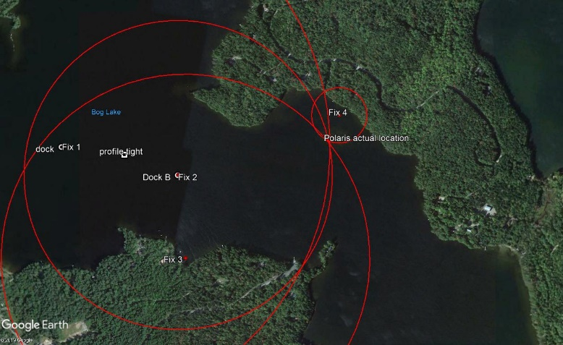
The morning of February 11th, the gantry was erected over the location determined by the acoustic ranging and avalanche beacon, and a new hole for recovery was cut out of the ice. Polaris was successfully recovered, though the antenna had suffered permanent damage from being pressed against the ice. The rest of the day was used to fill in the ice holes so they would refreeze evenly with the rest of the lake, and pack away all the equipment. The team also evaluated data and vehicle performance offering an opportunity for both MBARI/WHOI to develop lessons learned list. The following day was used for final packing steps and the MABRI and WHOI teams returned to their respective institutions.

Supplemental Data Collection
Video and still shots were captured via pole cams, the LRAUV camera and lighting system, a UAS and other portable camera devices to be used for outreach, project reporting and engineering. An ROV was used to document docking and undocking behaviors.
Figure 10. Footage captured by the WHOI UAS and Blue ROV show the gantry and deployment ice-hole, as well as the vehicle on the dock from below the ice.
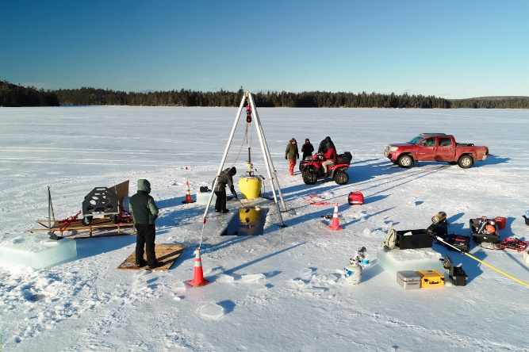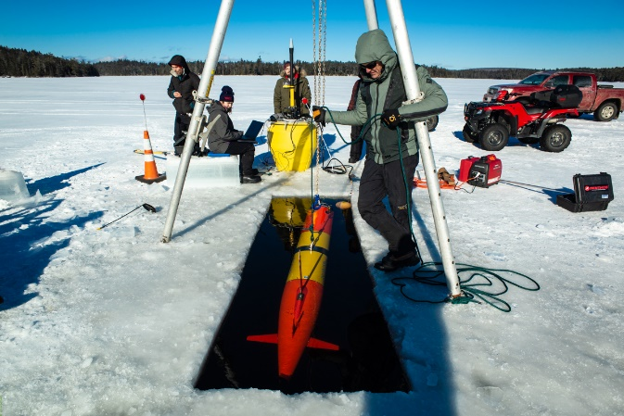
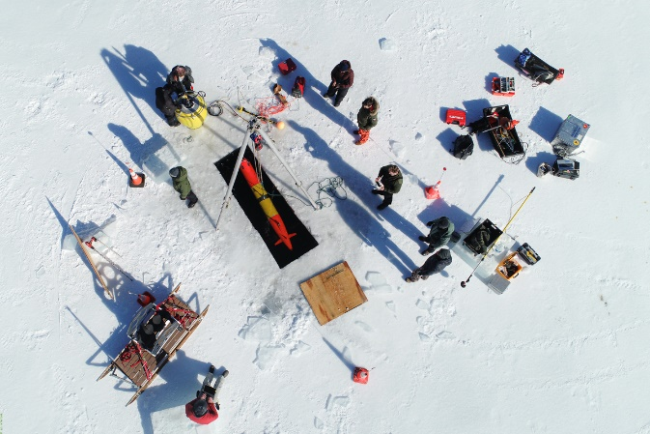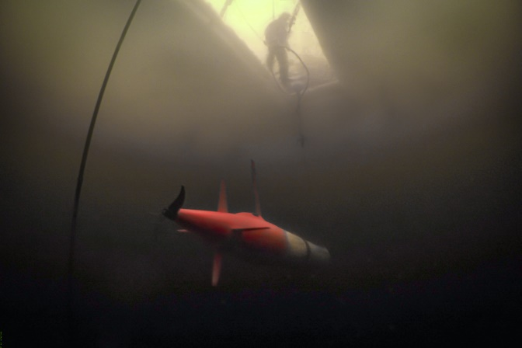

Data Management

WHOI Dashboard
Snippets of LRAUV data pertaining to mission behavior execution including docking and undocking were transmitted acoustically from the LRAUV to the buoy and back to a local machine at command control via line of sight Freewave. From there, the local machine packaged data as Short Burst Data (SBD) messages and sent them via email to the WHOI and MBARI dashboards where they were automatically unpacked and displayed. The team was able to monitor the mission remotely and make mission parameter changes while keeping Polaris under-ice. On two occasions, the team floated the LRAUV to the surface in the ice hole in order to establish a cellular link to the vehicle for a larger data extraction, and to upload new controller code to the vehicle based on lessons learned.
Figure 11. The WHOI dashboard can be accessed by LRAUV operators around the world at http://lrauv.whoi.edu
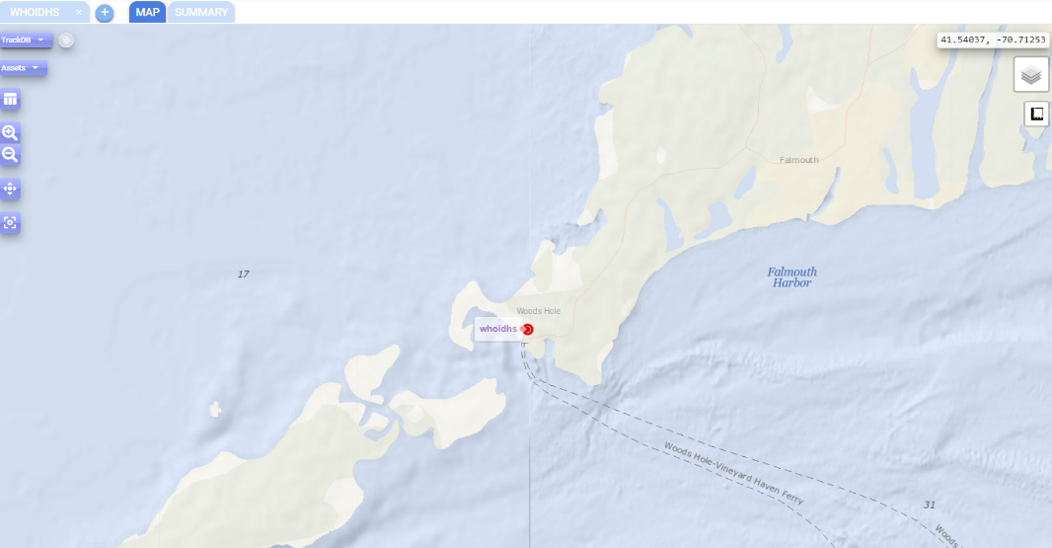

Data Post-Processing
Once the vehicle was recovered, full resolution data was offloaded from the vehicle via its tethered cable. These files were then unserialized into many different file formats including Matlab files, CSVs, and Netcdfs. Currently these commands must be run manually, but in the future this process will be automatically initiated when the vehicle is connected to the tether. This will allow us to rapidly export files for NOAA to upload data to their DIVER and ERMA response tool sites.

Conclusions
The three New England deployments of the LRAUV, Polaris, greatly furthered the team’s operational readiness for an Arctic under-ice deployment. The training provided by the MBARI team members throughout these deployments has greatly increased operational and technical expertise to WHOI-LRAUV operators working on the ADAC project. The under-ice missions prepared both teams for the environmental challenges of deploying an LRAUV through the ice and revealed a number of areas for continued development in order to make the vehicle behaviors more robust for future deployments. Since these deployments, the improved under ice missions and software behaviors are ready to be tested in Buzzard’s Bay baring Covid-19 limitations. Ultimately, the missions provided valuable training, and allowed the WHOI and MBARI team to address potential issues in the vehicle under-ice behaviors, however more testing is needed to allow for further mitigation in high risk behaviors such as undocking under-ice in shallower environments.

