Feb 3-11 2020
LRAUV Polaris was run on 3 deployments, two in Buzzard’s Bay and one in Bog Lake, for a total of approximately 105 hours.
- Demonstrated opening/closing of the pressure hull and basic vehicle assembly.
- Debugged gateway buoy (GWB) python scripts to run on WHOI network, dash server, and local machine.
- Debugged modem configurations to enable homing/data via a single WHOI micromodem.
- Adjusted current limit settings on Dynamic Docking Module (DDM) to enable whisker open/close in the conditions at Buzzard’s Bay.
- Transferred Iridium, Verizon, Argos accounts to WHOI and forwarded e-mail appropriately to appear in the WHOI dash
- Data transferred from the LRAUV to shore via acoustics/GWB
- Commands/Missions sent acoustically via dash/GWB and received on vehicle
- Reset navigation when close to the dock
- Training on pre-deployment checklists
- Non-volatile position update worked upon underwater restart.

Deployment 25 – Buzzard’s Bay
Vehicle splashed: 2020-02-04 15:10:01 PST
Vehicle recovered: 2020-02-06 08:41:33 PST
- Mission planning (see WHOI - Buzzards Bay.kmz)
- Buoy deployed with HF uModem and Sellars transponder
- Compass calibration
- Ballast and trim (366 cc / 0.77 mm)
- Profile station mission to stand off
- Line Capture depth mission to test homing/docking to uModem
  - Whiskers failed to extend
  - Around 2 a.m. local elected to disable the DDM component at park for the night
  - Changed DDM code to use current limit 0xC0 and ran line capture depth
  - Docked successfully 20200205T160201 (e.g., GOPRO481.MP4)
  - Multiple docking runs using line capture depth only docking with only 20% success rates. 20200205T193923. Initially it was assumed that the faster (5 min) uModem comms rate was to blame but no data transfers were observed while in armed state. It was later found that the Sellars transponder was responding to interrogations despite not being addressed which may have interfered.
  - Once on the dock again a stop command was sent acoustically via the dash and was received by the vehicle. The vehicle successfully ran defaultWithUndock and came off the dock cleanly and returned to the surface.
- Tests of the default under ice mission were run with an overall mission timeout added temporarily. The default script was set to default with undock.
- Tests of the sci2 under ice mission were run
- Significant trouble getting off the surface during further default under ice testing which was later found to be due to a missing whisker. Flew over the dock at 10m from the surface multiple times.
- Drop weight incident: vehicle failed to undock due to software issue. The Undock behavior satisfied prematurely, and the vehicle attempted to float up to the surface while still attached to the line. This issue was isolated to the behavior’s init routine, was addressed, and committed to the repo.
Deployment 26 – Buzzard’s Bay
Vehicle splashed: 2020-02-06 17:58:23 PST
Vehicle recovered: 2020-02-07 07:05:48 PST
- Ballast and trim (324 cc / 2.4 mm)
- Profile station was run towards the site West of the dock and a stop command was sent from the dash via the GWB acoustic interface and executed onboard leaving defaultWithUndock to run.
- Line capture depth was run with successful docking.
- Around midnight local the lights flooded and stopped working due to a cut in the power cable. The component was isolated and shut down and the associated ground fault was observed to have gone away.
2020-02-07T04:48:48.053Z,1581050928.053 [CBIT](IMPORTANT): Low side ground fault detected
- The default mission was switched to be defaultUnder at this time.
- A worksite fix was noted upon restart: 2020-02-07T05:13:00.272Z,1581052380.272 [WorkSite](IMPORTANT): WorkSite fix at 20200207T050003: (41.548864, -70.694924)
- The DDM was unable to extend the whiskers in time, but eventually docked on the 8th try and spent the remainder of the deployment on the dock.
- Multiple missions were sent via acoustics but not all 3 SBDs could be parsed.
- DefaultWithUndock was successfully run via the acoustic interface. The undock behavior ran and opened the latch, however the DDM was erroneously reporting the cable being not present and the vehicle thought it was undocked and closed the latch again. Further noise was noted on the DDM cablePresent signal throughout the remainder of the mission and subsequent defaultUnder mission.
- Vehicle was recovered while attached to the dock due to incoming weather.

Deployment 27 – Bog Lake
Vehicle splashed: 2020-02-09 09:32:22 PST
Vehicle recovered: 2020-02-11 10:11:07 PST
- Ballast and trim following freshwater ballast at WHOI (605 cc / 15.5 mm)
- Vehicle was acoustically commanded off dock, ran a profile station science mission and returned to the dock successfully after the 8th try. A backlog of acoustic data contributed to interference with docking chirps which is believed to have led to so many tries to hit the dock.
- The vehicle was not able to undock due to a lack of searoom above/below the dock line and was manually cast off the docking line.
- Vehicle did not receive a worksite navigation update this time
- Ignore DDM critical in 20200210T202907 (manually induced)
- Catapult undock was tested and failed. Profile station was run and the vehicle made it back to the dock on the second try but was driving on the underside of the ice due to an altitude envelope activation earlier in the mission. Once on the ice the vehicle could not dive with the thruster on and was recovered by hand (Sean) at the hole.
- Further debugging was put in place to diagnose the lack of arming that was noted on the DDM and the vehicle was sent on another profile_stationUnder mission.
- Following mission completion the vehicle began running defaultUnder but a software bug prevented the heading command from getting updated and the vehicle drove the last commanded heading until it became trapped.
- 4 acoustic ranges localized the vehicle under the ice (see below) and an avalanche beacon was used to close the location from there. RDF provided rough location to the cove, though was not very deterministic.
- Vehicle was cut free and hoisted out for recovery. The antenna tip suffered permanent damage from scraping on the ice.
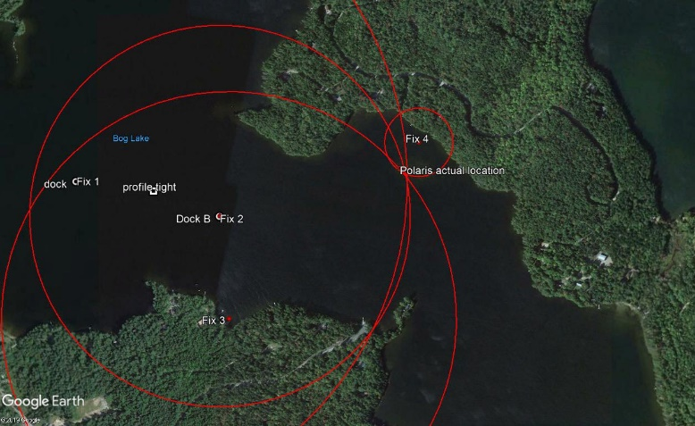

Test plan results from revision 4 of the test plan 2/3/2020. Strikethrough indicates completion

Test Objectives
The primary objective of this effort from 2-12 February will be to test the following:
2-5 February, Woods Hole:
- Deliver LRAUV-Polaris to Woods Hole and conduct FAT
- Have MBARI team train WHOI personnel on the following:
  - Opening and closing vehicle – check for shipping damage
- Buzzard Bay Testing
  - Setup mooring 1 for 14m of water with strongback at 11m off bottom and transponder A at 10m above bottom. AUV will fly at 6m depth, 8m off bottom
  - Setup two freewave radios (one omni, one yagi) on cupula for Buzzards Bay tests
  - Integrate neutral buoyant avi-beacon in the nose, and adjust buoyancy
  - Deploy first nearshore buoy from Hurricane RHIB; precisely note position
    - ~14m of water, riser to 11m off bottom, transponder below strongback at 10m off bottom. Vehicle flys at 6m deph, in middle of water column
  - Prep and load LRAUV into Hurricane RHIB
  - Deploy LRAUV near mooring 1
    - Run Default/undock – vehicle stays on the surface
    - Confirm Acomms and dock ranges
    - Run any under-ice mission that ends on the dock
  - Rig and Deploy 2nd mooring with transponder B approx. 9 km to the NW – note precise position
  - Run a Profile station mission for 30min, return to dock
  - Run a Sci2 mission to a waypoint 500m away, return to dock
  - Run a Sci2 mission outside of acomms/homing range, return to dock
  - Run a sci2 mission to the new dock
      - Will loose acomms from dock 1, switch to dock 2 GWB and hopefully re-establish comms when in range.
      - Vehicle resets nav, then docks
    - Run a sci2 back to mooring 1
  - Repeat all of the above all night long
- Wednesday
  - Recover LRAUV first, then both moorings
  - Reconfigure moorings for on-ice;not floats, no chain, ~20lb depressor at 20’ – vehicle flys at 10’ depth, transponder at 8’ depth
  - Remove vehicle shells and ballast weights, add 100m foam to nose, close up and check ballast in fresh water tank. Mount new ballast weights and re install shells
  - Charge LRAUV batteries
  - Pack all gear in Vans
    - Load LRAUV on cradle in van with ramps
- Testing 2 – Bog Lake
  - Advance team leaves early Thursday to setup and cut the hole and check out camp and work site. Determine if we have all the technical kit needed to do the job and fill in any information relative to accommodations relating to sleeping, eating, personal gear. (Jeff, Avery, Sean to head up in first group with 4x4 rental pickup truck and rental van ). Ice cutting gear and support gear is captured in the following spreadsheet snapshot (Fig. 1) (NOTE, will we pack mooring and buoys in same van as Polaris?)
  - Set up a gantry over our deposit/docking site. Set up Arctic Oven tent?
  - Make an ice hole approximately 3 feet by 9 feet for vehicle launch and recovery
  - Pull out ice blocks
  - Conduct pre-mission checkouts of buoy, aux gear, radios, LRAUV
  - Setup data relay antennas back to command control House-A.
  - Hang transponder/dock in hole 1
  - Attach vehicle onto mooring and launch thru ice hole(vehicle has emergency lights, avalanche beacon and stand-alone transponder for locating the vehicle if internal systems are malfunctioning). We will check these systems prior to launch
  - Conduct acoustic tests prior to sending vehicle on mission
  - Run circle mission around the buoy and confirm ACOMMS to command control (CC)
  - Send data to and from vehicle from CC to buoy and back
  - Redirect mission(s) from CC
  - Test emergency behaviors (highest priority and time needed for testing)
  - Reliably dock/undock vehicle
  - The team will also have an ROV on hand and will practice vehicle emergency recovery
  - Continue under-ice behavior and mission development and testing (high priority to get here)
    - Profile station mission
    - Waypoint following
    - Second dock capability mission
    - Reset navigation position using multiple USBL capability transponders/buoys
  - The lake is not large enough to deploy and test a second buoy relay to test long-range comms and homing beyond 1 km, therefore more tests are needed prior to operating in the Arctic in order to minimize risk

