Three inshore, guaranteed ice-covered operations area choices for the March Demo:
- Offshore the MTU
  - Small, shallow, convenient (direct Freewave, nice shoreside facilities)
- Torch Lake, NW of the Keweenan Channel
  - Small, but relatively deep
  - Too far from NTU for freewave link, so need a local radio link
- Portage Lake
  - Large enough, deep enough,
  - Too far from NTU for freewave link, but there is a decent lakeside house available
    - https://www.airbnb.com/rooms/38104078?location=Torch%20Lake%2C%20MI&adults=8&check_in=2020-03-22&check_out=2020-03-30&source_impression_id=p3_1582760993_zyLXJU4czsPsKbpn
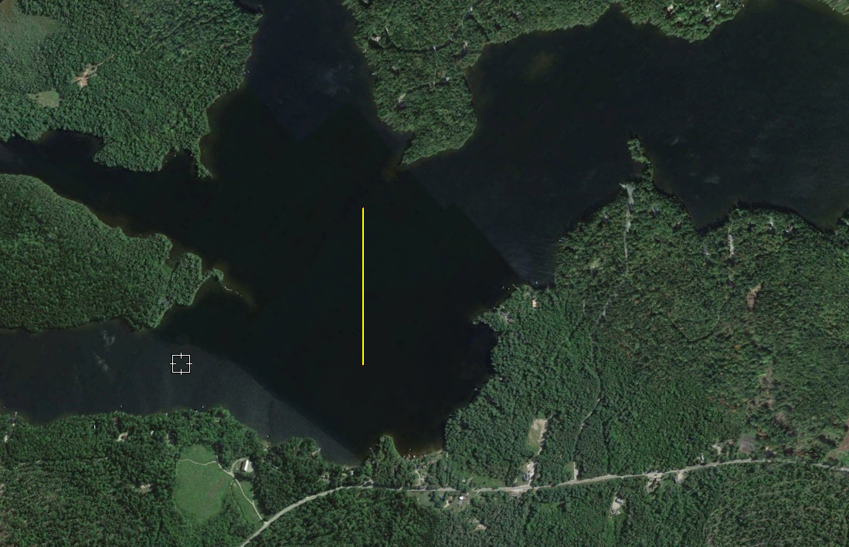
Figure 1: Bog lake, for comparison. 500m line
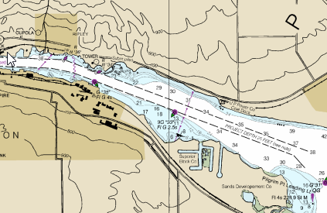
Figure 2: Depths in Keweenan Channel, offshore NTU
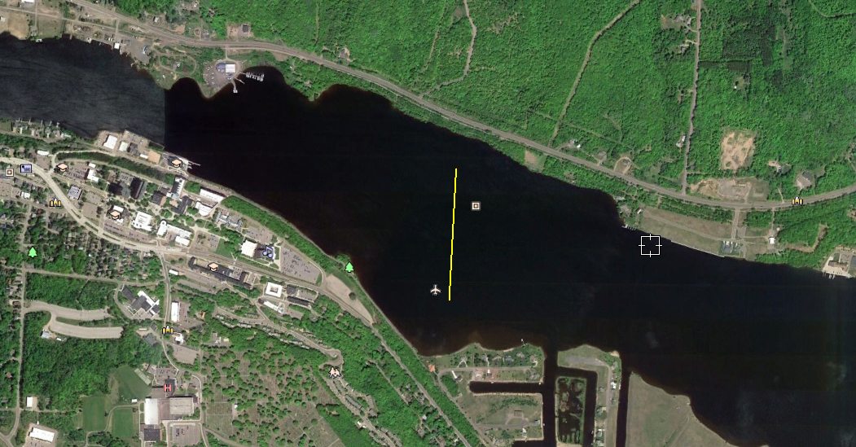
Figure 3: Image of Keweenan Channel with 500m line

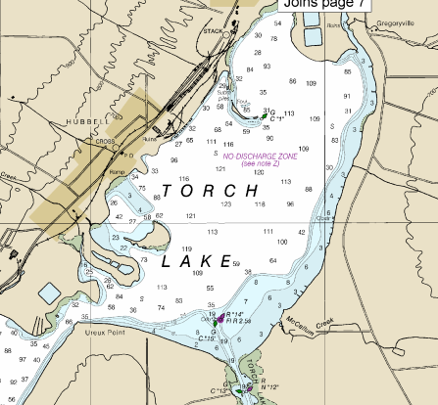
Figure 4: Torch Lake with depths
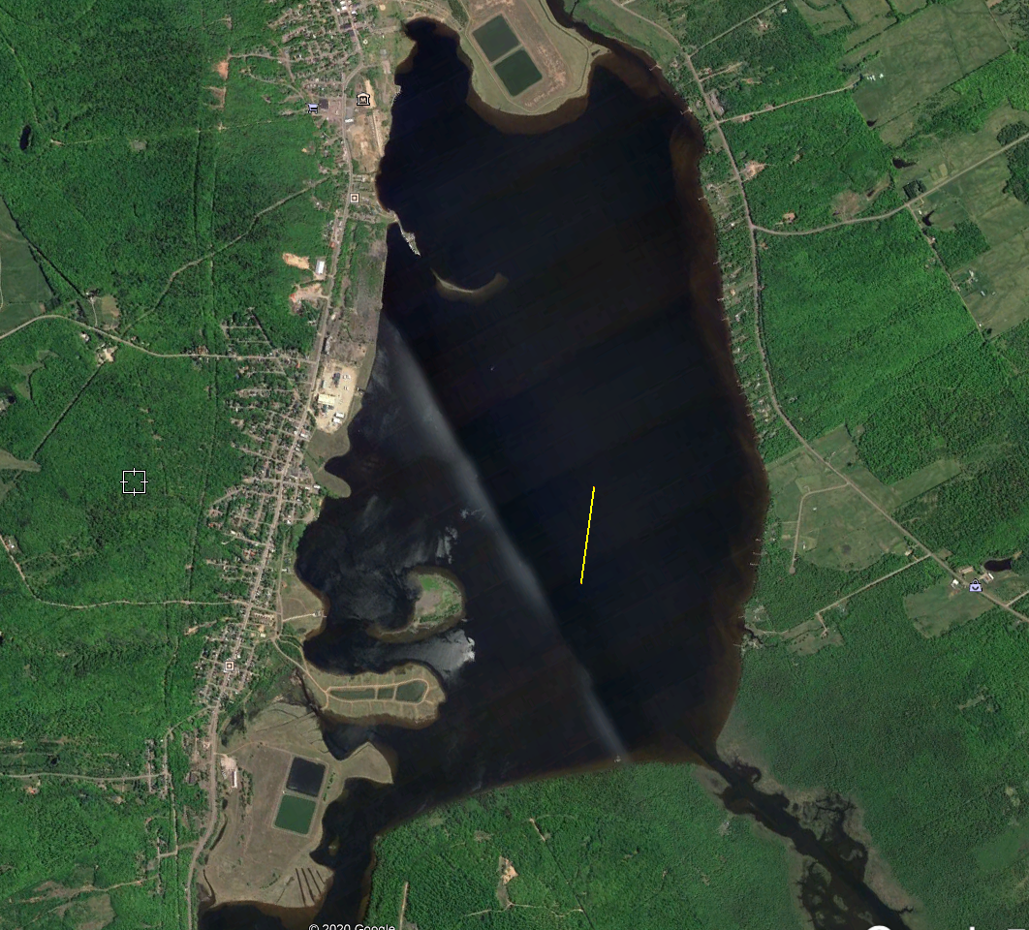
Figure 5: Torch Lake, with 500m line
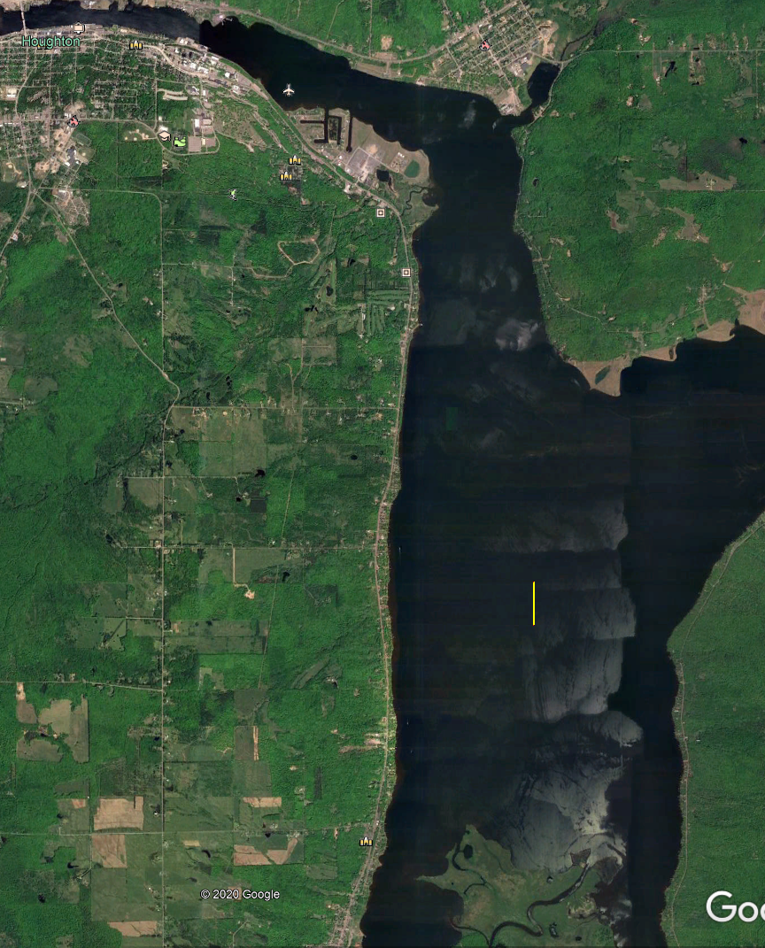
Figure 6: Portage Lake with 500m line
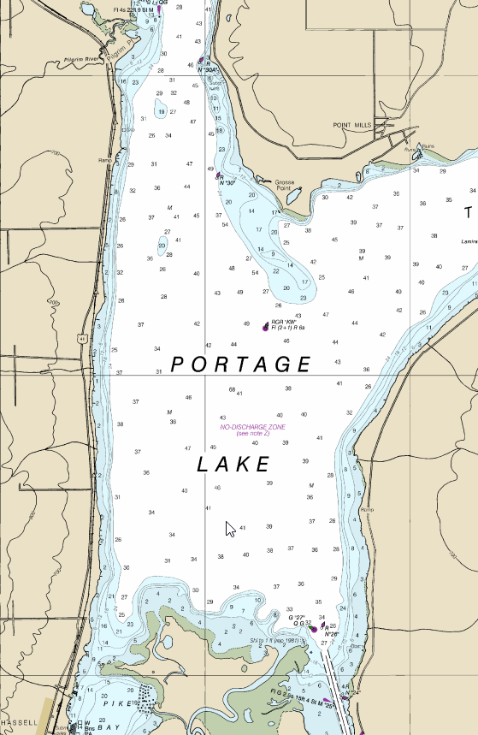
Figure 7: Portage Lake with depths

