Project Motivation and Overview:
The use of marine energy converters to support remote charging of vehicles and instrumentation with high power requirements is becoming contingent upon the integration of adequate power storage systems that can accommodate the unique operations of marine energy converters. Some of the challenges associated with leveraging marine energy converters to support at sea load are (1) high-peak to mean power ratios, (2) rapid charge/discharge requirements for controls optimization, and (3) long periods where conditions may result in little to no power generation. Improvements in battery technology and a broader interest in exploiting marine energy conversion for at-sea power means that there is a general need to develop improved power storage and management systems.
The goal of this project is to procure a battery system suitable for integration across multiple marine energy converters (initially MBARI’s wave energy converter and UW’s Turbine Lander) and to ultimately integrate the system with the respective devices. Currently, both of these target systems (UW’s Turbine Lander and MBARI’s WEC) are using the same power conversion electronics to create a constant charge voltage from the varying voltage produced by the motors in the respective systems. Therefore, battery interface requirements for the two systems are identical.
While it would be possible to perform this work in-house at either institution, there are numerous reasons to consider leveraging commercial manufacturers for the battery component. Key among these are safety considerations and the general position of the project sponsor to see a commercially available product as a result of this development. Thus, to achieve the project’s objective MBARI and APL will collaborate to identify a suitable manufacturer for the battery, procure the units, and integrate the result into the tidal turbine lander and the MBARI wave-energy conversion. The supporting work required will be split between the respective institutions according to need.
As part of this process, it will be necessary to compile detailed technical requirements to provide to potential manufacturers, gather quotes and select a manufacturer, modify pre-existing contractual documents to carry out the proposed work, procure the units, design suitable housings, and ultimately to perform required system testing and field deployments. UW and MBARI, under co-investigators Christopher Bassett (APL) and Andrew Hamilton (MBARI), will collaborate to achieve these objectives beginning in late 2023 and throughout the time period required to complete the project. A detailed summary of tasks, personnel, and anticipated time requirements is included in the following section.
Note that this task will provide no direct support for field-based testing of the storage systems at sea. Further, it is intended that the non-recurring development costs of the battery system and the implementation costs for the tidal turbine lander will be borne by this project, and the costs of procuring, housing, and implementing a second battery in the MBARI wave-energy system will be borne by MBARI.

Project Tasks:
Task 1 – System requirements: Compile system requirements to reflect needs across both marine energy converter systems. The system requirement document will include, but not be limited to, desired storage capacity, voltage/current requirements, system management and monitoring needs, start/stop procedures, and related topics of value to manufacturers. In addition, desired system attributes such as expandable capacity through parallelization and chassis design will be documented. These requirements and preferences will be consolidated into a formal document to share with suitable vendors. Both APL and MBARI co-investigators will gather feedback from internal team members prior to the document’s submission. The anticipated completion date for this task is February 2024. Appendix A includes a preliminary document of this type.
Task 2 – Solicit quotes: Project co-investigators will identify multiple potential manufacturers that will be contacted to provide quotes. If an insufficient number of quotes are received, C. Bassett will work with the project sponsor and APL’s administrative staff to identify the best path forward. It may be possible to proceed with sole source documentation, but a public request for quotations may be required. Proposed completion April 2024. Appendix B includes a quote previously obtained for a battery system of this type, that quote was for an advanced battery type (lithium titenate) that added costs and may not be required for this application.
Task 3 – Select manufacturer and modify contract: Once quotes have been received MBARI and APL the quotes and process will dictate the path forward. Project co-investigators will establish budgets that include procuring the battery systems, develop housings, integrating units with relevant systems and all related expenses including personnel time, supplies, and testing requirements. At this point APL will brief the sponsor and submit a Task Order Revision with the sponsor to modify the contract to allow the project to proceed. Anticipated completion date June 2024.
Task 4 – Procurement and supporting design work: Once the TDR has been approved, submit purchase requests for the battery systems. In parallel, both institutions will proceed with developing the required mechanical designs, submitting designs for manufacturing, and purchases associated supplies. Targeted completion date November 2024. An outcome of this task will be to finalize BOMs and cost estimates for manufactured units suitable for field deployment.
Task 5 – Assembly and evaluation: Once the battery systems and necessary components have been received the systems will be assembled and tested. Specific tests that will be performed will be established during the budgeting and planning exercise in Task 3. Anticipated completion date – June 2025.
UW and MBARI will collaborate on the various tasks with UW taking the leading on procurement of the systems.
Timeline Summary:
The following timeline has relatively short turnaround times for initial tasking to move the project forward. Depending on the general responsiveness of potential commercial partners and the requirements to overcome administrative hurdles, some of these targets may be difficult to achieve. Due to more generous timelines for Tasks 4 and 5, it should be possible to complete all of the tasks in the proposed timeline.
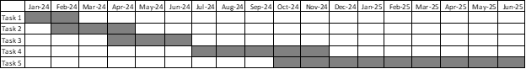
Key personnel:
Monterrey Bay Aquarium Research Institute: Andrew Hamilton (Co-I), Scott Jenson
Applied Physics Laboratory UW: Christopher Bassett (Co-I), Harlin Wood/Paul Gibbs, Jesse Dosher

Appendix A – Preliminary system description and requirements document
Introduction
This document describes the fundamental requirements for a battery pack to be integrated with the wave energy and tidal turbine devices to be developed by the Monterey Bay Aquarium Research Institute and the University of Washington. Both devices are designed to generate power for use by oceanographic instrumentation. The wave and tidal energy converters have unique performance characteristics related to the average and instantaneous power generation and required system controls.
Wave energy converter: The wave-energy converter is a unique charging source in that while the average power is on the order of 100-800 Watts, it is delivered in series of large, short duration power pulses. Simultaneously, loads on the battery system are present and are typically in the 0-500 W range, but do not tend to oscillate as quickly. Figure 1 illustrates the current flow in and out of the battery during typical operation, showing a net charge over the period, but oscillating between a large charge current and a smaller continuous load current.
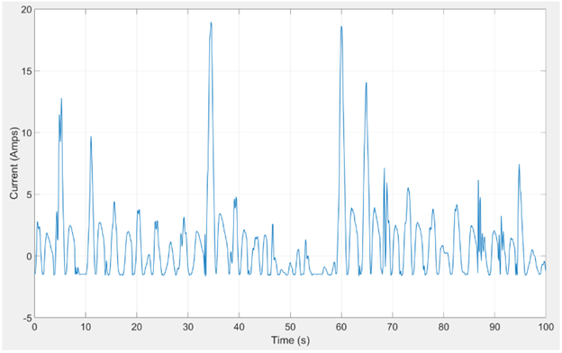
Figure 1: Battery Current at 300V.
Tidal energy converter: The mean and instantaneous power generation profiles for the tidal turbine also vary with time, but to a much smaller degree than the wave energy device. In most deployments the system can be expected to be generating power approximately 40% of the time or more. Net power production begins when currents are approximately 0.75 m/s and peak, due to mechanical limitations, when currents are approximately 2.5 m/s (with the present design). The current rotor contains four blades and the resulting power generation within a given revolution of the turbine shows four cycles (Figure 2). During relatively weak currents the system goes through periods where modest power input is required in order to maintain the rotation of the rotor while maximizing its efficiency. During strong currents input power is not generally required for optimized system performance. The result is a battery charge/discharge cycling at a relatively high frequency (~2Hz) in some conditions.
The operational range of the system spans instantaneous power values between approximately -200 W to 1800 W with time-averaged values between approximately 10 to 1700 W. Peak hydrodynamic efficiencies for the system occur at less than 100 RPM (although in torque control mode instantaneous variability on the order of 40% is possible). For this system, peak currents are considerably less than 20 A while maximum time-averaged currents are on the order of 6 A or less lasting for periods of a half hour or more under optimal (but not regularly occurring) conditions.
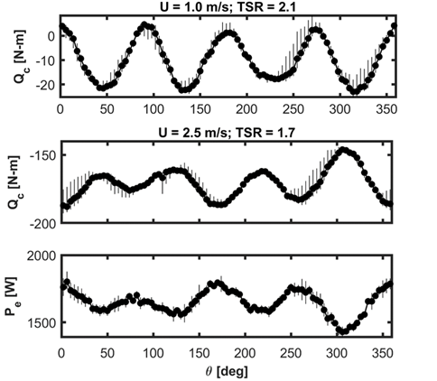
Figure 2. Examples of the torque and net power production from the turbine under two conditions. In these cases, the rotor is operating at a constant speed (or tip speed ratio). Negative torques (Qc) indicated net power generation. The top figure shows that over most of the rotation a small negative torque is applied indicating peak instantaneous powers on the order of 110 W with averages on the order of 50 W. During brief periods, however, power is required to maintain the rotor’s velocity, resulting in a current direction reversal for the batteries. The bottom two figures show the control torque and net power generation for currents of 2.5 m/s. During strong currents the system always generates power although intracycle variability on the order of 25 percent is observed. The mean power generation during periods of strong currents is greater than 1.5 kW, with instantaneous powers of 2.3 kW.
For both the wave and tidal energy devices a suitable battery system must accommodate the unusual charge/discharge profile. In addition, both systems are intended to operate autonomously, which imposes addition requirements on its behavior that include ground-fault monitoring, operations during times of low state-of-charge, and unexpected connection/disconnection. This document summarizes the intended system, provides a block diagram, and summarizes requirements on the various components.
Expected System Block Diagram
Figure 3 illustrates the components that make the system.. The components in the “Common Housing” rectangle are currently all housed in one waterproof enclosure, and some of these components such as the soft-start circuitry could potentially be re-used. The Motor Drive/Gen components are the charging source for the system, and the 24V computers and instruments in the system are not shown. Note that we do not intend for the system to be housed by the manufacturer. General requirements for chassis design and housings are discussed in a subsequent section.
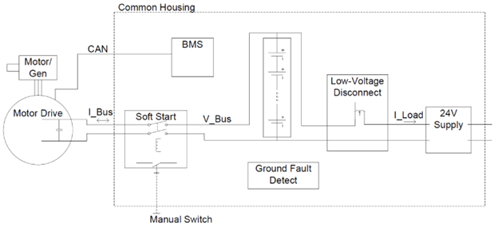
Figure 3. Block diagram of expected system.
In basic operation the battery system is connected to the Motor Drive and receives power while simultaneously providing power to a 24V power supply to power instrumentation aboard the buoy. While this is occurring, telemetry data about the bus current (I_Bus), Battery Voltage (V_Bus) and load current (I_load) are being streamed onto the CAN bus using a custom CAN protocol. Ground-faults are monitored (but there is currently no ground fault interruption). In cases of low-state of charge, a low-voltage disconnect turns off the 24V power but leaves the battery connected to the Motor Drive/Gen, after sufficient state-of-charge is recovered, the 24V supplies turn back on.
The sections below describe specific requirements and rationales for the components shown, along with some discussion.

System Components and Design Considerations
Batteries
The battery itself needs to operate at a nominal voltage of 325-375V, and be able to source/sink up to 35 Amps to be consistent with the motor drive/gen capabilities. The desired capacity range for this system is desired to be in the 6-12 kW-hr range and depending on the resulting size/weight.
Low-Voltage Disconnect and 24V supplies
The system must disconnect power to the 24V supplies when the battery state of charge drops below a suitable level, and then turn this supply back on when the state of charge increases because of subsequent charging or when a command is received from an external controller. The wave-energy device always makes a small amount of power (10’s of watts) so this feature simply shuts down all non-critical functions of the buoy until the weather changes and power generation resumes. A tidal turbine, by contrast, will go through multiple periods each day where no power is generated.
Currently the 24V power supply is housed with the batteries to preclude the need to send battery bus voltage out of the enclosure un-necessarily. This allows transistors to be used to perform the needed switching. It would also be possible to put these 24V supplies external to the battery (which would provide size flexibility), but the low-voltage disconnect would then need to be implemented with electro-mechanical contactors due to a requirement of galvanic isolation for the higher voltages. A convenient feature for the low-voltage disconnect system would be a data connection that would alert attached computers of the pending power disconnection using typical techniques used in the UPS industry.
Soft Start
The motor drive contains a 500uF DC-link capacitor that draws a significant inrush current when voltage is applied. This inrush is larger than can be tolerated by the output switch components of the motor drive. In the current system, a pair of electro-mechanical contactors are used to switch in a current limiting resistor prior to the main contactor being closed, this allows the voltage between the capacitor and the batteries to equalize before larger currents are allowed to flow. Currently this is an entirely independent circuit from the BMS that is powered directly from the battery bus, and needs to remain connected even at low battery voltages to allow autonomous charging from a low-voltage condition. If needed to protect the batteries, this contactor could turn off at some low shut-down battery voltage, but in that case at sea, a trip would need to be made out to charge the battery by another means to re-start the system, so this shouldn’t be a typical occurrence.
Ground Fault and Environmental Monitoring
Because the battery voltages travel through several undersea cables, there is a requirement for ground fault detection. Currently this is implemented using a commercially available unit (Bender) and simply reports the state of the insulation of the battery circuit from earth ground. No ground fault interruption is currently implemented. Similarly, battery housing temperature and humidity are convenient to monitor, although not absolutely necessary.
BMS
In addition to battery balancing and under/over voltage protections, the system requires V_Bus, I_Bus, I_Load, and ground-fault to be available on the CAN Bus for monitoring and logging. The motor drive/generator system can monitor these values and change output voltage in response as needed, but the system must also operate if this data link is not available. There is flexibility with regard to if the BMS itself handles all functions, or if some such as the soft-start are handled by separate systems. If at all possible, the BMS should run directly from the battery bus, independent of the 24V system on the buoy as that defeats the usefulness of the low-voltage disconnect.
Enclosure and connectors
The battery system itself does not need not be housed/sealed to the ocean environment by the vendor. Separate housings and connectors will be developed for each application of the battery depending on depth of use, etc. Safety to touch is sufficient. There is also flexibility with regard to if the 24V power supplies are housed with the battery. As noted above, moving these outside the housing introduces some flexibility, but also isolation challenges that would still need to be discussed. The packaging configuration becomes an important area of discussion for sub-sea use as cylindrical (or spherical) housings become much more efficient than rectangular housings at any appreciable depth.
Modularity/Parallelization
Although initial use of these systems will be single pack installations, the ability to utilize one or more of these systems in parallel is attractive. In that case the ancillary features of ground-fault detection, soft-start, and low-voltage disconnect would not need to be replicated in each system. Similarly, there are applications for rechargeable batteries of this capacity/chemistry that would be at a bus voltage of 48V nominally. We understand this simply may be a different system but are interested if any options exist around modular series/parallel configurations.
Chassis/Housing
A battery unit deployed in support of one of the tidal turbine devices may need to be deployed at depths of 10’s or even 100+ meters. For structural reasons, cylindrical housings are generally preferred, but aren’t strictly necessary. The requirements here are ultimately related to size. In contrast, a unit deployed in a wave energy converter will be housed inside of a buoy where housings will not need to withstand the significant ambient pressures. Despite these differences, our preference is to establish a general chassis design/aspect ratio that allows a single design to be effectively integrated in either of these scenarios (or others that may be envisioned). Without being overly prescriptive, a rectangular chassis suitable for sliding into cylindrical form factor housings would be ideal.
Chemistry
Optimal battery chemistry is driven by the suitability to meet charge/discharge profiles, safety concerns, and performance at relatively cool temperatures. Depending on the specific deployment, the battery housing will be deployed where ambient seawater is less than 10°C while a deployment where temperatures approach 0°C is possible. During these deployments there are generally high rates of heat transfer through the housing due to high flow rates of cold seawater over it. In contrast, in other deployments the battery could housed inside of a buoy with ambient temperatures similar to those outside. In balance, we think LiFePO₄ likely represents the best balance of performance, stability, and other factors.

