Background
The use of environmental energy harvesting in the ocean to support remote charging of vehicles and instrumentation with high power requirements is becoming contingent upon the integration of adequate power storage systems that can accommodate the unique operations of marine energy converters. The Monterey Bay Aquarium Research Institute has developed a wave-energy converter system that converts energy into the wave-field to electrical energy for the purpose of power on-buoy instrumentation and re-charging autonomous underwater vehicles that dock to the system (https://link.springer.com/article/10.1007/s40722-021-00197-9). The University of Washington Applied Physics lab has developed a tidal-turbine lander that sits on the seafloor and harvests energy from tidal flows for similar purposes (https://www.pnnl.gov/publications/first-tidal-turbine-pacific-northwest-signals-wave-future).
The goal of this project is to procure a battery system suitable for integration into these systems, replacing the rudimentary lead-acid battery pack currently in use. Both of these target systems (UW’s Turbine Lander and MBARI’s WEC) are using the same power conversion electronics to create a DC charge voltage from the varying three-phase AC voltages produced by the motors in the respective systems. Therefore, the battery interface requirements for the two systems are identical.
Some of the challenges associated with leveraging marine energy converters to support at sea load are (1) high-peak to mean power ratios, (2) rapid charge/discharge requirements for controls optimization, (3) long periods where conditions may result in intermediate states of charge, and (4) requirements for entirely autonomous operation.
For both the wave and tidal energy devices a suitable battery system must accommodate the unusual charge/discharge profile. In addition, both systems are intended to operate autonomously, which imposes addition requirements on its behavior that include ground-fault monitoring, operations during times of low state-of-charge, and unexpected connection/disconnection. This document summarizes the intended system, provides an overall system block diagram, and summarizes requirements on the various components
Appendix one provides some additional details about the wave and tidal harvesting systems this battery system is targeted for, and some examples of the specific charge/discharge profiles that are expected in each system, and some data about the vibration environment.

Figure 1: Overall system architecture

Proposal Request
We are requesting a brief proposal based on the requirements below (and any other information we can provide) outlining how your company will develop and deliver the required battery system. As we are developing prototype systems, only a handful of packs are needed at this time (2-4). Additionally, there are a number of requirements that will be subject to discussion and refinement and we hope to have a project structure that allows for that. Please include the following items in a proposal:
- Outline of company qualifications and capabilities
- Proposed system specifications. (Architecture, block-diagram, battery voltage range, capacity, battery type, expected lifespan, communication protocol, etc.)
- Proposed project structure (phases, reviews, and acceptance tests)
- Scope of work for project phases and timing.
- Deliverables
- Costs, NRE and per-unit.
- Other terms

Preliminary Requirements
Figure 1 above illustrates the entire system, and the components inside the “Common Housing” demarcation are what we are interested in procuring. The requirements below are written to describe the entire battery system. It is possible that some of these features (Isolation monitoring, switching circuits, etc.) could be supplied by us and we are open to discussion if it makes sense for some components/features to be user-supplied.

Batteries
The battery pack itself needs to operate in voltage range of nominally 300-350V, and be able to source/sink up to 35 Amps to be consistent with the motor drive/generators capabilities. The capacity for this system is desired to be in the 10-12 kW-hr range. There is no specific requirement on chemistry and this can be determined as needed to accommodate the cycle/cycle-life requirements, BMS restrictions given the charge/discharge profiles, etc.

Battery Management System
In operation, the BMS will be required to run from the batteries themselves and not require an external power supply, and of course be responsible for maintaining the battery cell balance and safety. The expected charge/discharge profiles are outlined in more detail in Appendix A below, but cell balancing capabilities shall be sufficient even when long periods of time exist between the battery pack being in a full state. The motor-drive system operates as a current-limited voltage supply in which the voltage and current set-points can be set remotely over CAN Bus, or the motor-drive system can be programmed to respond to battery state of charge information as needed. The system needs to default to a safe behavior in the event the CANbus communications link becomes unavailable.

Connections
The battery system requires several different power connections with differing requirements as described below

Power-Converter Connection (1)
The battery connection to the motor/drive power converter must be always on and should not be disconnected in cases of low -battery-state-of-charge. For servicing however, it is required that this connection can be turned off and galvanically isolated via a manual switch on the battery housing. When this switch is activated, a pre-charge circuit is required to accommodate the capacitance of the motor/drive power converter. This circuit should be fused at 50A.

Load Contactor-Circuits (2)
Two battery voltage connections to loads are required. These shall be switched and galvanically isolated, each with a pre-charge capability to accommodate capacitive loads. Switching of these circuits should be possible both by software control over CAN-bus, and autonomously in low state-of-charge conditions as described below. Current limiting is not required, but these connections should be fused at 20A.

24 Volt Supply (1)
An isolated 24V/10A supply is required that is not user switchable, but that does follow the low state-of-charge disconnect rules described below. Switching of his 24V connection does not need to be galvanically isolated.

Low-Voltage Disconnect
An important feature of this system is its ability to gracefully handle low energy conditions. Occasionally at sea the conditions are calm enough that only a small amount of charging is available for long enough that loads on the system bring the battery state of charge to the lower end of acceptable. When this occurs, the approach used to date is to turn off all non-critical loads on the system, leaving only the battery BMS active and the motor/drive power converter. Because even in the calmest conditions some 10’s of watts are typically generated, this re-charges the battery system to a suitable state of charge for the loads to be turned back on. This does mean that the power-converter connection is maintained at all times, and when ashore and no generation at all is available, the system must be carefully managed to keep the BMS from depleting the batteries entirely.

Communications and Telemetry
These systems are CANbus based, with a single network connecting the various controllers in the system and a main supervisory/telemetry-logging linux computer. A simple proprietary CAN protocol is used that aims to only require each controller to stream telemetry data synchronously, and respond to a small number of commands sent asynchronously. As described previously, the power-converter has maximum voltage and current limits that can be set via CANbus, so the battery system could request various levels of charge current and voltage as needed. In that case the system reverts to defaults if no update is given in a short timeout. Alternatively, the power-converter can be programmed with any needed algorithm to set voltage and current limits based upon a state-of-charge or similar message from the battery system. In every case, the system needs to revert to a safe behavior should the CANbus link become unavailable. Ideally these behaviors can be done by the BMS, but an external micro-controller supplied by MBARI to interpret standard data from a BMS could be implemented also.

Isolation and Environmental Monitoring
Because the battery voltages travel through several undersea cables, there is a requirement for isolation monitoring. Currently this is implemented using a commercially available unit (Bender) and simply reports the state of the insulation of the battery circuit from earth ground. No ground fault interruption is currently implemented.

Mechanical Packaging
The battery system itself does not need not be housed/sealed to the ocean environment by the vendor. Separate housings and connectors will be developed for each application of the battery depending on depth of use, etc. Safety to touch in a lab environment is sufficient. The packaging configuration becomes an important area of discussion for sub-sea use as cylindrical (or spherical) housings become much more efficient than rectangular housings at any appreciable depth.

Environmental Conditions
The battery system will be used on a surface buoy in the ocean, and therefore exposed to ambient temperatures of 35 to 100 degrees F. Sunlight and subsequent heating may occur and the housing designs and buoy mounting can be adjusted to limit this. This battery in a sub-sea housing will have a more limited ambient temperature range 35 to 70 degrees F with no sunlight heating. The battery housing internal temperature and humidity are desirable to monitor. Appendix A includes a power-spectral density of accelerations experienced on the buoy during use.

Modularity/Parallelization
Although initial use of these systems will be single pack installations, the ability to utilize one or more of these systems in parallel is attractive. In that case the ancillary features of ground-fault detection, soft-start, and low-voltage disconnect would not need to be replicated in each system.

Safety Certifications
TBD

Appendix A
The wave and tidal energy converters have unique performance characteristics related to the average and instantaneous power generation and required system controls.
Wave energy converter: The wave-energy converter is a unique charging source in that while the average power is on the order of 10-1000 Watts, it is delivered in series of large, short duration power pulses. Figure 2 illustrates the power supplied to the battery from the wave-harvesting power-converter in rough conditions. Simultaneously, loads on the battery system are present and are typically in the 0-1000 W range, but do not tend to oscillate as quickly. These are not shown in Figure 2 but contribute to a relatively high frequency oscillating charge/discharge cycle.
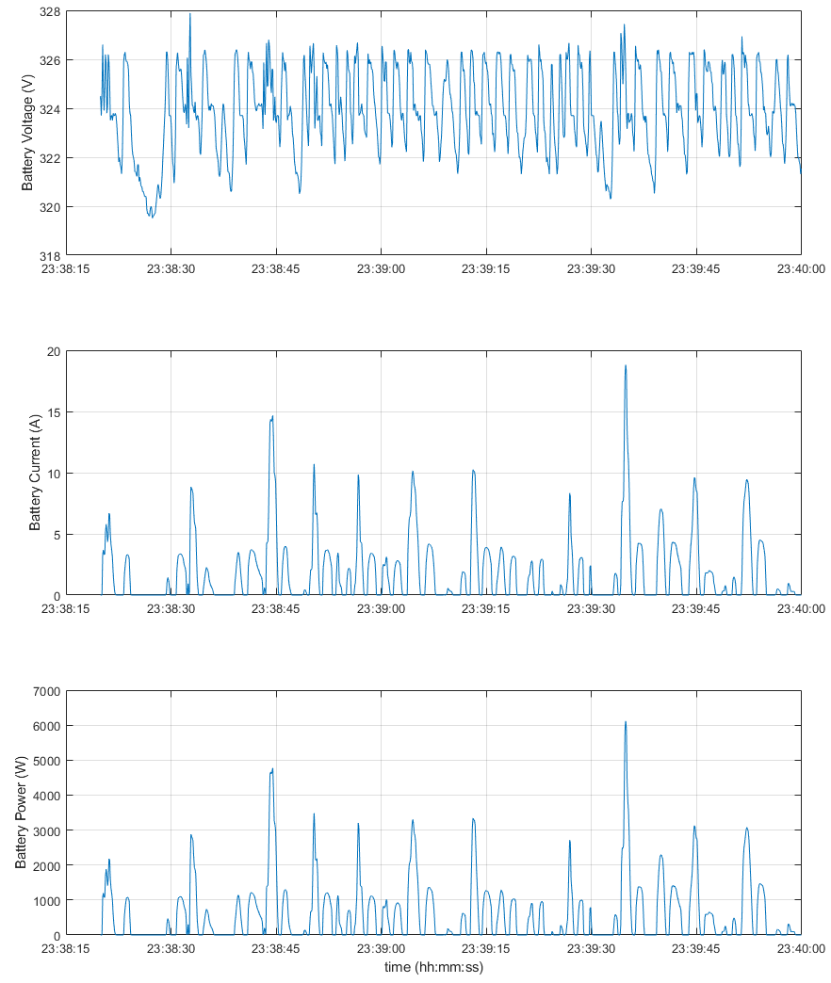
Figure 2: Wave-Energy Battery Power.
Figure 4 shows the computed power-spectral density of the linear accerations experienced on the surface of the buoy in rough conditions. Addionally, shock and vibration from normal shipping and handling needs to be tolerated.
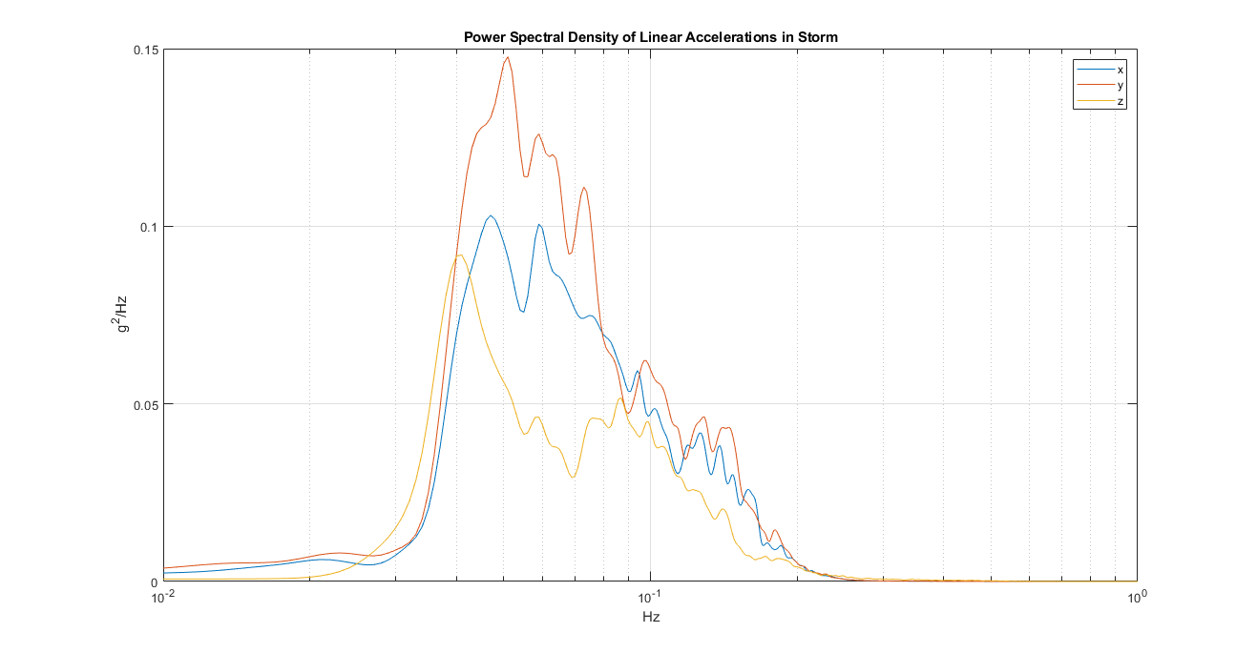
Figure 4: Acceleration PSD of surface buoy in rough conditions.

Tidal energy converter: The mean and instantaneous power generation profiles for the tidal turbine also vary with time, but to a much smaller degree than the wave energy device. In most deployments the system can be expected to be generating power approximately 40% of the time or more. Net power production begins when currents are approximately 0.75 m/s and peak, due to mechanical limitations, when currents are approximately 2.5 m/s (with the present design). The current rotor contains four blades and the resulting power generation within a given revolution of the turbine shows four cycles (Figure 2). During relatively weak currents the system goes through periods where modest power input is required in order to maintain the rotation of the rotor while maximizing its efficiency. During strong currents input power is not generally required for optimized system performance. The result is a battery charge/discharge cycling at a relatively high frequency (~2Hz) in some conditions.
The operational range of the system spans instantaneous power values between approximately -200 W to 1800 W with time-averaged values between approximately 10 to 1700 W. Peak hydrodynamic efficiencies for the system occur at less than 100 RPM (although in torque control mode instantaneous variability on the order of 40% is possible). For this system, peak currents are considerably less than 20 A while maximum time-averaged currents are on the order of 6 A or less lasting for periods of a half hour or more under optimal (but not regularly occurring) conditions.
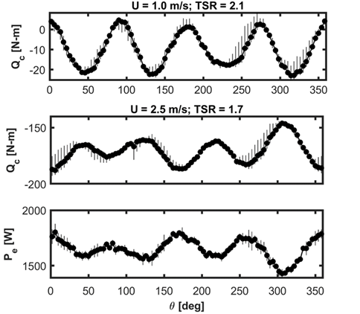
Figure 3: Examples of the torque and net power production from the turbine under two conditions. In these cases, the rotor is operating at a constant speed (or tip speed ratio). Negative torques (Qc) indicated net power generation. The top figure shows that over most of the rotation a small negative torque is applied indicating peak instantaneous powers on the order of 110 W with averages on the order of 50 W. During brief periods, however, power is required to maintain the rotor’s velocity, resulting in a current direction reversal for the batteries. The bottom two figures show the control torque and net power generation for currents of 2.5 m/s. During strong currents the system always generates power although intracycle variability on the order of 25 percent is observed. The mean power generation during periods of strong currents is greater than 1.5 kW, with instantaneous powers of 2.3 kW.

