This project aims to integrate the MBARI wave-energy converter power electronics into the UofW/APL Tidal Turbine system. The Tidal Turbine has historically used commercially available power electronics (Siemens) and has suffered from many of the same issues the MBARI wave-energy converter did when attempting to integrated this type of industrial equipment. These issues include the fact that equipment designed for a factory floor generally uses an unacceptably large amount of electrical power to support features that are not needed in the undersea case. Equally important, in the undersea equipment case, more autonomy is required and the system must be able to boot-strap itself from a cold start, be tolerant of a removal of external power, and be able to handle and recover from unexpected events without user intervention. The MBARI system has implemented these capabilities in a low power package and has direct applicability to the UofW Tidal Turbine system with minimal changes.
The purpose of the June 9-10, 2022 trip to Seattle was to demonstrate the compatibility of the systems, and make performance measurements of the integrated system using the UofW/APL bench test set-up. MBARI shipped the necessary power electronics components and test equipment the week before, and Andrew Hamilton and Scott Jensen arrived at APL on the morning of June 9 to perform the integration and testing, with help from Chris Bassett and Jesse Dosher from UofW/APL. This was successful and performance measurements were made across the torque-speed envelope of the system. Much was learned about the specific details of the compatibility of this system, this report summarizes the activities, results, and next steps.

Technical Background

Test Setup
The mechanical portion of the UofW/APl bench test setup is shown in figure 1. This setup allows the power takeoff to be operated in a simulated environment where by it may absorb or deliver mechanical power. A Torque sensor connects the two motor shafts. The MBARI electronics are shown in figure 2. A 325V power supply was used as a source during PTO motoring (delivering mechanical power). The MBARI electronics are capable of operating from the 325V bus but in this case a 15V lab bench power supply was included to maintained power to the MBARI electronics during power cycles of the 325V bus (this is the small power supply closest to the MBARI electronics). This allowed some check out, configuration and setup to happen without the need of the 325V present.
The APL motor of the PTO was originally fitted with a Siemens encoder which used Siemens proprietary bus as an interface. The MBARI electronics accepts a more standard quadrature signal. To allow the MBARI electronics to sense the motor rotor position a new encoder with quadrature outputs was fitted to the motor. There were some troubles with the mechanical adaptation of this new encoder to the motor but in the end it was adequately aligned to proceed.
During initial testing it was discovered that the voltage constant of the motor was larger than originally planned for. From the data sheet the voltage constant is 1520Vrms/krpm. At this value spinning at 150 RPM, the peak voltage of the motor is about 321V. Being that the MBARI electronics bus voltage has been set to 325V and the bus voltage must always be larger than the back EMF of the motor, it was decided to limit the test to no more than 100rpm.
From APL’s envelop of operating parameters and the limitations of the available power supply the current range was limited to 20 amps.
A Matlab script was utilized that feed speed commands to the Bench system while simultaneously suppling torque commands to the MBARI system. The output of the torque sensor is supplied to the MBARI electronics so that a single synchronized data stream was produced. With this ability a Speed-Torque map was produced over the full range of operating parameters.
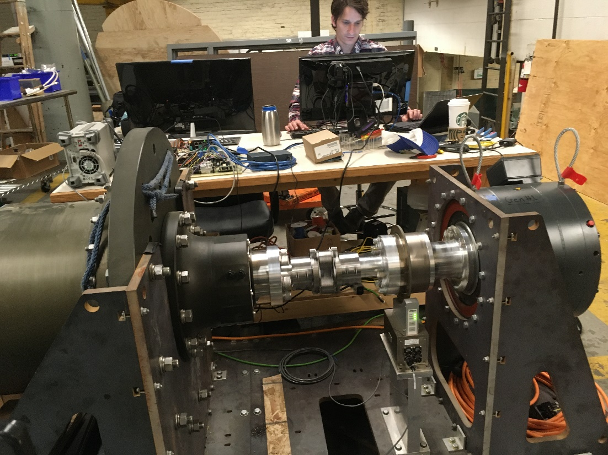
Figure 1: UofW/APL Tidal Turbine generator attached to test bench. The tidal turbine motor/generator is on the left, and the test bench motor is on the right. Torque is measured between the two to allow mechanical shaft power to be measured.

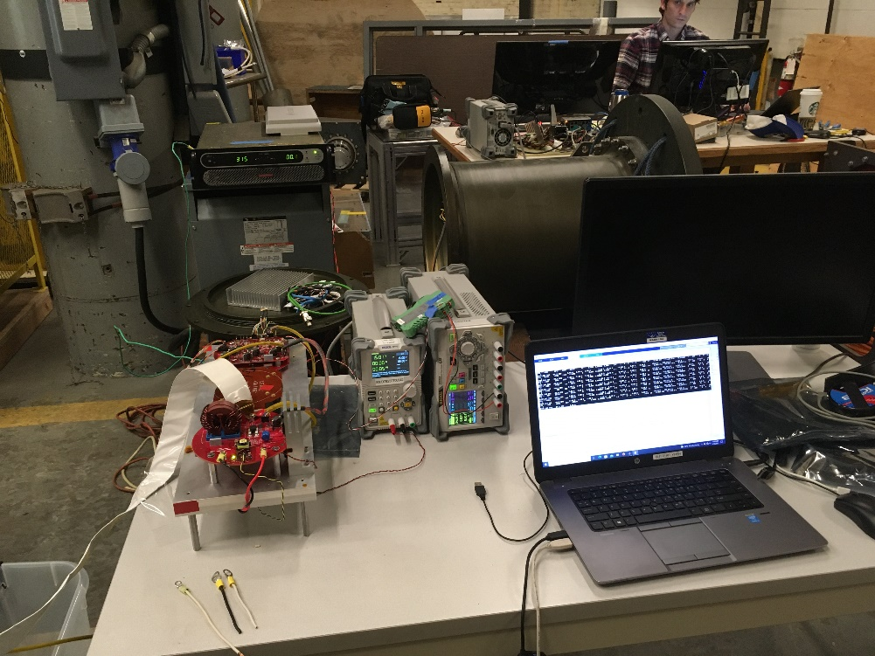
Figure 2: MBARI Power Electronics boards (red) and supporting test equipment. Out of frame on the lower left is a load-dump to absorb power. The power supply in the upper left provides DC power for the motoring quadrants of the test.

Results
As stated earlier the system was run from -20 to 20 Amps of winding current at steps of 2 Amps while the test bench motor was held at a constant RPM in the range of -100 to 100 RPM at steps of 10 RPM. This data matrix is plotted in figure 4. Figure 5 is a set of graphs summarizing the mechanical and electrical power.
To determine what the losses are within the system and their contribution the data matrix was parsed at 0 RPM and then at 12 Amp winding current. Figure 6 is the 0 RPM case and the reason is that the electronics are working while there is no mechanical work being done. The power loss at this operating point is then all attributed to the electrical system. The resulting graphs separate out the main loss components. The parabolic shape of the Electrical Power Loss graph, Figure 6 plot 1, implies resistive losses while the offset of the parabola suggests switching loss. To elicit the value of switching loss the various resistive losses have been measured and estimated (plot 2-4) and then subtracted from the Electrical Power Loss, plot 5. The remaining bias of 69W thus represents the switching loss of the transistors and associated components such as; parasitic inductance, capacitance and required snubbers. By combining the switching Loss and the Transistor I²R Loss graphs the total power Loss of the MBARI Electronics can be seen, plot 6. At 0 amps of winding current the switching loss dominates while above 8 amps the winding loss dominates.
Referring to figure 3, the torque sensor is located between the test bench motor and the PTO intake shaft. The intake shaft then passes through the seals and magnetic coupling. The other side of the magnetic coupling is connected to the PTO motor. While the PTO is delivering power seal loss is not detected by the torque sensor. While the PTO is absorbing power seal loss is detected by the torque sensor. The constant current path of 12A from the data matrix is chosen and graphed in figure 7 plot 1 showing torque Vs. RPM. From 100 to 10 PRM the test bench motor is driving and the PTO is generating. Power is mechanically flowing from the test bench to the PTO motor. In this configuration the seal drag is down stream of the torque sensor and thus the added drag of the seal is sensed by the torque sensor. Once the test bench reverses direction from 0 to -100 RPM power is now flowing mechanically from the PTO to the test bench. In this configuration some of the PTO torque is absorbed by the seals before reaching the torque sensor. This change is seen in the graph of figure 7 plot 1. The slope and offset of the two halves are in the title of the graph. The difference between the offsets is the seal torque. Plot 2 takes the 12A current line and plots the power curve. The Measured line is the equivalent mechanical power using the torque sensor reading. The Adjusted line is with the seal torque added while Line is the straight line estimation of the power curve. The asymmetry causes a slope change crossing the 0 RPM point. The distance between the Measured and Adjusted is the power loss due to the seal. With the seal drag now known the loss due to the seals is shown in figure 8 plot 1.

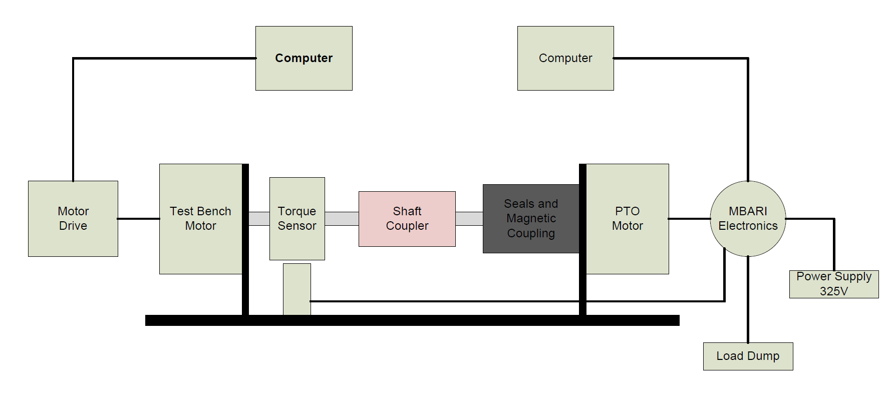
Figure 3 Test Setup Block Diagram
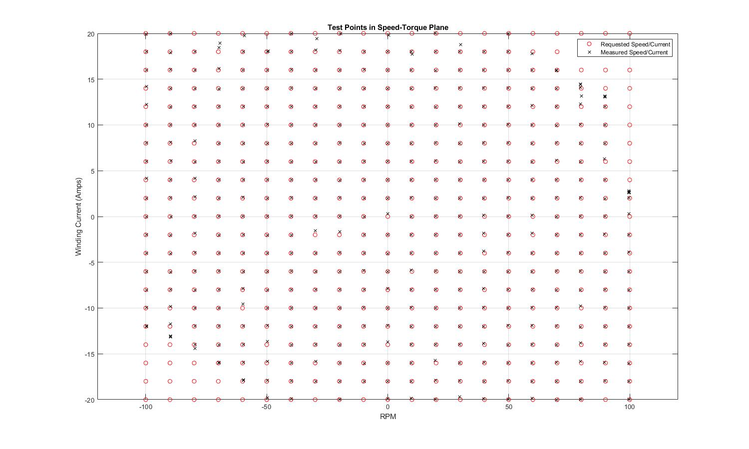
Figure 4: Torque/Speed test matrix showing requested and actual test points. Each point was run for 3 seconds and the torque/speed results were averaged. The power limit of the supply power is evident in the upper left and lower right quadarants.
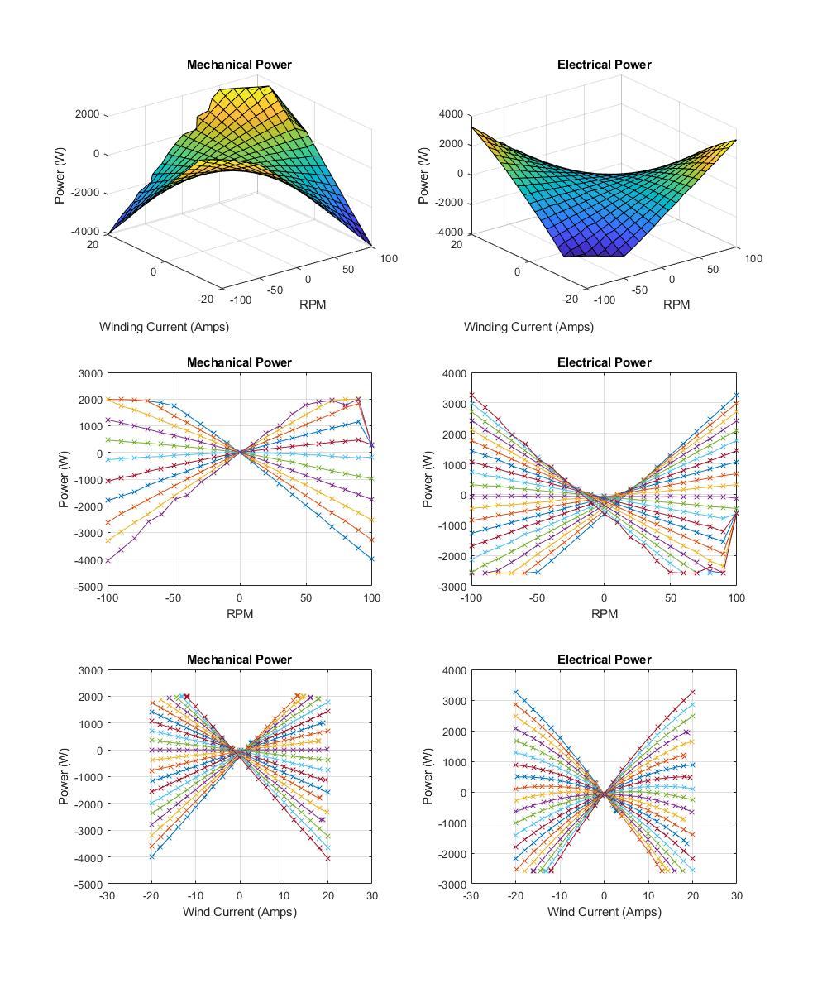
Figure 5: Summary mechanical and electrical power results.
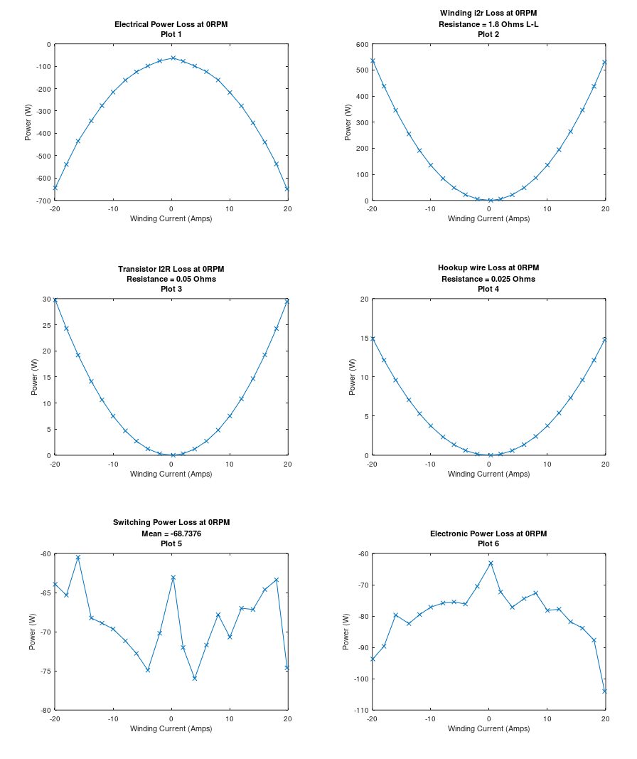
Figure 6 Electrical Power Losses at 0 RPM. Estimated I²R of motor windings, Transistor Resistance and Hookup wire resistance. Remaining is Electronic switching loss. Adding Switching Loss and Transistor Loss results in MBARI Electronics power loss.

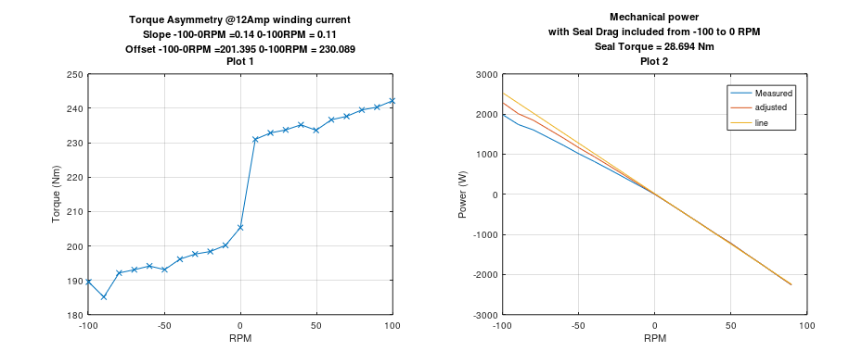
Figure 7 Torque Asymmetry due to placement of seal and Torque sensor. These graphs or of the 12Amp sweep. Effect on mechanical power. Seal Loss with 0 amps winding current. Mechanical power with Estimated Seal loss removed.

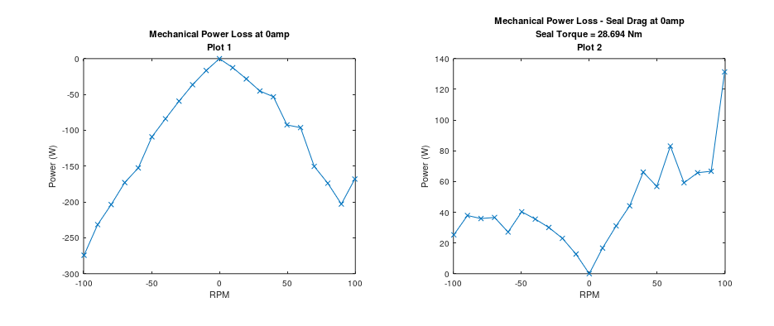
Figure 8 Mechanical power loss to seals

Next Steps
These compatibility tests have shown that the MBARI electronics are capable of delivering the required functions and power levels to control the Tidal Turbine and do it at lower power usage and improved algorithmic control. The current control algorithm that the MBARI electronics use was developed for its Wave Energy Converter. Discussion with UofW has highlighted a few areas where there are significant differences in behavior that need to be changed within the MBARI electronics. These changes are all firmware related and can be adjusted as needed. Three of these behaviors are 1) motoring, 2) load curve and 3) shutdown. Motoring applies power to the PTO motor thereby breaking static friction and enabling the turbine to spin during slower tidal events. Motoring is possible and can be supported by adjustments to the behavior model in firmware. The load curve of the Wave Energy Converter is different but the electronics are not tied to this platform and can be reprogrammed to other behaviors. The electronics are capable of shutting down the bridge thus removing the switching loss component during periods of inactivity. Conversely they are also very capable in reactivating the bridge in a very graceful manner. There may be other issues and these can be discussed and a solution determined.
The leading hardware issue is the voltage constant of the current PTO motor and the operating voltage of the MBARI Electronics. Currently the MBARI Electronics has a 325V bus, this can be adjusted up but some evaluation needs to be done prior to setting an upper limit. This could also be ameliorated by using a motor with a lower voltage constant. This does cause winding currents to increase but there is still headroom within the electronics to support this. Another more extensive area to explorer is a traditional servo motor with a gear box. This may have already been researched but it is something to consider in light of the resistive losses using the current torque motor.

MBARI electronics power requirements; logic power 3W, switching loss 69W
Motor winding loss vs gearing
Bridge shutdown during inactivity
Better understanding of control algorithm and adjustments to code to enable.
Motoring phase to avoid static friction.

Leftovers:
Figure 6 illuminates the mechanical loss of the system. The first graph is the run at 12Amps peak of winding current. As the PTO shifts from generating to motoring seal loss shifts goes from being included in the torque sensor output to being hidden from the torque sensor output. This causes a shift in the torque curve equal to the seal drag. By estimate the fit of the line for the left and right half and then the difference in there offsets an estimate of seal drag can be found; 28.7Nm.
I do not have a good explanation for the difference in slope of this graph from left to right. Left is 0.14 and right is 0.11? This also shows up in the next graph of RM vs Mechanical power.

These graphs are at 0 amps of winding current while the RPM of the MG set is stepped from -100 to 100 RPM. The mechanical losses are a combination of seal, bearing and windage drag. Estimating a constant drag torque of 25Nm brings the Mechanical loss to near 0 W.
The Graphs of figure 5 and 6 help to characterize the mechanical and electrical system but it must be understood that these data are taken from a complete map of the RPM-current space of the system thus including points outside of the in situ operating curve of the tidal system. One point as an example is 20 amps of winding current at 0 RPM. These graphs also explain the non-(0,0) crossing features within the graphs of figure 4.

