This project aims to integrate the MBARI wave-energy converter power electronics into the UofW/APL Tidal Turbine system. The Tidal Turbine has historically used commercially available power electronics (Siemens) and has suffered from many of the same issues the MBARI wave-energy converter did when attempting to integrated this type of industrial equipment. These issues include the fact that equipment designed for a factory floor generally uses an unacceptably large amount of electrical power to support features that are not needed in the undersea case. Equally important, in the undersea equipment case, more autonomy is required and the system must be able to boot-strap itself from a cold start, be tolerant of a removal of external power, and be able to handle and recover from unexpected events without user intervention. The MBARI system has implemented these capabilities in a low power package and has direct applicability to the UofW Tidal Turbine system with minimal changes.
The purpose of the June 9-10, 2022 trip to Seattle was to demonstrate the compatibility of the systems, and make performance measurements of the integrated system using the UofW/APL bench test set-up. MBARI shipped the necessary power electronics components and test equipment the week before, and Andrew Hamilton and Scott Jensen arrived at APL on the morning of June 9 to perform the integration and testing, with help from Chris Bassett and Jesse Dosher from UofW/APL. This was successful and performance measurements were made across the torque-speed envelope of the system. Much was learned about the specific details of the compatibility of this system, this report summarizes the activities, results, and next steps.

Technical Background
The MBARI Wave-Energy converter contains a 10kW boost power converter that takes the alternating three-phase voltage from the motor windings in the system and converts that to a constant output voltage (325V) suitable for charging batteries. The electrical power flowing from these electronics to a battery is current limited and there is an integrated load-dump system that diverts any power that can’t be accepted by the batteries (i.e. if they are full or disconnected) to an internal load-dump. This is required because the wave-energy system must be loaded at all times. These power converters implement “four-quadrant” current control in which the motor/generator winding currents can be positive or negative regardless of the direction of motion of the motor. This enable bi-directional power flow in which energy can flow from the wave-energy converter to the batteries (generating), or from the batteries into the wave-energy converter (motoring).
This system has been custom developed at MBARI to obtain optimum efficiencies, and to behave correctly and safety in all conditions that can occur in this autonomous system. It was found that it was very difficult to implement this system at this scale using commercially available power electronics due to the efficiency requirement, as well as the integration required with the load-dump and battery system for autonomous behavior that can recover and continue from all expected and un-expected conditions. This hardware has been operating at-sea autonomously in the MBARI wave-energy system for thousands of hours.

Typical of almost all motor drives, the peak allowable RPM of this system in generator is determined by a combination of the bus voltage of the system, and the voltage constant of the motor (Volts/RPM). As discussed below, the voltage constant of the UofW/APL system and our usual practice of operating at 325V limits the peak speed of the system to 100RPM. As this is a bit below the peak speed requirement of the system this issue is the main limitation in implementing the MBARI power electronics in the UofW/APL system. There are a couple of techniques available to address this as discussed below.
The MBARI power electronics implement a default control that sets the motor winding current as a function of RPM. The default winding-current/RPM relationship is programmed into the firmware of the device and can be changed. An external computer can over-ride this relationship at any time by sending a command over the systems CAN (Controller Area Network) bus. When a winding-current command is received, the power electronics control to that setpoint for two seconds, and then revert to the default relationship. By issuing current commands faster than 0.5Hz then, an external computer can take control of the power electronics, but in the case of a computer or communication failure, the system defaults quickly back to a safe behavior.
For efficiency reasons, the MBARI system also implements features that turn off the power-switching transistor bridge at low speeds, saving considerable switching losses when the motor is not turning (between waves in the WEC case, between tides in the tidal turbine case). This, along with the need to bootstrap from a cold start in the case no batteries are attached, require firmware features that gracefully turn the bridge on and off while the motor is spinning (slowly). These features are implemented and no jerk occurs at these transitions.
Test Setup
A block diagram of the set-up for these tests is shown in Figure 1, and includes both the UofW/APL tidal turbine motor, the MBARI supplied power electronics, and the UofW/APL drive test motor and controls. For all of the tests performed, the UofW/APL test machine was configured to run at a constant speed and the MBARI power electronics were commanded to exert a specific torque. As discussed later, all four torque/speed quadrants were explored. Photographs of the hardware are shown in Figure 2 and Figure 3. The torque sensor and MBARI electronics can be seen and a 325V power supply connected to the MBARI electronics was used as a source during PTO motoring (delivering mechanical power). The UofW/APL test machine motor operates from the building 3-phase power. The MBARI electronics are capable of operating from the 325V bus but in this case a 15V lab bench power supply was included to maintained power to the MBARI electronics during power cycles of the 325V bus (this is the small power supply closest to the MBARI electronics). This allowed some check out, configuration and setup to happen without the need of the 325V present. The MBARI power electronics have now logging capability but rather stream data in real-time over a CAN bus to be logged by an external computer. In this case a laptop was used in the test to log this data in real-time, a connection was made between the UofW/APL torque sensor and the MBARI power electronics such that all relevant data is contained in the data log (torque, speed, bus-voltage, and supply/load-dump current), from this data all performance metrics can be computed as described below.
The APL motor of the PTO was originally fitted with a Siemens encoder which used Siemens proprietary bus as an interface. The MBARI electronics accepts a more standard quadrature signal. To allow the MBARI electronics to sense the motor rotor position a new encoder with quadrature outputs was fitted to the motor. There were some troubles with the mechanical adaptation of this new encoder to the motor but in the end it was adequately aligned to proceed.
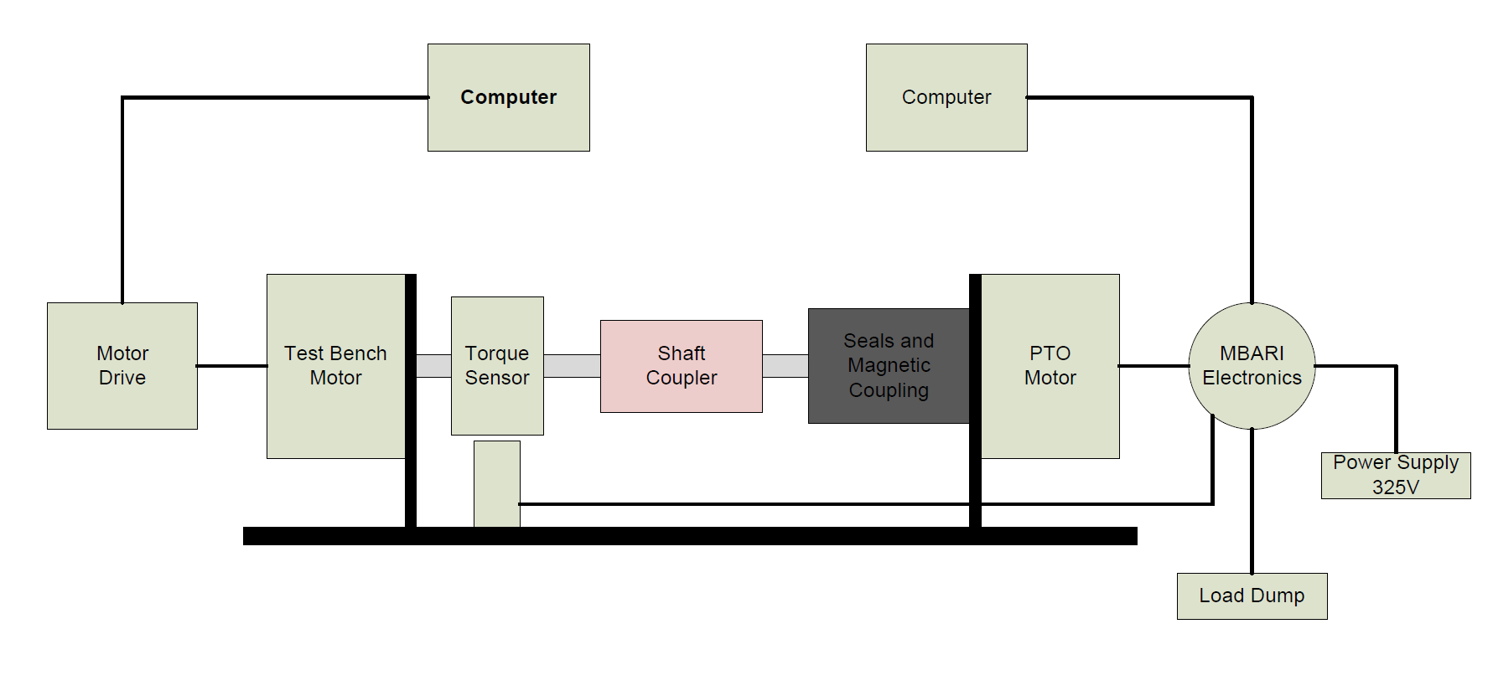
Figure 1: Test Setup Block Diagram
During initial testing it was discovered that the voltage constant of the motor was larger than originally planned for. From the data sheet the voltage constant is 1520Vrms/krpm. At this value spinning at 150 RPM, the peak voltage of the motor is about 321V. Being that the MBARI electronics bus voltage has been set to 325V and the bus voltage must always be larger than the back EMF of the motor, it was decided to limit the test to no more than 100rpm. This may be a limitation for the final application that may occasionally need to run faster, and this is discussed later in this report.
For this testing, the UofW/APL test machine was set manually to run at a fixed RPM. While at this speed, the MBARI power electronics were set to control the winding current in the motor (torque), and a range was cycled through, dwelling for a few seconds at each torque. In this way the entire torque-speed map was covered, and the measured versus target test-points is shown in Figure 4. For these tests, when the MBARI power electronics are operating as a generator, all electrical power is dissipated in the integrated load-dump, when operating as a motor, the power is provided by the attached DC power supply.
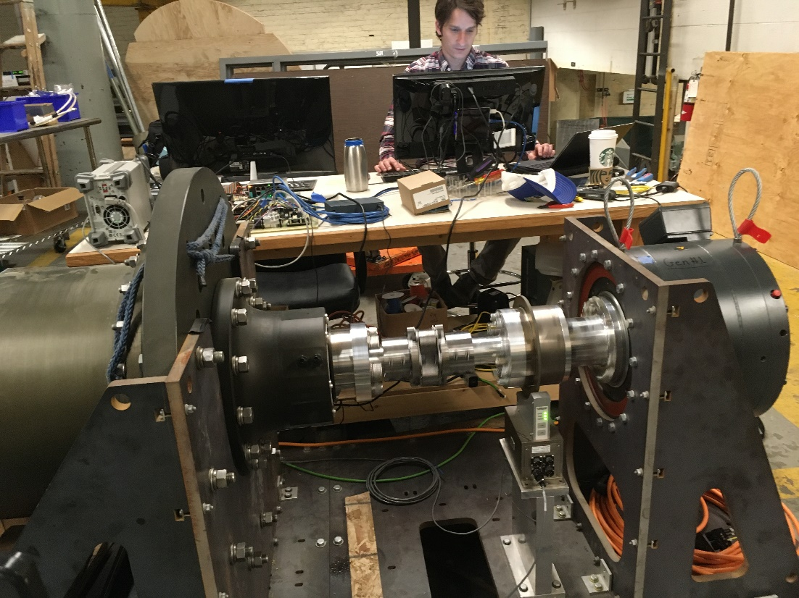
Figure 2: UofW/APL Tidal Turbine generator attached to test bench. The tidal turbine motor/generator is on the left, and the test bench motor is on the right. Torque is measured between the two to allow mechanical shaft power to be measured.

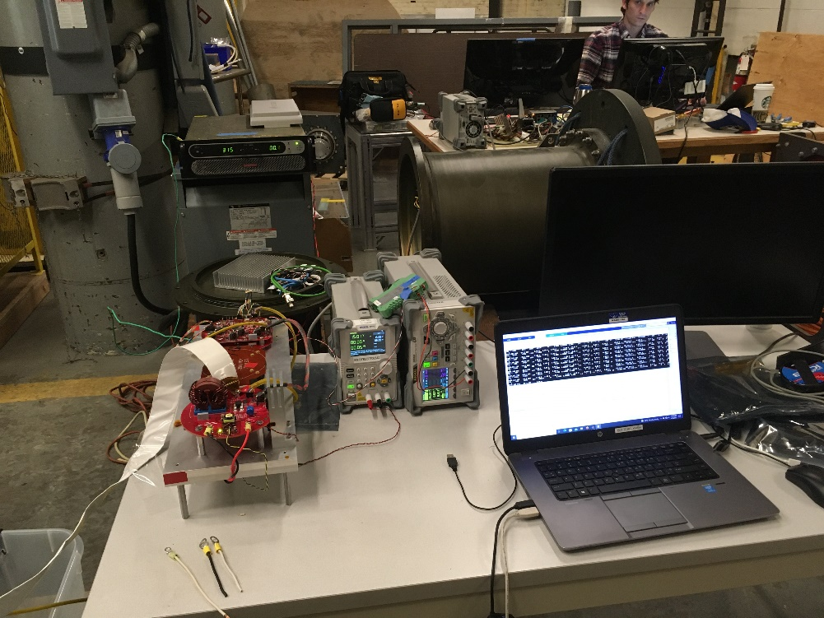
Figure 3: MBARI Power Electronics boards (red) and supporting test equipment. Out of frame on the lower left is a load-dump to absorb power. The power supply in the upper left provides DC power for the motoring quadrants of the test.
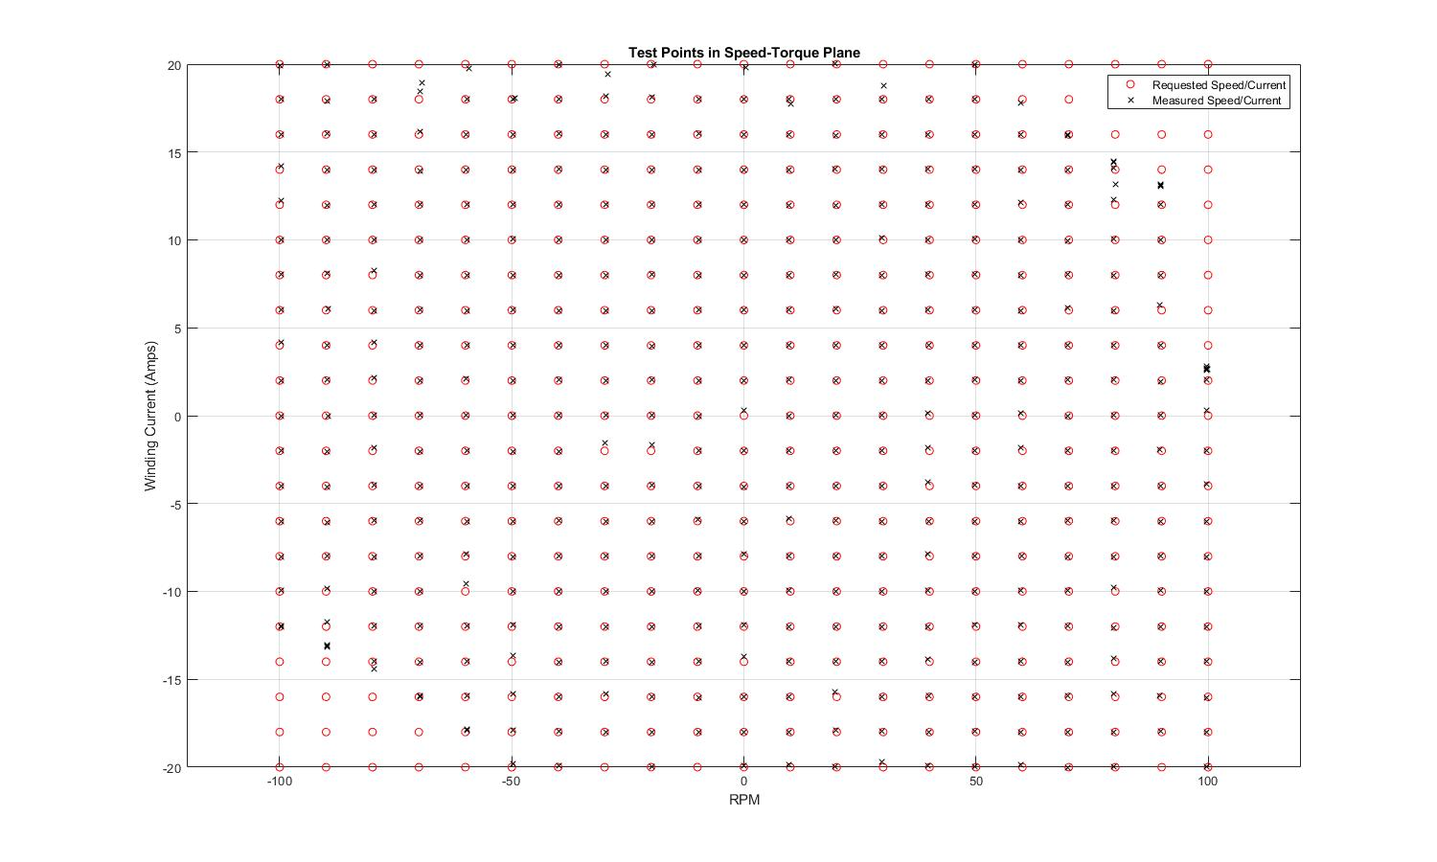
Figure 4: Torque/Speed test matrix showing requested and actual test points. Each point was run for 3 seconds and the torque/speed results were averaged. The power limit of the supply power is evident in the upper left and lower right quadarants.
Results
As stated earlier the system was run from -20 to 20 Amps of winding current at steps of 2 Amps while the test bench motor was held at a constant RPM in the range of -100 to 100 RPM at steps of 10 RPM. This data matrix is plotted in figure 4. Figure 5 is a set of graphs summarizing the mechanical and electrical power, from this data the systems losses and efficiency can be computed at different operating points. To determine what the losses are within the system and their contribution the data matrix was examined at 0 RPM and 12 Amp winding current. Figure 6 is the 0 RPM case for which there is no mechanical work being done, however the power electronics are still switching current and so this is a good case to examine the electrical losses that exist in the motor and power electronics, all of which are attributed to the resistance, switching, and other parasitic losses, and these are broken out in the subsequent graphs. The parabolic shape of the electrical power loss graph, Figure 6 plot 1, implies resistive losses while the offset of the parabola suggests switching loss. To elicit the value of switching loss the various resistive losses have been measured and estimated (plot 2-4) and then subtracted from the electrical power loss, plot 5. The remaining bias of 69W thus represents the switching loss of the transistors and associated components such as; parasitic inductance, capacitance and required electrical snubbers in the system. By combining the switching loss and the transistor I²R loss graphs the total power Loss of the MBARI Electronics can be seen, plot 6. At 0 amps of winding current the switching loss dominates while above 8 amps the winding loss dominates.
Referring to Figure 1 and Figure 2, the torque sensor is located between the test bench motor and the PTO intake shaft. The intake shaft then passes through the seals and magnetic coupling. The other side of the magnetic coupling is connected to the PTO motor. While the PTO is delivering power seal loss is not detected by the torque sensor. While the PTO is absorbing power seal loss is detected by the torque sensor. The constant current path of 12A from the data matrix is chosen and graphed in figure 7 plot 1 showing torque Vs. RPM. From 100 to 10 PRM the test bench motor is driving and the PTO is generating. Power is mechanically flowing from the test bench to the PTO motor. In this configuration the seal drag is downstream of the torque sensor and thus the added drag of the seal is sensed by the torque sensor. Once the test bench reverses direction from 0 to -100 RPM power is now flowing mechanically from the PTO to the test bench. In this configuration some of the PTO torque is absorbed by the seals before reaching the torque sensor. This change is seen in the graph of figure 7 plot 1. The slope and offset of the two halves are in the title of the graph. The difference between the offsets is the seal torque. Plot 2 takes the 12A current line and plots the power curve. The measured line is the equivalent mechanical power using the torque sensor reading. The adjusted line is the power with the seal torque added while line is the straight-line estimation of the power curve. The asymmetry causes a slope change crossing the 0 RPM point. The distance between the Measured and Adjusted is the power loss due to the seal. With the seal drag now known the loss due to the seals is shown in figure 8 plot 1.

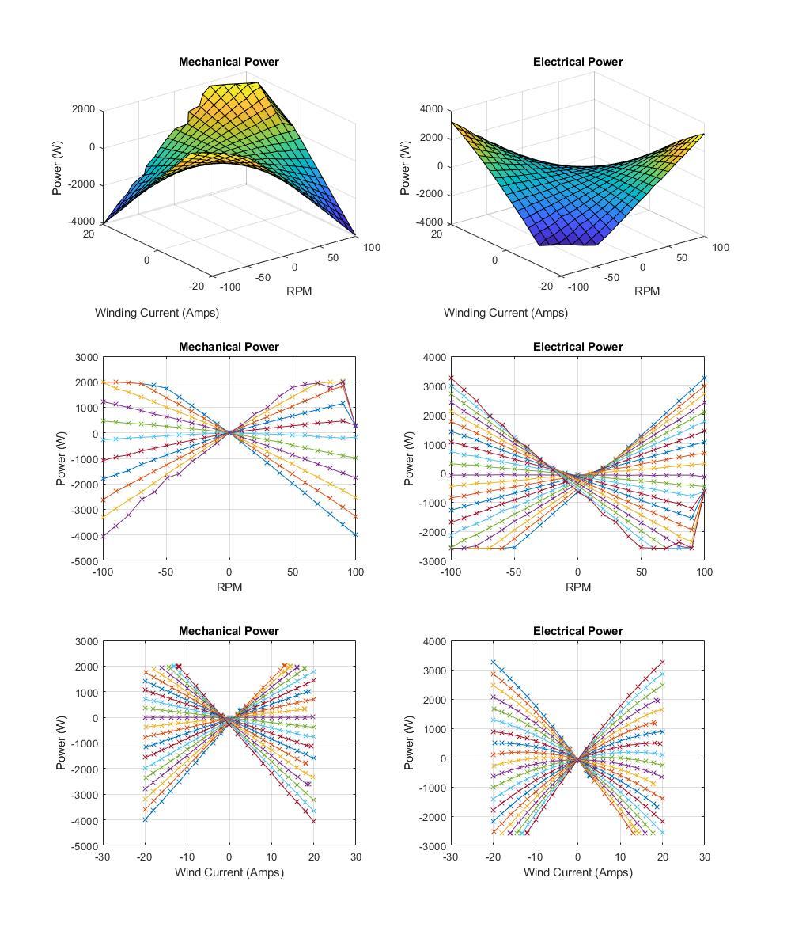
Figure 5: Summary mechanical and electrical power results.
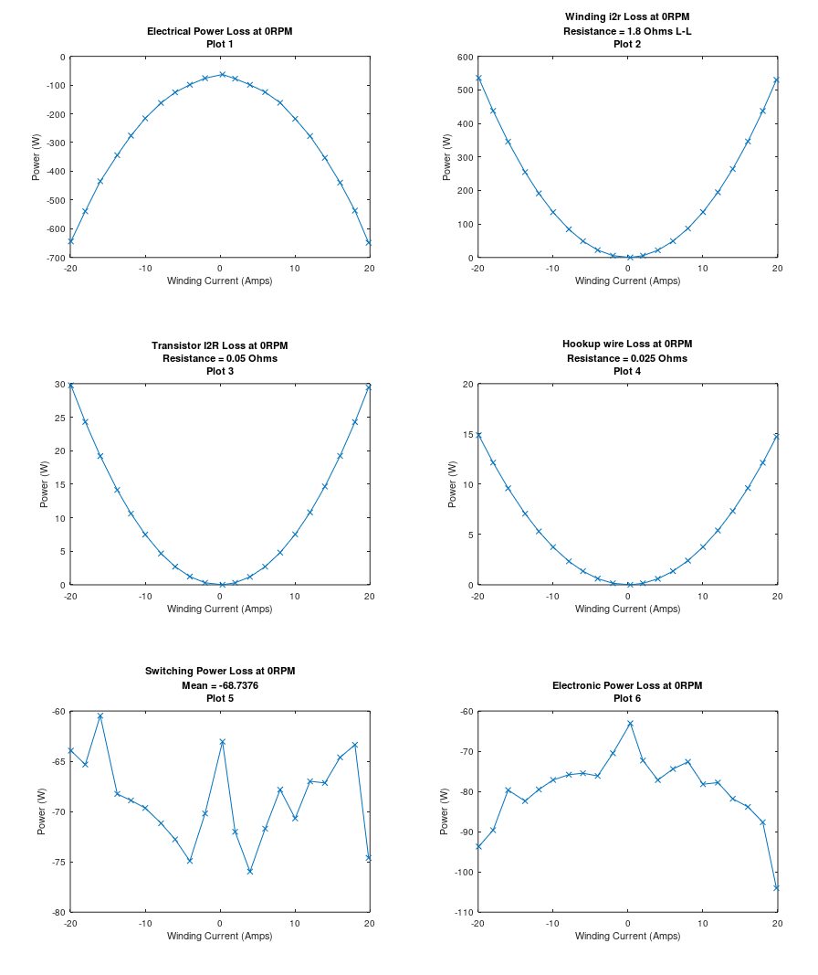
Figure 6 Electrical Power Losses at 0 RPM. Estimated I²R of motor windings, Transistor Resistance and Hookup wire resistance. Remaining is Electronic switching loss. Adding Switching Loss and Transistor Loss results in MBARI Electronics power loss.

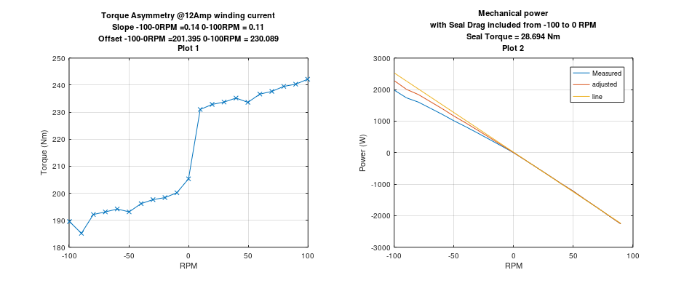
Figure 7 Torque Asymmetry due to placement of seal and Torque sensor. These graphs or of the 12Amp sweep. Effect on mechanical power. Seal Loss with 0 amps winding current. Mechanical power with Estimated Seal loss removed.

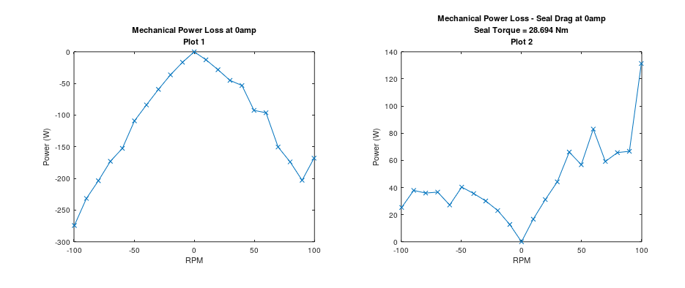
Figure 8 Mechanical power loss to seals

Next Steps
These compatibility tests have shown that the MBARI electronics are capable of delivering the required functions and power levels to control the tidal turbine and do it at lower power usage and improved algorithmic control. The leading hardware issue is the voltage constant of the current Turbine PTO motor and the operating voltage of the MBARI Electronics. Currently the MBARI Electronics has a 325V bus, this can be adjusted up but some evaluation needs to be done prior to setting an upper limit. In any event, the MBARI system provides a current-limited DC power output suitable for connection to a battery system. Such a battery system is required for practical use of this system (for demonstration it can always be run with the internal load-dump of course). MBARI currently uses a lead-acid system for this component and that would be difficult to adapt to a sub-sea environment due to venting requirements. A LiFeP04 system is a better choice and under development at MBARI.
A current estimate for the peak voltage of the MBARI system is 450V, and even that may require some component changes so needs to be verified. This corresponds to a peak speed of 140RPM with the current UofW/APL PTO motor. If this is insufficient there are a few other approaches to consider. The simplest is a change in motor to a lower voltage constant, one would expect Siemens could wind the same motor slightly differently to achieve this. This does cause winding currents to increase but there is still headroom within the electronics to support this. A second approach would be to implement field-weakening algorithms in the power electronics that would artificially lower the voltage constant of the motor at higher speeds. This is a common technique and the hardware/firmware in the MBARI system supports this. Some development and testing would be required, and this approach would lead to further motor heating in the system, but the large amount of copper in that systems torque-motor would almost certainly handle this extra power dissipation.
Finally, another more extensive area to explorer is a traditional servo motor with a gear box. This may have already been researched but it is something to consider in light of the resistive losses using the current torque motor. A gearbox will be quite lossy, but it would be interesting to know how those losses trade off against the resistive losses as well as the system inefficiencies that occur to the blockage effect of the large torque-motor relative to the turbine.
Discussion with UofW has highlighted that the ideal control for the turbine system would be a reactive to an external current speed measurement. This would result in a speed control system in which the controller is adjusting the motor winding current to maintain a rotor speed to match a setpoint that is a function of the measured current speed. This control system would take advantage of the four-quadrant capability of the system and motor at low speeds, breaking static friction and enabling the turbine to spin during slower tidal events.

