EyeRIS (Remote Imaging System):
A three-dimensional, high-resolution, autonomous particle and flow imaging instrument

Dr. Kakani Katija, Principal Engineer
Monterey Bay Aquarium Research Institution

Research Objectives
All processes in the ocean are fundamentally governed by the physics of fluid motion. However, the oceanographic community currently does not have instrumentation to characterize fluid motions at spatial and temporal scales relevant to many critical oceanographic processes. Robust, high resolution volumetric fluid-flow measurements are needed to answer a wide array of science questions that include: fluid fluxes along the seafloor for development of biogeochemical flux models in active seafloor environments, quantification of particle fluxes to elucidate carbon cycling in midwater, direct measurement of organismal feeding interactions, and monitoring complex flows that impact the health of coral reefs and other benthic systems. Without direct in situ measurements, the oceanographic community is currently limited to using laboratory studies and numerical modeling to address many of these issues. Some in situ flow instruments exist, but at their current state (e.g.; limited to 2D, requiring bright laser illumination, etc.) their utility is restricted to a narrow spectrum of situations in ideal conditions.
Visualization of fluid motion alone is nearly impossible because water is transparent. In order to infer motion of fluids, scientists and engineers rely on the motion of proxies like suspended microbubbles or particles. In the ocean, particles can be found at all depths, and they range in size, shape, and composition. While their presence can enable visualization of fluid motion in situ, particles and aggregates play a critical role in our understanding of how deep sea inhabitants survive (and thrive), and how the ocean regulates climate. Ocean biology helps regulate the amount of carbon dioxide in the Earth’s atmosphere through the biological carbon pump. This pump operates by capturing carbon dioxide in the upper-most part of the ocean via photosynthesis and subsequent generation of additional biomass. This biomass (and carbon) can eventually form ‘marine snow,’ and particles that sink to the deep sea may remove carbon from the atmosphere for thousands of years. Marine snow is also the primary food source for many deep-sea animals. The magnitude and mechanisms of the biological pump are still hotly debated due to the lack of observational tools that can resolve particle/aggregate fields and fluxes. This lack of observational tools leads to uncertainty in how much carbon is sequestered by the ocean globally.
To address this need, we propose to develop an optical imaging system called EyeRIS. This instrument will be capable of quantifying three-dimensional fluid motions and the size-and type distribution of particles (and living organisms) over unprecedented time and space scales throughout the water column. If successful, this instrument will enable quantitative observations in midwater and the benthos, and will inform nearly all fields in oceanography and marine science.

The Approach
To begin addressing some of these challenges, we developed DeepPIV, an instrument that can be deployed on remotely operated vehicles (ROVs) to measure in situ fluid motion and particle fields from the surface to 4000 m. Using a camera-laser configuration, we were able to measure two-dimensional flow velocities using particle streaklines and particle image velocimetry (PIV). To date, DeepPIV has been used to measure filtration rates and feeding strategies of midwater and benthic filter feeders (e.g., larvaceans, sponges, and corals) and their impact on carbon cycling. After 3 years of research and development, and 80 successful ROV deployments, we have identified key areas for improvement. For more widespread adoption of fluid quantification systems in the oceanographic community, we need an imaging system capable of 3D flow measurements that can be integrated on cabled and next-generation autonomous observation platforms.
We propose to develop an instrument called EyeRIS (Remote Imaging System) that utilizes imaging technologies inspired by compound eyes in nature, and transforms our ability to visualize and quantify particles and fluid motions in situ. This instrument will be able to measure volumetric particle and flow fields of in situ targets, including diverse particle fields and aggregates throughout the water column and fluid motion in midwater and benthic environments. We will achieve this by (1) developing EyeRIS, an instrument that will quantify volumetric particle fields and fluid motion using plenoptic imaging, (2) deploying new illumination hardware for more robust particle and flow measurements near boundaries and surfaces, and (3) building a cabled and autonomous version of EyeRIS that can be deployed for targeted as well as long-term, time-series missions. To accomplish these objectives, the EyeRIS development will be conducted in stages that include (1) procuring and testing new imaging hardware in the laboratory, (2) packaging hardware into 4000 m depth-rated housings to (3) demonstrate the functionality of this system on ROV platforms, and (4) miniaturizing the hardware for deployment on (5) proven (e.g., MBARI’s long-range AUV platform) and (6) novel observation platforms (e.g., Mesobot and Minions) to achieve new insights into particle species, dynamics, and fluid motion.
Technical Approach
This proposal builds from a very successful, and recently completed, three-year MBARI development to design, construct, and deploy a 2D particle and flow measurement instrument called DeepPIV (Figure 1) from an ROV platform. The DeepPIV instrument consists of a camera, red laser, and optics, which is used to illuminate a sheet of water and particles in front of the camera. Measurements of particles and flow dynamics have been conducted on midwater and benthic targets (Figure 2), yielding an unprecedented view of animal-particle dynamics that inform feeding behavior and carbon/nutrient cycling by little-studied midwater giant larvaceans., Although representing a significant step forward in underwater imaging, DeepPIV uses planar laser illumination which necessarily restricts measurements of particles and flows in two dimensions. However, with the advent of computer vision and new technologies like plenoptic imaging, three-dimensional measurements of particle fields and fluid motion can be achieved in situ.
To resolve particles or surfaces in a volume, computer vision algorithms and optical arrangements with single or multiple cameras can be used (Figure 3). Unlike traditional volumetric imaging techniques that require multiple cameras, plenoptic (or lightfield) imaging functions like compound eyes in nature, and utilizes a micro array of lenses placed between the image sensor and camera lens. This micro-lens array functionally subdivides the image on the camera sensor, where each lens in the microarray is carefully selected to have a different focal plane. Computer vision algorithms then use each subimage to reconstruct the data such that every object in the imaging volume is in focus. Demonstrations of this technology (with Raytrix LLC, Germany) have resulted in measurements of three-dimensional particle fields (Figure 4) and moving surfaces (Figure 5) with sub-millimeter depth resolution at 60 fps. By using a plenoptic camera and LED illumination, we can build a system that will fully resolve particle fields and fluid motions in three dimensions, while also simultaneously reconstructing stationary and/or moving surfaces in situ. Plenoptic cameras have been used for fluid and structural diagnostics in industrial (above-water) applications, and to our knowledge hasn’t been used in any marine science applications.
The initial EyeRIS development will result in a 4000 m depth-rated cabled instrument that will be deployed from MBARI’s ROV MiniROV. Because MiniROV can be operated in MBARI’s 10 m-deep test tank, we can refine the cabled system early in the program prior to any ocean deployments. In situ testing will involve using the EyeRIS instrument to image and quantify the empirical flow produced by an existing vortex generator (vortex ring) and measuring the particle/aggregate field during midwater transects. These results will be validated with simultaneous measurements of the same flow using DeepPIV. The lessons learned from the cabled ROV deployments will directly inform subsequent iterations of EyeRIS and our efforts to automate the operation of the instrument.
The final development will be an untethered instrument, with a local controller, battery pack, and on-board data storage, to enable deployments in a range of environments where longer-term or time-series measurements are needed to characterize particle fields and flow behavior. The autonomous EyeRIS instrument will be rated to 1000 m depths, and will be demonstrated by deployment on MBARI’s LRAUV. The LRAUV can execute automated transects as well as Lagrangian mode to follow specific water parcels. Each of these modes will be used to demonstrate EyeRIS’s ability to quantify particle/aggregate fields and fluid flows, respectively. By moving from 2D to 3D measurements of particles and flow, these capabilities will provide a step-change in our ability to quantify zooplankton feeding and quantification of particles fluxes in the ocean.
Anticipated Outcome & Impact
The development of EyeRIS will enable high temporal and spatial resolution characterizations of in situ volumetric particle fields and fluid motion, yielding a novel, autonomous instrument that can be deployed for either short- or long-term durations. The anticipated outcomes of this effort can be broken into four separate phases:
Phase 1: Design and build an EyeRIS instrument suitable for cabled platforms (e.g., ROVs and deep-sea cabled observatories) down to 4000 m. This instrument will be tested in Monterey Bay using an ROV, and validated with the DeepPIV instrument and an empirical flow using a vortex generator. These efforts will take place in years 1 and 2.
Phase 2: Design and build an autonomous EyeRIS instrument that is battery-powered and rated down to 1000 m. This instrument will be tested and validated by MBARI using an LRAUV. To demonstrate the utility of the instrument, we will quantify the particle field during a horizontal transect and background fluid turbulence levels during pre-planned transect and Lagrangian missions with LRAUV. These efforts will take place in years 2 and 3.
Phase 3: Design and build a miniaturized autonomous EyeRIS instrument that can be integrated on smaller, novel autonomous platforms (e.g. Mesobot and floats) to study particle and fluid dynamics in midwater. These efforts will take place in years 3 and 4.
Phase 4: Develop automated data handling workflows to synthesize EyeRIS data. These efforts will take place in year 4.

Science with Impact: This project offers truly exceptional potential for scientific progress. International organizations such as the IPCC and the oceanographic research community will be interested in both our scientific results and our improved capability for observing the marine environment in a cost effective way when compared to ship-based measurements. By integrating EyeRIS on a wide range of autonomous observation platforms, our efforts will enable volumetric imaging and fluid flow measurements that could be used for marine science applications from directly monitoring animal-fluid-particle interactions and transfer of energy through food webs to understanding of fine-scale turbulence throughout the ocean’s depths to inform mixing and biogeochemical models.
Budget
 | Year 1 | Year 2 | Year 3 | Year 4
Approx. request | $485,00 | $495,000 | $490,000 | $400,000
Total | $1,870,00

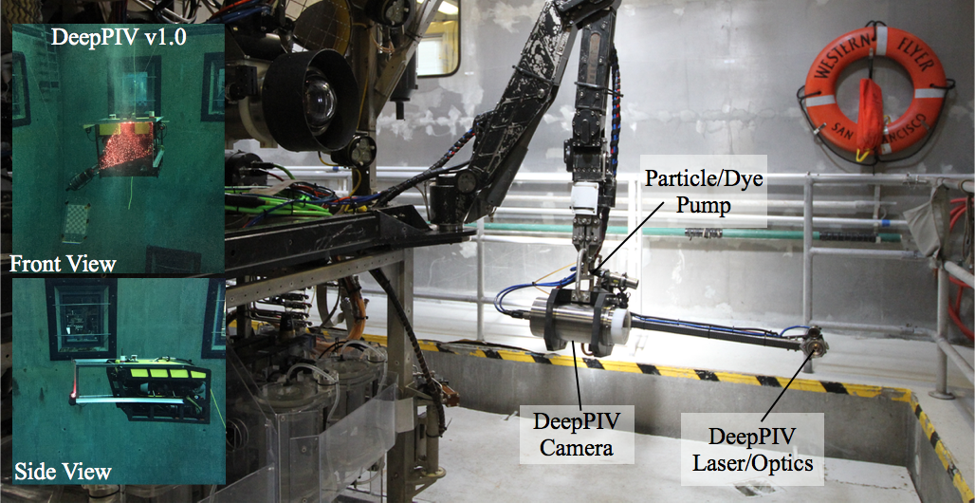
Figure 1. DeepPIV instrument. (L) DeepPIV being demonstrated in MBARI's test tank in 2015 and (R) the current iteration of DeepPIV integrated onto ROV Doc Ricketts' manipulator arm.

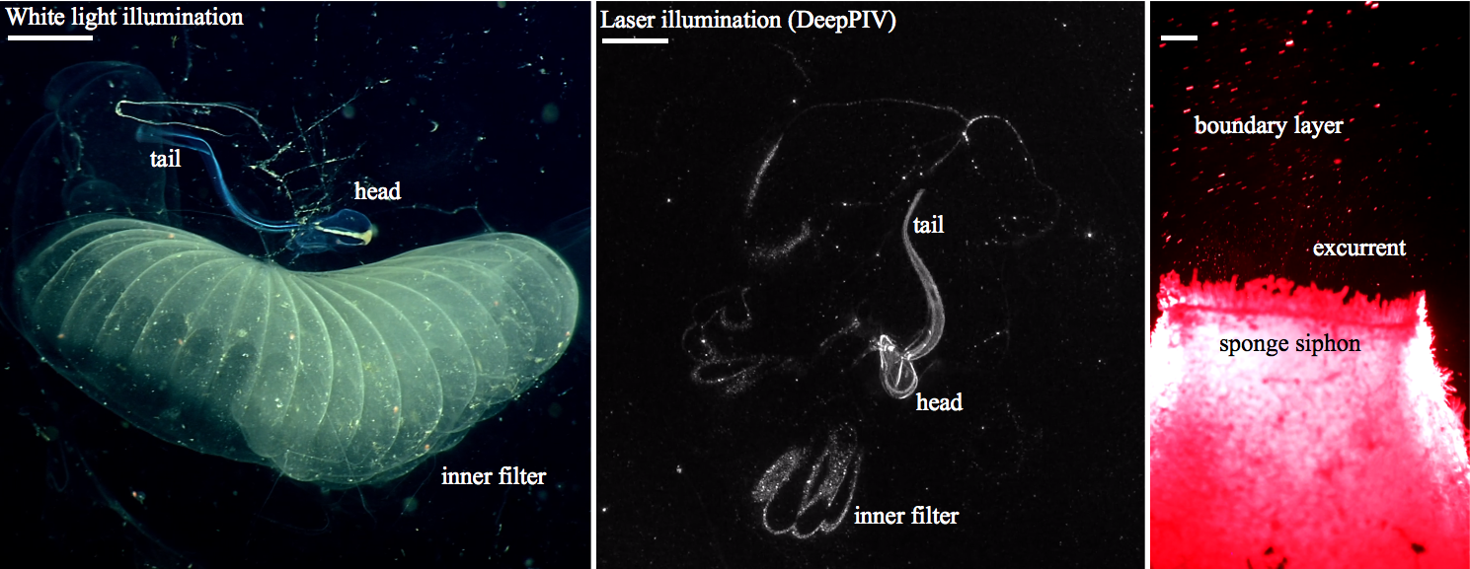
Figure 2. Demonstration of DeepPIV with midwater (C, giant larvacean) and benthic (R, deep sea sponge) targets. Contrast the laser illumination imagery using DeepPIV (in C) to white light-illuminated imagery of a giant larvacean and its inner filter (in L). Scale bar is 2 cm.
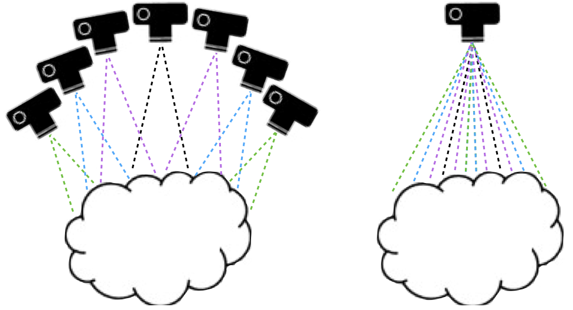
Figure 3. Diagram that shows the camera arrangement in (L) multi-camera volumetric imaging and (R) single-camera plenoptic imaging. Both methods result in fully resolved, three-dimensional particle field and fluid motion (as well as surface reconstruction) measurements with one option requiring far less hardware to integrate underwater.

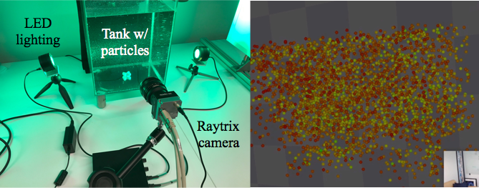
Figure 4. Demonstration of volumetric particle field and fluid flow measurements using (L) a Raytrix camera. (R) The particle field color corresponds to the relative distance of individual particles from the camera. Left image credit: Raytrix.

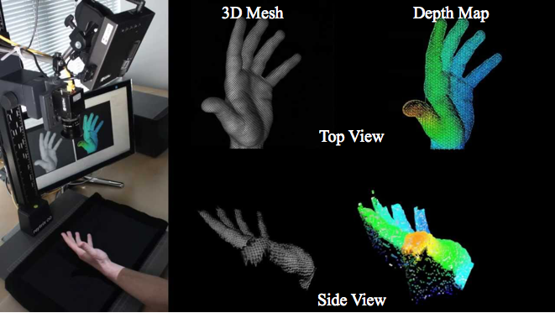
Figure 5. Demonstration of surface reconstruction capability of (L) a Raytrix camera. (R) Reconstructed mesh and depth map of a hand from the top (above) and side (below) views. Image credit: Raytrix.

Katija K, Sherman AD, Robison BH (2016). “DeepPIV: Fluid visualizations from the ocean surface to the seafloor.” APS-DFD Gallery of Fluid Motion, doi:10.1103/APS.DFD.2016.GFM.V0085.
Katija K, Sherlock RE, Sherman AD, Robison BH (2017). “New technology reveals role of giant larvaceans in oceanic carbon cycling.” Science Advances, e1602374.
Katija K*, Choy CA*, Sherlock RE, Sherman AD, Robison BH (2017). “From the surface to the seafloor: How giant larvaceans transport microplastics into the deep sea.” Science Advances, e1700715.

