Outcome 1, Output 1

We have acquired a Raytrix camera (model R26, 25 megapixel, 80 frames per second) and have set up the required GPU and Coaxpress frame grabber (Euresys Coaxlink Quad) such that images can be acquired from the camera and processed (refocused with 3D information) in real-time.

A series of camera calibrations have been performed in the lab using the targets provided by Raytrix, and the error in the calibration has been estimated to be on the order of 0.1 mm.

With the calibrated camera, three types of laboratory experiments were performed to quantify the imaging performance of the camera with a fixed focal length lens. The lens used was a Zeiss Planar f/1.4, 50 mm focal length lens with the aperture set to f/2.8 to be as close as possible to the aperture of the microlens array in the R26 camera. The following tests were performed.

- Resolution and depth of field measurements
- Particle concentration measurements
- 3D particle field estimation from a single image

Resolution and depth of field measurements

Using a 1951 US Air Force resolution target (Edmund Optics Part #36-275), a series of images were acquired in air starting at the farthest focal point of the camera and moving closer to the camera in 2 cm intervals. The farthest point was set to 52 cm from the camera lens to yield a 70 cm equivalent distance in water. At each step, a total focus image (an image refocused over the full imaged volume) was recorded and used to estimate the maximum resolution and contrast. The image contrast was computed as

$\%contrast=100*\left[\frac{I_{Max}-I_{Min}}{I_{Max}+I_{Min}}\right]$,

where I_{Max} and I_{Min} are the maximum and minimum pixel intensities in the selected line pair. The contrast for the 1.12 lp/mm resolution and the maximum resolution with at least 25% contrast were then determined for each image. For comparison, the same series was recorded with a conventional camera (Point Grey Grasshopper 3 GS3-U3-51S5M-C) using the identical imaging lens. As the two cameras have slightly different pixel sizes (4.5 um for the R26 and 3.45 um for the GS3) the image from the GS3 was scaled to match the resolution of the R26. Table 1 and Table 2 show the results for the R26 and GS3 cameras respectively, while Figure 1 shows the maximum resolution at 25% contrast for each camera. Figure 2 then qualitatively compares the images of the resolution target for the two cameras.

The results show the R26 camera has significantly lower resolution at the focal plane, but much larger depth of field and nearly 4x higher resolution at distances greater than 4 cm from the focal plane. This allows objects to be imaged with sufficient resolution for identification over a much larger volume than would be possible with a conventional camera at an equivalent f-number.

Target Distance in Air (cm) | Contrast at 1.12 lp/mm (%) | Optical Resolution @ > 25% Contrast (lp/mm) | Magnification (pixels/mm)
52 | 88 | 3.17 | 21
50 | 88 | 3.17 | 22
48 | 88 | 2.83 | 23
46 | 88 | 2.83 | 24
44 | 79 | 1.78 | 25
42 | 51 | 1.59 | 26
40 | 36 | 1.26 | 27
Table 1: Resolution and depth of field results for Raytrix R26 camera with 50 mm f/2.8 lens focused at a nominal range of 52 cm in air.

Target Distance in Air (cm) | Contrast at 1.12 lp/mm (%) | Optical Resolution @ > 25% Contrast (lp/mm) | Magnification (pixels/mm)
52 | 77 | 5.04 | 23
50 | 70 | 1.78 | 24
48 | 18 | 0.71 | 25
46 | 7 | 0.45 | 24
44 | 79 | 0.31 | 25
Table 2: Resolution and depth of field results for Point Grey Grasshopper 3 camera with 50 mm f/2.8 lens focused at a nominal range of 52 cm in air. Note that the image was too defocused to collect meaningful data closer than 44 cm.
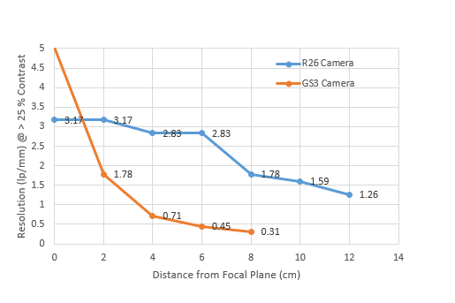
Figure 1: Plot of the resolution of the R26 and GS3-U3-51S5M-C camera as a function of distance away from the focal plane.

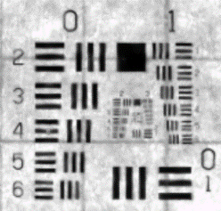 | 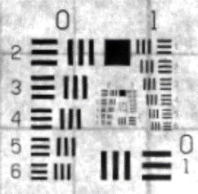 | 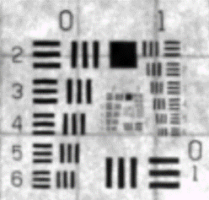 | 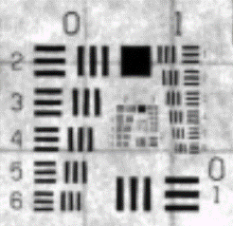 | 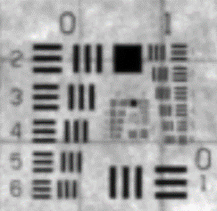
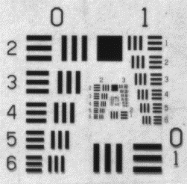 | 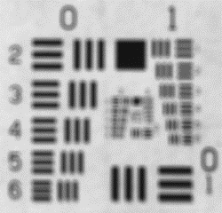 | 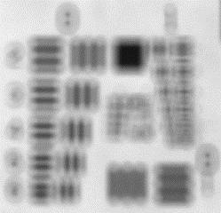 | 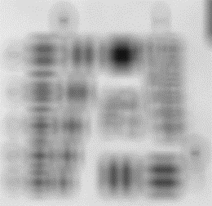 | 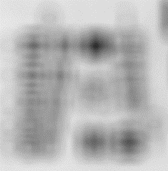
0 cm | 2 cm | 4 cm | 6 cm | 8 cm
Figure 2: Example images of the group 0 and group 1 series of the test target as a function of distance from the focal plane (increasing to the right) for the R26 camera (top row) and GS3 camera (bottom row). The group 0, element 1 line pairs on the bottom right of the image correspond to a resolution of 1 lp/mm or a line width of 500 um.

Particle Concentration Measurements

A preparation of Cospheric microspheres (125-150 um diameter) were measured out to 1 ml dry volume and diluted 5x into RO water. This dilution was then added to a small tank filled with 8.5 L of RO water. Images were then recorded at a series of dilution steps created by mixing up the particles, removing 4 L of water, and replacing that water with 4 L of RO water. At each step, a series of 6 images were recorded after mixing up the particles. The resulting expected particle concentration (orange) and estimated particle concentration (blue) are shown in Figure 3. At particle concentrations above 10 particles/ml, we found particle concentration estimates to be lower than expected. However, below that concentration we found good agreement between the detected number of particles and the expected number from the dilution. Please note that the curves were set to be equal at a concentration of 8.3 particles/ml as we did not know the exact concentration at the start of the dilution. We selected 8.3 particles / ml as this was the highest particle concentration that we did not find clear evidence of occlusion artifacts in the refocused image. By selecting this point for the two curves to be equal we are highlighting the bias at higher concentrations. A subsequent experiment is planned to confirm these results using a dilution starting from a concentration that is known more accurately. Figure 4 shows a qualitative view of the detected particles at each dilution step.
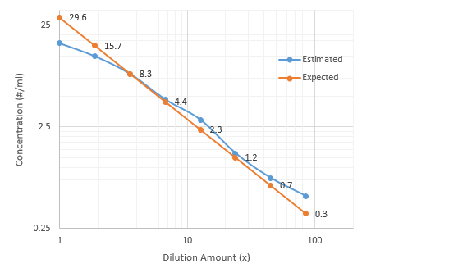
Figure 3: Plot of the estimated (blue) and expected (orange) particle concentrations in the dilution experiment. The expected concentration at each step is displayed next to the data point. The two curves were set to be equal at a concentration of 8.3 particles/ml because this was the highest concentration where we did not find clear evidence of occlusion artifacts in the refocused images.

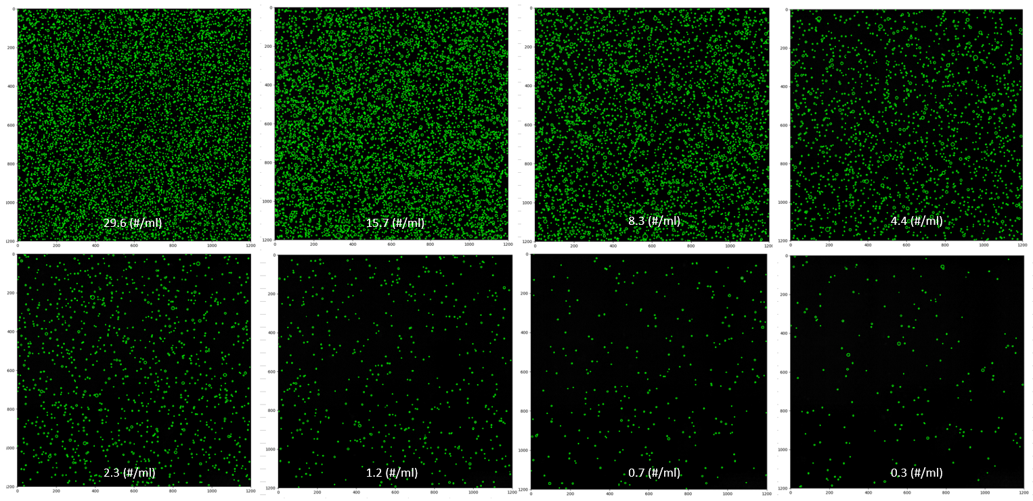
Figure 4: Example images of detected particle fields from the dilution experiment starting at the highest concentration (top-left) and moving left-to-right, top-to-bottom.

3D Particle Field Estimation

Using a single ray image from the 8.3 particles/ml dilution, a point cloud was generated using the provided camera software and processed in CloudCompare to segment the cloud into distinct objects with 3D position information. The result of this is a 3D particle field with position and size information for each particle that could be used as input to particle tracking software. An example of these data is shown in Figure 5.

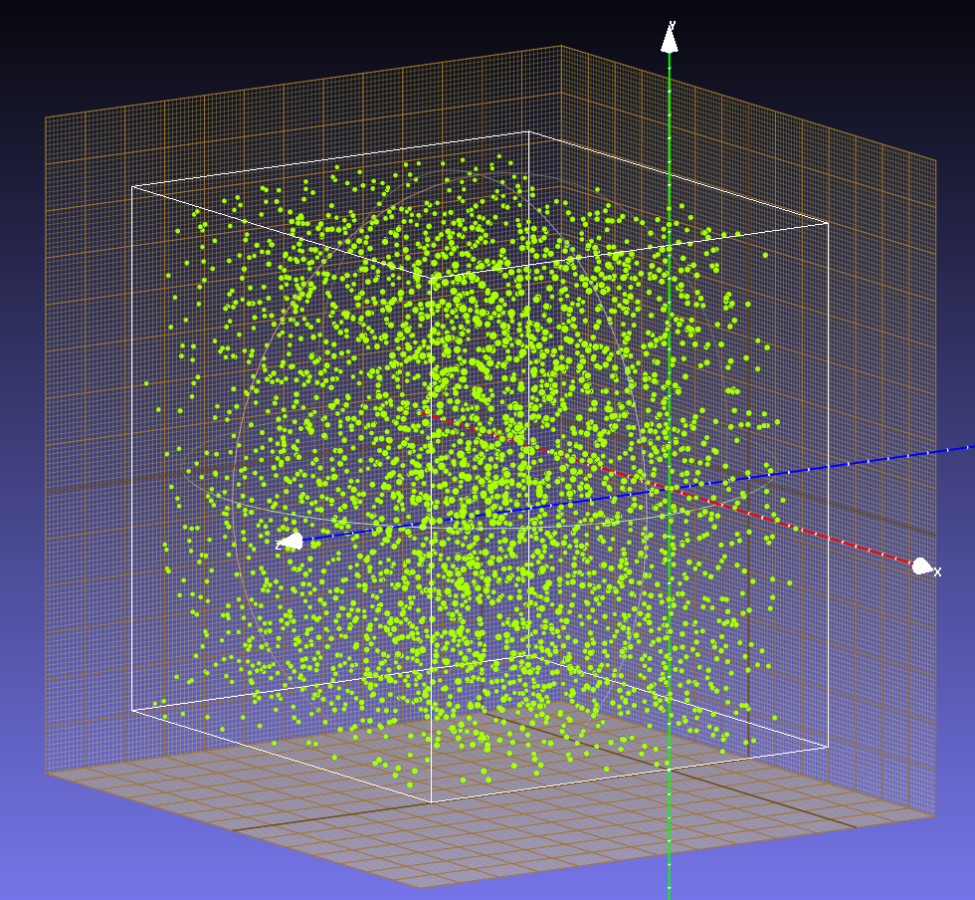
Figure 5: 3D particle field rendered as a point cloud in MeshLab.

Functional Requirements

We have prepared a list of functional requirements for EyeRIS based on several meetings with engineers and scientists at MBARI. These requirements will drive the design of the system for both cabled (Output 1, Outcome 2) and autonomous (Output 1, Outcome 4) operation.

1. Functional Requirements (General)
1.1. EyeRIS shall be configurable for a range of particle sizes, particle concentrations, flow rates, and platform profiling speeds for a specific use case.
1.2. EyeRIS shall measure particle sizes in the range 250-10000 microns with a resolution of 100 um.
1.3. EyeRIS shall be able to bin particle sizes with 10% accuracy (min 100 particles per bin).
1.4. EyeRIS shall provide images sufficient for morphological identification of objects in the range of 1 mm to 20 cm.
1.5. EyeRIS shall provide a quantifiable imaged volume.
1.6. EyeRIS shall provide direct color LED illumination, one for minimal animal disturbance [Red or Near IR] and one for optimal image quality [White or Red].
1.7. EyeRIS shall provide adjustment of illumination direction as needed for the application.
1.8. EyeRIS shall be calibrated in situ with targets and particle fields.
1.9 EyeRIS shall operate to a depth of 4000 m.

2. Functional Requirements (Cabled Instrument):

2.1. EyeRIS shall stream live video to a surface vessel.
2.2. EyeRIS shall record data on an external high-resolution recorder on a surface vessel.
2.3. EyeRIS shall be compatible with existing ROV power and communications.
2.4. EyeRIS shall be deployable on a manipulator arm of an ROV.

3. Functional Requirements (Autonomous Instrument)

3.1. EyeRIS shall record still image and video data locally.
3.2. EyeRIS shall operate autonomously for the duration of an LRAUV mission.
3.3. EyeRIS shall record continuously or be able to go in a low power sleep mode between recording intervals.
3.4. EyeRIS shall have internal control of the camera and CPU from a low-power MCU.
3.5. EyeRIS shall support vehicle ground fault detection.
3.6. EyeRIS shall be controllable with vehicle mission exec.
3.7. EyeRIS shall have a white light flash with illumination duration short enough to minimize motion smear.

4. Functional Requirements (3DPIV):

4.1. EyeRIS shall be able to resolve objects in the size range from 1-20 cm (x/y dimension).
4.2. EyeRIS shall be able to resolve objects in the size range 1-20 cm (z dimension).
4.3. EyeRIS shall measure fluid velocities from 1mm/s to 1 m/s.

5. Functional Requirements (3D(dt)R):

5.1. EyeRIS shall resolve features on the order of 1% of size on objects in the size range 1-20 cm (x/y/z).
5.2. EyeRIS shall resolve mucus and gelatinous structures with greater than 50% opacity.
5.3. EyeRIS shall be able to resolve objects in the size range from 1-20 cm in the x- and y-dimension.
5.4. EyeRIS shall size targets with accuracy better than 5%in the x-, y-, and z-dimension.
5.5. EyeRIS may use auxiliary/multiple cameras to verify target measurements.
5.6. EyeRIS may use structured illumination to enhance surface reconstructions.

6. Functional Requirements (Marine snow, plankton Imaging, CeNCOOS):

6.1. EyeRIS shall provide data that can be integrated into CeNCOOS workflows.
6.2. EyeRIS shall provide raw camera data for still image capture for reproducing results.
6.3. EyeRIS shall provide information to identify the type and size (equivalent spherical diameter is most common metric for marine snow particle size) of particles, including their location within the image for automated object classification.

Outcome 1, Output 2

We have identified hardware that should allow for cabled operation of EyeRIS on existing ROV assets at MBARI. The configuration uses a set of four fiber extenders (Phrontier Technologies PHT1) and Coarse Wavelength Division Multiplexing (CWDM) along with an off-the-shelf AC/DC converter and a custom control board.

We have developed a concept model that shows that the cabled version of EyeRIS can be packaged into an existing camera housing design used for DeepPIV (http://advances.sciencemag.org/content/3/5/e1602374) that has been proven on nearly 100 deep water dives. The illumination for the camera will be provided either by existing lights on the ROV when useful for testing, or by an “umbrella” frame when deployed during a science mission as shown in Figure 6.

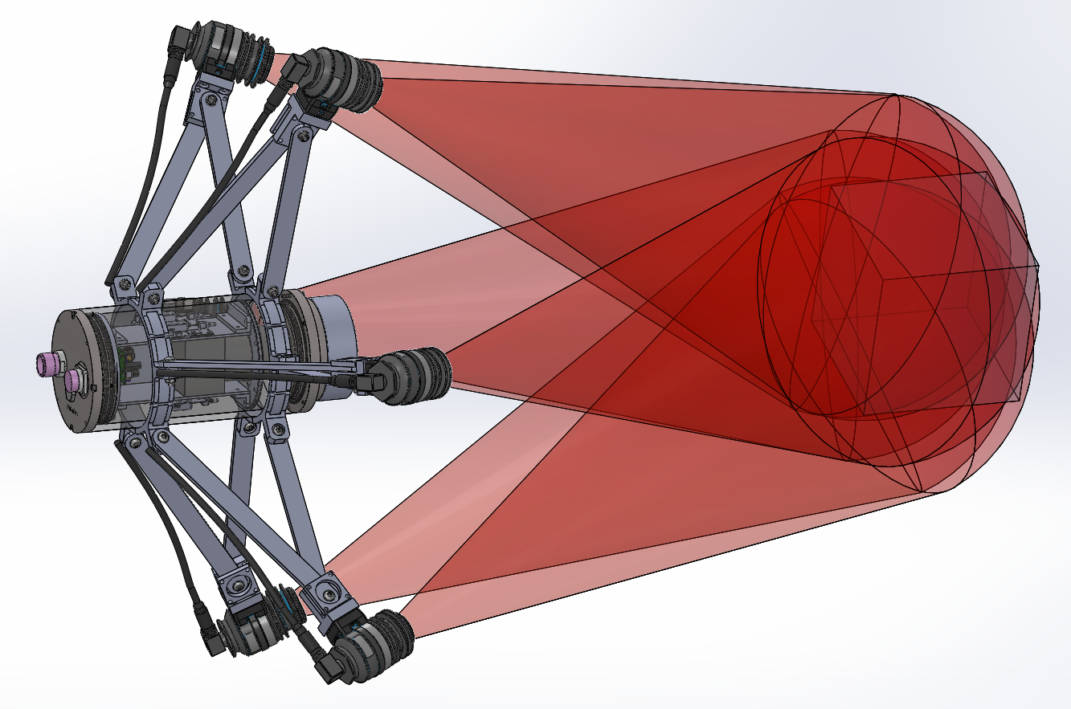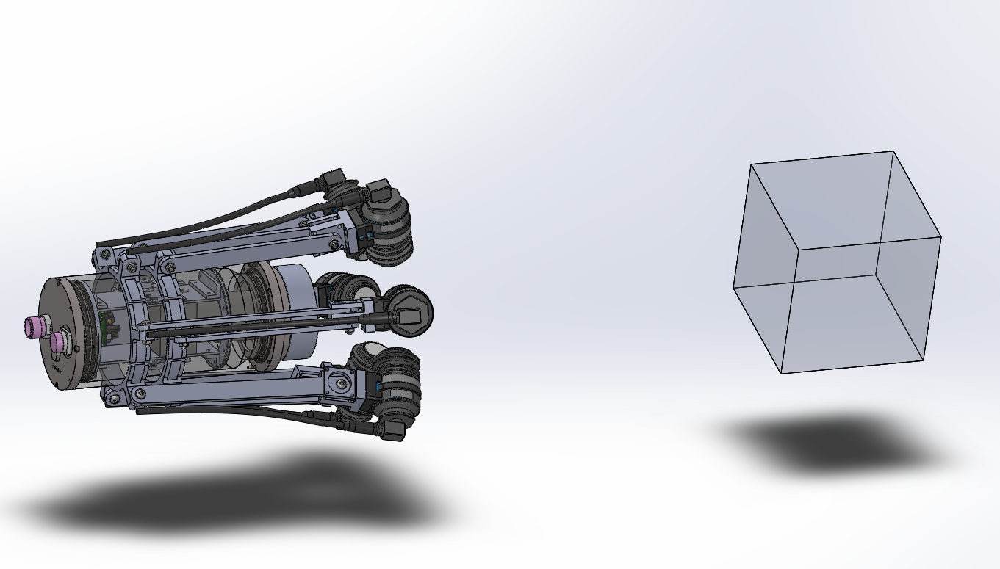

Figure 6: CAD models of the cabled instrument design in the extended (top) and retracted (bottom) configuration. The model shows the camera, lens, fiber extenders, CDWM mux, and AC/DC converter packaged into a 6” OD x 13” long housing. The “umbrella” frame for holding lights can be adjusted to change the angle of illumination, and in the future provide a mechanism to stow the system on the ROV sled in a compact form factor. The grey cube is the target imaged volume of 20 cm side length.

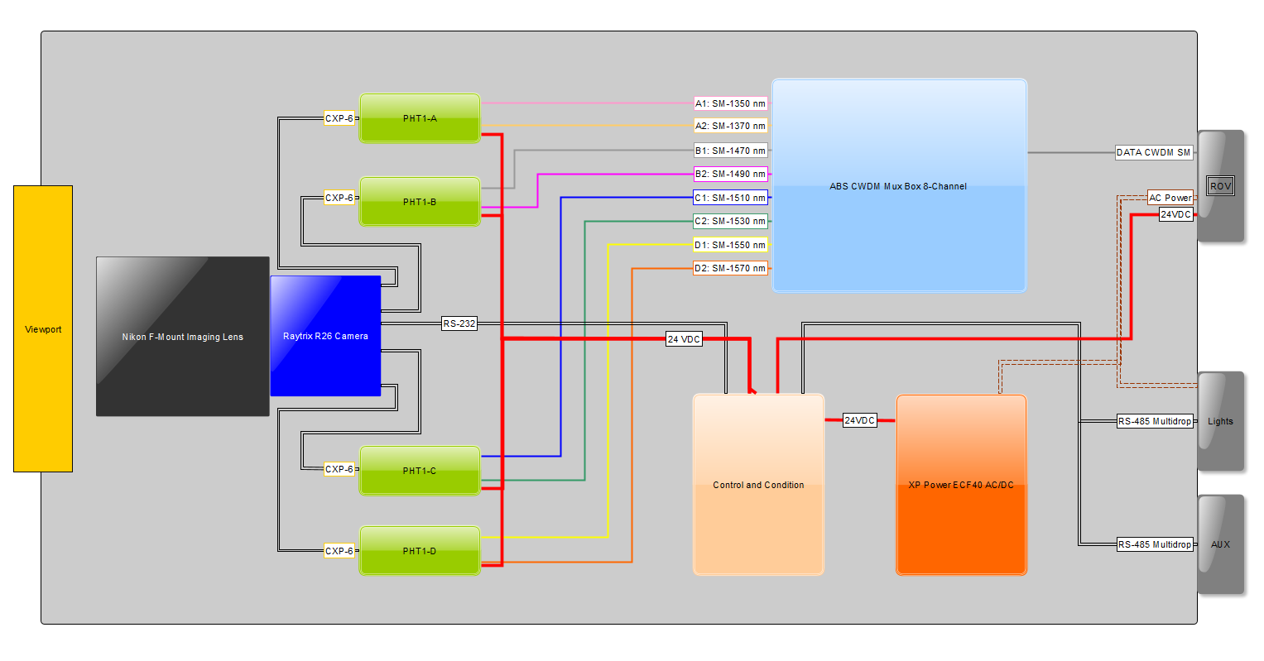
Figure 7: Block diagram of the key internal components for the cabled EyeRIS instrument. Aside from the Control and Condition module (the tan block), the other parts are off-the-shelf components. The choice of wavelengths for the CDWM system can be exchanged to ensure compatibility with other underwater vehicles.

