EyeRIS Imaging Geometry

Blender Simulation
Blender is a powerful raytracing program that includes a physics-based renderer named Cycles. To quickly explore different imaging geometries we built a blender simulation with a perspective camera model, 67 mm focal length lens (50 mm in air) with F/2.4 aperture, and a resolution target 1 m from the camera. We place spot lights with 28 degree beam angles around the camera and tilt them towards the target.
This general model is then used to explore the influence of varying the number of lights and also the spacing between camera and lights.

Selecting the number of lights
Since we need to separate the lights from the camera to mitigate common volume backscatter from small and large particles alike, we end up creating shadows in the image for large objects. The reduce the impact of shadows we can add more lights. Here we use Blender to simulate geometries with different numbers of lights distributed around the camera with a 45 cm separation between camera and nearest light (90 cm total spacing between lights. The lights are all assumed to have equal power output and are directed towards the subject. During the simulation we keep the energy in the image constant by adjusting the exposure time to compensate for more or fewer lights.

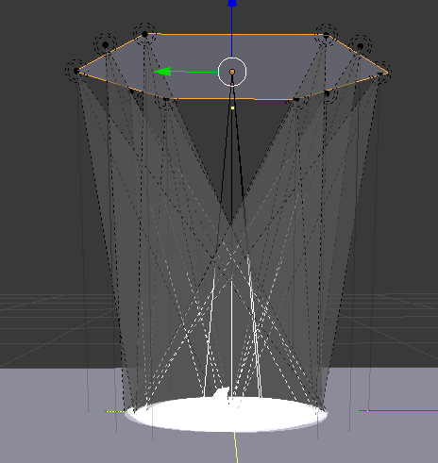
Figure 1: Setup of the Blender simulation. A 3D model of a giant larvacean is placed 1 m from the camera (white circle) and the array of lights (black dots with beam) are positioned around the camera.

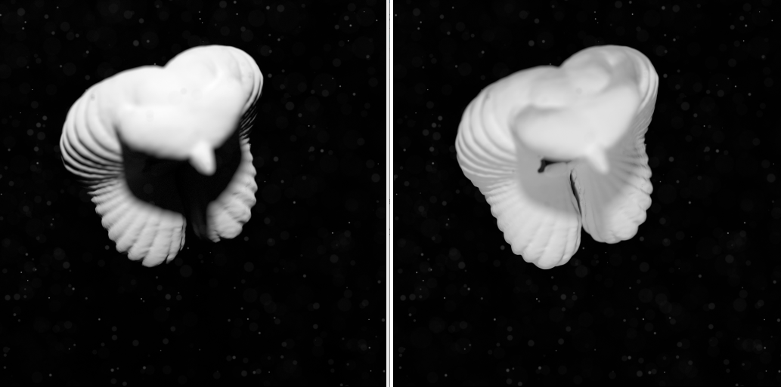
One Light Two lights
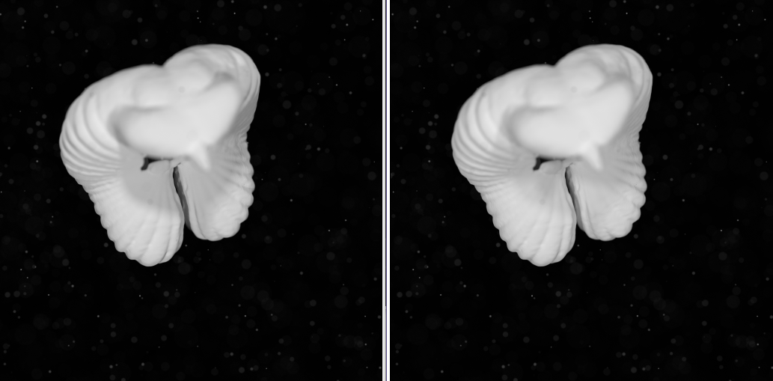
Three lights Six lights
Figure 2: Simulated images with different numbers of lights starting at the top left (1 light) and moving left to right, top to bottom. Note the strong shadowing with 1 or two lights is significantly reduced with 6 lights.

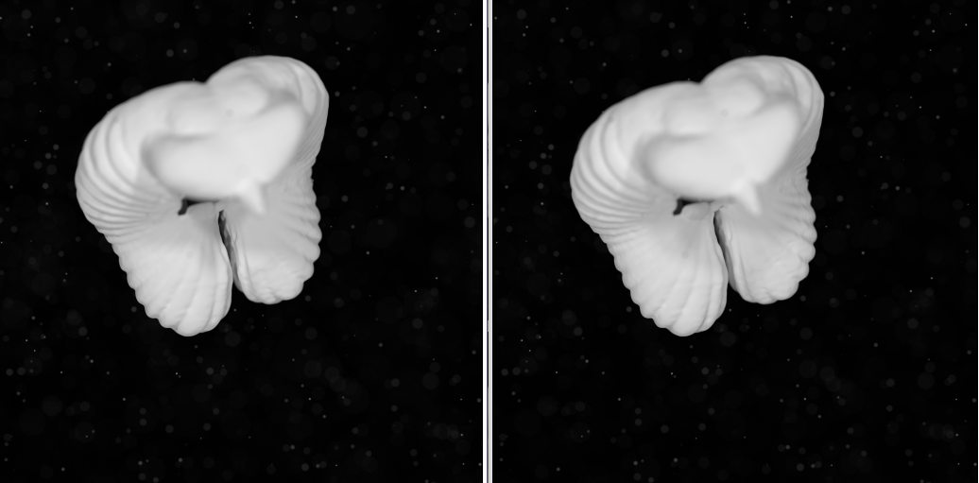
Four lights Six lights
Figure 3: Comparison between 4 (left) and 6 (right) lights. Although both images look quite similar, there is a significant reduction in shadowing when using six lights that can be better seen numerically below.

Measuring the Contrast of Shadows
A region that encompasses most of the image is drawn over the foreground and shown below
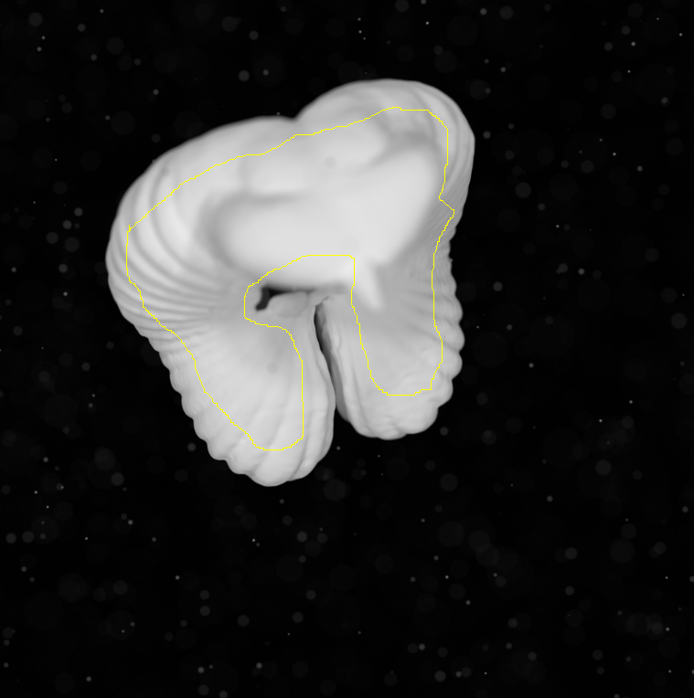
Figure 4: The yellow line defines a region where pixel statistics are computed from the image for each number of lights.

To define the shadow contrast, we take the difference between the min and max pixel value over the region divided by the sum of the min and max pixel value. With this definition, a value of 100 % means the shadow consumes the full range in the image, where a value of 0 % means the shadow is not present in the image.
# of lights | Mean | StdDev | Mode | Min | Max | Median | Shadow Contrast
1 | 168.023 | 83.974 | 243 | 0 | 255 | 204 | 100
2 | 194.847 | 25.132 | 224 | 109 | 234 | 203 | 36.44
3 | 197.593 | 20.656 | 222 | 125 | 233 | 203 | 30.16
4 | 201.415 | 18.401 | 225 | 139 | 236 | 204 | 25.86
6 | 199.188 | 18.873 | 223 | 144 | 233 | 203 | 23.60
Table 1: Pixel stats for varying numbers of lights. The shadow contrast is 100*(max-min)/(max+min). A lower shadow contrast is better.

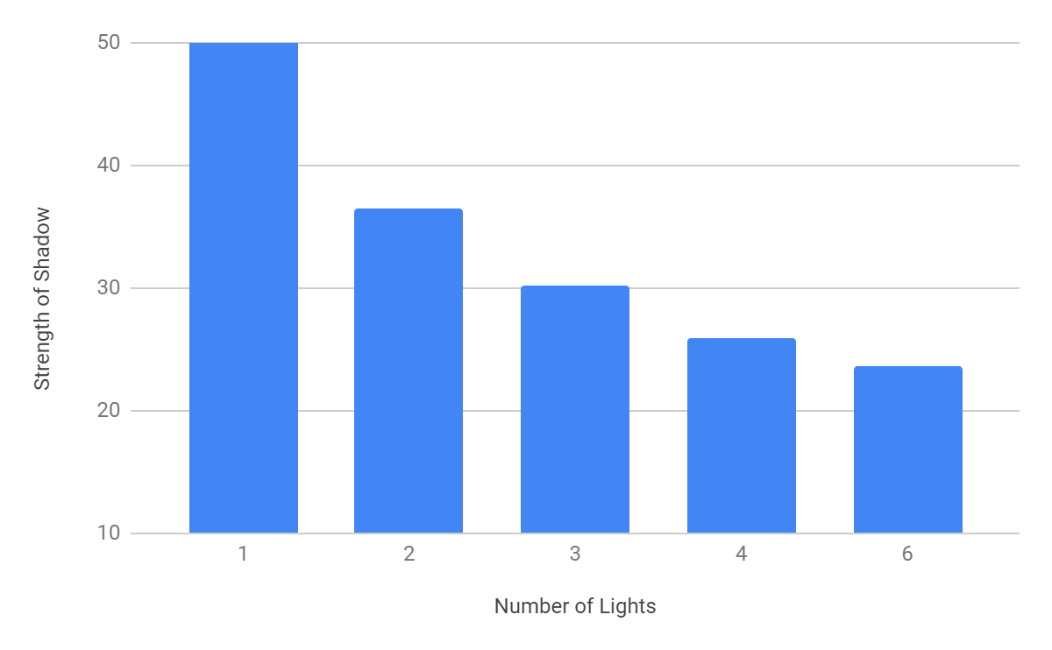
Figure 5: Graphical depiction of the shadow contrast from Table 1. Lower is better.

Selecting the Spacing Between Lights
We use Blender again to simulate imaging through a field of 1 mm diffuse scattering particles and also volume scatter. We place six lights around a hexagon and change the radius of the circle that contains the hexagon. As the radius increases, we find reduced common volume backscatter, better contrast of the target and better contrast of the in-focus particles.

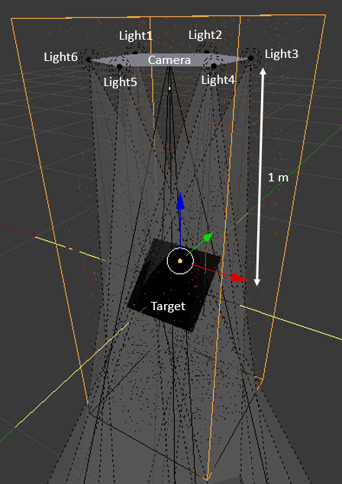
Figure 6: Setup for simulating the impact of moving the lights farther away from the camera. Note the small orange dots are particles uniformly randomly distributed in the volume. There is also volume scattering modeled using a variable density and an anisotropy of 0.9 (strongly forward scattering).
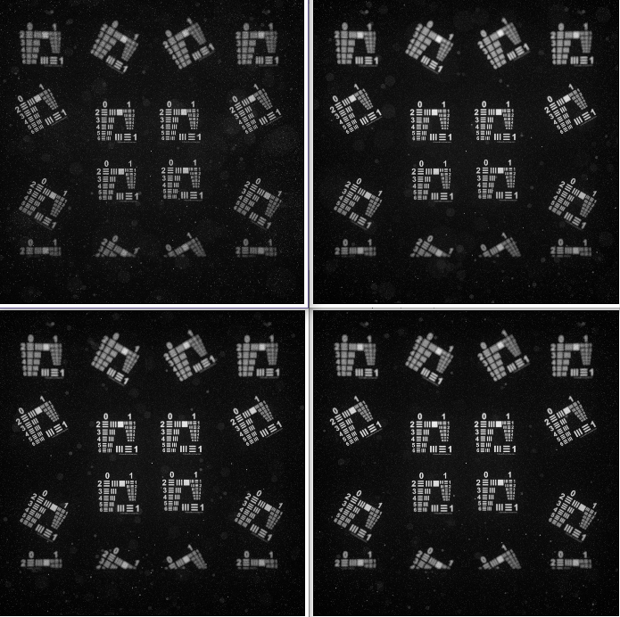
Figure 7: Simulated images for a medium scattering case: 6.25 particles / liter and 0.5 scattering density for 10 cm (top left), 20 cm (top right), 30 cm (bottom left) and 45 cm (bottom right) spacing between lights and camera.

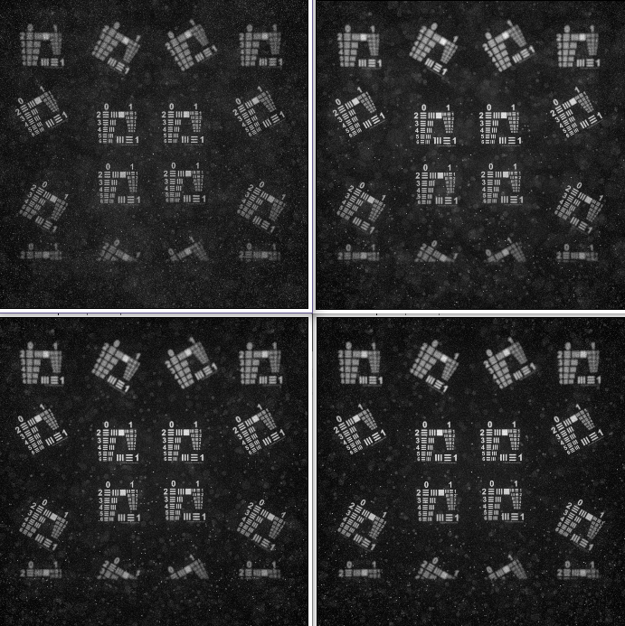
Figure 8: Simulated images for a high scattering case: 62.5 particles / liter and 1.0 scattering density for 10 cm (top left), 20 cm (top right), 30 cm (bottom left) and 45 cm (bottom right) spacing between lights and camera.

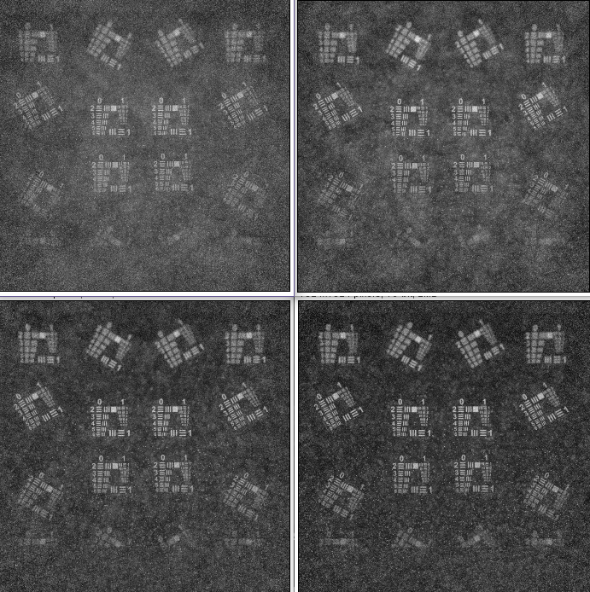
Figure 9: Simulated images for a very high scattering case: 625 particles / liter and 2.0 scattering density for 10 cm (top left), 20 cm (top right), 30 cm (bottom left) and 45 cm (bottom right) spacing between lights and camera.

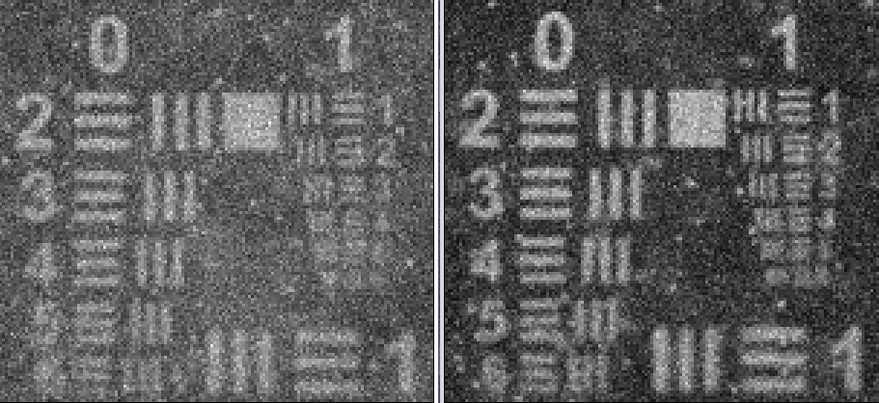
Figure 10: Zoomed in comparison of target contrast between 10 cm spacing (left) and 45 cm spacing (right).

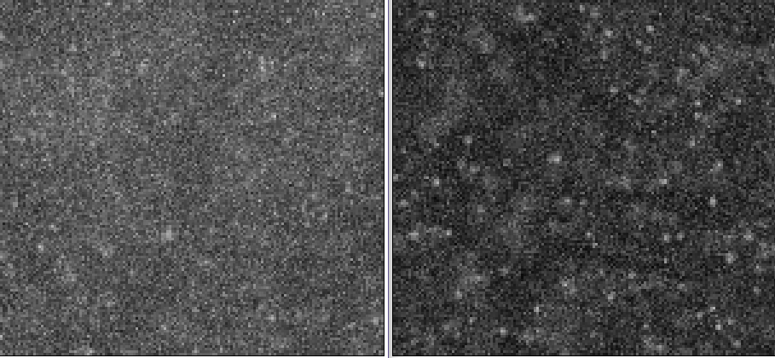
Figure 11: Zoomed in comparison of particle contrast between 10 cm spacing (left) and 45 cm spacing (right).

