Dimensions:
Max outer diameter | 85 cm
Min outer diameter | 42 cm
Max instrument length | 89 cm
Approximate weight in air | 25 kg
Approximate weight in seawater | 15 kg

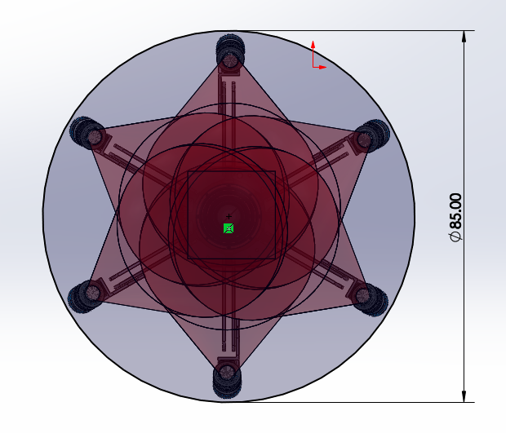
Figure 1: View of the front of EyeRIS with the illumination expanded to its max size. The diameter of the array is 85 cm.

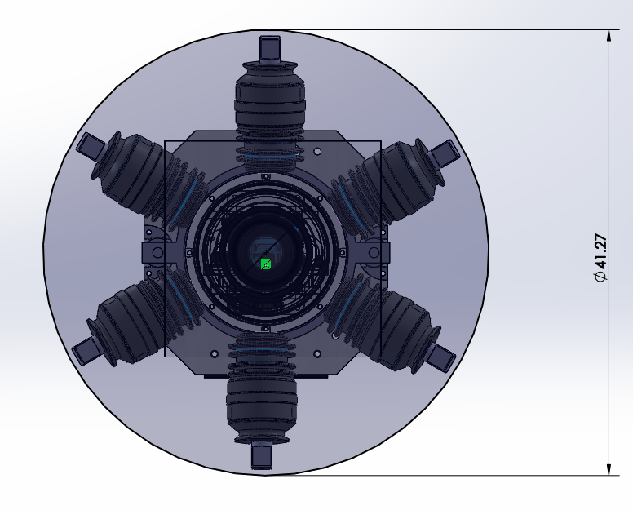
Figure 2: View of the front of EyeRIS with the illumination folded to its minimum size. The diameter of the array is 42 cm.

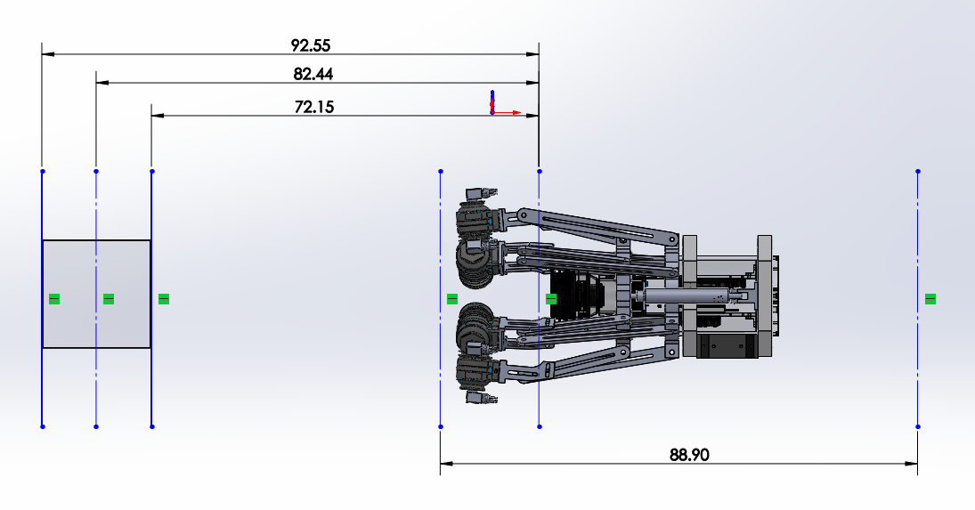
Figure 3: View of the side of EyeRIS showing the far (92.55 cm), middle (82.44 cm), and near (72.15 cm) distances from the viewport to the imaged volume. Accounting for space for cables and connectors, the instrument length is less than 89 cm.

