EyeRIS Measurement Accuracy
Comparison of measurements in solidworks to a 3D printed model imaged with the R26 camera.

“Ground Truth” 3D model
A small “crown” with pillars of different heights and locations around a central point. To help aid point picking in the model, a chamber is applied to take the radius down from 4.92 mm to 1 mm. Four compies of the model were printed on a Creality ender3 printer and setup a different 3D positions in the FOV of the camera as shown below

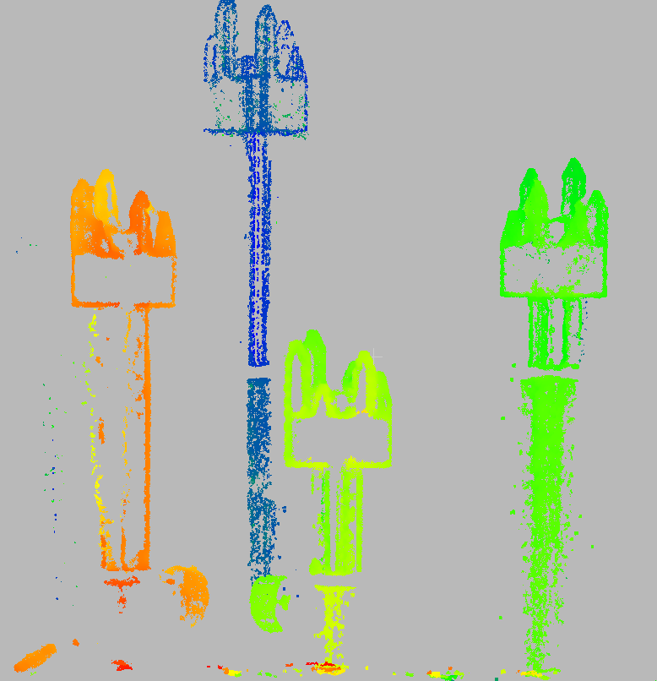
Figure 1: Scene with four targets distributed in x, y, and z.

Point cloud measurements at different positions in the FOV
Positions on the model were measured in solidworks and positions in the point cloud were measured using Cloud Compare. Since the selection of points in the cloud is subjective, and effort was made to consistently pick points with similar appearance in the cloud.
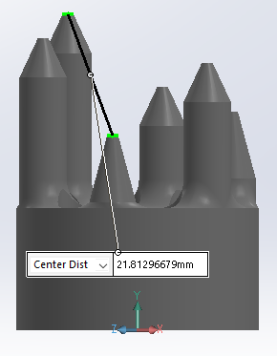 | 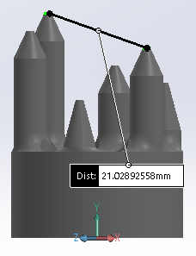
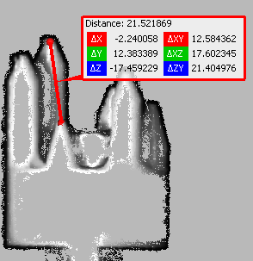 | 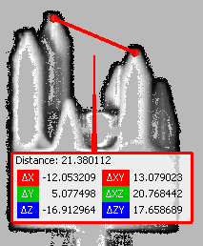
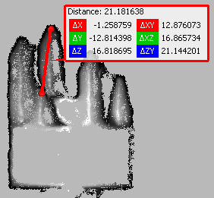 | 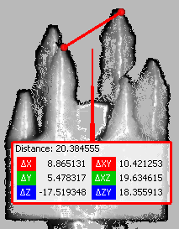
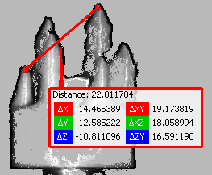 | 