EyeRIS Thermal Calculations

Sources of heat in the housing:
- MBC-275: 27W
- MBC-41: 3W
- PHT4: 7 W
- R26: 13 W

Setup and Assumptions:
- All heat flux from camera is through the bottom mounting plate. This is a worst-case assumption and in practice there is likely convection inside the camera housing that will better distribute heat.
- Tflex HD90000, 0.12” thick material is used to transfer heat from PCBs and camera to chassis. The material has a thermal conductivity of 7.5 W/mK.

Case 1: housing immersed in 7 C water, all components at full power
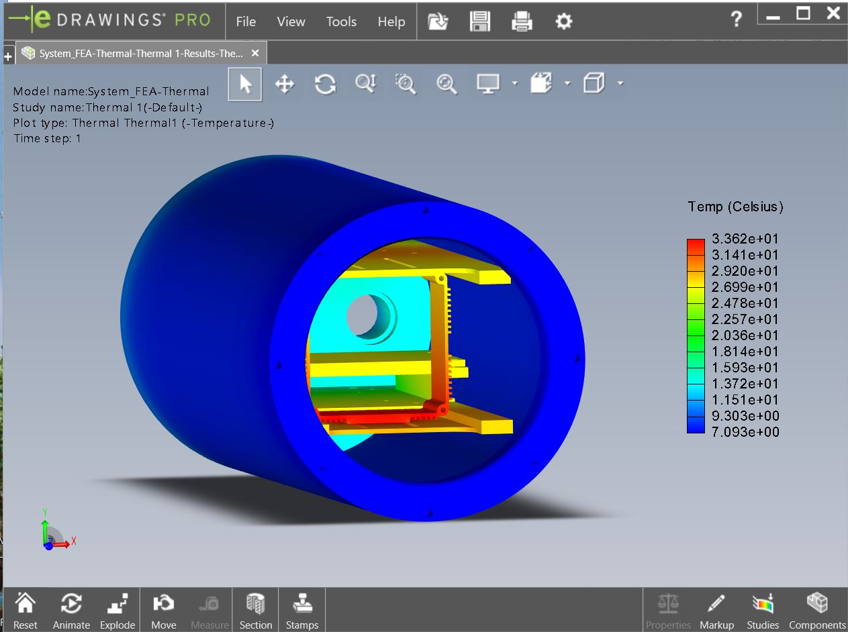
Case 2: Camera operated in air without light powered on
