Potential impacts of the MARS Cable on the seabed and benthic faunal assemblages

J.P. Barry, L. Kuhnz, K. Buck, C. Lovera, P.J. Whaling
Monterey Bay Aquarium Research Institute

SUMMARY
A geological and biological sampling program to assess the condition of the MARS cable and its potential effects on seabed geology and biology was performed in late 2007-2008. The sampling program was designed to;
- Observe the condition of the cable or cable trench along the cable route (52 km),
- Assess the potential impacts of the MARS cable on geological characteristics and biological assemblages on a local scale (0-100m from cable) and a regional scale (km), using ROV video transects and sediment samples.
The major conclusion of the study is that the MARS cable has had little detectable impact on seabed geomorphology, sediment conditions, or biological assemblages. Specific conclusions include the following:
- Over most of its length, the cable remains buried, with little evidence of change since installation
  - The burial trench remains intact along deeper areas of the cable route,
  - Sediment is slowly filling the cable trench
- No detectable changes in sediment characteristics (mean grain size, or percent organic carbon) can be attributed to the MARS cable
- Local variation in benthic megafaunal communities within 50-100 m of the MARS cable is minor or undetectable.
  - The abundances of most animals observed did not differ between the area over the cable route and 50 m away
  - Longnose skates (Raja rhina) were significantly more abundant along sections where the MARS cable is suspended over topography (~300 m depth), and are likely to respond to electromagnetic fields generated by the cable.
- The MARS cable has little or no detectable effect on the distribution and abundance of macrofaunal and megafaunal assemblages on a regional scale (e.g. kilometers).
  - Megafauna and macrofauna compared before and after cable installation among 3 control stations and 1 cable station at each of 3 depth zones (Shelf - <200 m, Neck – 200-500 m, Slope - >500 m) indicated very few potential changes in benthic biological patterns due to the MARS cable.
  - Natural spatial and temporal variation in the abundance and distribution of benthic macrofauna and megafauna appears to be greater than any detectable effects of the MARS cable.

INTRODUCTION
The Monterey Accelerated Research System (MARS) is an undersea cable from the Monterey Bay Aquarium Research Institute (MBARI) to a science ‘node’ at a depth of 891 m on the continental slope just outside Monterey Bay, California. The system provides power and high data bandwidth for science instruments connected to the node via thin ‘extension’ cables deployed on the seabed by remotely operated vehicles (ROVs). MARS is one of a few cabled ocean observing systems that enable continuous, long-term science capabilities for ocean science with real-time communication, control, and data capture from offshore subsea sensor systems.
The main MARS cable was installed in March 2007 from the cable-laying ship Global Sentinel. It stretches 52 km from shore to the science node, which is positioned in 891 m depth roughly 35 km from shore. The cable was buried (jetted into the sediment) during installation though most of its length, though although this was not possible just below the continental shelf break (200 – 400 m depth) where carbonate and bedrock outcrops prevent complete burial of the cable. The MARS science node was installed and powered briefly in February, 2008, but failed due to subsea connector corrosion. The failed parts were recovered, repaired, and reinstalled in November 2008. MARS has been fully operational since that time.
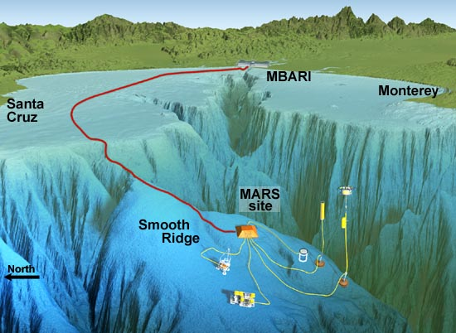
Figure 1. View of the MARS cable, node, and potential science instruments over exaggerated bathymetry of Monterey Bay, Monterey Canyon, and the continental slope. The science node is indicated as “MARS site”.
Prior to MARS cable installation, an environmental impact report was prepared, including characterization of seabed biological communities along the cable route and initial sampling for future environmental impact assessment. This survey included characterization of the megafaunal animals (organisms identifiable in video recordings) and macrofaunal organisms (worms, crustaceans, etc., captured from sieved sediment samples) along the cable route. Subsequent to MARS cable installation, an environmental impact assessment is required at ~18 month intervals, including observations of the condition of the cable and potential effects on biological communities. In this report, we present the results of environmental impact assessment surveys performed prior to cable installation and following cable installation in January 2008.

METHODS

Cable Condition Survey
The position and condition of the cable was assessed by a ‘fly-over’ survey of the cable and cable route using the ROV Ventana. The ROV was flown over the cable or cable route approximately 1-3 m over the seabed, using a cable-sensing system attached to the ROV to determine accurately the position of the cable over the buried portion of the cable route. Annotations of video observations included the superficial condition of the seabed, damage to the seabed related to cable installation, and whether the cable was still buried, the condition of the burial trench (i.e. exposed, filled with mud, etc.), and if not buried, if it is lying on the seabed or suspended due to ‘bridging’ between seabed objects.

Seabed Observations and Sediment Sampling
Observations of the seabed and sample collection were performed using the ROV Ventana, supported by the RV Pt. Lobos. The main camera on the ROV Ventana is a High Definition Insite Zues Plus, mounted on a 3-axis pan and tilt capable of +/- 45º of tilt. Two manipulator arms and a sample drawer provide space and manipulation capabilities for sediment sampling. All available recorded video was annotated using MBARI’s computer annotation system, Video Information Capture with Knowledge Inferencing (VICKI).

Video Transects
Quantitative estimates of the densities of seabed organisms and objects were obtained from the analysis of video transects. For each video transects, the ROV camera was tilted toward the seabed and zoomed to provide a 1-1.5 m wide swath visible at the base of the image frame. Each transect was run at ~0.1-0.2 ms⁻¹ over a distance of 100 m. Paired lasers (~33 cm apart) provided a reference scale for estimating the spatial dimensions of the video image. Voucher specimens were collected as needed for additional taxonomic study.
Video transects were annotated using the VICKI annotation system in a quantitative manner to provide estimates of the density (# m⁻²) of identifiable objects and organisms. Taxonomic identification of all megafauna was performed to the lowest practical taxonomic level. Because identification of organisms from video can be difficult, we were conservative in assignment of taxonomic names. All objects within a 1-1.5 m wide swath (width determined repeatedly during each transect using the paired laser system) were annotated (counted) along the length of the transect. To avoid bias in counts of the number of organisms due to field of view distortion, animals in the upper third of the image were not counted. Thus only those organisms passing through a 1-1.5 m wide swath in the lower 2/3 of the image were used for counts. The density of objects and organisms over a single transects was used a sample unit for further analyses.

Sediment Samples
Samples of seabed sediments for faunal and geologic characteristics were collected using 7.5 cm diameter tube cores, which penetrated the sediment to a depth of ~20 cm. The top 5 cm of these core samples were washed gently through a 0.3 mm sieve using cold seawater.
All organisms collected were relaxed using a 7% solution of magnesium chloride (MgCl2), then preserved in a 4% formaldehyde (10% formalin) solution for several days. Samples were then rinsed with de-ionized water and stored in 70% ethanol for subsequent sorting and identification under a dissecting microscope.

Biological Communities
Local Effects of Cable Installation
Are there detectable differences in the abundances of animals living directly on or over the cable path compared to nearby areas not on the cable path? This was evaluated using video transects at stations positioned at 5 km intervals along the entire cable route, comprising 10 cable stations (Figure 2). At each station, a 100 m long video transect was run over the cable route (cable treatment), and a second 100 m long transect (control treatment) was performed parallel to the cable, but 50 m away from it. For each transect, all identifiable organisms were identified and counted. Data from cable and control treatments were then compared to assess differences in megafaunal assemblages potentially caused by the cable.
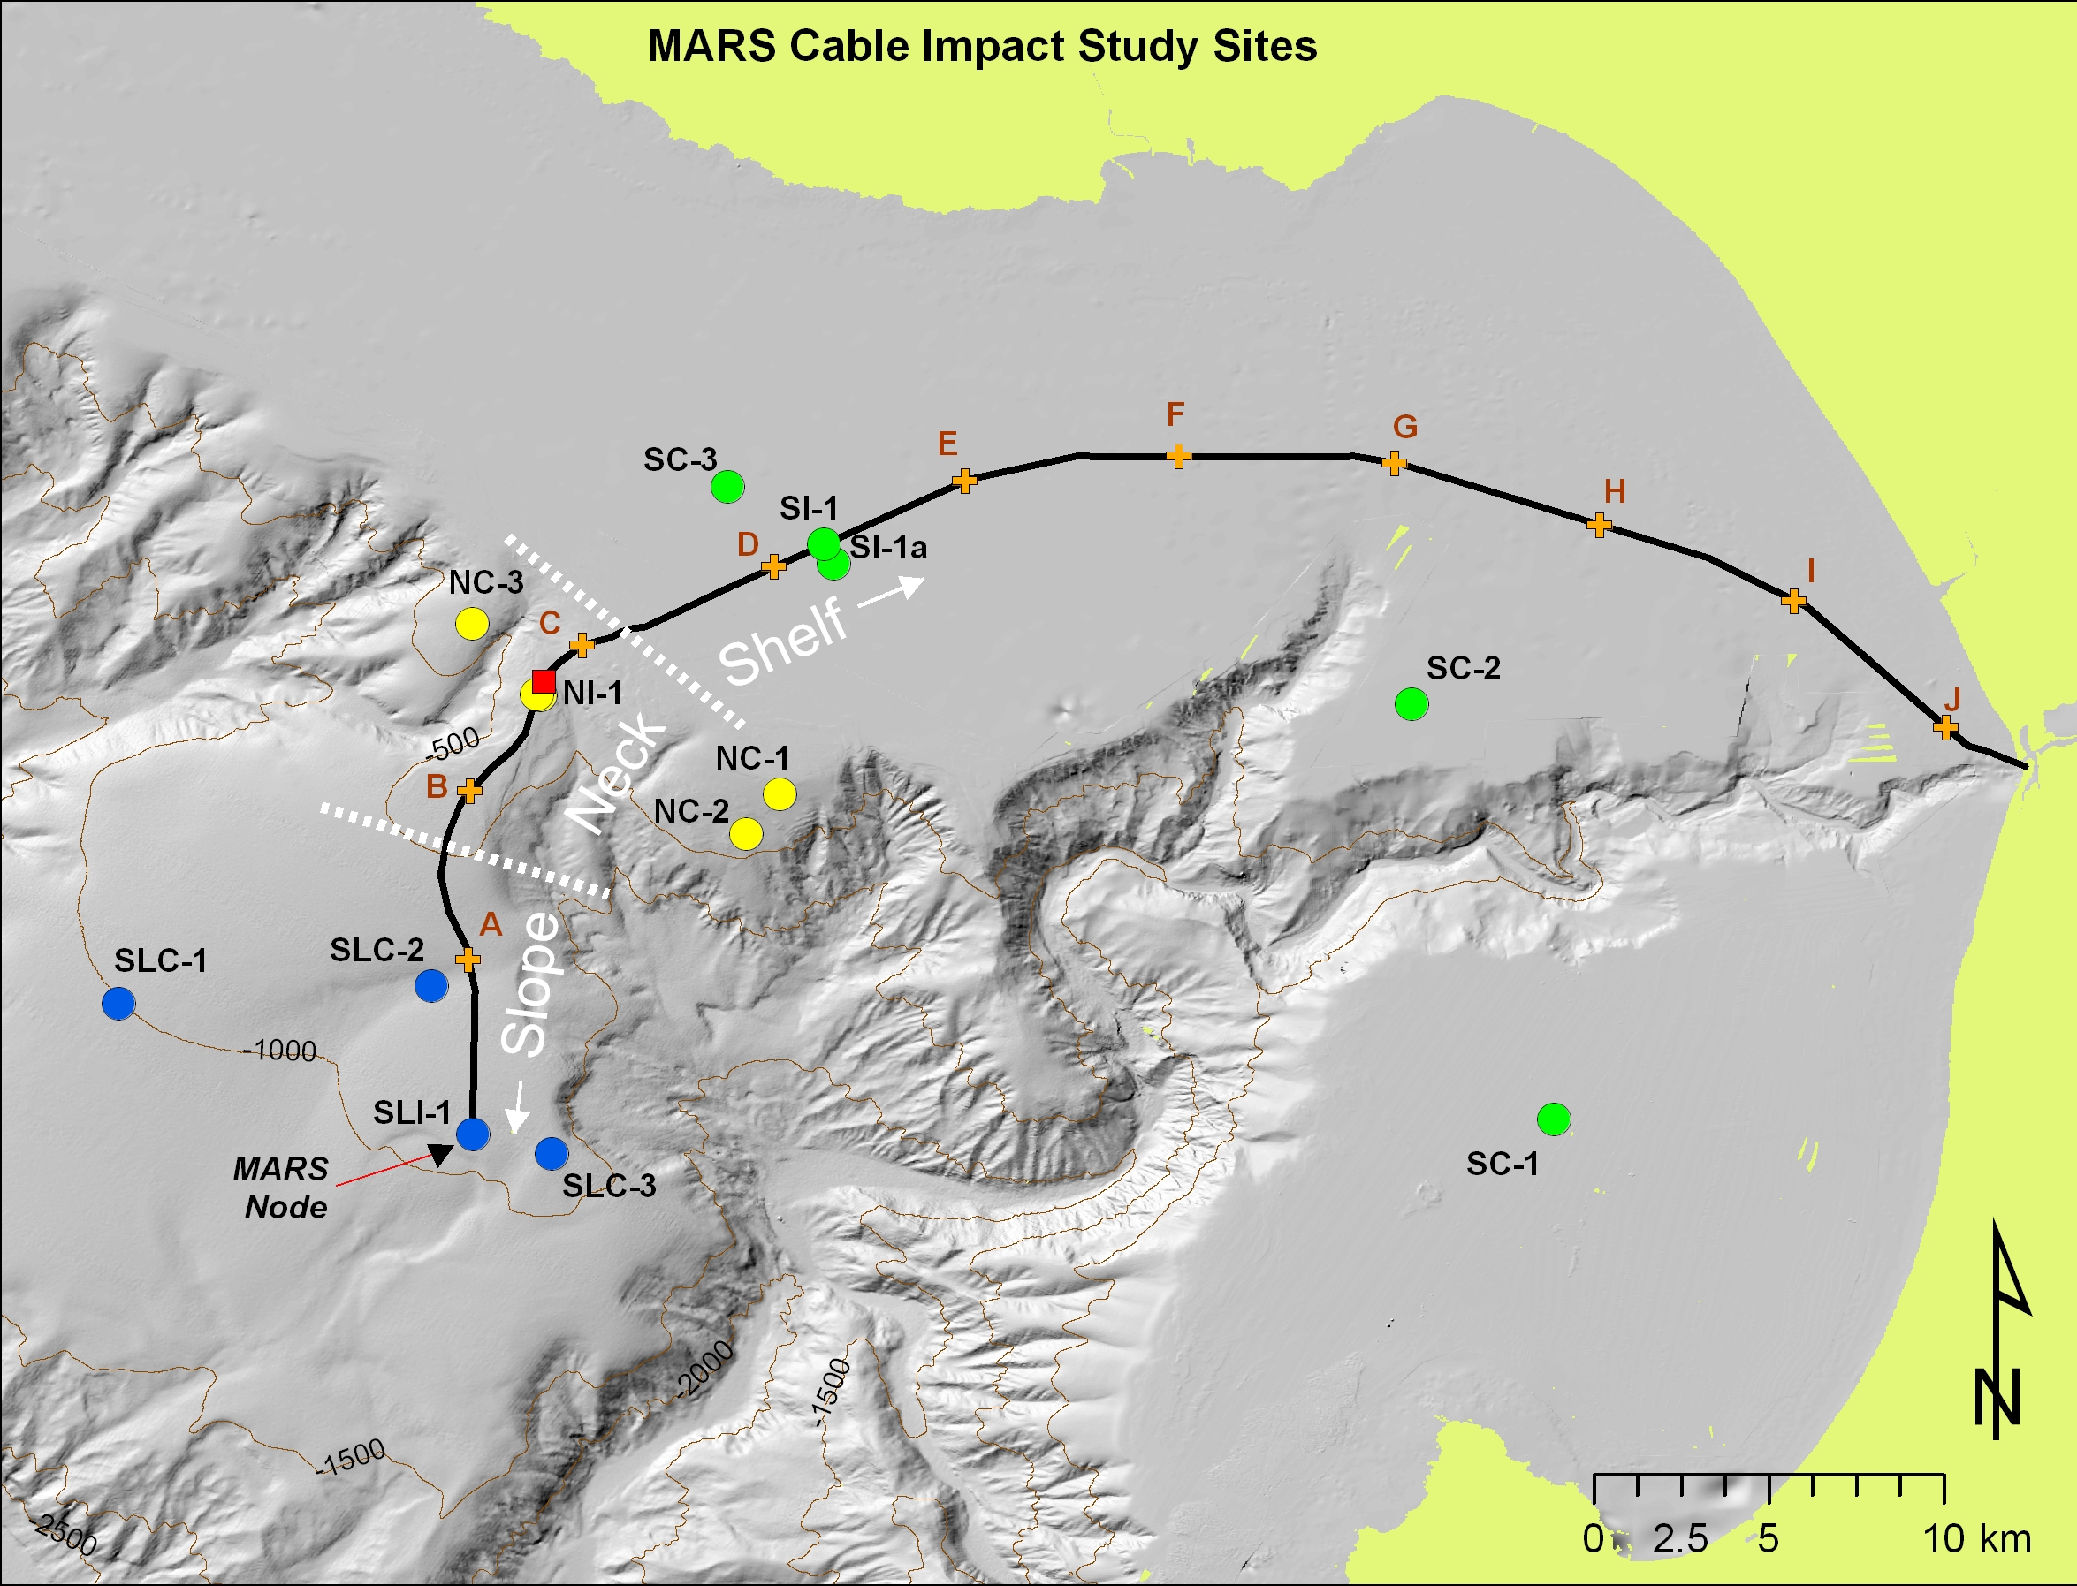
Figure 2. Map of MARS cable (black line) environmental studies sites. Colored circles represent regional sites for impact studies at Shelf (green), Neck (yellow), and Slope (blue) depths. Red box indicates location for Skate transects. Brown plus symbols (A-J) indicate transect locations for localized megafaunal studies.

Regional Effects of Cable Installation
Geological and biological impacts potentially associated with the installation and presence of the MARS cable were investigated at three depths selected within the 3 major habitat types or “cable zones” occupied by the cable (Figure 2). These include; 1) the continental shelf (Shelf), 2) the continental shelf break and upper slope (Neck), and 3) the continental slope region near the MARS benthic node (Slope). These depths represent the principal habitat types along the cable path. Within each cable zone (depth), a single ‘cable’ site was selected over the cable route, and 3 control sites were selected in the region, each ranging from 1-16 km from the cable route.

Figure 3. Sampling protocol for cable and control sites at each depth. Circle – 200 m diameter site. Blue lines – 100 m long video transects. Green circles – sediment core samples for macrofaunal assemblage characterization. Brown circles – sediment cores for tracer measurements.

Each sampling site was considered as a ~200 m diameter circular area within which 3 replicate 100 m long ROV video transects were performed (Figure 3). All animals, as well as rocks, debris, and other items, were identified to the lowest possible taxon, and counted. In addition, replicate sediment cores (7.5 cm diameter) were collected (Figure 4) along video transects to characterize macrofauna (n= 6 cores per site) and sediment characteristics (n=3 per site; %C, %N, stable C and N isotopes, grain size composition).

Skate and Ray Abundance at Neck Cable Zone
Early observations of apparent aggregations of some species of elasmobranches (skates and rays) may aggregate near the cable, particularly near suspended sections of the cable. To test the hypothesis that these species (and perhaps others) are more (or less) abundance near suspended portions of the MARS cable, 3 replicate ROV video transects (100 m long) were performed along suspended or exposed portions of the cable in the Neck cable zone, and compared to 3 similar control transects performed ~100 – 200 m from the cable-transects. Counts of all identifiable megafauna were made along each transect.

Analytical Methods
Detection of differences in geologic and biologic parameters between cable and control sites with data available for both before and after cable installation were made using a BACI (Before-After, Control-Impact) analytical design (Oaten et al. 1986; Underwood et al. 1994; Hewitt et al. 2001). Using this design, individual 2-factor (Period (before, after), Treatment (cable, control)) comparisons were performed using permutation statistics available with PRIMER-6 and PERMANOVA+ (v.1.03; www.primer-e.com). This design was used for both multivariate and univariate data sets of biological or geological parameters. In most cases, raw counts of abundance (# 100 m⁻², megafauna; # m⁻² macrofauna) were transformed (4th root) prior to analysis to increase homogeneity of variances among groups and to reduce the influence of very abundant species. Similarity matrices for Permanova analyses were calculated using Bray-Curtis overlap for multivariate tests and Euclidean Distance for univariate tests. Monte Carlo P-values (Anderson and Robinson 2003) were used to assess statistical significance.
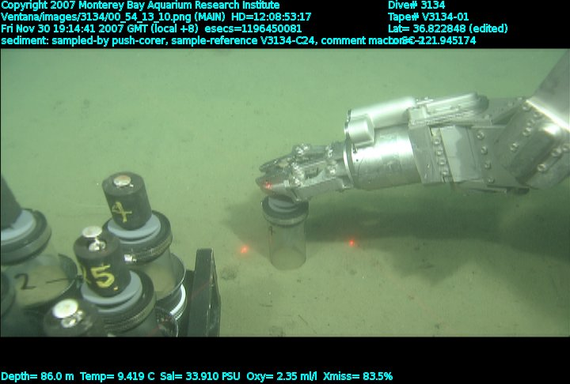
Figure 4. Collection of sediment core.
Univariate tests were run for sediment characteristics (mean grain size and % organic carbon), with no transformation of raw data and Euclidean Distance as an overlap measure.
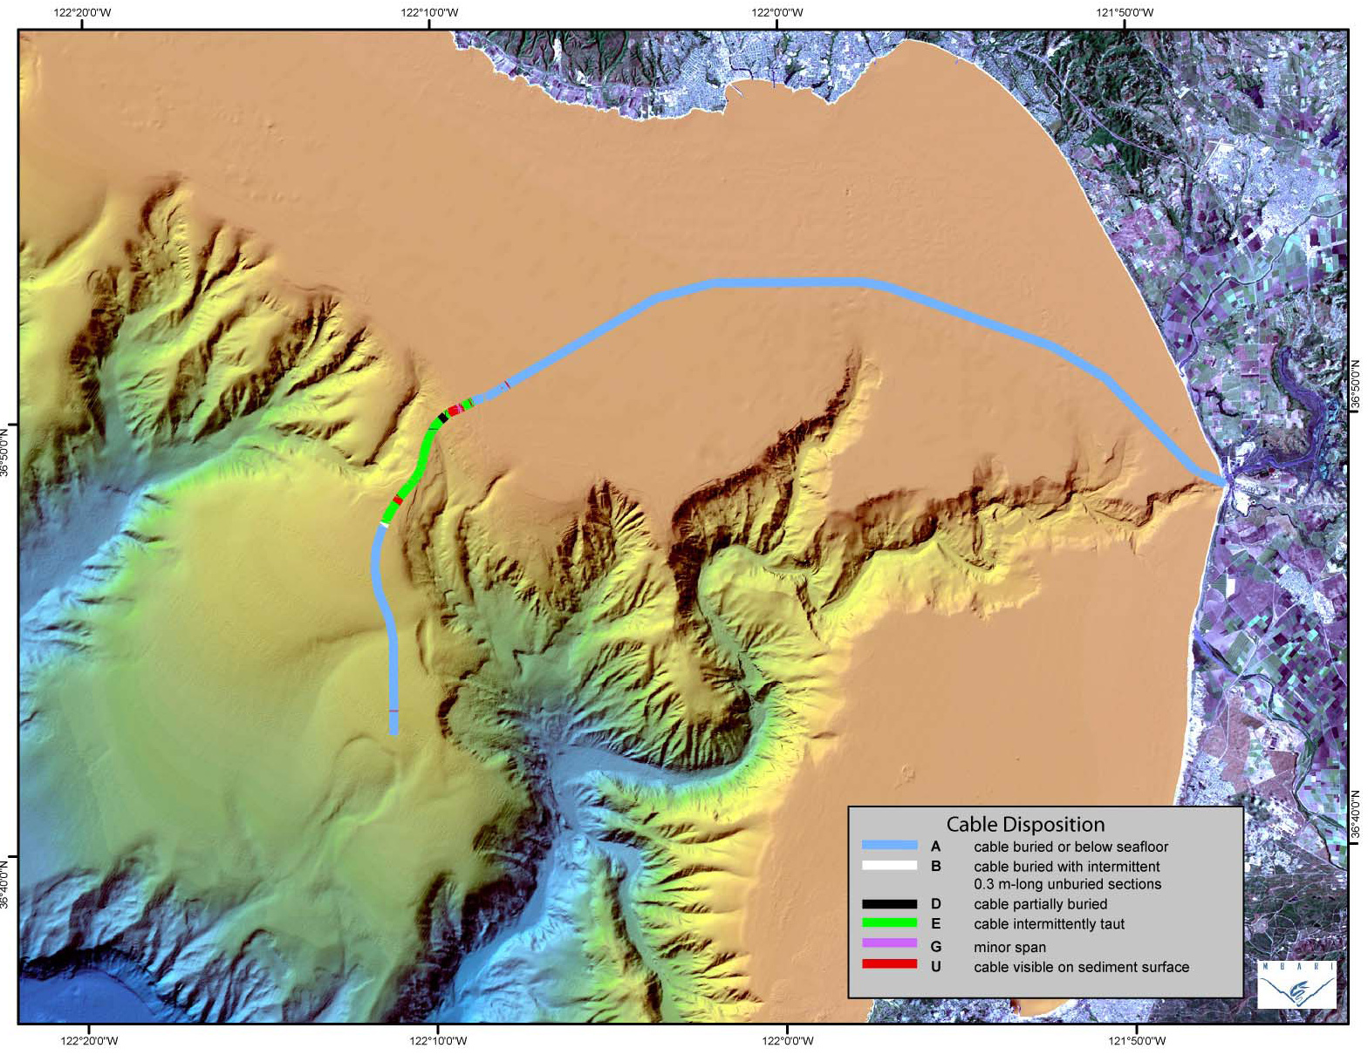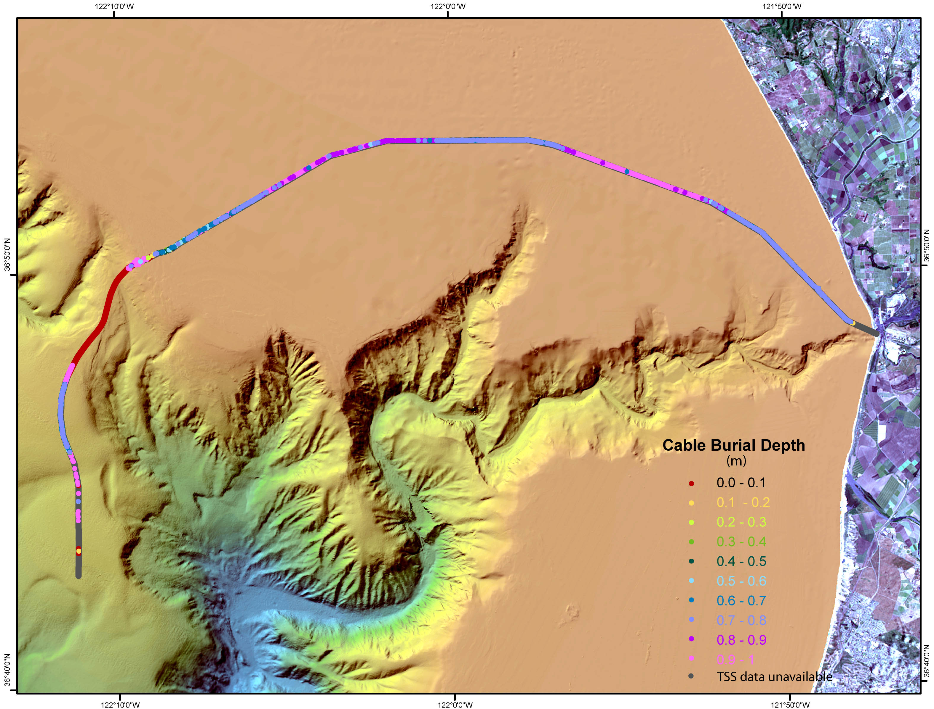Figure 5. Exposure and depth of burial of the MARS cable after installation. Upper map – buried versus exposed condition of cable. Note exposure in Neck Cable zone. Lower panel – depth of burial of cable. These observations were made during the 2007 survey.
Faunal assemblage data were analyzed on a level of individual species and major faunal groups (e.g. Classes) for both multivariate and univariate tests. For multivariate tests, all species or all major groups were analyzed together. For univariate tests, only the most abundant species (~>1% of total faunal abundance) or major groups (~>3% of total faunal abundance) were analyzed.
Because of the large number of individual tests run, the likelihood of a type 1 error increases, and α (the likelihood of type 1 error) is often adjusted downward from 0.05 to a lower proportion based on the number of tests performed (Cabin and Mitchell 2000). Unfortunately, decreasing the likelihood of type 1 errors also increases the likelihood of type II errors (accepting a false null hypothesis). Thus, the use of such adjustments is questionable (Perneger 1998; Cabin and Mitchell 2000), and we have not used them in analyses of cable impact data.

RESULTS & DISCUSSION

ROV Dive Series
A total of 16 days of ROV dives using the R/V Pt. Lobos and the ROV Ventana were used to complete the MARS cable environmental studies from November 30, 2007 to April 1, 2008 (Appendix 1). Three additional sea days were cancelled or postponed due to weather. Observations, including ROV surveys & transects, and sediment collections (tube cores) were completed during these cruises. In addition to surveying the entire length (~57 km) of the cable route, the field and analysis team completed 62 quantitative video transects, and collected & analyzed 114 sediment cores (72 for macrofaunal analyses, 36 for sediment characteristics, 6 spare cores).

Condition of Cable
Inspection of the cable and underlying seabed indicated that there was little change in the position of the cable 18 months after installation. Survey observations verified that the cable is still buried from 0-1 m beneath the surface of the seabed, as measured during the first post-installation survey (March-June 2007) (Figure 5). No evidence of trawling impact was observed. Nor was any change apparent along the exposed or suspended portions of the cable (Figure 6), which during the post-installation survey were largely confined to the Neck depths (Figure 4). There is no new evidence of strumming or other movement of the cable. The cable remains buried with no trace of habitat disturbance in shallow sandy areas (Figure 6a), which comprise roughly 50 percent of the cable route. In many other areas, habitat disturbance is less evident compared with the previous survey and the burial trench is filling in with time (Figure 6e), as indicated by the accumulation of soft, light-colored sediment in the trench.
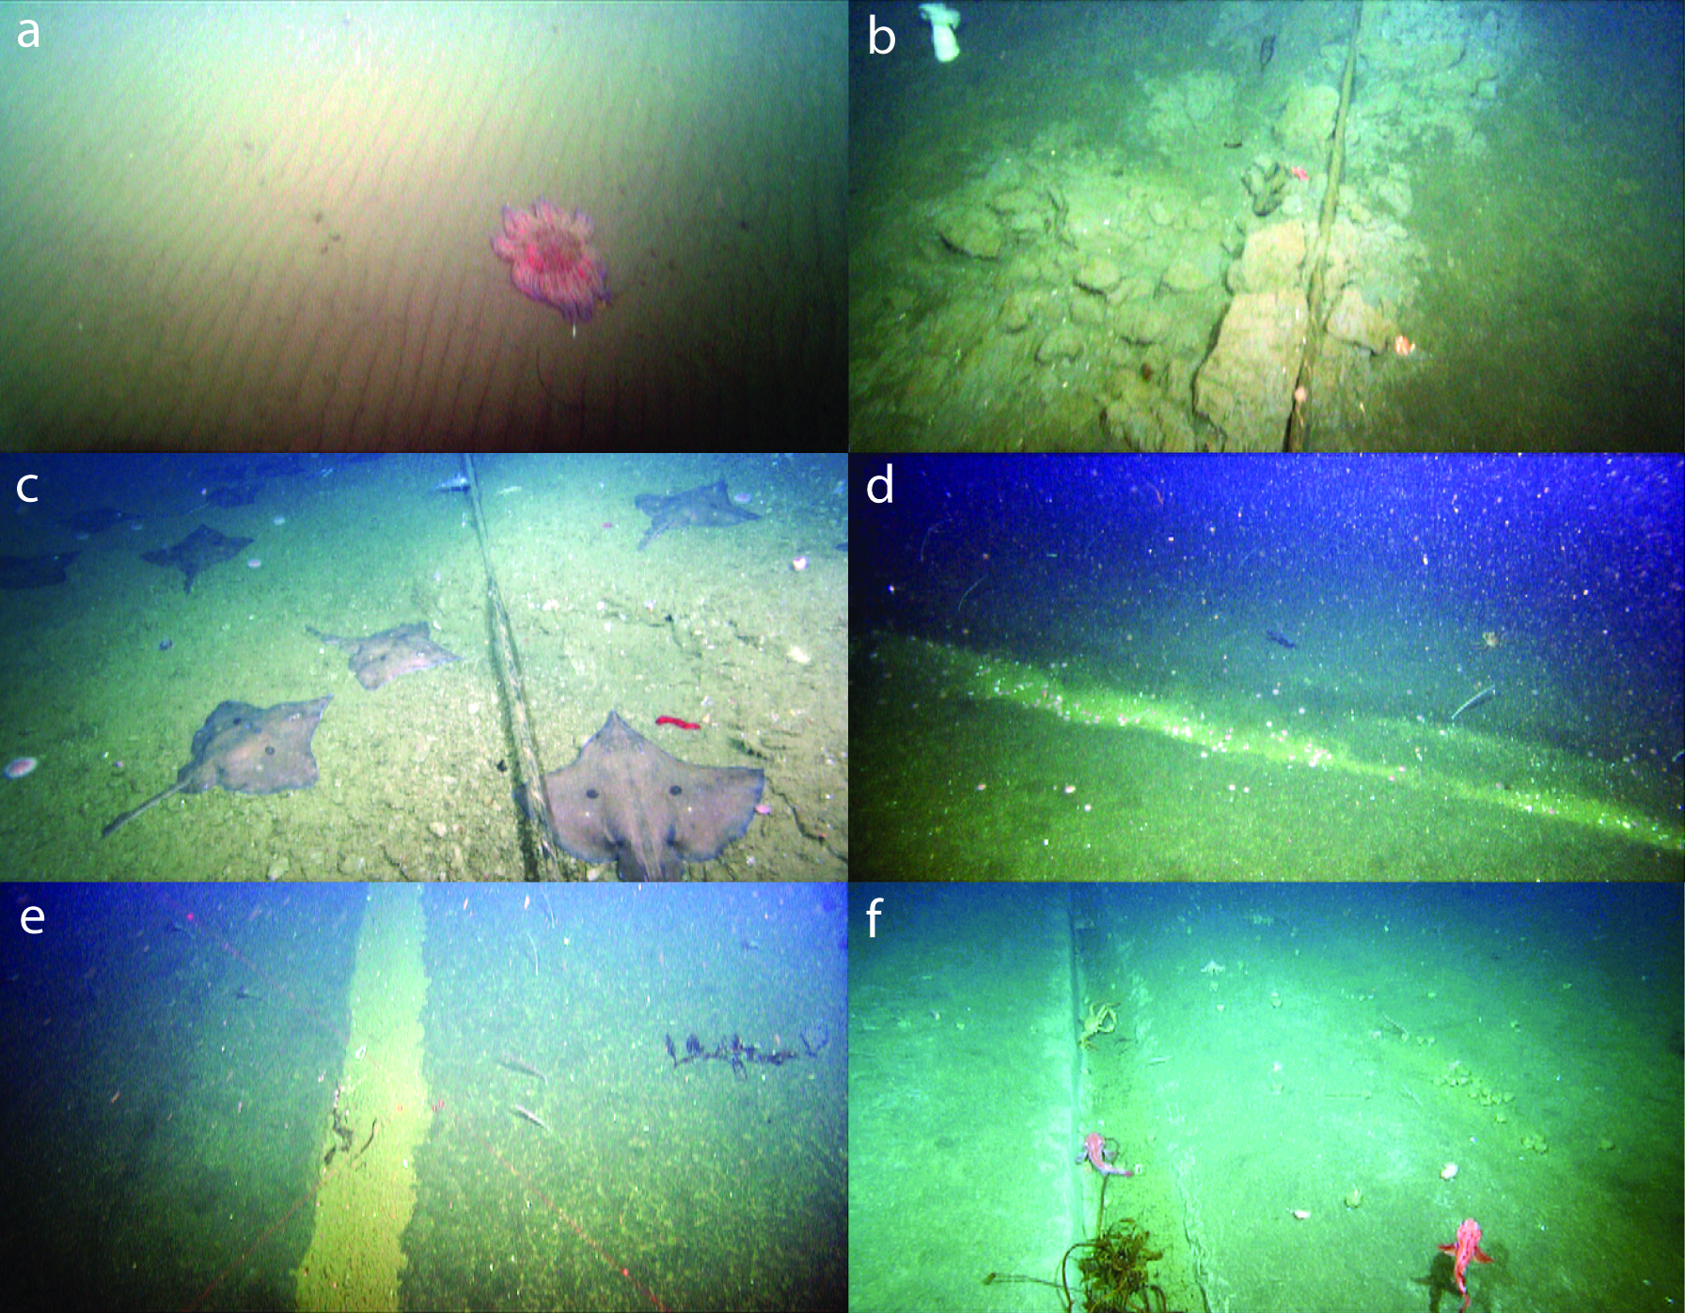
Figure 6. Images of the seabed along the cable route. A. Sand ripples at 31 m depth, cable not visible. B. Cable on seabed at 115 m. C. Skate (Raja rhina) aggregation at 303 m depth. D. Cable trench at 82 m. E. Cable trench sediment infilling at 653 m. F. Cable trench at 826 m.

Sediment Characteristics
The grain size and percentage carbon content of sediments varied significantly between treatments and sites for all 3 cable depth zones. However, because no “Before” data were available, any effects of the cable on sediment grain size could be inferred only from comparisons among impact and control sites after installation of the cable.

Sediment Grain Size
Mean sediment grain size varied among Cable Depth Zones from 20 to 143 µm, with the coarsest sediments at Neck stations (mean = 82.4 µm) and similar sized, but finer mean sizes (44, 49 µm) at Shelf and Slope depths.
Figure 7. Mean sediment grain size (+/- SD) at control and cable stations for 3 cable depth zones. Note the high variation between treatments and stations for each depth. Black bars at bottom of graph indicate significant variation between groups for each depth (overlapping bars are not significantly different in grain size).
Grain size at the shelf control sites were significantly smaller than at the impact site (p<0.001) (Figure 7), which might be expected in association with the installation of the cable. But because grain size also varied significantly between sites, irrespective of treatment (e.g. SC-1 < SC-2, SC-3; p<0.05), it is possible that the difference among stations is due to natural variability rather than any effects of the cable.
This pattern of significant variation between treatments and among control sites was also observed at Neck and Slope depths (Figure 7). Within the Neck cable depth zone, Control sites differed significantly from Cable sites overall (p<0.05), but variation among control sites was also significant (p<0.01). In contrast to Shelf depths, grain size at the Neck cable zone was much finer at the Cable site than the Control sites. It remains difficult to determine definitively the effects of the cable on grain size.
Intersite variation in grain size observed at shallower depth also occurred at the Slope depth sites. Together, these results suggest strongly that variation in mean sediment grain size varies greatly among stations both within and between depths. Although significant variation in grain size was detected between control and cable stations, it is not possible to determine if this difference is due to the effects of the cable or simply to naturally high station to station variation.

Sediment Percent Carbon Content
The mean organic carbon content of sediments ranged among sites from 0.39 to 1.11 percent (Figure 8), with the more organic-rich sediments generally found in the finer grain sizes (R² = 0.28, p<0.06). Analysis of the percentage carbon content of sediments at control and cable sites for each cable depth zone indicated marginally significant variation in carbon content between cable and control stations at the Neck depth (p<0.05), but no significant variation between treatments at the Shelf (p>0.6) and Slope (p>0.3) depths. Variation among stations within each depth was often significant. These results indicate that there was little variation in the carbon content of sediments related to the installation of the cable.
Figure 8. Mean percent organic carbon in surficial sediments for control and cable sites at three Cable Depth Zones. Comparisons of Cable versus Control sites within each depth were nonsignificant (Shelf, p>0.6, Slope (p>0.3) and marginally significant at the Neck depth (p<0.05).

Biological Characteristics
Megafaunal Assemblage
The seabed megafaunal assemblage along the cable route included 116 species (or unidentified species) observed in 94 ROV video transects (Appendix 2). The overall average density of megafauna averaged 148 individuals / 100 m²). By phyla or major taxonomic groups, Echinoderms were the most abundance phylum comprising just over 37 percent of the total megafaunal abundance, particularly sea stars (Asteroidea), urchins (Echinoidea), and sea cucumbers (Holothuroidea) (Table 1). Cnidarians ranked second among phyla with 31 percent of the total abundance, represented mainly by sea pens (Pennatulacea) and anemones (Actinaria). Fishes (Chordata) were the third most abundance phylum with nearly 10 percent of the total abundance.
The top 7 ranking megafaunal species accounted for nearly 60 percent of the total abundance. Three common taxa (Figure 9a-c.) comprised 32 percent of the total megafauna. Funiculina sp., a common sea pen at slope depths near 500 – 1000 m was the most abundant species (17.3 ind. 100 m⁻²), with 11.6 percent of the total megafaunal abundance. The common sea star Rathbunaster californicus ranked second with 11.4 percent of the total. Allocentrotus, fragilis, a common urchin at upper slope depths, ranked third, with 9 percent.

Table 1. Summary of megafaunal abundance by phyla and major groups. Abundance is listed as a mean (# 100 m⁻²), standard deviation (SD), and percent of total abundance (%).

Phylum / Major Group Mean SD %
Echinodermata 55.90 110.95 37.65 Asteroidea 23.28 50.41 15.68
Echinoidea 13.42 40.40 9.04
Holothuroidea 11.82 54.50 7.96
Ophiuroidea 7.27 33.82 4.90
Crinoidea 0.10 0.43 0.07

Cnidaria 47.13 67.11 31.74
Pennatulacea 33.37 56.36 22.47
Actiniaria 11.25 19.76 7.58
Ceriantharia 1.97 2.89 1.33
Gorgonacea 0.23 1.27 0.16
Corallimorphidae 0.17 0.86 0.11
Alcyonacea 0.07 0.36 0.05
Anthozoa 0.03 0.18 0.02
Hydromedusae 0.02 0.15 0.01
Cnidaria (unid.) 0.01 0.10 0.01

Vertebrata 14.05 15.40 9.46
Myxinidae 0.17 0.56 0.11
Rajiformes 1.58 10.76 1.07
Chimaeridae 0.18 0.91 0.12
Scyliorhinidae 0.11 0.48 0.07
Scorpaenidae 5.31 12.23 3.58
Pleuronectiformes 3.44 4.50 2.32
Zoarcidae 1.36 3.09 0.91
Osteichthyes 0.76 3.18 0.51
Agonidae 0.30 0.80 0.20
Merlucciidae 0.25 1.47 0.17
Macrouridae 0.13 0.78 0.09
Stichaeidae 0.11 0.50 0.07
Liparidae 0.08 0.48 0.05
Zaniolepididae 0.07 0.39 0.05
Moridae 0.06 0.32 0.04
Ophidiidae 0.04 0.26 0.03
Anoplopomatidae 0.04 0.25 0.03
Hexagrammidae 0.01 0.12 0.01
Osmeridae 0.01 0.11 0.01
Alepocephalidae 0.01 0.10 0.01
Embiotocidae 0.01 0.10 0.01
Torpedinidae 0.01 0.10 0.01

Phylum / Major Group Mean SD %
Detritus 13.04 18.44 8.78
Phyllospadix 12.63 18.12 8.51
Laminariales 0.41 0.89 0.28

Annelida (Polychaeta) 7.56 38.78 5.09

Mollusca 6.90 14.45 4.65
Gastropoda 6.72 14.51 4.53
Cephalopoda 0.19 0.68 0.12

Arthropoda 2.02 5.73 1.36
Decapoda 1.11 2.55 0.75
Caridea 0.68 4.17 0.46
Anomura 0.23 1.05 0.15

Porifera 1.75 5.54 1.18

Brachipoda 0.06 0.62 0.04

Echiura 0.03 0.18 0.02

Urochordata 0.02 0.14 0.01

Grand Total 148.47

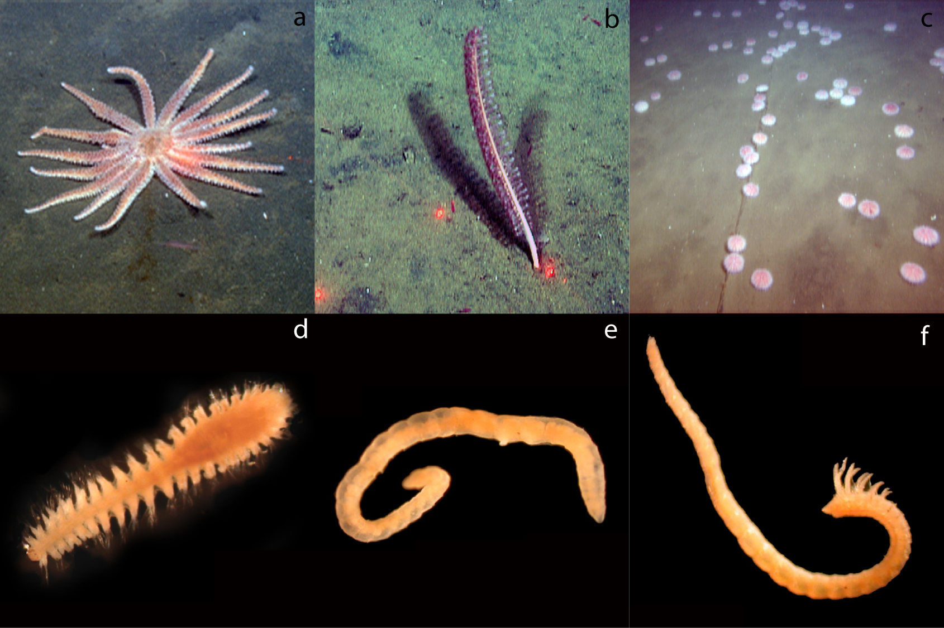Figure 9. Common megafaunal and macrofaunal animals along the MARS Cable route. A-C: Megafauna: A. Rathbunaster californicus (sea star). B. Funiculina sp. (sea pen). C. Allocentrotus fragilis, (urchin). D-F: Macrofauna: D. Cossura sp. (polychaete E. Oligochaeta. F. Prionospio sp. These taxa are some of the most abundant organisms observed in video (megafauna) or collected in sediment cores (macrofauna).

Macrofaunal Assemblage
The macrofaunal assemblage along the MARS cable route was diverse (280 taxa identified), but was dominated greatly by annelid worms (53 % of total macrofaunal abundance), especially polychaetes (Table 2). Arthropoda, mainly amphipods were second in abundance with 35 % of total abundance). Molluscs (mostly bivalves) comprised nearly 8 percent of the total. Other groups were minor elements of the fauna.
On a species level, several polychaete annelids were abundant. Polychaetes included Mediomastus sp. (9.5% of total macrofaunal abundance), Nepthys sp. (3.8 %), Prionospio sp. (3.3 %) and Cossura sp. (2.2 %), as well as several unidentified species (9.4 %) (Figure 9d-f). Oligochaeta were not identified to species, but together comprised 4% of the total macrofaunal assemblage.

Local Effects of Cable Installation
Little variation in the megafaunal assemblage was detected between video transects directly over the cable route and parallel transects 50 m from the cable (Figure 10). Multivariate tests comparing cable and control treatments for all species or all groups were non-significant (p>0.95). Likewise, univariate tests evaluating the abundance of faunal groups or individual species indicated no significant variation in the megafaunal assemblage from directly over the cable to 50 m away. Thus, local variation in the megafaunal assemblage very near the cable was largely undetectable.
Table 2. Mean density of macrofaunal taxa, by major groups over all samples. Density is listed as number per core (45.4 cm²). % indicates the percentage of the taxon of the total macrofaunal abundance.

Phylum | Major Group | Mean (#/core) | SE | %
Annelida |  | 24.893 | 1.994 | 52.597
 | Polychaeta | 22.884 | 1.844 | 48.352
 | Oligochaeta | 2.009 | 0.427 | 4.245
Arthropoda |  | 16.397 | 1.790 | 34.644
 | Amphipoda | 10.611 | 1.413 | 22.420
 | Tanaidacea | 1.934 | 0.438 | 4.086
 | Isopoda | 1.364 | 0.208 | 2.882
 | Ostracoda | 1.291 | 0.239 | 2.727
 | Cumacea | 1.098 | 0.158 | 2.320
 | Mysida | 0.095 | 0.037 | 0.200
 | Decapoda | 0.004 | 0.003 | 0.008
 | Pycnogonida | 0.001 | 0.001 | 0.002
Mollusca |  | 3.766 | 0.369 | 7.958
 | Bivalvia | 2.803 | 0.280 | 5.923
 | Scaphopoda | 0.536 | 0.095 | 1.133
 | Gastropoda | 0.273 | 0.063 | 0.577
 | Aplacophora | 0.138 | 0.046 | 0.291
 | Polyplacophora | 0.016 | 0.010 | 0.033
Nemertea |  | 1.150 | 0.189 | 2.430
Echinodermata |  | 0.942 | 0.122 | 1.991
 | Ophiuroidea | 0.909 | 0.121 | 1.921
 | Echinoidea | 0.021 | 0.012 | 0.045
 | Holothuroidea | 0.012 | 0.009 | 0.025
Cnidaria |  | 0.109 | 0.036 | 0.231
 | Actiniaria | 0.109 | 0.036 | 0.231
Sipuncula |  | 0.027 | 0.014 | 0.058
Echiura |  | 0.017 | 0.012 | 0.036
Enteropneusta |  | 0.017 | 0.012 | 0.036
Platyhelminthes |  | 0.009 | 0.009 | 0.018
Total |  | 47.329

One important exception to this pattern was observed near 300 m depth in the Neck Zone, where the cable is occasionally suspended between rocks for short distances. At these locations, the density of longnose skates (Raja rhina) was anomalously high (Figure 6c). The density or R. rhina was 42 per 100 m² over the cable, but only 0.3 per 100 m² at nearby control areas (p<0.027), representing an increase by a factor of 126. A number of marine fishes, especially elasmobranchs are known to sense electromagnetic fields using electroreceptors as a method of prey detection (Bullock 1982). The suspended MARS cable very likely produced a weak electromagnetic field as local ocean currents flow through the Earth’s magnetic field and around the cable (Sanford, 1971). This is possible even though the cable was not energized during the 2008 video survey. This electric field is apparently detectable by R. rhina, which aggregated near the cable. Electric fields from seabed cables including telecommunications cables and power distribution cables (e.g. coastal windfarms) are expected to have ecological effects due to their effects on the behavior of various species capable of electroreception (Gill 2005). It is likely that the response of longnose skates and perhaps other species may respond to the MARS cable after it is energized and operational.

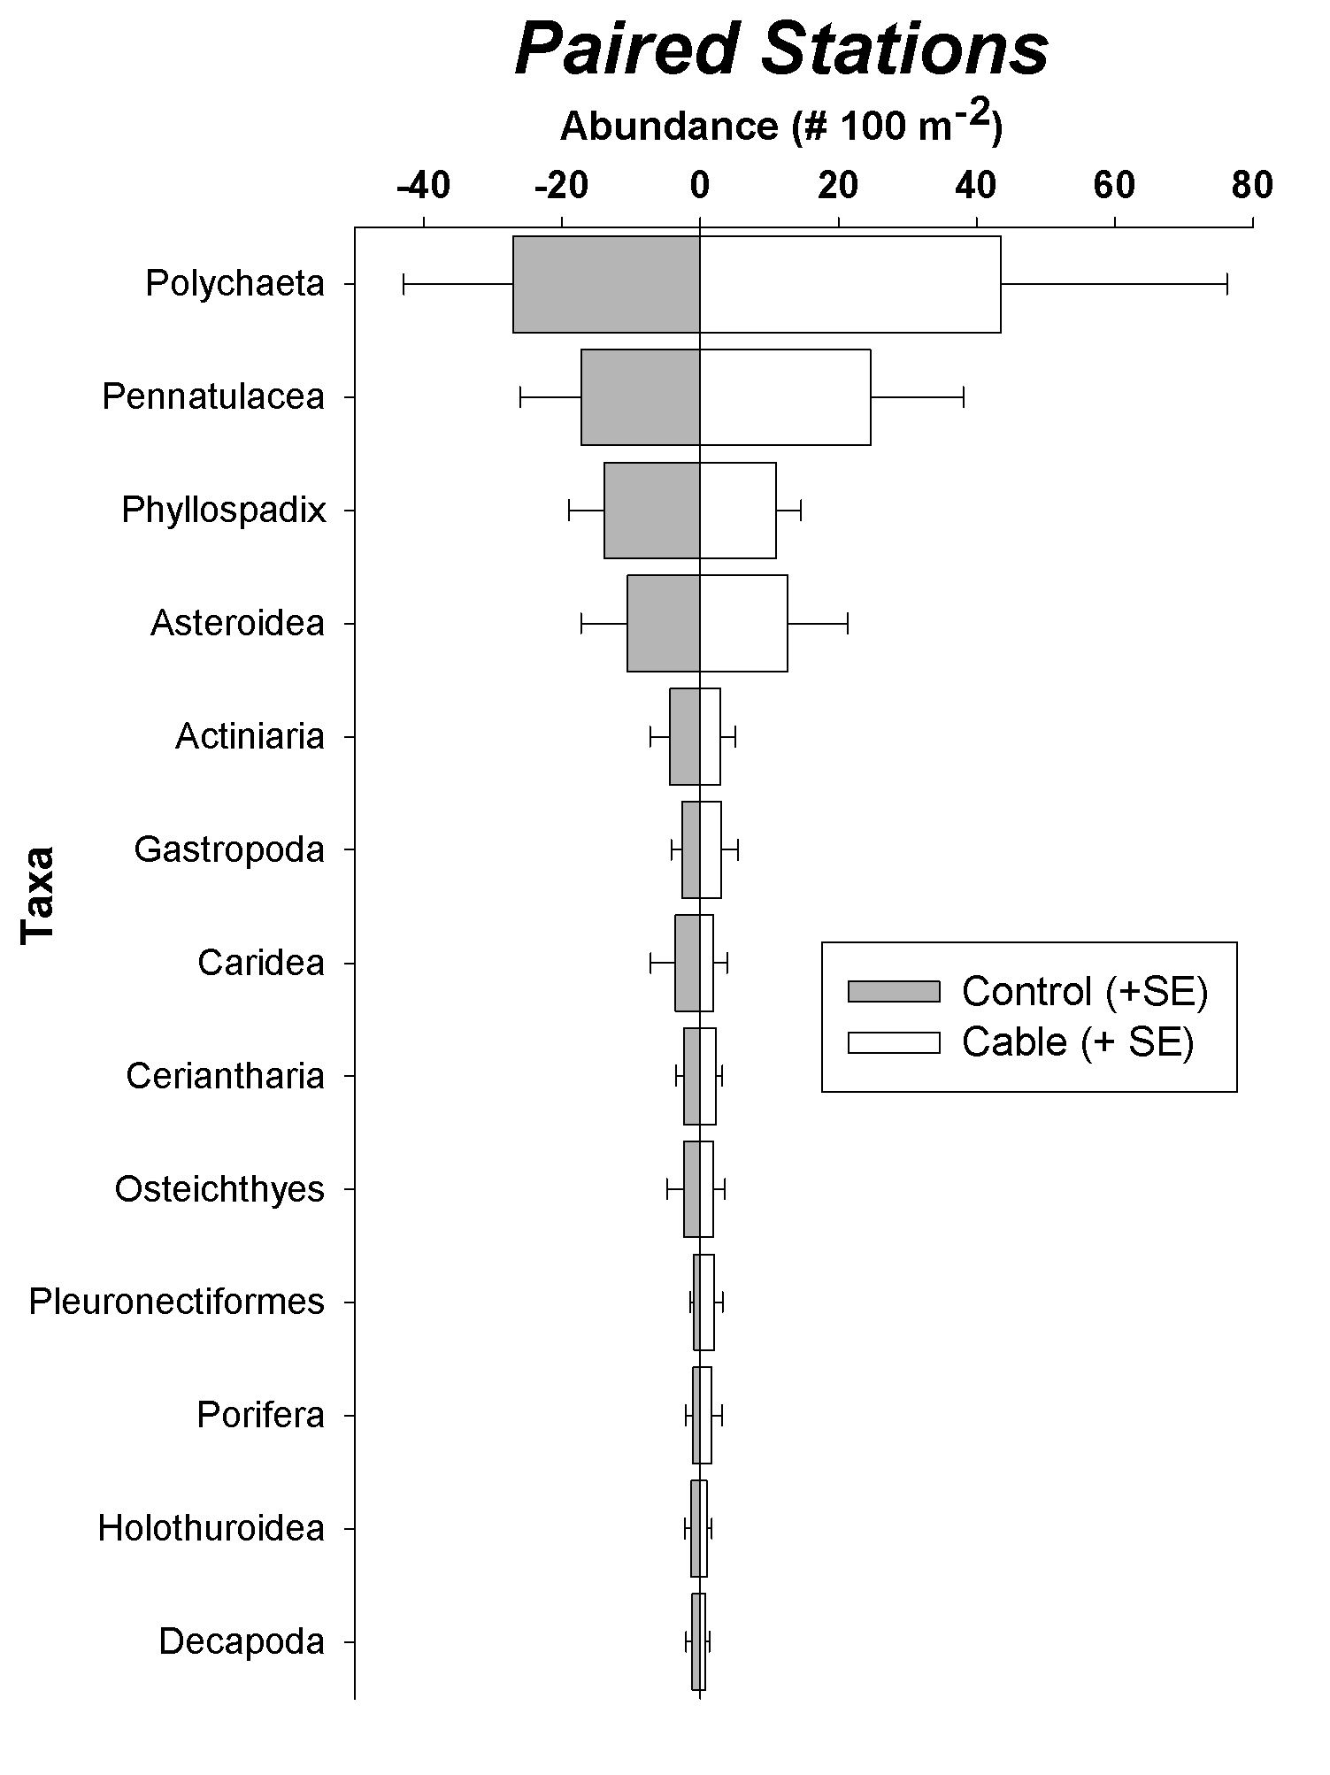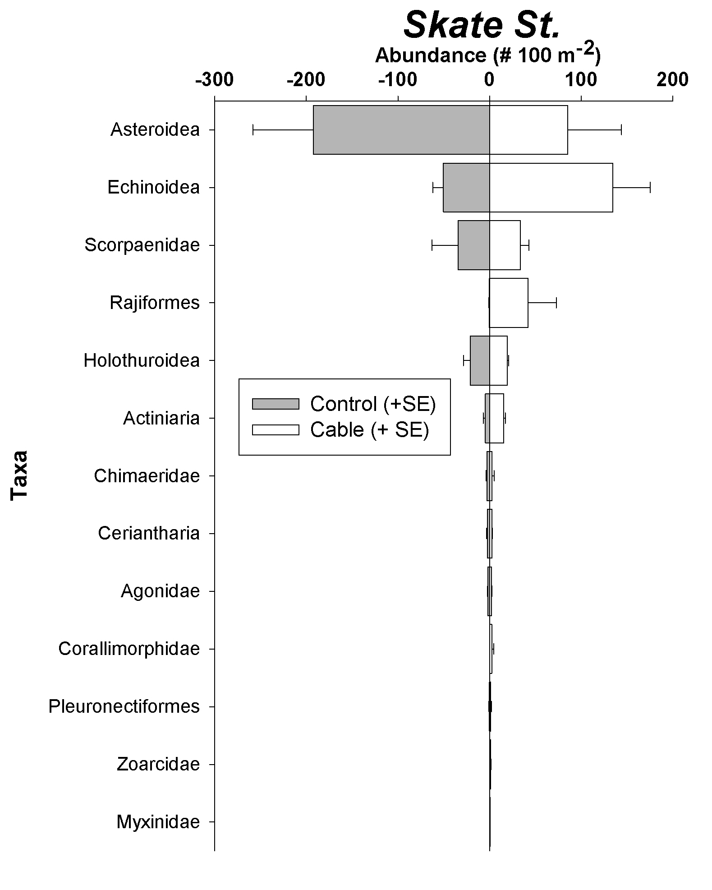
Figure 10. Variation in abundance of megafaunal groups along the cable route. Paired stations (left chart) show little variation in mean densities of megafauna over 10 stations along the cable. Right chart – variation in megafaunal groups at 3 stations at Neck depths (~500 m) where the cable is suspended slightly above the bottom. Note the higher abundance of Rajiformes (Skates) over the cable compared to 50 m away. Cable = directly over the cable route. Control = 50 m from the cable.

Regional Cable Impacts- Megafauna
The installation and presence of the MARS cable appears to have very mild to benign effects on the structure of the macrofaunal and megafaunal assemblages on the scale of kilometers, based on the results of megafaunal and macrofaunal samples at cable and control sites before and after cable installation. Using both multivariate and univariate analyses, few statistically significant differences in the densities of megafauna or macrofauna were detected in relation to the installation of the cable.
For these BACI analyses, a significant effect of the installation of the cable would be detected by finding a statistically significant Period x Treatment (PxT) interaction term for the abundance of a particular taxon (for univariate or multivariate tests). This result would indicate that any change in the abundance of the taxon changed between periods (i.e. Before and After cable installation) at the Cable stations was different than changes in abundance at Control stations.
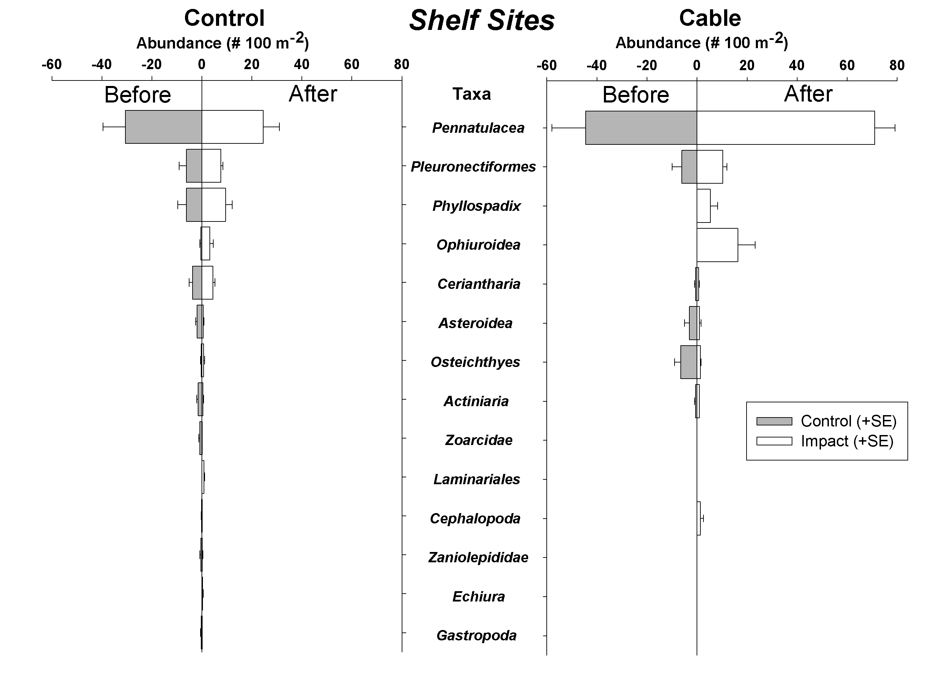Figure 11. Variation in dominant megafaunal groups at the Shelf depth station.
At Shelf, Neck, and Slope depths, multivariate comparisons (i.e. comparisons between the entire megafaunal assemblage) indicated no significant Period x Treatment interaction terms (p>0.13, 0.23, 0.58, for Shelf, Neck, and Slope, respectively), indicating that there was little change in the overall megafaunal community that is attributable to the installation of the cable. These tests also indicated that there was significant variation in megafaunal abundance for the main factors of Periods or Treatments, or both. Overall, these results indicate that most of the variation in the abundance and distribution of megafauna is due to natural variability between stations or periods – in other words, natural variation in megafaunal abundance among Control stations was equal or greater than that measured between Control and Cable stations. These results were found for multivariate tests using either species-level data or higher taxon-level data.
There were few changes in the abundances of individual species or higher taxa in relation to the installation of the MARS cable, based on univariate tests to examine cable impacts. Even

Table 3. Summary of univariate BACI analysis for megafaunal taxa for all cable depths. P=Period, T= Treatment, PxT = Period x Treatment interaction term. A significant PxT term suggests an effect of cable installation. Comments explain patterns of results or propose possible factors influencing differences detected among treatments.

Taxon P T PxT P T PxT P T PxT Comment
Higher Taxa
Multivariate Tests
All Groups ** ** ns ns ** ns ** ** ns

Univariate Tests
Actinaria (anemones) - - - - - - * ns ns > after cable inst.
Ceriantharia (tube anemones) ns * ns - - - - - - Sig. Station variability
Pennatulacea (sea pens) ns ns ns - - - ns ** ns Sig. Station variability
Phyllospadix (surf grass detritus) ** ns ns ns ** ns ** ns * Sig. Sta., Period var.
Asteroidea (sea stars) - - - ns ** ns - - - Sig. Station variability
Echinoidea (sea urchins) - - - ns * ns - - - Cable > Control
Holothuroidea (sea cucumbers) - - - ns ns ns - - -
Ophiuroidea (brittle stars) ** ns ns - - - ns ns ns > after cable inst.
Gastropoda (snails) - - - - - - ** ns ** Natural variation?
Pleuronectiformes (flatfishes) ns ns ns - - - - - -

Species
Multivariate Tests
All Species * ** ns ns ** ns * * ns

Univariate Tests
Funiculina sp. (sea pen) - - - - - - ns ** ns Sig. Station variation
Rathbunaster californicus (sea star) ns ns ns ns ** ns - - - Cable > Control
Allocentrotus fragilis (urchin) - - - ns * ns ns ns ns Cable > Control
Psolus squamatus (sea cucumber) - - - ns ns ns - - -
Mesomyaria sp. (anemone) - - - - - - * ns ns All Treat. increased
Umbellula lindahli (sea pen) - - - - - - ns ** ns Cable > Control
Sebastolobus sp. (fish) - - - ns ns ns ns ns ns
Pannychia moseleyi (sea cucumber) - - - - - - ** ** ** Natural variability?
Metridium farcimen (anemone) ns ns ns - - - - - -

though there was frequently significant variation in the abundance of species or higher taxa between Periods or Treatments (Table 3), very few significant PxT interaction terms were found, indicating little effect of the MARS cable. Univariate tests were conducted for most major taxa shown in Figure 11-13. Among these, the PxT interaction term was significant for only a few taxa. For example, Phyllospadix sp. (surf grass) is detritus that was not observed at the Slope Cable site during the pre-installation survey, but occurred there during the 2008 survey. It may have accumulated in the cable trench after cable installation, as observed for other objects and detritus (Figure 6). Marine snails (Gastropoda) also may have been affected by the cable, as indicated by the significant PxT interaction (Table 3). Snails were low in abundance at the Slope Cable station prior to cable installation (0.3 per 100 m²), but increased by 2008 to a mean of 45 individuals per 100 m². During both periods, snail densities at the Control stations averaged ~17 per 100 m². While this may represent natural variability, it is possible that snails (e.g. Neptunea sp.) aggregated near the Cable station and in the cable trench in association with increased abundance of detritus and other material. The PxT interaction term was also highly significant at the Slope Depth for the deep-sea cucumber, Pannychia moseleyi. It was initially abundant at the Slope Cable station (40 / 100 m²), but sparse at Slope Control stations (mean = 0.3 / 100 m²). During the 2008 survey, this
sea cucumber was not observed at any Slope Depth stations. Because P. moseleyi appears to vary considerably between stations and periods, the observed changes in abundance may be due simply to natural variability rather than specific cable effects.
Although few effects of cable installation were detectable, significant main effects (Treatment or Period) were detected for many taxa and Cable Depth zones (Table 3). Closer examination of these frequently indicated that significant Treatment effects were related to statistically significant variation among Control stations as well as differences between Control and Impact stations. Thus, natural variability in megafaunal abundance and distribution appears to be as large as differences in abundance related to the cable.
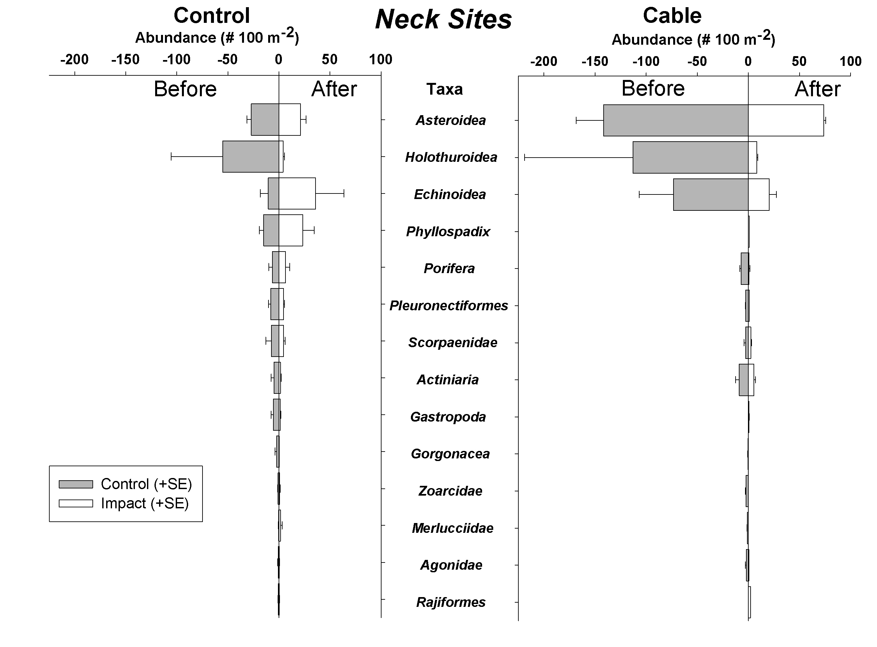Figure 12. Variation in megafaunal assemblage among periods and treatments at the Neck Depth Zone.

Figure 10.Variation in the megafaunal assemblage at the Neck Depth Zone.
Cable Impacts on Macrofaunal Organisms
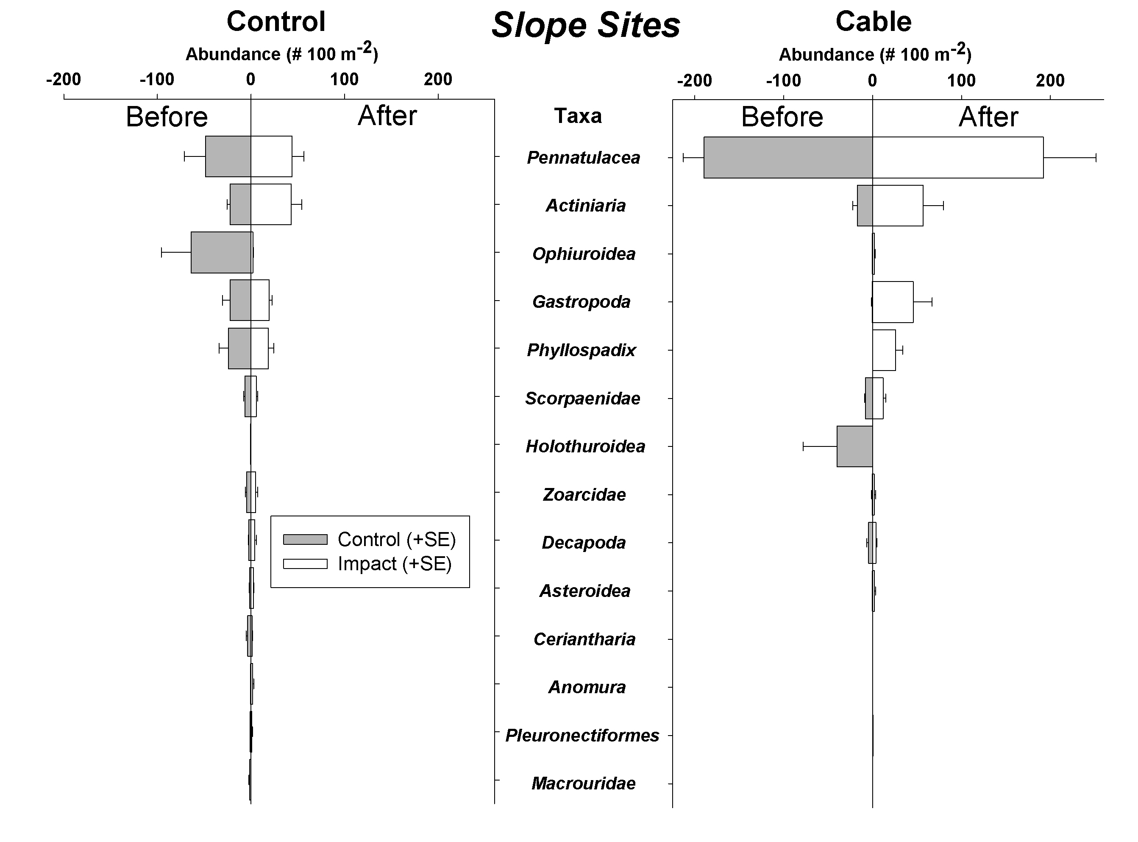
Figure 13. Variation in megafaunal abundance among Treatments and Periods at Slope Depths
Macrofaunal assemblages along the cable route appear to be largely unaffected by the installation of the cable, as found for the megafaunal assemblage (Table 4). Multivariate tests indicated that there was no detectable cable effect at the Neck or Slope depths (i.e. PxT = ns), even though there were significant main effects (Period, Treatment) found at one or both depths. At the Shelf depth, however, a significant PxT interaction term was detected for both the higher taxa and species tests (Table 4). Owing to the overwhelming dominance of polychaete worms in the macrofauna, and the Shelf Depth in particular, this group has a large influence on the multivariate test. The abundance of polychaetes, and thus the macrofauna in general, increased at after cable installation, but increased far more at the Shelf Cable station than at Control stations (Figure 14). Simultaneously, the abundance of most macrofaunal taxa at Control stations decreased. While it is possible that cable installation affected conditions (e.g. increased detritus) that lead to an increase in polychaetes and other infauna, it is also possible that other factors drove these changes.
Univariate tests of individual higher taxa or species were very similar to the results from examination of megafaunal patterns, with few detectable impacts of cable installation at any depth (Table 4). As observed for multivariate tests (see above), polychaete worms had a significant PxT term, and were more abundant following cable installation at the Shelf Depth cable site for unknown reasons. Statistically significant PxT terms were also observed at the Neck Cable depth for two amphipod crustacean species, Photis typhlops and Hardematopa nasuta. Unlike polychaete

Table 4. Summary of Univariate BACI analysis for macrofaunal taxa. P=Period, T= Treatment, PxT = Period x Treatment interaction term. A significant PxT term suggests an effect of cable installation. Comments explain patterns of results or propose possible factors influencing differences detected among treatments. C= Control Stations, I = Cable Stations.

Taxon P T PxT P T PxT P T PxT Comment
Higher Taxa
Multivariate Tests
All Groups ** * ** ns ** ns ** ** ns Cable St. increased

Univariate Tests
Polychaeta (worms) ** ns ** ns ns ns ns ns ns All increased, C>I
Amphipoda (crustacea) ns ns ns ns ** ns * * ns All inc., sta. var.
Bivalvia (clams) ns ns ns ns ** ns * ns ns All inc., sta. var.
Oligochaeta (worms) ns ns ns ns ns ns ns ns ns
Tanaidacea (crustacea) * ns ns ns * ns ns ns ns All increased
Isopoda (crustacea) ** ns ns ns ns ns ns ns ns All increased
Ostracoda (crustacea) ns ns ns ns ns ns ns * ns Sig. sta. variability

Species
Multivariate Tests
All Species ** ** * ns ** ns * ** ns Cable St. increased

Univariate Tests
Nepthys sp. ns ns ns - - - - - -
Prionospio sp. ns ** ns ns * ns - - - Sig. sta. variability
Mesometatopa neglecta - - - ns ** ns - - - Sig. sta. variability
Cossura sp. ns ns ns - - - ns ** ns Sig. sta. variability
Gammaropsis cf. ociosa - - - - - - ns ns ns
Photis typhlops ns ** ns ** ** ** ns * ns St. var., incr. at I
Hardametopa nasuta * ns ns ns * * - - - Sig. inc. at C., not I.

worms, which increased greatly at the cable site after cable installation, these amphipods did not change in abundance at the Cable site, but did increase significantly at Control sites at this depth (see Amphipoda in Figure 15). Although the change at Control stations may have resulted from various factors unrelated to the cable, this probably resulted in the significant PxT test. Several other macrofaunal taxa varied significantly either between Periods or Treatments at each depth zone (Figure 14-16), but these changes were often related to general changes in abundance at all stations (i.e. Control and Cable) or to natural variation among stations.
These results indicated few detectable effects of the MARS cable on seabed biology are similar to results reported in other studies. Kogan et al. (2003) reported that few statistically significant effects of the ATOC submarine cable were detectable. They noted that the major effect of the cable was on organisms that attached to it, especially anemones, and also reported erosion of the seabed by strumming of the exposed cable at shallow depths.
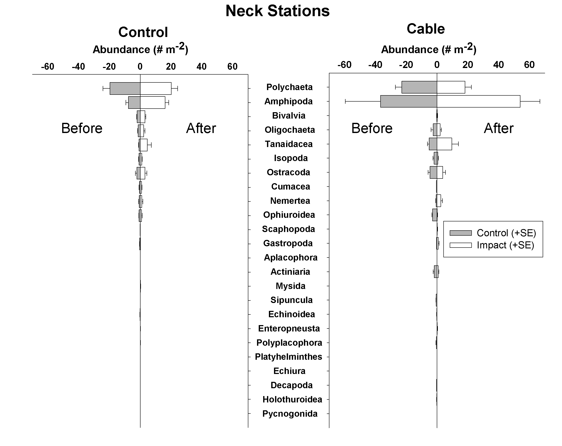Figure 15. Variation in the abundance of macrofaunal taxa (higher groups) at the Neck Cable zone among Treatments and Periods.
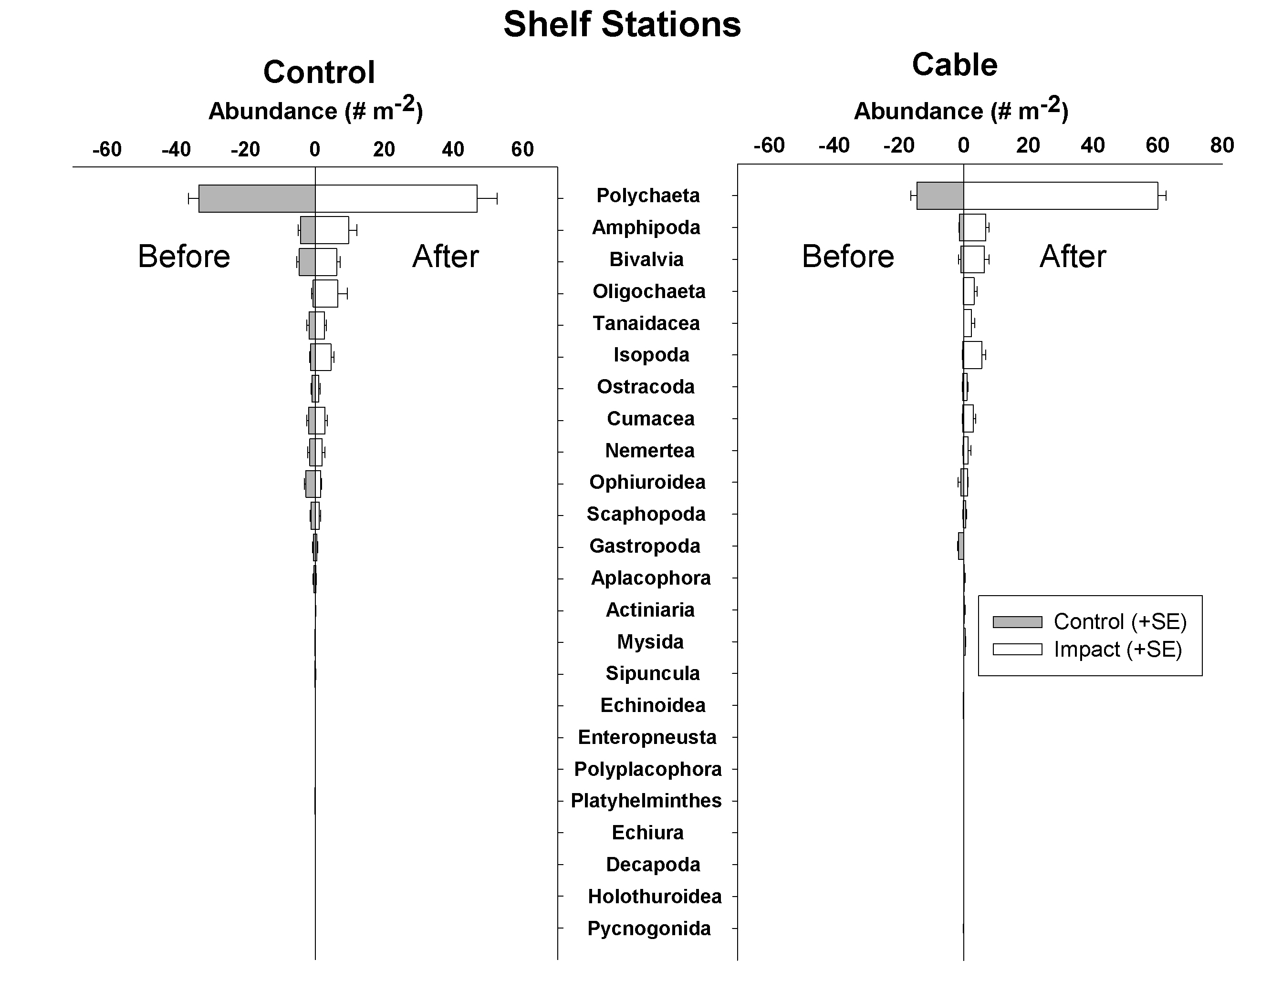Figure 14. Variation in the abundance of macrofaunal taxa (higher groups) at the Shelf Cable zone among Treatments and Periods.
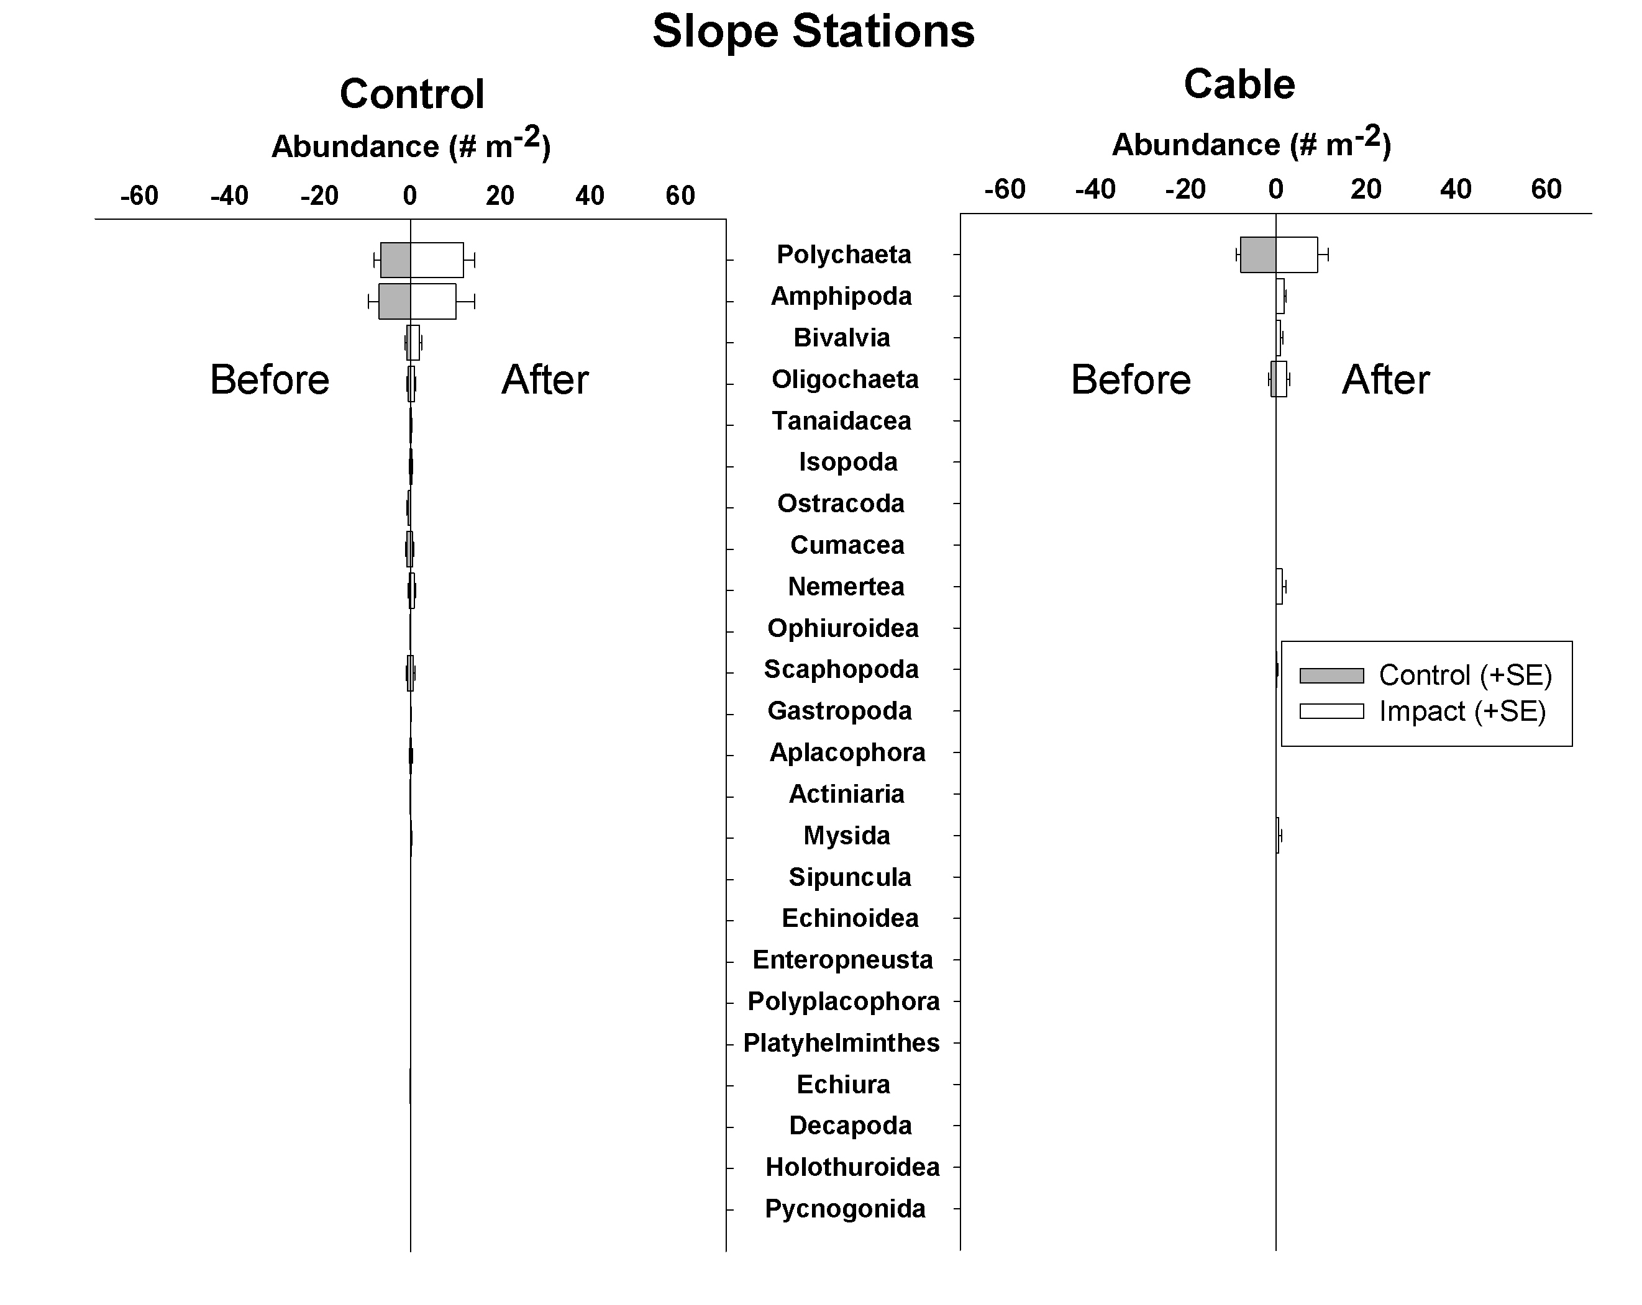Figure 16. Variation in the abundance of macrofaunal taxa (higher groups) at the Slope Cable zone among Treatments and Periods.
Other factors
Several other factors may have influenced the variability observed in the abundance and distribution of benthic megafauna and macrofauna in relation to the installation of the MARS Cable. First, the geological and biological sampling program included a few samples collected as early 1999 and 2001. Natural variation in faunal abundance during the extended sampling period used for the “Before” sample base may have affected estimates the mean and standard deviation of abundance for many taxa. Considering that the 2007-2008 sample base was collected over only a few months, it is more likely to reflect the status of the benthic faunal communities than the “Before” samples.
Second, although the vast majority of sediment samples were collected using the same method (7.5 inch diameter tube core), 4 samples (again from 1999) were collected using a Smith-MacIntyre Grab (0.1 x 0.1 m). The abundances of macrofauna derived from these samples were adjusted to 45.2 cm² (the area of a tube core), but the efficiency of the two collection devices may have affected the results.
Third, there were no adjustments of probability levels to account for the large number of statistical tests. Over 100 statistical tests were performed, using an α of 0.05 – that is the probability of a type 1 error (rejecting a true null hypothesis) is 1 in 20. Thus, for 100 statistical tests, one would by chance detect a significant effect (e.g. Period x Treatment interaction term indicating an effect of the MARS cable) approximately 5 times. There are methods of reducing α to further reduce the probability of a type 1 error, but this is generally avoided, since it also increases type II errors (the acceptance of a false null hypothesis) (Cabin and Mitchell 2000).

CONCLUSIONS
Inspection of the MARS cable, coupled with a sampling program to evaluate changes in geological and biological conditions on local and regional scales with respect to the installation of the cable indicate little detectable influence of the cable. The most conspicuous evidence of cable installation is the cable trench and the cable, where exposed on the seabed. Analyses of the geological and biological sampling program indicate the following:

- Over most of its length, the cable remains buried, with little evidence of change since installation
- No detectable changes in sediment characteristics (mean grain size, or percent organic carbon) can be attributed to the MARS cable
- Local variation in benthic megafaunal communities within 50-100 m of the MARS cable is minor or undetectable.
  - The abundances of most animals observed did not differ between the area over the cable route and 50 m away
  - Longnose skates (Raja rhina) are significantly more abundant near regions where the MARS cable is suspended over topography (~300 m depth), and are likely to respond to electromagnetic fields generated by the cable.
- The MARS cable has little or no detectable effect on the distribution and abundance of macrofaunal and megafaunal assemblages on a regional scale (e.g. kilometers).
  - Megafauna and macrofauna compared before and after cable installation among 3 control stations and 1 cable station at each of 3 depth zones (Shelf - <200 m, Neck – 200-500 m, Slope - >500 m) indicated very few potential changes in benthic biological patterns due to the MARS cable.
  - Natural spatial and temporal variation in the abundance and distribution of benthic macrofauna and megafauna appears to be greater than any detectable effects of the MARS cable.

ACKNOWLEDGEMENTS
This study was funded by the David and Lucille Packard Foundation. We are grateful for the expertise and support of the crews of the R/V Pt. Lobos and ROV Ventana.

REFERENCES
Anderson, M.J., Robinson, j. 2003. Generalised discriminant analysis based on distances. Aust. & New Zealand J. of Statistics, 45: 301-318.
Bullock, T.H. 1982. Electroreception. Ann. Rev. of Neuroscience, 5: 121-170.
Cabin, R.J., Mitchell, R.J. 2009. To Bonferroni or not to Bonferroni: When and how are the questions. Bull. Ecol. Soc. Amer., 81(3): 246-248
Gill, A.B. 2005. Offshore renewable energy: ecological implications of generating electricity in the coastal zone. J. Applied Ecology 42, 605-615.
Hewitt, J.E., Thrush, S.E., Cummings, V.J. 2001. Assessing environmental impacts: effects of spatial and temporal variability at likely impact scales. Ecological Appl. 11(5): 1502-1516.
Kogan, I., Paull, C.K., Kuhnz, L., Burton, E.J., VonThun, S., Greene, H.G., Barry, J.P. 2003. Environmental impact of the ATOC / Pioneer Seamount submarine cable. Monterey Bay National Marine Sanctuary.
Perneger, T.V. 1998. What’s wrong with Bonferroni adjustments. BMJ, 316: 1236-38.
Stewart-Oaten, A., Murdoch, W.W. 1986. Environmental impact assessment: “pseudoreplication “ in time? Ecology, 67(4): 929-940.
Underwood, A.J. 1994. On beyond BACI: sampling designs that might reliably detect environmental disturbances. Ecol. Appl., 4(1): 4-15.

Appendix 1. ROV video transect information. Transect Code (Tr. Code), Station, Cable Depth Zone (Zone), Treatment (control or cable location), Period (before or after cable installation, depth in meters, Date, Dive number for ROV Ventana, transect length (m), and estimated accuracy of navigation used to calculate transect length. Exact locations were unavailable for some transects, in which case station location information was used.
Tr. Code Station Zone Treatment Period Latitude Longitude Depth Date Dive # Length Accuracy
A-A-2008 A All Cable After 36.756899 -122.188391 710 12/12/2007 3139 115 good
A-B-2008 A All Control After 36.756899 -122.187710 724 12/12/2007 3139 114 good
B-A-2008 B All Cable After 36.799730 -122.186883 435 1/29/2008 3164 97 good
B-B-2008 B All Control After 36.799712 -122.186290 431 1/29/2008 3164 97 good
C-A-2008 C All Cable After 36.836974 -122.158251 172 1/31/2008 3167 83 good
C-B-2008 C All Control After 36.837340 -122.158864 162 1/31/2008 3167 87 good
D-A-2008 D All Cable After 36.857358 -122.108810 95 2/8/2008 3169 100 good
D-B-2008 D All Control After 36.856905 -122.108491 94 2/8/2008 3169 100 good
E-A-2008 E All Cable After 36.879787 -122.059782 72 4/1/2008 3186 100 good
E-B-2008 E All Control After 36.880117 -122.060248 71 4/1/2008 3186 111 good
F-A-2008 F All Cable After 36.885715 -122.006020 48 4/1/2008 3186 100 good
F-B-2008 F All Control After 36.885231 -122.006393 49 4/1/2008 3186 100 good
G-A-2008 G All Cable After 36.883813 -121.949321 39 1/8/2008 3149 100 unknown
G-B-2008 G All Control After 36.883895 -121.949741 40 1/8/2008 3149 100 unknown
H-A-2008 H All Cable After 36.868305 -121.895886 44 1/28/2008 3163 100 poor nav
H-B-2008 H All Control After 36.867867 -121.896324 44 1/28/2008 3163 100 good
I-A-2008 I All Cable After 36.848015 -121.845586 26 1/22/2010 3173 100 VARS, TC
I-B-2008 I All Control After 36.847485 -121.844780 26 1/22/2010 3173 100 poor
J-A-2008 J All Cable After 36.815585 -121.807344 20 3/31/2008 3184 107 good
J-B-2008 J All Control After 36.816038 -121.806923 20 3/31/2008 3184 107 good
SC1-A-2006 SC-1 Shelf Control Before 36.714458 -121.909033 90 9/25/2006 2891 100 unknown
SC1-A-2008 SC-1 Shelf Control After 36.714458 -121.909033 89 11/30/2007 3135 100 poor
SC1-B-2006 SC-1 Shelf Control Before 36.714299 -121.908597 90 9/25/2006 2891 100 unknown
SC1-B-2008 SC-1 Shelf Control After 36.714299 -121.908597 90 11/30/2007 3135 100 poor
SC1-C-2006 SC-1 Shelf Control Before 36.713548 -121.907717 90 9/25/2006 2891 100 unknown
SC1-C-2008 SC-1 Shelf Control After 36.713548 -121.907717 89 11/30/2007 3135 100 poor
SC2-A-2006 SC-2 Shelf Control Before 36.821804 -121.944500 87 10/5/2006 2905 100 unknown
SC2-A-2008 SC-2 Shelf Control After 36.822428 -121.945564 87 11/30/2007 3134 100 poor
SC2-B-2006 SC-2 Shelf Control Before 36.822571 -121.943540 86 10/5/2006 2905 100 unknown
Tr. Code Station Zone Treatment Period Latitude Longitude Depth Date Dive # Length Accuracy
SC2-B-2008 SC-2 Shelf Control After 36.822978 -121.944894 86 11/30/2007 3134 100 poor
SC2-C-2008 SC-2 Shelf Control After 36.823517 -121.944924 86 11/30/2007 3134 100 poor
SC3-A-2006 SC-3 Shelf Control Before 36.878461 -122.121178 89 10/5/2006 2904 100 unknown
SC3-A-2008 SC-3 Shelf Control After 36.877177 -122.120826 90 1/30/2008 3166 100 good
SC3-B-2006 SC-3 Shelf Control Before 36.878765 -122.120205 89 10/5/2006 2904 100 unknown
SC3-B-2008 SC-3 Shelf Control After 36.877639 -122.121503 91 1/30/2008 3166 100 good
SC3-C-2008 SC-3 Shelf Control After 36.877494 -122.120593 91 1/30/2008 3166 90 moderate
SI1-A-1999 SI-1 Shelf Cable Before 36.863391 -122.096900 90 1999 MCI-ACAD90 100 unknown
SI1-A-2008 SI-1 Shelf Cable After 36.863391 -122.096900 91 1/23/2008 3161 100 poor
SI1-B-1999 SI-1 Shelf Cable Before 36.863186 -122.096707 90 1999 MCI-ACAD90 100 unknown
SI1-B-2008 SI-1 Shelf Cable After 36.863186 -122.096707 92 1/23/2008 3161 100 poor
SI1-C-2008 SI-1 Shelf Cable After 36.863471 -122.096143 92 1/23/2008 3161 100 poor
NC1-A-2005 NC-1 Neck Control Before 36.789158 -122.124280 401 7/13/2005 2687 100 unknown
NC1-A-2008 NC-1 Neck Control After 36.788543 -122.117341 399 1/30/2008 3165 109 good
NC1-B-2005 NC-1 Neck Control Before 36.789383 -122.125140 400 7/13/2005 2687 100 unknown
NC1-B-2008 NC-1 Neck Control After 36.789039 -122.117852 394 1/30/2008 3165 96 good
NC1-C-2005 NC-1 Neck Control Before 36.788088 -122.121619 400 7/13/2005 2687 50 unknown
NC1-C-2008 NC-1 Neck Control After 36.789491 -122.116151 386 1/30/2008 3165 100 poor
NC2-A-2005 NC-2 Neck Control Before 36.803011 -122.122515 196 8/1/2005 2696 100 unknown
NC2-A-2008 NC-2 Neck Control After 36.799381 -122.107564 207 1/30/2008 3165 100 good
NC2-B-2005 NC-2 Neck Control Before 36.803356 -122.123501 197 8/1/2005 2696 100 unknown
NC2-B-2008 NC-2 Neck Control After 36.799928 -122.108486 189 1/30/2008 3165 100 good
NC2-C-2005 NC-2 Neck Control Before 36.803646 -122.124485 198 8/1/2005 2696 100 unknown
NC2-C-2008 NC-2 Neck Control After 36.799216 -122.108455 195 1/30/2008 3165 100 good
NC3-A-2006 NC-3 Neck Control Before 36.842645 -122.189108 361 10/3/2006 2899 100 unknown
NC3-A-2008 NC-3 Neck Control After 36.842894 -122.187867 361 1/24/2008 3162 100 good
NC3-B-2006 NC-3 Neck Control Before 36.842120 -122.189979 368 10/3/2006 2899 100 unknown
NC3-B-2008 NC-3 Neck Control After 36.842918 -122.187669 352 1/24/2008 3162 100 good
NC3-C-2008 NC-3 Neck Control After 36.842812 -122.186766 356 1/24/2008 3162 100 good
NI1-A-1999 NI-1 Neck Cable Before 36.824453 -122.169606 325 1999 MCI-Pref325 100 unknown
NI1-A-2008 NI-1 Neck Cable After 36.824453 -122.169606 321 1/31/2008 3167 100 good
NI1-B-1999 NI-1 Neck Cable Before 36.824886 -122.170095 325 1999 MCI-Pref325 100 unknown
NI1-B-2008 NI-1 Neck Cable After 36.824886 -122.170095 318 1/31/2008 3167 100 good
NI1-C-1999 NI-1 Neck Cable Before 36.824287 -122.170539 325 1999 MCI-ACAD325 100 unknown
Tr. Code Station Zone Treatment Period Latitude Longitude Depth Date Dive # Length Accuracy
NI1-C-2008 NI-1 Neck Cable After 36.824287 -122.170539 323 1/31/2008 3167 100 good
SLC1-A-2001 SLC-1 Slope Control Before 36.743379 -122.275459 1000 10/12/2001 2083 100 unknown
SLC1-A-2008 SLC-1 Slope Control After 36.745790 -122.277049 992 1/7/2008 3147 100 good
SLC1-B-2001 SLC-1 Slope Control Before 36.742199 -122.274547 1000 10/12/2001 2083 100 unknown
SLC1-B-2008 SLC-1 Slope Control After 36.745207 -122.277572 1001 1/7/2008 3147 80 good
SLC1-C-2001 SLC-1 Slope Control Before 36.741165 -122.273010 999 10/12/2001 2083 100 unknown
SLC1-C-2008 SLC-1 Slope Control After 36.745351 -122.278318 1007 1/7/2008 3147 100 good
SLC2-A-2005 SLC-2 Slope Control Before 36.752527 -122.200020 801 6/8/2005 2674 100 unknown
SLC2-A-2008 SLC-2 Slope Control After 36.748745 -122.197382 820 1/23/2008 3160 100 good
SLC2-B-2005 SLC-2 Slope Control Before 36.752640 -122.200906 800 6/8/2005 2674 100 unknown
SLC2-B-2008 SLC-2 Slope Control After 36.748580 -122.197578 817 1/23/2008 3160 100 good
SLC2-C-2005 SLC-2 Slope Control Before 36.752558 -122.202336 801 6/8/2005 2674 100 unknown
SLC2-C-2008 SLC-2 Slope Control After 36.748988 -122.198433 827 1/23/2008 3160 100 good
SLC3-A-2006 SLC-3 Slope Control Before 36.707094 -122.167266 881 10/3/2006 2898 100 unknown
SLC3-A-2008 SLC-3 Slope Control After 36.705268 -122.166423 895 1/8/2008 3148 100 good
SLC3-B-2006 SLC-3 Slope Control Before 36.707753 -122.166954 877 10/3/2006 2898 100 unknown
SLC3-B-2008 SLC-3 Slope Control After 36.706463 -122.165729 884 1/8/2008 3148 100 good
SLC3-C-2006 SLC-3 Slope Control Before 36.707710 -122.165860 874 10/3/2006 2898 100 unknown
SLC3-C-2008 SLC-3 Slope Control After 36.705928 -122.164967 887 1/8/2008 3148 100 good
SLI1-A-2003 SLI-1 Slope Cable Before 36.711241 -122.186781 885 10/13/2003 V2439 100 unknown
SLI1-A-2008 SLI-1 Slope Cable After 36.712528 -122.187070 877 12/6/2007 3136 100 poor
SLI1-B-2003 SLI-1 Slope Cable Before 36.711353 -122.186449 883 10/13/2003 V2439 100 unknown
SLI1-B-2008 SLI-1 Slope Cable After 36.713020 -122.186753 877 12/6/2007 3136 100 poor
SLI1-C-2003 SLI-1 Slope Cable Before 36.711883 -122.186523 882 10/13/2003 V2439 100 unknown
SLI1-C-2008 SLI-1 Slope Cable After 36.712683 -122.186665 874 12/6/2007 3136 100 poor
Skate1-A Skate Skate Control After 36.825740 -122.168653 313 1/31/2008 3167 100 good
Skate1-B Skate Skate Control After 36.826303 -122.168202 310 1/31/2008 3167 82 good
Skate1-C Skate Skate Control After 36.827346 -122.167738 309 1/31/2008 3167 100 good
Skate2-A Skate Skate Cable After 36.826029 -122.169319 317 1/31/2008 3167 100 good
Skate2-B Skate Skate Cable After 36.826903 -122.168852 311 1/31/2008 3167 100 good
Skate2-C Skate Skate Cable After 36.827570 -122.168474 306 1/31/2008 3167 86 good

Appendix 2. Mean megafaunal density along the MARS cable route and control sites, organized by phylum (or subphylum). The density (# m⁻²) of each taxon at all available video transects (n=94) and all depths were averaged to produce an overall average density. SD = standard deviation. Percent indicates the percentage of the total average faunal density (1.41 megafaunal individuals 100 m⁻²).
Phylum Major Group Taxa Density SD %
Agnatha Myxinidae Eptatretus stoutii 0.17 0.56 0.11
Annelida Polychaeta Diopatra 7.51 38.79 5.06
Annelida Polychaeta Sabellidae 0.05 0.27 0.04
Arthropoda Anomura Diogenidae 0.23 1.05 0.15
Arthropoda Caridea Caridea 0.60 4.16 0.40
Arthropoda Caridea Caridea sp.1 0.09 0.41 0.06
Arthropoda Decapoda Brachyura 0.01 0.10 0.01
Arthropoda Decapoda Cancer 0.03 0.23 0.02
Arthropoda Decapoda Chionoecetes tanneri 0.99 2.48 0.67
Arthropoda Decapoda Chorilia longipes 0.07 0.30 0.05
Arthropoda Decapoda Decapoda 0.01 0.10 0.01
Brachipoda Brachipoda Laqueus californianus 0.06 0.62 0.04
Chondrichthyes Chimaeridae Hydrolagus colliei 0.18 0.91 0.12
Chondrichthyes Rajiformes Bathyraja kincaidii 0.05 0.23 0.04
Chondrichthyes Rajiformes Raja binoculata 0.01 0.10 0.01
Chondrichthyes Rajiformes Raja rhina 1.52 10.77 1.02
Chondrichthyes Scyliorhinidae Parmaturus xaniurus 0.11 0.48 0.07
Cnidaria Actiniaria Actiniaria 1.02 2.73 0.69
Cnidaria Actiniaria Actiniaria sp. 1 0.59 1.95 0.39
Cnidaria Actiniaria Actiniaria sp. 3 0.72 2.66 0.49
Cnidaria Actiniaria Liponema brevicornis 0.44 1.88 0.30
Cnidaria Actiniaria Mesomyaria 6.58 15.63 4.43
Cnidaria Actiniaria Metridium farcimen 0.23 0.68 0.16
Cnidaria Actiniaria Stomphia 1.67 2.89 1.13
Cnidaria Alcyonacea Anthomastus ritteri 0.07 0.36 0.05
Cnidaria Anthozoa Anthozoa 0.03 0.18 0.02
Cnidaria Ceriantharia Ceriantharia 1.28 2.40 0.86
Cnidaria Ceriantharia Ceriantharia sp. 1 0.07 0.57 0.05
Cnidaria Ceriantharia Ceriantharia sp. 2 0.44 1.95 0.30
Cnidaria Ceriantharia Ceriantharia sp. 3 0.18 0.71 0.12
Cnidaria Cnidaria Cnidaria 0.01 0.10 0.01
Cnidaria Corallimorphidae Corallimorphus pilatus 0.17 0.86 0.11
Cnidaria Gorgonacea Gorgonacea 0.01 0.10 0.01
Cnidaria Gorgonacea Swiftia simplex 0.22 1.26 0.15
Cnidaria Hydrozoa LRJ Complex 0.02 0.15 0.01
Cnidaria Pennatulacea Anthoptilum grandiflorum 0.03 0.21 0.02
Cnidaria Pennatulacea Funiculina 17.30 47.23 11.65
Cnidaria Pennatulacea Halipteris californica 0.64 3.31 0.43
Phylum Major Group Taxa Density SD %
Cnidaria Pennatulacea Pennatula aculeata 0.40 1.96 0.27
Cnidaria Pennatulacea Pennatula phosphorea californica 0.11 0.58 0.07
Cnidaria Pennatulacea Pennatulacea 12.04 24.28 8.11
Cnidaria Pennatulacea Ptilosarcus gurneyi 0.07 0.37 0.05
Cnidaria Pennatulacea Umbellula lindahli 2.78 8.30 1.87
Detritus Laminariales 0.41 0.89 0.28
Detritus Phyllospadix 12.63 18.12 8.51
Echinodermata Asteroidea Asteroidea 1.03 4.02 0.69
Echinodermata Asteroidea Benthopecten 0.15 1.05 0.10
Echinodermata Asteroidea Henricia aspera 0.11 0.50 0.07
Echinodermata Asteroidea Henricia sanguinolenta 0.02 0.15 0.01
Echinodermata Asteroidea Hippasteria 0.43 1.44 0.29
Echinodermata Asteroidea Luidia foliolata 0.28 0.90 0.19
Echinodermata Asteroidea Mediaster 3.30 8.07 2.22
Echinodermata Asteroidea Pycnopodia helianthoides 0.01 0.10 0.01
Echinodermata Asteroidea Rathbunaster californicus 16.90 47.13 11.38
Echinodermata Asteroidea Solaster borealis 0.40 1.16 0.27
Echinodermata Asteroidea Stylasterias forreri 0.65 1.88 0.44
Echinodermata Crinoidea Florametra serratissima 0.10 0.43 0.07
Echinodermata Echinoidea Allocentrotus fragilis 13.31 40.37 8.96
Echinodermata Echinoidea Brisaster 0.12 0.41 0.08
Echinodermata Holothuroidea Holothuroidea 0.01 0.10 0.01
Echinodermata Holothuroidea Pannychia moseleyi 1.32 11.96 0.89
Echinodermata Holothuroidea Parastichopus californicus 0.01 0.10 0.01
Echinodermata Holothuroidea Parastichopus johnsoni 0.11 0.74 0.07
Echinodermata Holothuroidea Parastichopus leukothele 1.90 5.47 1.28
Echinodermata Holothuroidea Psolus squamatus 8.48 53.08 5.71
Echinodermata Ophiuroidea Asteronyx 0.05 0.27 0.04
Echinodermata Ophiuroidea Ophiuroidea 7.22 33.77 4.86
Echiura Echiura Echiura 0.03 0.18 0.02
Mollusca Cephalopoda Octopoda 0.07 0.44 0.05
Mollusca Cephalopoda Octopus rubescens 0.11 0.53 0.08
Mollusca Gastropoda Calliostoma platinum 0.37 1.68 0.25
Mollusca Gastropoda Gastropoda 5.31 14.10 3.58
Mollusca Gastropoda Gastropoda sp.3 0.11 0.73 0.07
Mollusca Gastropoda Neptunea 0.82 2.37 0.55
Mollusca Gastropoda Nudibranchia 0.03 0.23 0.02
Mollusca Gastropoda Nudibranchia sp.1 0.01 0.09 0.01
Mollusca Gastropoda Pleurobranchaea californica 0.06 0.29 0.04
Mollusca Gastropoda Tritonia diomedea 0.01 0.10 0.01
Osteichthyes Agonidae Agonidae 0.24 0.70 0.16
Osteichthyes Agonidae Xeneretmus 0.05 0.42 0.04
Osteichthyes Alepocephalidae Alepocephalus tenebrosus 0.01 0.10 0.01
Osteichthyes Anoplopomatidae Anoplopoma fimbria 0.04 0.25 0.03
Phylum Major Group Taxa Density SD %
Osteichthyes Embiotocidae Zalembius rosaceus 0.01 0.10 0.01
Osteichthyes Hexagrammidae Ophiodon elongatus 0.01 0.12 0.01
Osteichthyes Liparidae Careproctus melanurus 0.06 0.46 0.04
Osteichthyes Liparidae Liparidae 0.02 0.14 0.01
Osteichthyes Macrouridae Coryphaenoides acrolepis 0.13 0.78 0.09
Osteichthyes Merlucciidae Merluccius productus 0.25 1.47 0.17
Osteichthyes Moridae Antimora microlepis 0.06 0.32 0.04
Osteichthyes Ophidiidae Bothrocara brunneum 0.02 0.21 0.01
Osteichthyes Ophidiidae Ophidion scrippsae 0.02 0.15 0.02
Osteichthyes Osmeridae Osmeridae 0.01 0.11 0.01
Osteichthyes Osteichthyes Osteichthyes 0.76 3.18 0.51
Osteichthyes Pleuronectiformes Embassichthys bathybius 0.11 0.40 0.07
Osteichthyes Pleuronectiformes Glyptocephalus zachirus 0.82 2.04 0.55
Osteichthyes Pleuronectiformes Lyopsetta exilis 0.01 0.10 0.01
Osteichthyes Pleuronectiformes Microstomus pacificus 0.50 1.43 0.34
Osteichthyes Pleuronectiformes Pleuronectiformes 2.00 4.02 1.35
Osteichthyes Scorpaenidae Sebastes 1.93 10.32 1.30
Osteichthyes Scorpaenidae Sebastes aurora 0.08 0.45 0.06
Osteichthyes Scorpaenidae Sebastes diploproa 0.96 3.42 0.65
Osteichthyes Scorpaenidae Sebastes paucispinis 0.02 0.21 0.01
Osteichthyes Scorpaenidae Sebastes rosenblatti 0.01 0.10 0.01
Osteichthyes Scorpaenidae Sebastes rubrivinctus 0.01 0.12 0.01
Osteichthyes Scorpaenidae Sebastes saxicola 0.07 0.72 0.05
Osteichthyes Scorpaenidae Sebastolobus 2.21 3.96 1.49
Osteichthyes Scorpaenidae Sebastomus complex 0.01 0.10 0.01
Osteichthyes Stichaeidae Lumpenus sagitta 0.11 0.50 0.07
Osteichthyes Torpedinidae Torpedo californica 0.01 0.10 0.01
Osteichthyes Zaniolepididae Zaniolepididae 0.07 0.39 0.05
Osteichthyes Zoarcidae Lycenchelys camchatica 0.91 2.75 0.62
Osteichthyes Zoarcidae Lycodapus 0.08 0.57 0.05
Osteichthyes Zoarcidae Lycodes cortezianus 0.29 0.77 0.19
Osteichthyes Zoarcidae Lycodes diapterus 0.03 0.21 0.02
Osteichthyes Zoarcidae Lyconema barbatum 0.01 0.10 0.01
Osteichthyes Zoarcidae Zoarcidae 0.03 0.18 0.02
Porifera Porifera Asbestopluma 0.05 0.53 0.04
Porifera Porifera Porifera 1.69 5.42 1.14
Urochordata Urochordata Megalodicopia hians 0.02 0.14 0.01

Total, all taxa 148.47 131.94 100.00

Appendix 3. Sediment core samples collected during the MARS Cable survey, 2007-2008. Depth indicated in meters.
Sample Depth Station Type Date Latitude Longitude Comment
 | V3165-C02 |  | 400 | NC-1 |  |  | Macrofauna |  |  |  |  | 1/30/2008 |  |  |  |  | 36.788670 |  |  | -122.116560
 | V3165-C17 |  | 400 | NC-1 |  |  | Macrofauna |  |  |  |  | 1/30/2008 |  |  |  |  | 36.788670 |  |  | -122.116560
 | V3165-C23 |  | 400 | NC-1 |  |  | Macrofauna |  |  |  |  | 1/30/2008 |  |  |  |  | 36.788670 |  |  | -122.116560
 | V3165-C24 |  | 400 | NC-1 |  |  | Macrofauna |  |  |  |  | 1/30/2008 |  |  |  |  | 36.788670 |  |  | -122.116560
 | V3165-C28 |  | 400 | NC-1 |  |  | Macrofauna |  |  |  |  | 1/30/2008 |  |  |  |  | 36.788670 |  |  | -122.116560 |  |  | extra
 | V3165-C40 |  | 400 | NC-1 |  |  | Macrofauna |  |  |  |  | 1/30/2008 |  |  |  |  | 36.788670 |  |  | -122.116560
 | V3165-C10 |  | 200 | NC-2 |  |  | Macrofauna |  |  |  |  | 1/30/2008 |  |  |  |  | 36.798840 |  |  | -122.107930 |  |  | extra
 | V3165-C31 |  | 200 | NC-2 |  |  | Macrofauna |  |  |  |  | 1/30/2008 |  |  |  |  | 36.798840 |  |  | -122.107930
 | V3165-C33 |  | 200 | NC-2 |  |  | Macrofauna |  |  |  |  | 1/30/2008 |  |  |  |  | 36.798840 |  |  | -122.107930
 | V3165-C34 |  | 200 | NC-2 |  |  | Macrofauna |  |  |  |  | 1/30/2008 |  |  |  |  | 36.798840 |  |  | -122.107930
 | V3165-C37 |  | 200 | NC-2 |  |  | Macrofauna |  |  |  |  | 1/30/2008 |  |  |  |  | 36.798840 |  |  | -122.107930
 | V3165-C39 |  | 200 | NC-2 |  |  | Macrofauna |  |  |  |  | 1/30/2008 |  |  |  |  | 36.798840 |  |  | -122.107930
 | V3162-C16 |  | 360 | NC-3 |  |  | Macrofauna |  |  |  |  | 1/24/2008 |  |  |  |  | 36.842590 |  |  | -122.187070 |  |  | extra
 | V3162-C20 |  | 360 | NC-3 |  |  | Macrofauna |  |  |  |  | 1/24/2008 |  |  |  |  | 36.842590 |  |  | -122.187070
 | V3162-C22 |  | 360 | NC-3 |  |  | Macrofauna |  |  |  |  | 1/24/2008 |  |  |  |  | 36.842590 |  |  | -122.187070
 | V3162-C26 |  | 360 | NC-3 |  |  | Macrofauna |  |  |  |  | 1/24/2008 |  |  |  |  | 36.842590 |  |  | -122.187070
 | V3162-C32 |  | 360 | NC-3 |  |  | Macrofauna |  |  |  |  | 1/24/2008 |  |  |  |  | 36.842590 |  |  | -122.187070
 | V3162-C36 |  | 360 | NC-3 |  |  | Macrofauna |  |  |  |  | 1/24/2008 |  |  |  |  | 36.842590 |  |  | -122.187070
 | V3167-C09 |  | 324 | NI-1A |  |  | Macrofauna |  |  |  |  | 1/31/2008 |  |  |  |  | 36.834352 |  |  | -122.170323
 | V3167-C16 |  | 324 | NI-1A |  |  | Macrofauna |  |  |  |  | 1/31/2008 |  |  |  |  | 36.834352 |  |  | -122.170323
 | V3167-C21 |  | 324 | NI-1A |  |  | Macrofauna |  |  |  |  | 1/31/2008 |  |  |  |  | 36.834352 |  |  | -122.170323
 | V3167-C25 |  | 324 | NI-1A |  |  | Macrofauna |  |  |  |  | 1/31/2008 |  |  |  |  | 36.834352 |  |  | -122.170323
 | V3167-C32 |  | 324 | NI-1A |  |  | Macrofauna |  |  |  |  | 1/31/2008 |  |  |  |  | 36.834352 |  |  | -122.170323
 | V3135-C29 |  | 88 | SC-1 |  |  | Macrofauna |  |  |  |  | 11/30/2007 |  |  |  |  | 36.714237 |  |  | -121.909300
 | V3135-C31 |  | 88 | SC-1 |  |  | Macrofauna |  |  |  |  | 11/30/2007 |  |  |  |  | 36.715420 |  |  | -121.908850
 | V3135-C33 |  | 88 | SC-1 |  |  | Macrofauna |  |  |  |  | 11/30/2007 |  |  |  |  | 36.714290 |  |  | -121.909004
 | V3135-C35 |  | 88 | SC-1 |  |  | Macrofauna |  |  |  |  | 11/30/2007 |  |  |  |  | 36.714220 |  |  | -121.908160
 | V3135-C39 |  | 88 | SC-1 |  |  | Macrofauna |  |  |  |  | 11/30/2007 |  |  |  |  | 36.713783 |  |  | -121.907860
 | V3134-C04 |  | 86 | SC-2 |  |  | Macrofauna |  |  |  |  | 11/30/2007 |  |  |  |  | 36.821796 |  |  | -121.945610
 | V3134-C23 |  | 86 | SC-2 |  |  | Macrofauna |  |  |  |  | 11/30/2007 |  |  |  |  | 36.822098 |  |  | -121.945680
 | V3134-C24 |  | 86 | SC-2 |  |  | Macrofauna |  |  |  |  | 11/30/2007 |  |  |  |  | 36.822850 |  |  | -121.945175 |  |  | extra
 | V3134-C26 |  | 86 | SC-2 |  |  | Macrofauna |  |  |  |  | 11/30/2007 |  |  |  |  | 36.823080 |  |  | -121.944670
 | V3134-C27 |  | 86 | SC-2 |  |  | Macrofauna |  |  |  |  | 11/30/2007 |  |  |  |  | 36.823370 |  |  | -121.944730
 | V3134-C32 |  | 86 | SC-2 |  |  | Macrofauna |  |  |  |  | 11/30/2007 |  |  |  |  | 36.823883 |  |  | -121.945390
 | V3166-C05 |  | 89 | SC-3 |  |  | Macrofauna |  |  |  |  | 1/30/2008 |  |  |  |  | 36.877770 |  |  | -122.121320
 | V3166-C11 |  | 89 | SC-3 |  |  | Macrofauna |  |  |  |  | 1/30/2008 |  |  |  |  | 36.877770 |  |  | -122.121320
 | V3166-C12 |  | 89 | SC-3 |  |  | Macrofauna |  |  |  |  | 1/30/2008 |  |  |  |  | 36.877770 |  |  | -122.121320 |  |  | extra
 | V3166-C14 |  | 89 | SC-3 |  |  | Macrofauna |  |  |  |  | 1/30/2008 |  |  |  |  | 36.877770 |  |  | -122.121320
 | Sample | Depth |  |  | Station |  |  |  |  |  | Type |  |  |  |  | Date |  | Latitude |  |  | Longitude |  | Comment
 | V3166-C18 |  | 89 |  |  | SC-3 |  |  | Macrofauna |  |  |  | 1/30/2008 |  |  |  |  | 36.877770 |  |  | -122.121320
 | V3166-C38 |  | 89 |  |  | SC-3 |  |  | Macrofauna |  |  |  | 1/30/2008 |  |  |  |  | 36.877770 |  |  | -122.121320
V3161-C02 |  |  | 89 |  |  | SI-1A |  |  | Macrofauna |  |  |  | 1/23/2008 |  |  |  |  | 36.863070 |  |  | -122.096550 |  | extra
V3161-C05 |  |  | 89 |  |  | SI-1A |  |  | Macrofauna |  |  |  | 1/23/2008 |  |  |  |  | 36.863070 |  |  | -122.096550
V3161-C08 |  |  | 89 |  |  | SI-1A |  |  | Macrofauna |  |  |  | 1/23/2008 |  |  |  |  | 36.863070 |  |  | -122.096550
V3161-C09 |  |  | 89 |  |  | SI-1A |  |  | Macrofauna |  |  |  | 1/23/2008 |  |  |  |  | 36.863070 |  |  | -122.096550
V3161-C11 |  |  | 89 |  |  | SI-1A |  |  | Macrofauna |  |  |  | 1/23/2008 |  |  |  |  | 36.863070 |  |  | -122.096550
V3161-C15 |  |  | 89 |  |  | SI-1A |  |  | Macrofauna |  |  |  | 1/23/2008 |  |  |  |  | 36.863070 |  |  | -122.096550
V3147-C11 |  |  | 1000 |  |  | SLC-1 |  |  | Macrofauna |  |  |  | 1/7/2008 |  |  |  |  | 36.744930 |  |  | -122.277850
V3147-C14 |  |  | 1000 |  |  | SLC-1 |  |  | Macrofauna |  |  |  | 1/7/2008 |  |  |  |  | 36.744930 |  |  | -122.277850
V3147-C17 |  |  | 1000 |  |  | SLC-1 |  |  | Macrofauna |  |  |  | 1/7/2008 |  |  |  |  | 36.744930 |  |  | -122.277850
V3147-C23 |  |  | 1000 |  |  | SLC-1 |  |  | Macrofauna |  |  |  | 1/7/2008 |  |  |  |  | 36.744930 |  |  | -122.277850
V3147-C24 |  |  | 1000 |  |  | SLC-1 |  |  | Macrofauna |  |  |  | 1/7/2008 |  |  |  |  | 36.744930 |  |  | -122.277850
V3147-C27 |  |  | 1000 |  |  | SLC-1 |  |  | Macrofauna |  |  |  | 1/7/2008 |  |  |  |  | 36.744930 |  |  | -122.277850
V3160-C06 |  |  | 820 |  |  | SLC-2 |  |  | Macrofauna |  |  |  | 1/23/2008 |  |  |  |  | 36.749540 |  |  | -122.197410
V3160-C13 |  |  | 820 |  |  | SLC-2 |  |  | Macrofauna |  |  |  | 1/23/2008 |  |  |  |  | 36.749540 |  |  | -122.197410 |  | extra
V3160-C17 |  |  | 820 |  |  | SLC-2 |  |  | Macrofauna |  |  |  | 1/23/2008 |  |  |  |  | 36.749540 |  |  | -122.197410
V3160-C18 |  |  | 820 |  |  | SLC-2 |  |  | Macrofauna |  |  |  | 1/23/2008 |  |  |  |  | 36.749540 |  |  | -122.197410
V3160-C28 |  |  | 820 |  |  | SLC-2 |  |  | Macrofauna |  |  |  | 1/23/2008 |  |  |  |  | 36.749540 |  |  | -122.197410
V3160-C35 |  |  | 820 |  |  | SLC-2 |  |  | Macrofauna |  |  |  | 1/23/2008 |  |  |  |  | 36.749540 |  |  | -122.197410
V3148-C02 |  |  | 893 |  |  | SLC-3 |  |  | Macrofauna |  |  |  | 1/8/2008 |  |  |  |  | 36.706360 |  |  | -122.166440
V3148-C04 |  |  | 885 |  |  | SLC-3 |  |  | Macrofauna |  |  |  | 1/8/2008 |  |  |  |  | 36.706360 |  |  | -122.166440
V3148-C05 |  |  | 891 |  |  | SLC-3 |  |  | Macrofauna |  |  |  | 1/8/2008 |  |  |  |  | 36.706360 |  |  | -122.166440
V3148-C07 |  |  | 884 |  |  | SLC-3 |  |  | Macrofauna |  |  |  | 1/8/2008 |  |  |  |  | 36.706360 |  |  | -122.166440
V3148-C08 |  |  | 891 |  |  | SLC-3 |  |  | Macrofauna |  |  |  | 1/8/2008 |  |  |  |  | 36.706360 |  |  | -122.166440
V3148-C09 |  |  | 896 |  |  | SLC-3 |  |  | Macrofauna |  |  |  | 1/8/2008 |  |  |  |  | 36.706360 |  |  | -122.166440
V3136-C21 |  |  | 877.66 |  |  | SLI-1 |  |  | Macrofauna |  |  |  | 12/6/2007 |  |  |  |  | 36.712677 |  |  | -122.187160
V3136-C22 |  |  | 872.59 |  |  | SLI-1 |  |  | Macrofauna |  |  |  | 12/6/2007 |  |  |  |  | 36.713020 |  |  | -122.185814
V3136-C26 |  |  | 874.46 |  |  | SLI-1 |  |  | Macrofauna |  |  |  | 12/6/2007 |  |  |  |  | 36.712856 |  |  | -122.186360 |  | extra
V3136-C29 |  |  | 876.71 |  |  | SLI-1 |  |  | Macrofauna |  |  |  | 12/6/2007 |  |  |  |  | 36.712910 |  |  | -122.187080
V3136-C33 |  |  | 874.72 |  |  | SLI-1 |  |  | Macrofauna |  |  |  | 12/6/2007 |  |  |  |  | 36.713290 |  |  | -122.187400
V3136-C34 |  |  | 875.98 |  |  | SLI-1 |  |  | Macrofauna |  |  |  | 12/6/2007 |  |  |  |  | 36.712753 |  |  | -122.186745
V3165-C08 |  |  | 400 |  |  | NC-1 |  |  | Tracer |  |  |  | 1/30/2008 |  |  |  |  | 36.788670 |  |  | -122.116560
V3165-C15 |  |  | 400 |  |  | NC-1 |  |  | Tracer |  |  |  | 1/30/2008 |  |  |  |  | 36.788670 |  |  | -122.116560
V3165-C35 |  |  | 400 |  |  | NC-1 |  |  | Tracer |  |  |  | 1/30/2008 |  |  |  |  | 36.788670 |  |  | -122.116560
V3165-C03 |  |  | 200 |  |  | NC-2 |  |  | Tracer |  |  |  | 1/30/2008 |  |  |  |  | 36.798840 |  |  | -122.107930
V3165-C29 |  |  | 200 |  |  | NC-2 |  |  | Tracer |  |  |  | 1/30/2008 |  |  |  |  | 36.798840 |  |  | -122.107930
V3165-C30 |  |  | 200 |  |  | NC-2 |  |  | Tracer |  |  |  | 1/30/2008 |  |  |  |  | 36.798840 |  |  | -122.107930
V3162-C19 |  |  | 360 |  |  | NC-3 |  |  | Tracer |  |  |  | 1/24/2008 |  |  |  |  | 36.842590 |  |  | -122.187070
V3162-C25 |  |  | 360 |  |  | NC-3 |  |  | Tracer |  |  |  | 1/24/2008 |  |  |  |  | 36.842590 |  |  | -122.187070
V3162-C27 |  |  | 360 |  |  | NC-3 |  |  | Tracer |  |  |  | 1/24/2008 |  |  |  |  | 36.842590 |  |  | -122.187070
Sample |  |  | Depth |  |  | Station |  |  |  | Type |  |  |  |  | Date |  |  | Latitude |  |  | Longitude |  | Comment
V3167-C20 |  |  | 324 |  |  | NI-1A |  | Tracer |  |  |  |  |  | 1/31/2008 |  |  |  |  | 36.834352 |  |  | -122.170323
V3167-C22 |  |  | 324 |  |  | NI-1A |  | Tracer |  |  |  |  |  | 1/31/2008 |  |  |  |  | 36.834352 |  |  | -122.170323
V3167-C36 |  |  | 324 |  |  | NI-1A |  | Tracer |  |  |  |  |  | 1/31/2008 |  |  |  |  | 36.834352 |  |  | -122.170323
V3135-C30 |  |  | 88 |  |  | SC-1 |  | Tracer |  |  |  |  |  | 11/30/2007 |  |  |  |  | 36.715400 |  |  | -121.908930
V3135-C34 |  |  | 88 |  |  | SC-1 |  | Tracer |  |  |  |  |  | 11/30/2007 |  |  |  |  | 36.714413 |  |  | -121.908966
V3135-C38 |  |  | 88 |  |  | SC-1 |  | Tracer |  |  |  |  |  |  | 11/30/2007 |  |  |  | 36.713850 |  |  | -121.907920
V3134-C02 |  |  | 86 |  |  | SC-2 |  | Tracer |  |  |  |  |  |  | 11/30/2007 |  |  |  | 36.822210 |  |  | -121.945710
V3134-C25 |  |  | 86 |  |  | SC-2 |  | Tracer |  |  |  |  |  |  | 11/30/2007 |  |  |  | 36.822853 |  |  | -121.945170
V3134-C28 |  |  | 86 |  |  | SC-2 |  | Tracer |  |  |  |  |  |  | 11/30/2007 |  |  |  | 36.823875 |  |  | -121.945370
V3166-C04 |  |  | 89 |  |  | SC-3 |  | Tracer |  |  |  |  |  |  | 1/30/2008 |  |  |  | 36.877770 |  |  | -122.121320
V3166-C06 |  |  | 89 |  |  | SC-3 |  | Tracer |  |  |  |  |  |  | 1/30/2008 |  |  |  | 36.877770 |  |  | -122.121320
V3166-C07 |  |  | 89 |  |  | SC-3 |  | Tracer |  |  |  |  |  |  | 1/30/2008 |  |  |  | 36.877770 |  |  | -122.121320
V3161-C04 |  |  | 89 |  |  | SI-1A |  | Tracer |  |  |  |  |  |  | 1/23/2008 |  |  |  | 36.863070 |  |  | -122.096550
V3161-C24 |  |  | 89 |  |  | SI-1A |  | Tracer |  |  |  |  |  |  | 1/23/2008 |  |  |  | 36.863070 |  |  | -122.096550
V3161-C40 |  |  | 89 |  |  | SI-1A |  | Tracer |  |  |  |  |  |  | 1/23/2008 |  |  |  | 36.863070 |  |  | -122.096550
V3147-C13 |  |  | 1000 |  |  | SLC-1 |  | Tracer |  |  |  |  |  |  | 1/7/2008 |  |  |  | 36.744930 |  |  | -122.277850
V3147-C15 |  |  | 1000 |  |  | SLC-1 |  | Tracer |  |  |  |  |  |  | 1/7/2008 |  |  |  | 36.744930 |  |  | -122.277850
V3147-C28 |  |  | 1000 |  |  | SLC-1 |  | Tracer |  |  |  |  |  |  | 1/7/2008 |  |  |  | 36.744930 |  |  | -122.277850
V3160-C12 |  |  | 820 |  |  | SLC-2 |  | Tracer |  |  |  |  |  |  | 1/23/2008 |  |  |  | 36.749540 |  |  | -122.197410
V3160-C14 |  |  | 820 |  |  | SLC-2 |  | Tracer |  |  |  |  |  |  | 1/23/2008 |  |  |  | 36.749540 |  |  | -122.197410
V3160-C23 |  |  | 820 |  |  | SLC-2 |  | Tracer |  |  |  |  |  |  | 1/23/2008 |  |  |  | 36.749540 |  |  | -122.197410
V3148-C03 |  |  | 891 |  |  | SLC-3 |  | Tracer |  |  |  |  |  |  | 1/8/2008 |  |  |  | 36.706360 |  |  | -122.166440
V3148-C06 |  |  | 891 |  |  | SLC-3 |  | Tracer |  |  |  |  |  |  | 1/8/2008 |  |  |  | 36.706360 |  |  | -122.166440
V3148-C12 |  |  | 891 |  |  | SLC-3 |  | Tracer |  |  |  |  |  |  | 1/8/2008 |  |  |  | 36.706360 |  |  | -122.166440
V3136-C25 |  |  | 877.68 |  |  | SLI-1 |  | Tracer |  |  |  |  |  |  | 12/6/2007 |  |  |  | 36.712597 |  |  | -122.187040
V3136-C30 |  |  | 874.46 |  |  | SLI-1 |  | Tracer |  |  |  |  |  |  | 12/6/2007 |  |  |  | 36.712880 |  |  | -122.186360
V3136-C37 |  |  | 874.69 |  |  | SLI-1 |  | Tracer |  |  |  |  |  |  | 12/6/2007 |  |  |  | 36.713290 |  |  | -122.187570
V3136-A07 |  |  | 878 |  |  | SLI-1 |  | Actiniaria sp. 1 |  |  |  |  |  |  | 12/6/2007 |  |  |  | 36.712560 |  |  | -122.186950 |  |  | voucher
V3162-C19 |  |  | 360 |  |  | NC-3 |  | Enteropneusta? |  |  |  |  |  |  | 1/24/2008 |  |  |  | 36.842590 |  |  | -122.187070 |  |  | voucher
V3136-A03 |  |  | 878 |  |  | SLI-1 |  | Gastropoda |  |  |  |  |  |  | 12/6/2007 |  |  |  | 36.712322 |  |  | -122.186770 |  |  | voucher
V3136-A02 |  |  | 878 |  |  | SLI-1 |  | Mesomyaria |  |  |  |  |  |  | 12/6/2007 |  |  |  | 36.712260 |  |  | -122.186870 |  |  | voucher
V3136-A06 |  |  | 878 |  |  | SLI-1 |  | Pennatulacea (red) |  |  |  |  |  |  | 12/6/2007 |  |  |  | 36.712660 |  |  | -122.187096 |  |  | voucher
V3136-A04 |  |  | 878 |  |  | SLI-1 |  | Pennatulacea (white) |  |  |  |  |  |  | 12/6/2007 |  |  |  | 36.712326 |  |  | -122.186740 |  |  | voucher
V3136-A01 |  |  | 879 |  |  | SLI-1 |  | Solaster |  |  |  |  |  |  | 12/6/2007 |  |  |  | 36.712337 |  |  | -122.186830 |  |  | voucher
V3136-A05 |  |  | 878 |  |  | SLI-1 |  | Stomphia |  |  |  |  |  |  | 12/6/2007 |  |  |  | 36.712654 |  |  | -122.187096 |  |  | voucher

