Ballast Light - Preliminary overview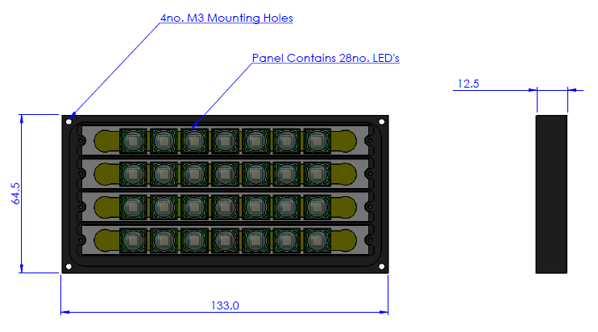
Conservatively at 100% rated strobed led power ( 9A per led).. 950W panel
- 70-80,000 lumens
Over driven at 166% rated strobed led power ( 15A per led).. 1650W panel
- 110-120,000lumens
Input 18-48Vdc
low constant power draw not exceeding 50W (typically <20W for 1-5fps)
Very high power density in a pressure compensated design light head
- custom shapes are possible
- Up to full ocean depth capability
Remote ballast bottle
- budget size 80mmOD X 170mm ling
- Available in different forms up to full ocean depth rating.
Micro processor Controlled with RS485 connectivity.
Fast ramp up and down or optical square pulse.
Triggered from camera or other external source
Temperature monitoring of light panel.
All inputs optically isolated.

