
Aphos 32 Operating Manual

Document Number: CA82-0030
Document Version: Rev 1.2

Table of Contents
1 Overview of the Aphos 32 Strobe light 4
2 Serial Communications Setup 5
2.1 Packet structure Host to Aphos 6
2.2 Packet structure Aphos to Host 7
2.3 Basic light operations 9
2.3.1 Adjusting the pulse duration 9
2.3.2 Adjusting the LED intensity 9
2.4 Command reference 10
3 Aphos 32 architecture 12
3.1 Capacitor bank charging 12
3.2 Triggering the Aphos 32 13
4 Modes of operation 14
4.1.3 Pulsed Mode 14
4.1.4 Single Shot Mode 14
4.2 Factory settings 14
4.3 Strobe operation – Pulsed 15
4.3.5 Delay 15
4.3.6 Pulse 16
4.3.7 Charge 1 – 4 16
4.3.8 Trickle 16
4.4 Strobe Operation – Single Shot 17
4.4.9 Example A32 single shot configuration 17
4.5 Single shot mode details 17
4.5.10 Light output 17
4.5.11 Auto Charging 18
4.5.12 Re-arming the light in single shot mode 19

List of Tables
Table 2-1 Host to Aphos 32 packet format 6
Table 2-2 Aphos to Host packet structure 8
Table 2-3 setting the light pulse duration 9
Table 2-4 setting the LED intensity level 9
Table 3-1 Aphos Strobe 32 Trigger input specifics 13
Table 4-1 Snapshot of factory set registers 14
Table 4-2 Strobe light pulse operation 15
Table 4-3 Example A32 single shot configuration 17

List of Figures
Figure 1 - Photo of the Aphos 32 Strobe light 4
Figure 2 - Serial setup for the Aphos 32 CLI 5
Figure 3 - Host to Aphos Strobe packet structure 6
Figure 4 - Putty setup to append CRLF onto each packet sent to the light 7
Figure 5 - Aphos Strobe to Host packet structure 8
Figure 6 - Power Data from an Aphos 32 @4Hz 12
Figure 7 - Strobe light setting box in the Cathx Camera configuration software 16
Figure 8 - Aphos 32 65msec single shot trace 18

Overview of the Aphos 32 Strobe light

The Aphos 32 Strobe light (strobe) is a pulsed only high intensity LED light designed for subsea operation. It consists of a subsea bottle and an LED panel. The bottle contains the control and interface electronics along with the energy storage capacitor banks and charging circuits. For reliability, the strobe consists of four independent channels each with their own charging, monitoring and storage circuits.
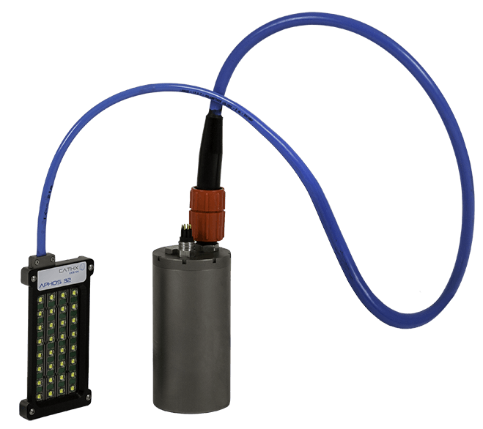
Figure 1 - Photo of the Aphos 32 Strobe light
The LED panel consists of 4 channels each with 8 high Power LED’s connected in series. Each channel is routed back to its associated channel in the bottle. The LED panels come in wide angle and controlled angle variants. To trigger the light, a TTL level trigger is applied to the Trigger +/- inputs via the rear bulkhead connector. The trigger input circuit is optically isolated. The light uses its own internal timing register to determine how long to fire for. This register is controllable over the RS485 interface.
To aid in quick deployment of the light, each Aphos 32 is programmed to automatically charge on power up. This means that the light can be strobed by applying a trigger signal, there is no software control required. Table 2 details the lights default factory setup. The light can be further controlled and configured via the RS485 interface on pins 3 and 4 of the rear bulkhead connector. The Strobe light has a full set of control registers and details of these are provided in the Serial communications section. The internal microcontroller in the light is equipped with a data EEPROM so the light will retain any settings that are programmed into its registers over the serial interface.

Serial Communications Setup
The light is equipped with an RS485 half-duplex serial interface. The baud rate used to communicate with the lights is 57600 baud. It is possible to change the baud rate to one of a fixed number of speeds. The data format used is 8 data bits, no parity and 1 stop bit (8N1). Fig.2 shows a screen shot from the Putty terminal software showing an example of the serial setup for COM6
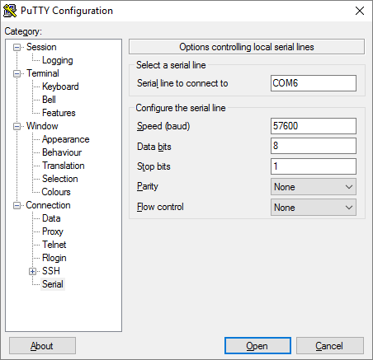
Figure 2 - Serial setup for the Aphos 32 CLI
The communications architecture is a master/slave system in the light. The light will never send data onto the RS485 bus unless it is asked to do so by the host.

Packet structure Host to Aphos
Fig.5 illustrates the packet structure for querying or commanding the light.
Figure 3 - Host to Aphos Strobe packet structure
When sending a query or command to a light the packet fields are broken down as shown in table 2-1;
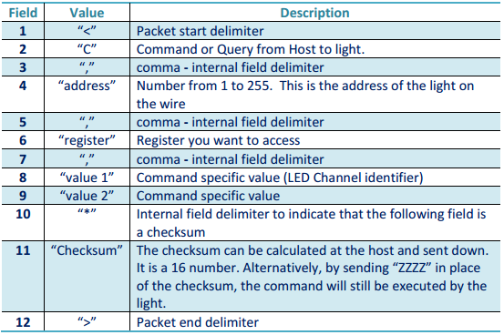
Table 2-1 Host to Aphos 32 packet format

Note 1:
Field 9 is optional. Many commands will have only a single parameter. Also when reading data from the light, you do not send anything in Field 8 or 9. The light will interpret the lack of parameters as a ‘Get’ command and return the relevant data to the Host. If a parameter is present in Field 8 (9) then the light will interpret this command as a ‘Set’ command.

Note 2:
For Strobe firmware version 132 and earlier, you need to append a carriage return and line feed (CRLF) onto the end of each packet sent to the light as there is a bug in the lights CLI code that causes intermittent packet receive failures. This has been resolved in later firmware versions. Fig.4 below illustrates how this can be appended in the Putty terminal program.
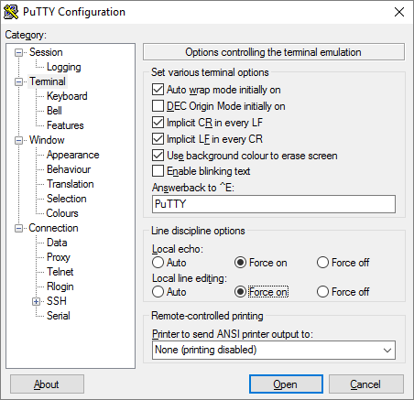
Figure 4 - Putty setup to append CRLF onto each packet sent to the light

Packet structure Aphos to Host
Fig.5 below illustrates the packet structure used by the light when responding to the host. The packet below is a single character response packet. In this case field 6 is the value returned from the light. Some queries from the light will result in more than one character being returned.
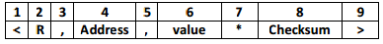
Figure 5 - Aphos Strobe to Host packet structure
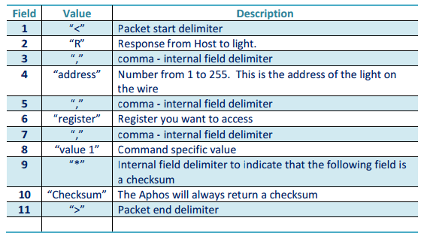
Table 2-2 Aphos to Host packet structure

Basic light operations
When the light leaves the factory it is setup in a ready to operate configuration. The light will simply need power and a valid trigger to begin firing. There is no requirement to control the light via the RS485 interface unless you wish to adjust its parameters.
The light is relatively simple to control and for most operations the only parameters that will need adjustment are the pulse duration and the light intensity.

Adjusting the pulse duration
The commands below can be used change the length of time that the light will turn on for when a trigger is received. The command is detailed in Table 2-3. Refer to the Command reference section for a list of all commands, their format and the expected reply.

Command (Host to Aphos) | Response (Aphos to Host) | Details
<C,2,s_pulse 3000*ZZZZ> | None | This sets the pulse duration to 3000 usec
<C,2,s_pulse*ZZZZ> | <R,2,3000*ZZZZ> | This command asks the light to send back its pulse duration
Table 2-3 setting the light pulse duration

Adjusting the LED intensity
The LED intensity will increase or decrease the LED power emitted from the panel. Be aware that the amount intensity of the panel will diminish as the frame rate increases. This is due to the fact that at high frame rates there is less time available for the capacitor banks to charge.
Command (Host to Aphos) | Response (Aphos to Host) | Details
<C,2,c_level 0 84*ZZZZ> | None | This sets the LED intensity to 84%
Table 2-4 setting the LED intensity level

Command reference
The following commands can be used to communicate with the lights. For this table the lights RS485 address is assumed to be 2.
Command | Syntax (Host to A32) | Syntax (A32 to Host) | Details
s_mode | <C,2,s_mode 1*ZZZZ> | None | This command will program the light into single shot mode. This is a non-volatile command
s_mode | <C,2,s_mode 0*ZZZZ> | None | This command will program the light for normal pulsed operation. This is a non-volatile command
s_mode | <C,2,s_mode*ZZZZ> | <R,2,1*ZZZZ> | By not sending a parameter the light will respond with the current s_mode value. In this case, s_mode is set to 1, i.e. single shot mode. (Note Checksum set to ‘ZZZZ’ for read examples)
s_shot | <C,2,s_shot 65*ZZZZ> | None | This command sets the single shot pulse duration. The units are msec, and the range is from 1msec to 100msec. In this example the shot duration is set to 65msec
s_shot | <C,2,s_shot*ZZZZ> | <R,2,65*ZZZZ> | This command reads the single shot pulse duration from a light. In this case the value is 65 so the light will fire for 65msec once a trigger is detected
s_trigger | <C,2,s_trigger 1*ZZZZ> | None | This command sets the light to be falling edge triggered. (W.R.T the trigger signal at the bulkhead)
s_trigger | <C,2,s_trigger 0*ZZZZ> | None | This command sets the light to be rising edge triggered
s_trigger | <C,2,s_trigger*ZZZZ> | <R,2,0*ZZZZ> | This command reads the lights trigger edge configuration. In this case the light it rising edge triggered.
set_vcap | <C,2,set_vcap 53*ZZZZ> | None | This command sets the charge voltage on the capacitor banks. The units are volts and must be entered as integers. The range is from 10V to 56V. For single shot operating, 53V is recommended.
set_vcap | <C,2,set_vcap*ZZZZ> | <R,2,53*ZZZZ> | This command reads the lights capacitor bank target voltage. In this case the lights will charge the capacitors to 53V
auto_en | <C,2,auto_en 2*ZZZZ> | None | This command sets the light to auto charge on power up. When it is sent to the light it is effective from the next restart.
auto_en | <C,2,auto_en 0*ZZZZ> | None | This command sets the light so that capacitor charging only occurs when a charge_en command is received. When it is sent to the light it is effective from the next restart.
auto_en | <C,2,auto_en*ZZZZ> | <R,2,2*ZZZZ> | This command reads the auto charge register. In this case the light is set to auto charge on power up.
Command | Syntax (Host to A32) | Syntax (A32 to Host) | Details
c_level | <C,2,c_level 0 80*ZZZZ> | None | Set the light level to 80%. Range is 0 to 100.
s_delay | <C,2,s_delay 100*ZZZZ> | None | Set light to wait 100usec after trigger is detected to power on the LED’s
s_delay | <C,2,s_delay*ZZZZ> | <R,2,100* ZZZZ > | Light response, strobe delay is 100usec. Note that cable delays are also present. On a 5 meter cable run max light output was achieved at +154usec from the trigger input
s_pulse | <C,2,s_pulse 2500*ZZZZ> | None | Set strobe LED pulse duration to 2500usec for pulsed mode operation
s_pulse | <C,2,s_pulse*ZZZZ> | <R,2,2500* ZZZZ > | Light response, strobe duration is 2500usec. Note this value is saved in the lights eeprom.
s_pulse_limit | <C,2,s_pulse_limit 10000*ZZZZ> | None | Set strobe maximum LED pulse duration to 10000usec for pulsed mode operation
s_pulse_limit | <C,2,s_pulse_limit*ZZZZ> | <R,2,10000* ZZZZ > | Light response, maximum limit for strobe pulse duration is 10000usec. Note this value is saved in the lights eeprom.  If the s_pulse is set to a value great than then s_pulse_limit the light will use the value of s_pulse_limit instead.
version | <C,2,version*ZZZZ> | <R,2,132*ZZZZ> | This command allows you to read the firmware version from the light
s_no | <C,2,s_no*ZZZZ> | <R,2,199*ZZZZ> | This command will read the lights serial number which should match the numerals stamped on the lights base plate. In this example the lights serial number is A32-0199
s_enable | <C,2,s_enable 1*ZZZZ> | None | This command enables the light for strobed operation.
s_enable | <C,2,s_enable 0*ZZZZ> | None | This command will disable the light, it will not respond to incoming trigger signals
s_enable | <C,2,s_enable*ZZZZ> | <R,2,1*ZZZZ> | Light response, this light is enabled.  Note this command is saved in the lights eeprom. So whatever you set it to is saved.
d_address | <C,2,d_address 3*ZZZZ> | None | This command can be used to change a light’s RS485 address; in this case the lights address is changing from 2 to 3. The usable range is 0 – 254. Address 255 is reserved as a broadcast address.
d_address | <C,2,d_address*ZZZZ> | <R,2,2*ZZZZ> | In this case the light responds with its RS485 address.
d_address | <C,255,d_address 2*ZZZZ> | None | Using the command in this manner will change the RS485 address of any light on the network from whatever it is to 2. So if you have a light with an unknown RS485 address you can use this command to set it to a known value.

Aphos 32 architecture

Capacitor bank charging
The Aphos 32 has been designed to operate with low input power, using a slow charge /rapid discharge architecture. The purpose of this is to ensure that the strobe light takes very little power from the vehicle power supply when the light pulse is active.
Figure 6 below shows a graph of data gathered from an Aphos 32 operating with a 24VDC supply and triggered by a 4Hz source. The light was setup to generate 3.5msec lights pulses at maximum output power. The blue trace is the power taken by the light during the charging cycles, the orange trace is the LED power for Channel 1 of the Aphos 32. The graph shows the power required by the light drops when the light is firing so that the vehicle supply is not adversely affected by the light discharge.

Figure 6 - Power Data from an Aphos 32 @4Hz

Triggering the Aphos 32
As stated above, the strobe light is configured to Auto charge by default. This means that as soon as power is applied to the Strobe light, it will begin charging. The initial (cold) charge time will vary slightly from unit to unit, but will be complete within one minute from power on. The purpose of the auto-charge control is to allow a user to operate the light without having to configure it via the RS485 interface. It is possible to change the lights setup so that it does not auto charge.
Once the cold charge is complete the light is then ready to operate. If at this point a trigger signal is present at the lights trigger + / - pin’s then the light will begin to strobe.
The light will continue to strobe so long as a trigger signal is detected on the lights trigger in pins. The Strobe can operate at frame rates up to 30Hz – but be aware that the light output will diminish with increasing frame rate. Table 3-1 below provides as guideline on the input range of the trigger signal that can be applied to the light.

Aphos 32 Strobe Input Trigger electrical specifications
Trigger +/- input voltage level | Minimum | Typical | Maximum
Trigger +/- input voltage level | 3.0VDC | 5.0VDC | 12VDC
Trigger input frequency¹ | Minimum | Typical | Maximum
Trigger input frequency¹ | 1/10Hz | 5Hz | 30Hz
Trigger signal pulse duration² | Minimum | Typical | Maximum
Trigger signal pulse duration² | 200usec | 1msec | ---
Trigger mode | Rising / Falling Edge | Software configurable
Table 3-1 Aphos Strobe 32 Trigger input specifics
¹ The frequency of operation will be a factor in determining the amount of light than the strobe can produce. Higher frequencies afford shorter recharge times for the capacitor banks
² The Strobe light is edge triggered, and can be triggered by an active high or active low signal. Also, note that the trigger input circuit is optically isolated and inverts the incoming TTL signal as it is processed. The 200usec time is defined as a safe tested minimum. Operation with smaller trigger widths is possible but has not been tested.

Modes of operation
The Aphos 32 has two distinct modes of operation available, these are; Pulsed mode and Single shot mode. These modes are selectable via the RS485 CLI.

Pulsed Mode
Pulsed pulse mode is the default mode of operation, in this mode the light will emit a pulse of light for every input trigger it receives. This is the normal operational mode of the light and would be the typical mode of operation for the light.

Single Shot Mode
Single shot mode is a secondary mode of operation designed for use in stationary undersea systems that would not be taking images sequentially. This mode of operation allow for very long light pulses to be generated in the light (up to 200msec), but the pulse repetition rate is much lower than in Pulsed mode, approx 1 image every 10 seconds.
The Aphos 32 ships in Pulsed pulse mode as default unless specified. The lights mode can be changed via the serial interface and the mode is a saved setting in the lights Eeprom.

Factory settings
The strobe light is factory configured with some default operational settings. For the most part the factory settings can be used as good defaults throughout the products life. However there are some parameters that may require tuning depending on the application. Table 4-1 details the factory default register load out.
Aphos 32 Strobe Default Operational Settings
LED pulse duration | Minimum | Typical | Maximum | Factory set
LED pulse duration | 200µsec |  | 10000µsec¹ | 2500µsec
RS485 Address | Minimum | Typical | Maximum | Factory set
RS485 Address | 1 |  | 254 | 2²
Automatic charge | Enabled | Disabled |  | Factory Set
Automatic charge | 1 or 2 | 0 |  | 2
LED current limit | Minimum | Typical | Maximum | Factory set
LED current limit | 1000mA | 25000mA | 27000mA | 25000mA³
Table 4-1 Snapshot of factory set registers
¹ The LED pulse duration is the time that the LED’s are on once the pulse has been detected. The larger this number is the longer the LED pulse is, and consequently the larger the power demand from the capacitor banks.
² The RS485 address will be set to 2 if the light is shipping in a quantity of 1. If however there is more than one light in the order, then the serial number of the light will determine the RS485 address.
³The LED target current is used by the Lights PID control algorithm to set and maintain the peak current output from the light. As with point ¹ a large figure here will require more power than a smaller figure. To achieve an output of 100000 Lumen at 5Hz, it is recommended to put this number to 18000. The LED’s used on the panel are rated for pulsed operations up to 27000mA

Strobe operation – Pulsed
The strobe light contains an internal microcontroller that controls how the capacitor banks are charged and also monitors the LED channel current to maintain output stability over a range of trigger frequencies and pulse durations.
When pulsing, the Strobe light is effectively a finite state machine. Note here that during the pulse, the light electrically disconnects itself from the vehicles power system to prevent the vehicle ‘seeing’ a spike in power demand during the pulse duration. Table 4-2 shows how the light changes state when strobing.
1 | 2LED ON | 3 LED OFF | 4 LED OFF | 5 LED OFF | 6 LED OFF | 7 LED OFF
DELAY | PULSE (LED ON) | CHARGE 1 | CHARGE 2 | CHARGE 3 | CHARGE 4 | TRICKLE
CH1 OFF | CH1 LED ON | CH1 FAST | CH1_OFF | CH1_OFF | CH1_OFF | CH1 TRICKLE
CH2 OFF | CH2 LED ON | CH2_OFF | CH2 FAST | CH2_OFF | CH2_OFF | CH2 TRICKLE
CH3 OFF | CH3 LED ON | CH3_OFF | CH3_OFF | CH3 FAST | CH3_OFF | CH3 TRICKLE
CH4 OFF | CH4 LED ON | CH4_OFF | CH4_OFF | CH4_OFF | CH 4 FAST | CH4 TRICKLE
Table 4-2 Strobe light pulse operation
There are seven different stages (states) to the lights trigger operation, as follows;

Delay
This is a configurable state, it is entered whenever the microcontroller detects the incoming trigger and acts as delay from trigger acquisition to actual light output. This is used when the light is being operated in a multi spectral imaging setup. The length of this delay is configurable via a serial command. Refer to the API for details on this.

Pulse
This is the state where the lights actually fire. It occurs once the delay state has elapsed and its length is user configurable. It’s the state where the light is on. On the Cathx Configuration software, this state is controlled via the Pulse Duration slider as illustrated in Fig.7;
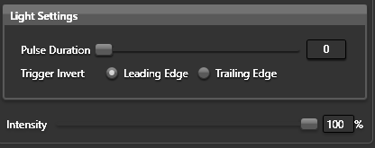
Figure 7 - Strobe light setting box in the Cathx Camera configuration software

Charge 1 – 4
These states are the channel fast charge states. The named channel is fast charged during these states. Only one channel is fast charged at a time. The fast charge current is set by the LED current control PID algorithm. The duration of the each charge interval has a limit of 56msec. The duration is calculated by the microcontrollers frame rate reading function.

Trickle
This state is only entered if there is enough time in the interval between pulses. During this state all channels are charged at a minimum effort. This is used to top off the channels during low frame rate operations.

Strobe Operation – Single Shot

Example A32 single shot configuration
The command list below will setup an A32 to operate in single shot mode where the light will be falling edge triggered. The light pulse will be set to fire for 85msec. The A32 will also auto charge once power is applied.
<C,2,auto_en 2*ZZZZ> | This command sets the light to auto charge on power up. Effective from the next restart
<C,2,s_mode 1*ZZZZ> | This command will program the light into single shot mode
<C,2,s_trigger 1*ZZZZ> | This command will configure the light to be falling edge triggered
<C,2,s_shot 30*ZZZZ> | This command will fire the LED’s at full power for 30msec once the trigger is detected
Table 4-3 Example A32 single shot configuration

Single shot mode details

Light output
Fig.8 shows a data grab of the LED current and voltage captured from a single channel of an A32 firing in single shot mode. The graph spans a total of 120msec. The blue line is the LED voltage and the orange line is the LED channel current. The left hand y axis measures LED voltage and the blue trace is related to this data. The right hand y axis is related to the LED current (orange trace)
In this instance the lights capacitors were charged to 46V and the pulse duration was set to 65msec. It can be seen from the graph that the power provided to the LED channel drops exponentially once the pulse begins firing. There is a plateau at the start of the pulse where the LED current is relatively constant. By 2msec into the pulse the LED current starts to drop. Increasing the charge voltage on the capacitor bank to 53V will extend this curve further.

Figure 8 - Aphos 32 65msec single shot trace
Although the shape of the LED current curve is a decaying exponential, it should be noted that the light LED’s are on for the entire 65msec and in fact the forward current applied to the LED’s is enough to maintain 100,000 lumen for the first 7.5msec of the pulse. Beyond that the lumen output is falling off but there is still considerable light being generated right up until 20msec. After 20msec the light is falling rapidly and by 65msec is low.
If the camera being used has a global shutter in place, it will have the benefit of being able to integrate all the light produced by the A32 for the entire 65msec.

Auto Charging
If Automatic charge is enabled the light will immediately being charging its capacitor banks once power is applied. There are 4 independent switch mode charging circuits inside the A32 bottle. Each of these is assigned to an LED channel. To prevent excessive loading when power is applied the microcontroller staggers the channel charging by 1 second. So channel 1 starts charging, the one second later channel 2 starts and so on until all four channels are charging. Once each channel reaches the target charge voltage the lights arms itself and if a trigger is received from this point onwards the lights will flash.
The advantage of auto charging is that the light does not need any software intervention to fire. Once the lights have charged all you need to do is apply the trigger and the light will fire according to its programmed parameters.

Bench top method for Determining when the light is ready to fire
Before leaving the factory all lights have their auto-charge time measured and entered into the build configuration documents that accompanies the light. If you don’t have that, there is a method of determining the auto charge time, this requires an RS485 interface to the light.
- Turn off the light and leave it off for at least 10 minutes.
- Start-up Putty (or whatever command line tool you use)
- Enter the following command but do not press enter on the keyboard <C,2,rep_vcap 1*ZZZZ>
- Get a stopwatch ready.
- Power on the light and wait approx. 3 seconds. Press enter on the keyboard to send down the last command and start your stopwatch.
- As soon as the light has auto charged it will output 4 lines on the screen detailing the voltage on each channel. Stop your stopwatch when this appears.
- The elapsed time is the auto-charge duration, with some error in terms of the 3 second delay at the start.

Re-arming the light in single shot mode
The single shot mode developed for the A32 was designed to be used on a permanent installation where power conservation is a key requirement. In normal ‘pulsed’ mode, once the LED’s fire the A32 immediately begins recharging its capacitor banks. In single shot mode, once the LED pulse is over the light internally shuts down; it disables its trigger input and does not recharge its capacitors banks. This minimises the power drawn from the light once the LED’s have fired. To re-arm the light for the next pulse you must power cycle the light.

