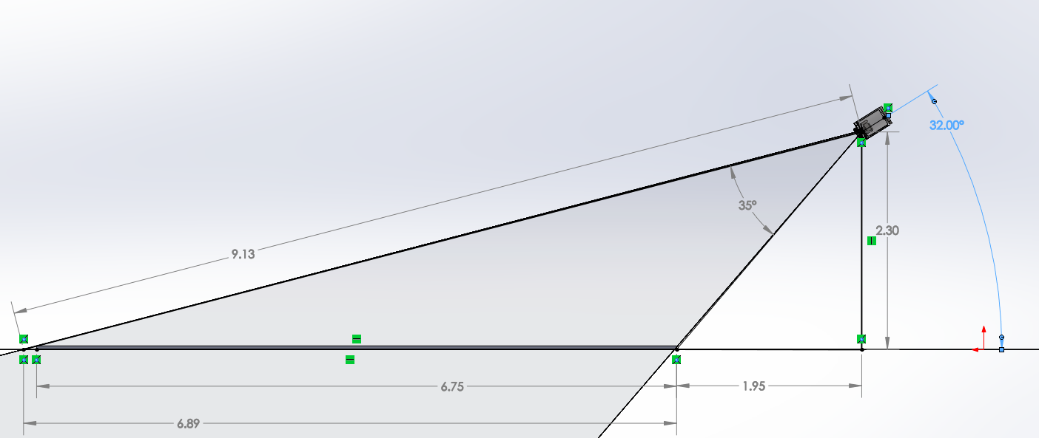
Figure 1: Side View of Tripod FOV
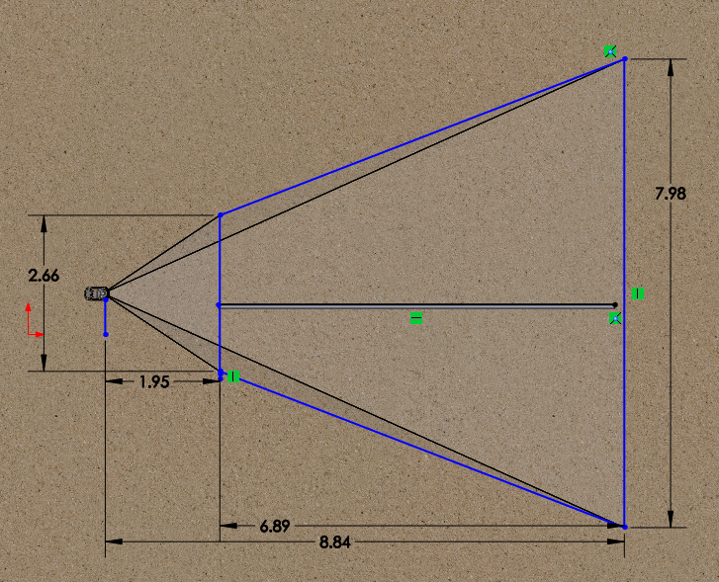
Figure 2: Plan View of Tripod FOV. Imaged area on Seafloor is 36.6 m²

