Iceberg AUV Camera system requirements

Revisions
2/2/15 | Initial | BH
- Scope of the Project
MBARI operates a long duration time series observatory at Station M, which is in 4000 meters of water about 120 nm off central California in the Eastern Pacific Ocean. This observatory has been taking hourly images for over 18 years. We are interested in extending the service interval of this observatory and one of the drivers for that interval is to replenish the energy storage and one of the dominant energy consumers is the existing xenon strobe system. Two, 250J xenon strobes are used and they have a guide number of about 32 and area placed about 1m on either side of the camera, oriented as shown in Figure 1 and 2 below. The camera system was upgraded from a 35mm film camera to a Canon 5D DSLR camera in 2007 and a second upgrade to a Canon 5D Mk2 is planned for 2015. The increased sensitivity of these cameras over the original film should require less light to provide an equivalent, or better image of the seafloor. One of the lighting challenges is to adequately illuminate the seafloor far from the camera without saturating the ground in front of oblique view of the camera. We are looking for a lighting solution that will consume less energy, does not require major changes to the existing system and provides even light distribution on the seafloor to produce equivalent or better images.

- Requirements
  - User/High-Level
    - A lighting system is needed for operation continuously at Station M that consumes less power than the existing dual xenon strobes.
    - The new lighting system shall provide similar illumination intensity and coverage to the current xenon-based system.
    - The new lighting system shall not require changes to the existing electrical system, or tripod structure.

  - Design-Derived
  - The lighting system shall be depth rated to at least 4000m [2.1.1]
  - The lighting system shall be fabricated out of materials that will survive 20 years of continuous deployment, e.g. Titanium, plastic, FRP. [2.1.1]
  - The lighting system shall draw no more than 2 amps peak current and operate with a bus voltage of 22-32 vdc. [2.1.3]
  - Once per hour the camera will apply bus power to the lighting system to charge the ballast for one minute; then, pull a light trigger line to ground to turn on the light for the pre-planned duration and then power will be removed 30 seconds later. The duration the lights are on shall be configurable through a serial data deck cable but the deck cable should not be needed for normal operation. [2.1.3]
  - The lighting system shall be bright enough so the camera exposure length is shorter than 100 ms and a maximum ISO setting of 3200 is needed to produce images comparable to existing images of which Figure 4 is an example. [2.1.3]

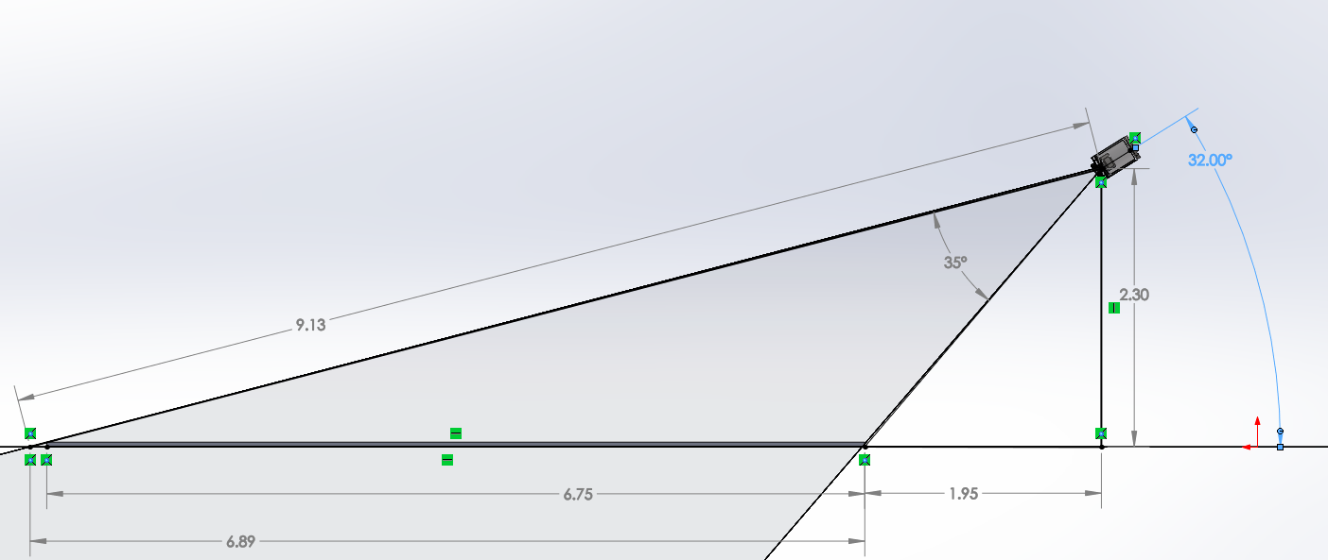
Figure 1: Side View of Tripod FOV
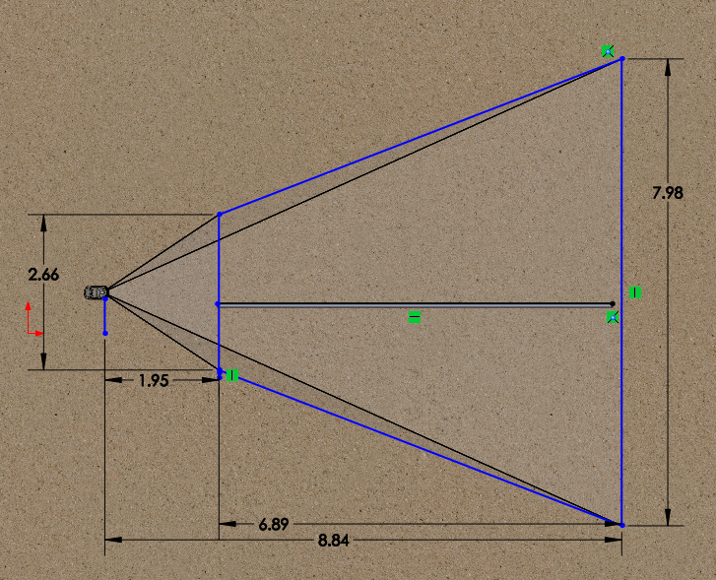
Figure 2: Plan View of Tripod FOV. Imaged area on Seafloor is 36.6 m²
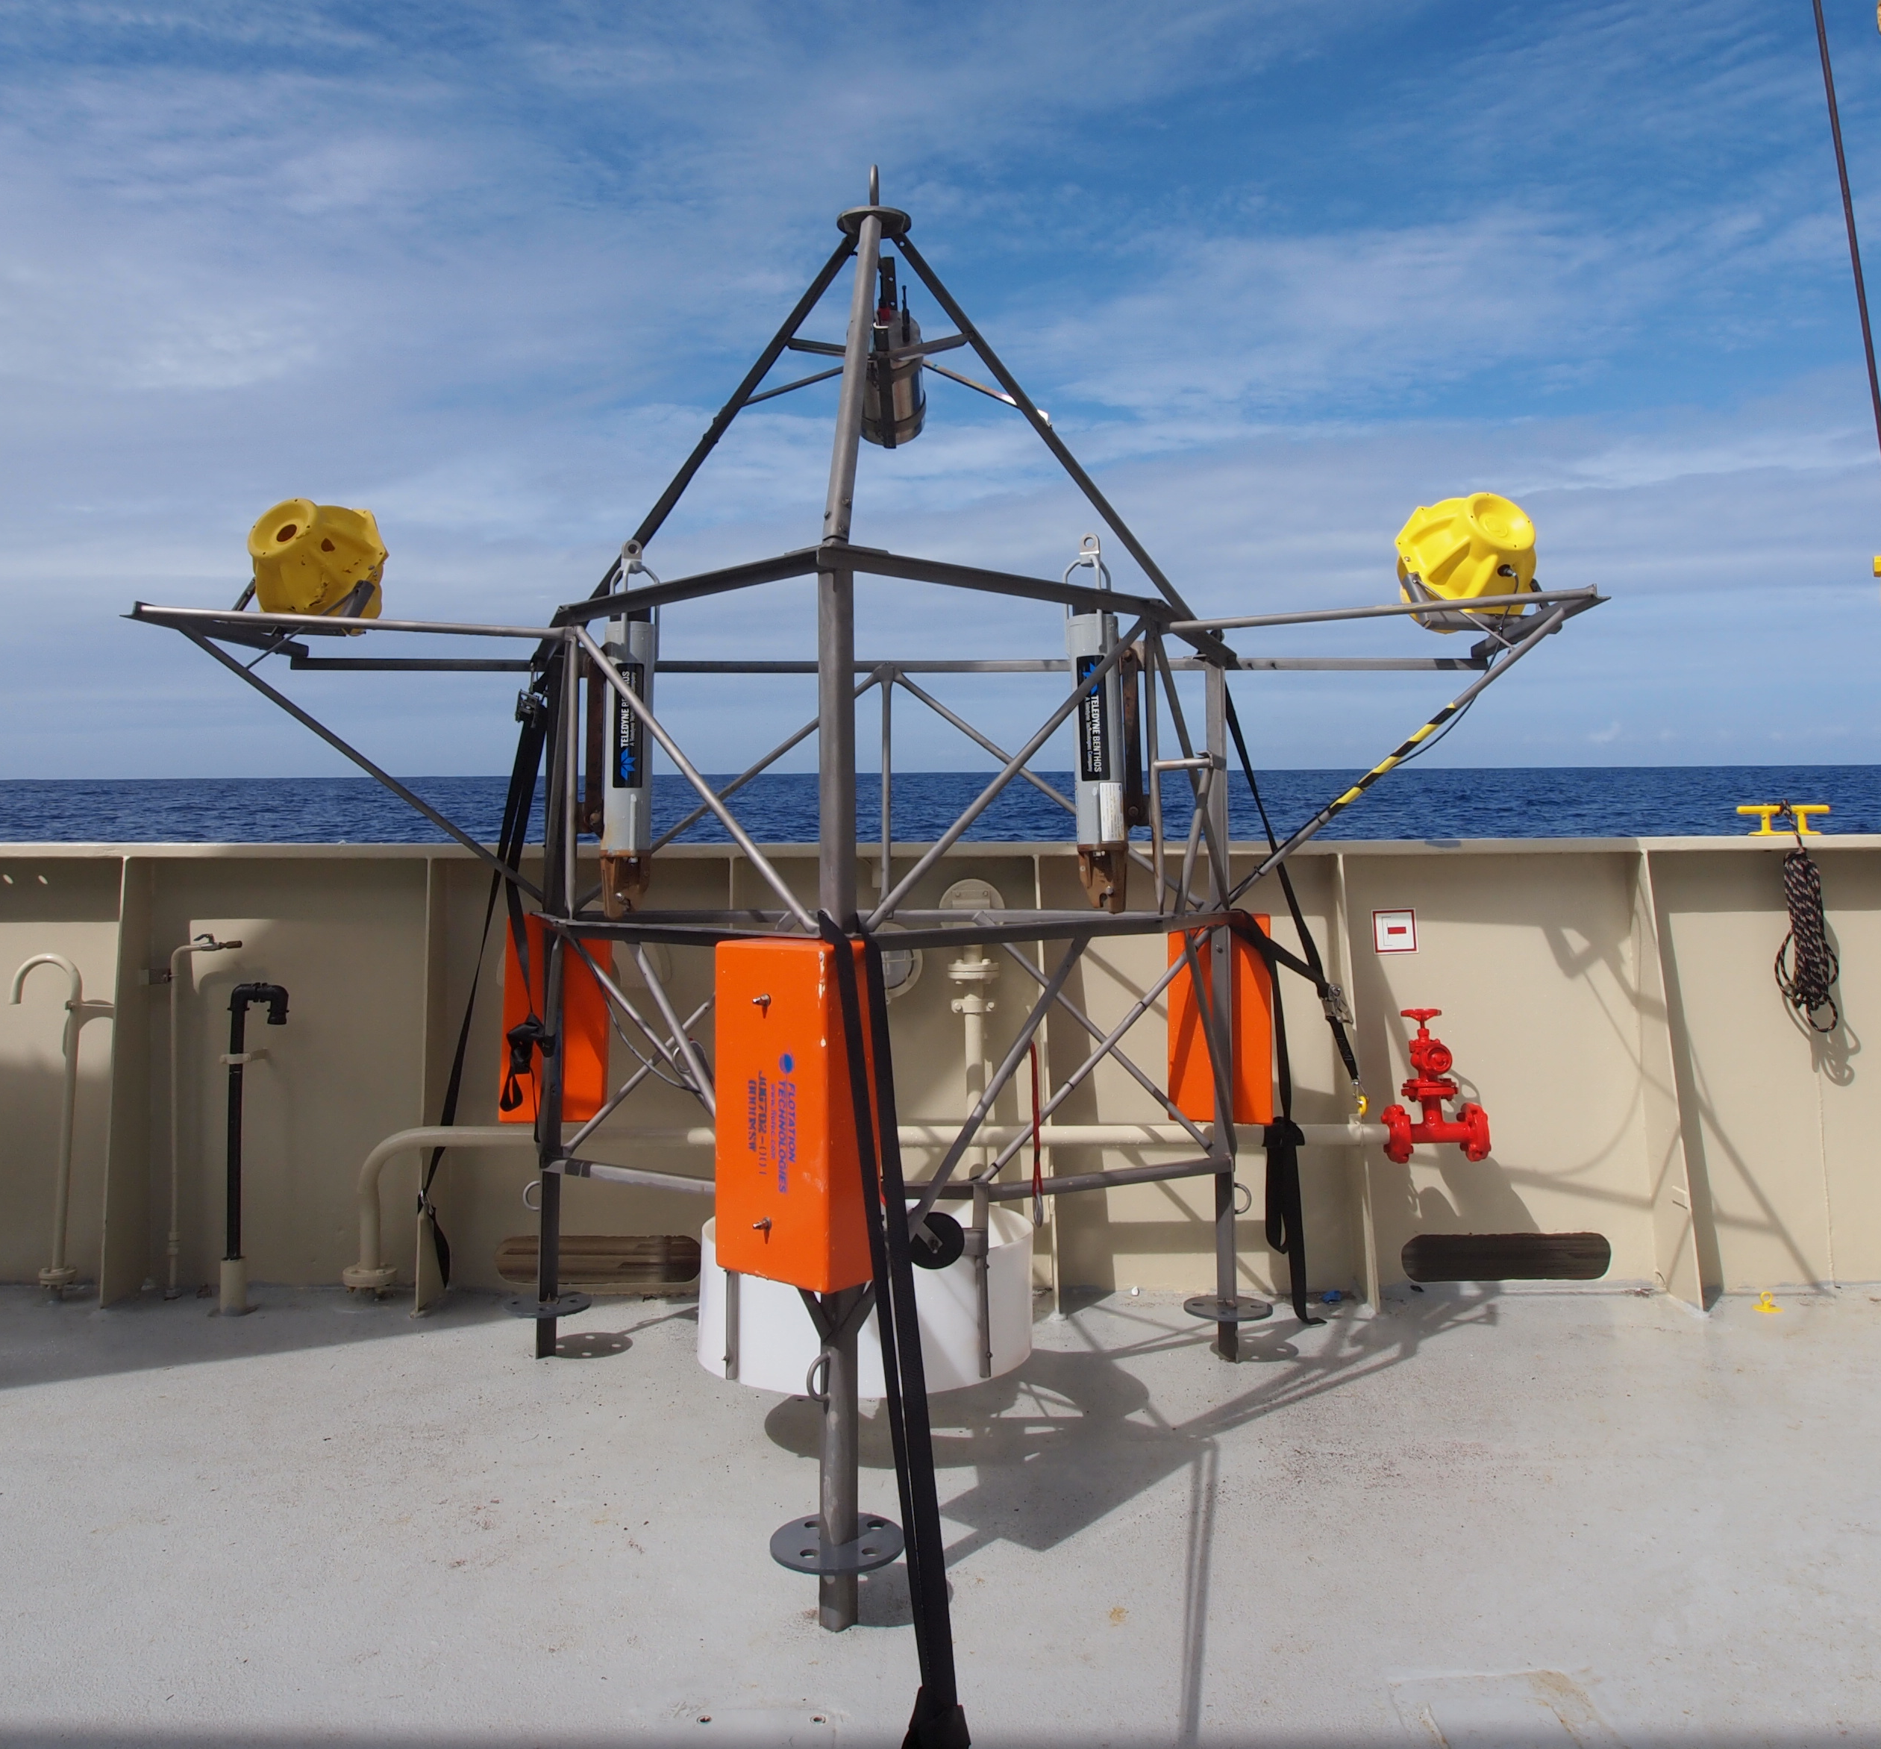
Figure 3 Camera Tripod on deck
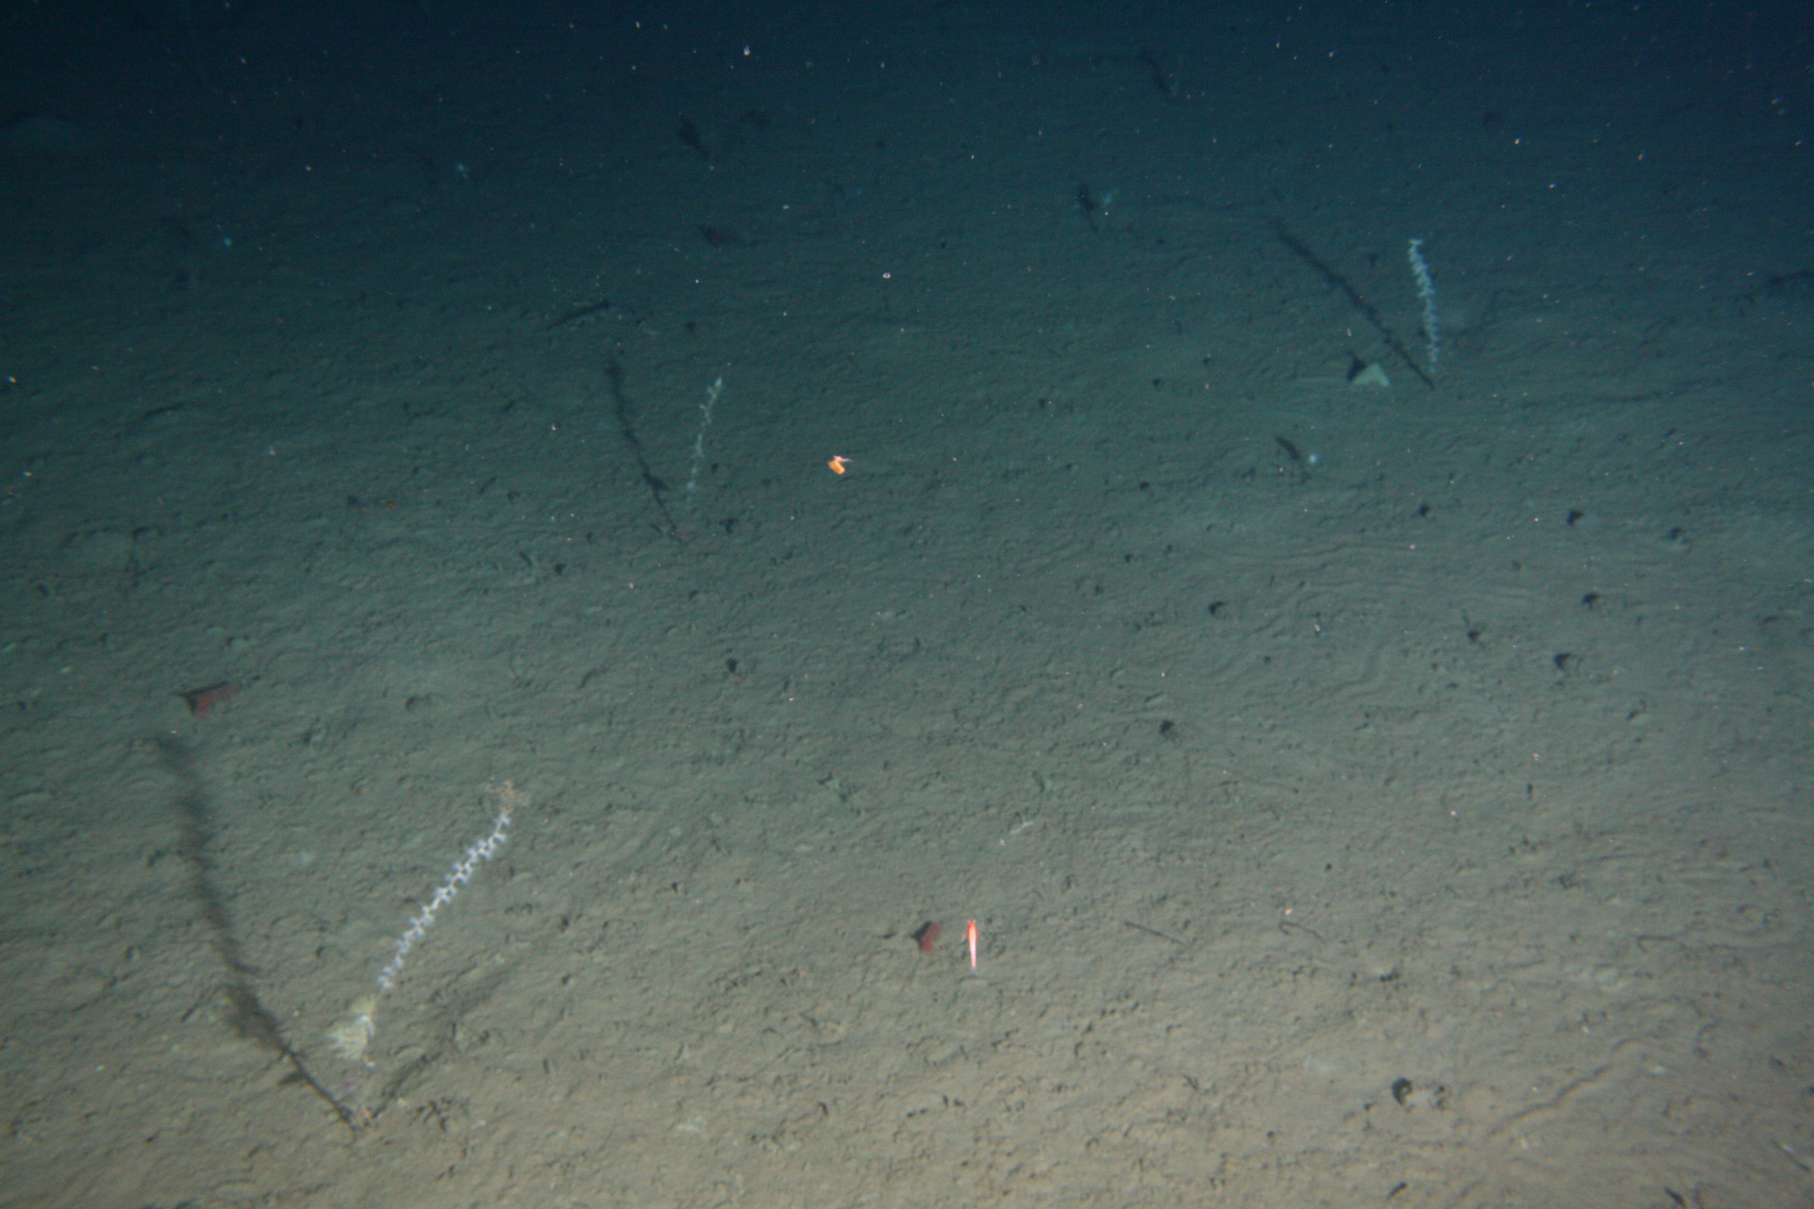
Figure 4 Typical tripod image

