Aphos Strobe 32 – Lightning Bolt
  - Scope trace data for MBARI
  - 23-July-2015

Introduction
This document contains screen grabs secured from a TDS3032B oscilloscope at the Cathx facility. The data recorded related to the effect of the strobe light on the vehicle power supply. Figure 1 below shows an illustration of the test setup used to acquire the data.
Figure 1 test setup in Cathx facility

AC component on the PSU supply line into the strobe light
The scope data shown in Figures 2 and 3 show measurements made as per the setup in figure 1, with the following exception;
Figure 2 shows the result with no Filtering of the Power supply voltage. So no common mode choke and no bulk capacitance.
Figure 3 shows the same with the Power supply filter in place.

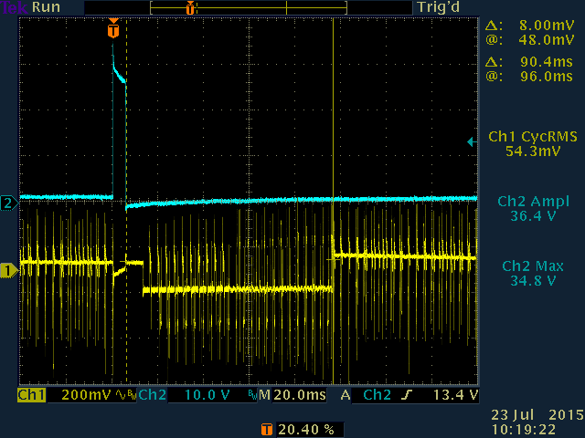
Figure 2 AC noise from strobe light with no filtering in place
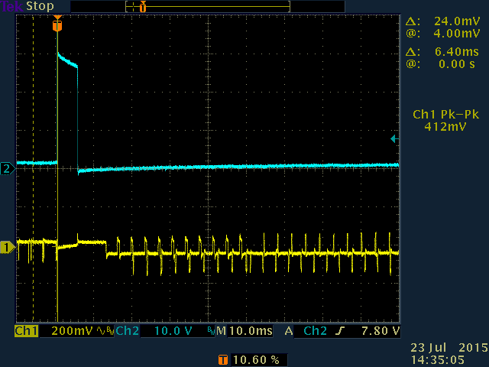
Figure 3 AC noise from strobe light with filtering in place

Figure 4 below shows how the data on the scope can be interpreted from the point of view of timing;
Figure 4 Explanation of the waveforms from Figure 2 and 3

Figure 5 Ripple voltage on the Power supply line – close up
Figure 5 shows a close up of the ripple induced on the PSU line. The Strobe light uses 4 DC/DC boost converters to charge the 4 capacitor banks. These 4 DC/DC converters are set to run at a nominal rate of 304Hz – however this rate is set by a capacitor value. The tolerance on the capacitor is 20% and so the frequency of the DC converters does vary a little.

Differential measurements
These measurements used 2 channels of the scope with the scope ground point being connected to the PSU earth and the Ch1 of the scope being set to the 24V+ supply while Ch2 is set to the 0VDC supply. Figures 6, 7 illustrates the results of these measurements

