Smith Macro Camera Operational Procedures
September 8, 2021

Deployment
  - Once the tripod is assembled and all the cables (strobes, battery NOT laser yet) and connected to the Camera housing, assemble the following to prepare the unit for deployment:
    - Laptop computer with: uCon, VirtualHere, Canon EOS Utility
    - Power supply capable of +24V at 3A
    - Deck cable with MCIL10M at one end, and banana plugs, RJ45 and DB9 at the other end
  - Set laptop network connection before turning system on:
    - Network addresses:
      - RaspberryPi in Camera Houing
        - IP address: 192.168.1.15
        - Subnet mask: 255.255.255.0
        - Gateway: 192.168.1.1
      - Ensure laptop set to:
        - IP address: 192.168.1. X
        - Subnet mask: 255.255.255.0
        - Gateway: 192.168.1.1

  - Plug deck cable into Camera housing MCBH10F connector and to power supply and laptop. The DB9 is not currently used in this system.
  - Turn the power supply on. At +28V the system should draw between 120 - 150 mA.
  - Test network connection by opening a command window and “ping”ing the camera IP address. (command is “ping –t 192.168.1.15”, you can also “ping raspberrypi.local”) To stop pinging press “ctrl”+”c” at the same time.
  - Open up VirtualHere window (icon labeled vhui64.exe, when the Raspberry Pi is booted up, you should see:
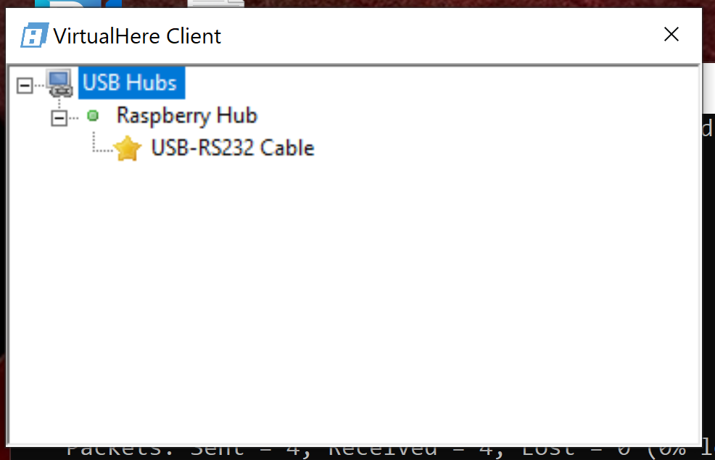
  - You should see one for USB-RS232 Cable. Right click on “USB-RS232 Cable” click on “Use This Device”
  - Now it should look like this: 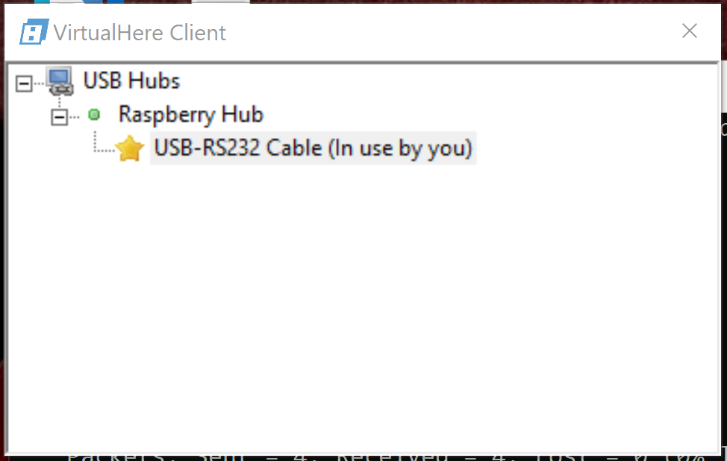

  - Next open up the terminal software uCon to talk to the Snappy Camera controlller.
Open uCon and implement logging and timestamping as described in section 1.m. . 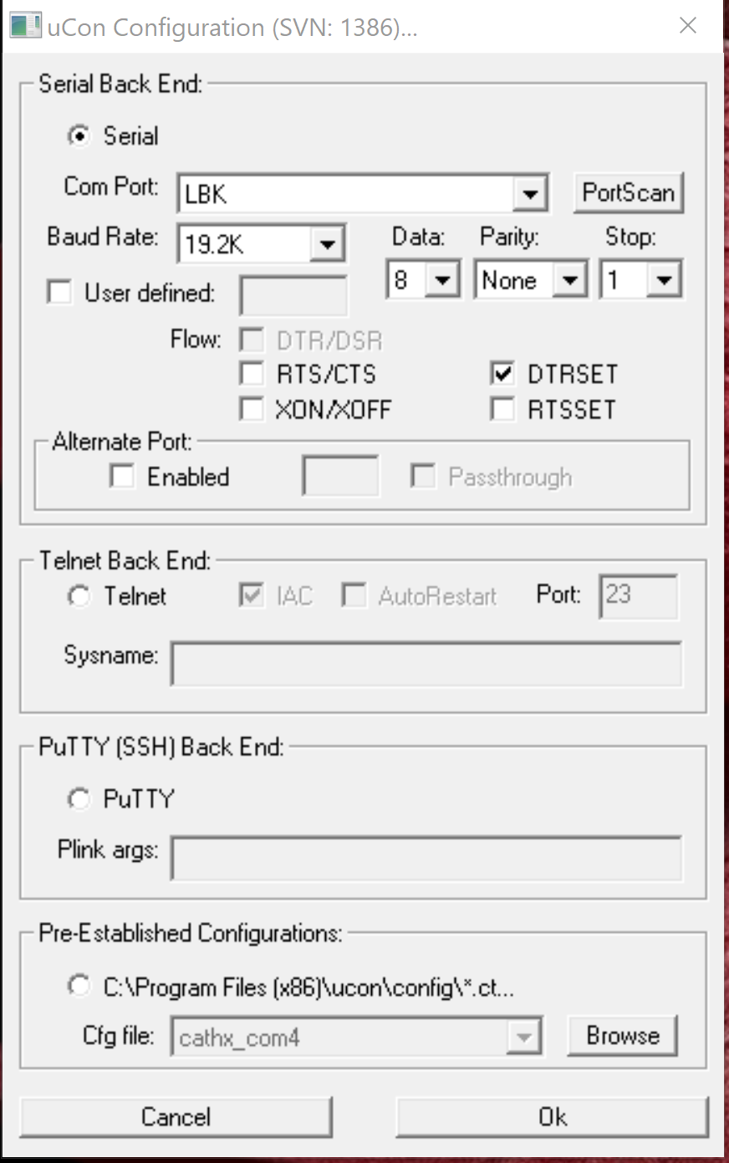
    - Click the “PortScan” button to update the serial ports in the “Serial Back End” section of the configuration. If you are not sure of which port it is check in Device Manager.
    - Connect at COMX 9600,8,n,1. Press OK and a terminal window will open.
    - If you press return you should see a prompt with the Snappy version number, if not recheck you have selected the right COM port. Once you are “talking” to Snappy proceed through the next steps.
    - Turn on time-stamping and logging in ucon
      - In the Config menu select “Timestamp”
      - Select “Enabled” and “Stamp at toggle” and “Local only”
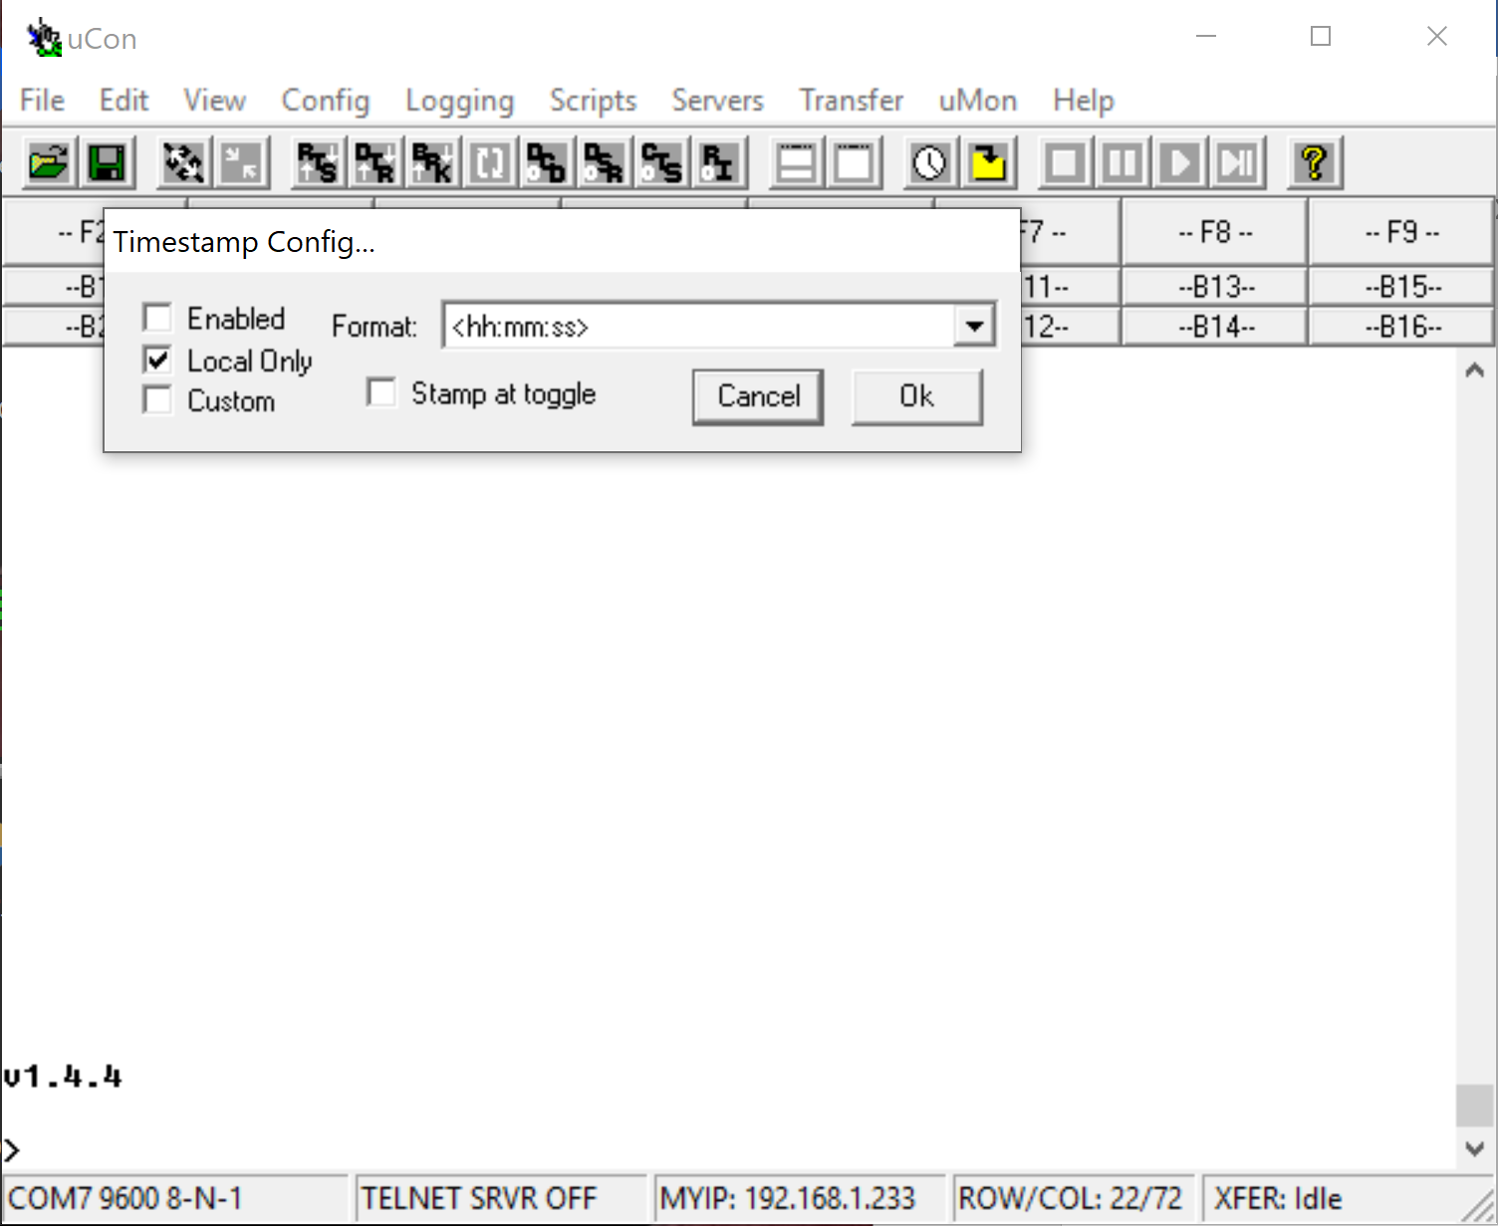

      - Press OK and continue to setting up logging
      - Under the “Logging” menu select “Standard” then you will see this window:
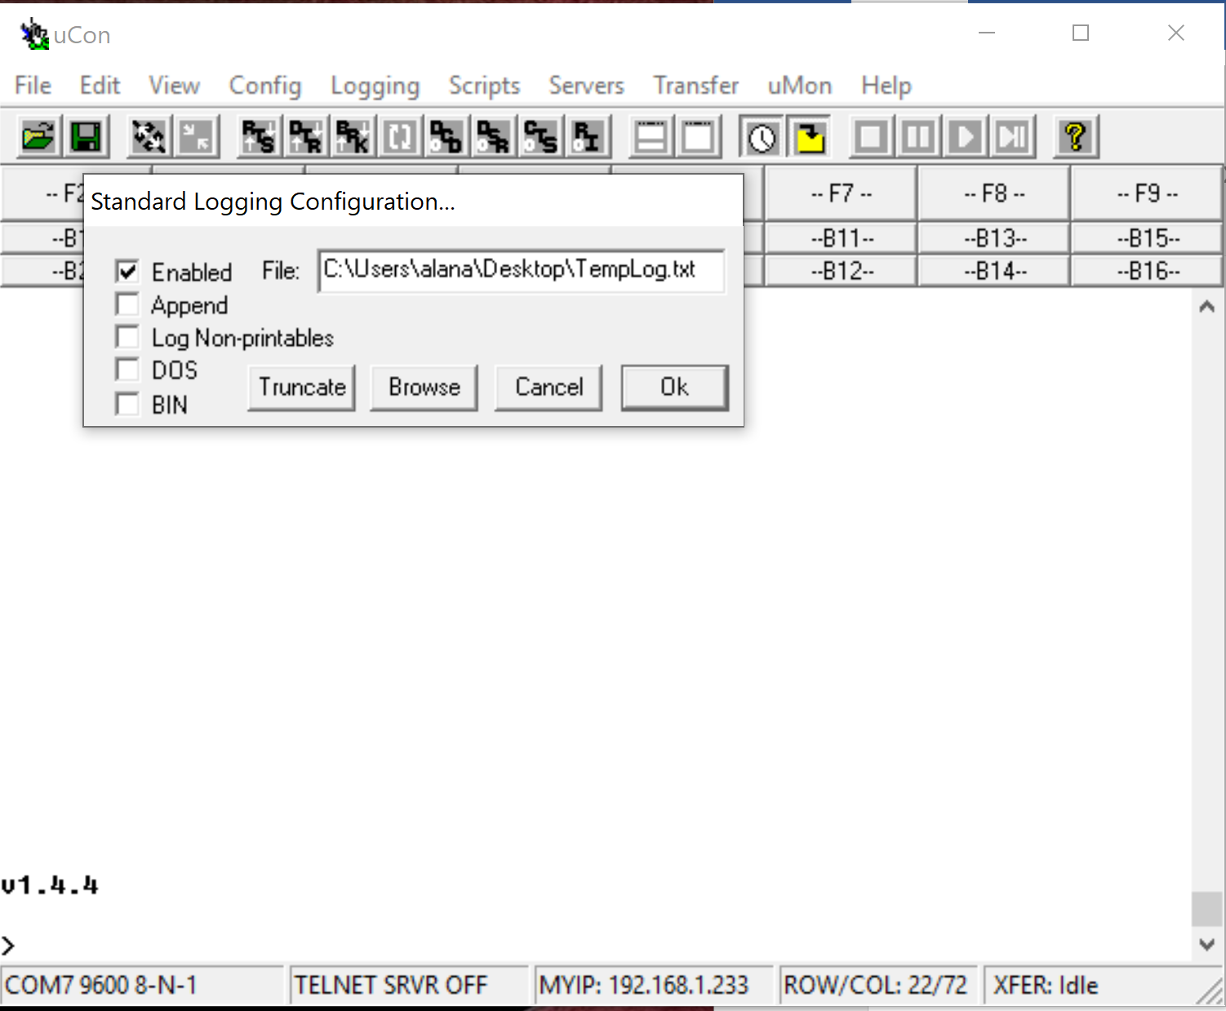
      - Select “Enabled” and then using the “Browse button” you can name and save the file in a place you won’t forget. Press Ok when finished.

  - Once uCon is open, press enter and you should see the software version on the Snappy Controller. This is version 1.4.7 .
  - There is no menu option for Snappy so use the command set at the end of this document.
  - Before programming the mission verify the function of the following:
    - Strobes
      - Type “25” this provides power to the capacitors powering the strobes. You cant test the two strobes separately on this system without unplugging on or the other (despite the commands for “right” and “left” strobe, turning on either strobe provides power to both. UNLIKE the smith strobes, these must be turned on to be triggered.
      - Type “22” to see voltage on strobe, see if it is charged now ~37 V
      - After charge time is complete (5 seconds max), type “30” to trigger the both strobes.
    - Test the camera
      - Type “19” plus enter to turn the cameras on
      - Important to know, with this Canon camera the remote shutter trigger used by snappy will not work when the deck or ODI cables is powered up AND the Canon “Remote Shooting” software is no open. The camera is locked up by the USB port until you start the software. Nor will the strobes fire if you take an image with LIVEVIEW open.
      - The camera is on it should appear in the VirtualHere window:
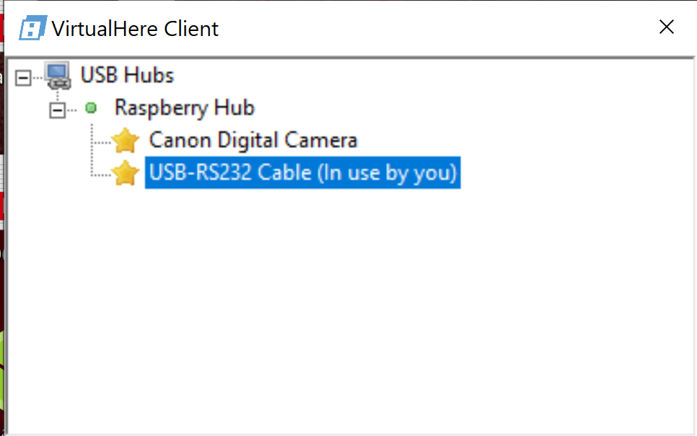
      - Right Click on “Canon Digital Camera” and select “Use this Device” from menu, this should result in Canon EOS Utility software starting up.
      - Select “Remote Shooting” from the EOS Utility Window:
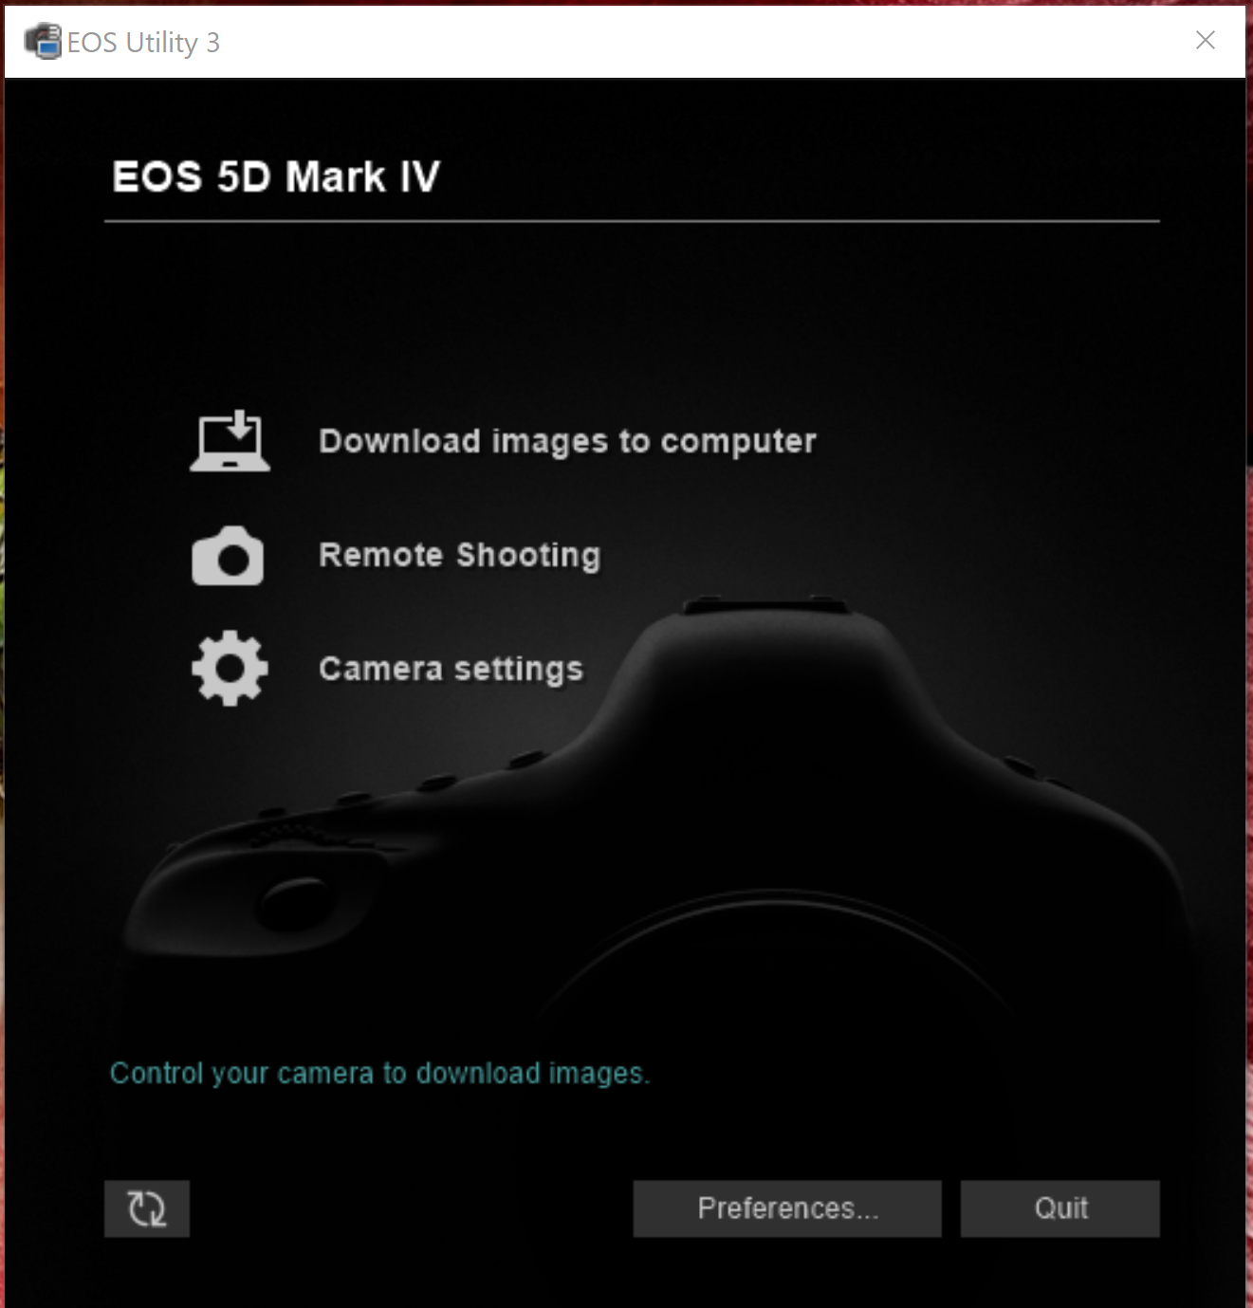

      - The remote shooting window looks like this: these were camera settings for 2020-2021 deployment below:

Now you can control the shutter both with the button on the upper right and using the commands to snappy listed below

      - Use “32” or “34” to take an image with the FF camera. “34” will charge the strobes as well.

      - Use EOS utility to verify camera settings:
        - ISO= CHECK
        - Shutter = CHECK
        - White balance = AWB
        - Image quality = Large Fine
        - Check the date and time
      - The button in the upper right hand corner takes a picture, which will be automatically uploaded. Take a picture to try out.
      - Once this is tested, practice taking images in the mode of an ROV dive which is to turn on both strobes than use the trigger button on the EOS window to capture an image. Verify this triggers the strobes.
      - Once this is complete you can close the EOS Utility window and then in the Virtual Here window right click on the camera and select “Stop Using this device”. The device will still appear in the window but will not say “(in use by you)” next to it.
    - Once camera is set and tested type “20” to turn camera off
    - Read battery voltage by typing in “14” and enter. The battery pack should start out around +24V??
    - Once you are satisfied that all subsystems are operational, it is time to start a mission
  - Starting the mission
    - Set Clk by typing “17”, this will lead you through setting the date and time. Use only 2 digits for the year.
    - Type “18”to read clock and confirm correct time.
    - Set delay: type “9” to set the delay. This is the time between sending the deploy command and starting the mission. I set for 120 seconds to allow a shutdown to the raspberry pi and turn off the deck cable. If the raspberry pi is powered up EVEN if the camera is not connected through the Virtual Here, it may interfere with the cameras ability to take images using the remote connection. Confirm delay by entering “10” to read the delay value
    - Set sleep: use command “7” to set the sleep. Sleep is the number of minutes between taking a picture. Set this to 1 minute less than you want the elapsed time to be. Read that it is set correctly by typing 8
    - Once sleep and delay are set you can start the deployment by pressing “3”. Once the deployment is started if you want to interrupt it, you will need to either disconnect battery power or wait until the PIC wakes from sleep to take the next picture. See step “2. o”
    - Disconnect deck cable, and replace dummy plug (clean and lubed with medium 44).
    - Plug in laser cable just before deployment!!!!
    - Make sure beacons have fresh batteries and are turned on.
    - Release belay pins for recovery line
  - To “halt” the system you need to type “5” either:
      - If you can disconnect the battery, turn deck power off for a minute – so that it is completely powered down. Have your ucon window up and ready, same with virtual here. As soon as you power it up wait for the virtual here to bring up the USB-RS232 cable then select “Use this device”, then jump to ucon and use the button with the two arrows pointing to each other to connect. You should see the system counting down from 70, type “5” to halt. Do this twice.
      - IF you cant disconnect the battery you need to connect through the deck cable. Once you are connected and powered up, use Virtual Here to enable the USB to serial server. Open uCon and patiently wait for the PIC to wake up. You then have 20 seconds to halt the program by pressing “5”.

  - Take screen grab of ucon window with communications to snappy before closing then check your log file worked.
  - The end!
Final deployment checklist
      - Battery plugged in
      - Camera taking images
      - Laser plugged in
      - Acoutsic release set up
      - Tripod secured to elevator
      - Elevator release lines secure

- Recovery Procedures
  - Once camera tripod is on deck thoroughly rinse the system with fresh water.
  - Dry connector on battery can with towel, then disconnect the cable from the battery housing to the camera housing and dummy it off. This removes power from the camera controller. Use a metal shell dummy cap to seal the connector on the battery housing, and a plastic or metal plug on the cable side to protect the connector.
  - Start up a laptop that has the following software: VirtualHere, uCon, and Canon EOS Utility. These three programs will allow you to download all data and images.
  - Connect the deck cable to the MCBH10F connector on the back of the camera housing. Secure with ziptie to the frame near the camera. In the lab, connect the RJ45 of the deck cable either directly to the laptop or to a network switch to which the laptop is already connected. DO NOT have switch attached to any external network (ship, shore, etc)
  - Network addresses:
    - RaspberryPi in Camera Houing
      - IP address: 192.168.1.15
      - Subnet mask: 255.255.255.0
      - Gateway: 192.168.1.1
    - Ensure laptop set to:
      - IP address: 192.168.1. X
      - Subnet mask: 255.255.255.0
      - Gateway: 192.168.1.1
  - Power Supply: Set up a power supply capable of +28 V and at least 3 A. Confirm that voltage and current settings and then plug in banana plugs to the power supply.
  - Turn power on to deck cable. You may see an initial voltage dip, but the power supply should draw about 120 - 150 mA @28V when the pi is booted up.
  - Test network connection by opening a command window and “ping”ing the camera IP address. (command is “ping –t 192.168.1.15”, you can also “ping raspberrypi.local”)
    - If you do not get a response after 40 seconds:
      - Check deck cable is drawing correct current
      - In command window type “ipconfig” then hit enter, check that your laptop is set at the right IP address
      - Confirm there are lights coming from the RJ45 connection from the deck cable and your laptop if using a switch
    - If you get a reply proceed to the next step
  - Open Virtual Here software (icon on desktop says “vhui64”
  - Ideally you see something like this:
  - Right click on “USB-RS232 Cable” and click on “Use This Device”, the order you click the devices effects which com port it is assigned. The com port number also varied by laptop.
  - Now it should look like this:
  - Next open up the terminal software uCon. The configuration window looks like this:
    - Click the “PortScan” button to update the serial ports in the “Serial Back End” section of the configuration. Use device manager if you do not have a good idea which COM port is attached.
    - Connect at COMX 9600,8,n,1. Alternatively check the “Pre-Estblished Configurations” at the bottom of the window for a DiSCO config file. This will have the right setup. Press OK and a terminal window will open.
    - If you press return and do not see a prompt you chose the wrong com port, to change it go into go to the configuration menu at the top of the screen, select “Backend” then “Com port” and you will be taken to a menu where you can change the port number.
    - Turn on time-stamping and logging in ucon
      - In the Config menu select “Timestamp”
      - Select “Enabled” and “Stamp at toggle” and “Local only”

      - Press OK and continue to setting up logging
      - Under the “Logging” menu select “Standard” then you will see this window:
      - Select “Enabled” and then using the “Browse button” you can name and save the file in a place you won’t forget. Press Ok when finished.

    - Press Enter, most likely nothing will happen because the PIC on Snappy which you are communicating with is asleep or it is trying to take a picture. Now that you have everything configured right you will need to restart Snappy.
- Fresh restart:
    - Disconnect the serial port in the uCon window by clicking on the button with two arrows pointing away from each other. See red arrow above for help finding the button in the figure below. 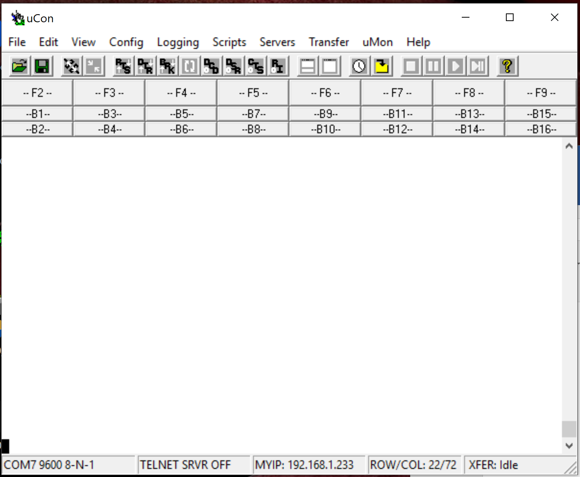
    - Turn power off to the deck cable for at least a full minute. The next steps are time critical for stopping the program so read fully before starting.
    - With ucon and VirtualHere windows open and visible start turn power supply back on.
    - As soon as the USB-RS232 Cable appears in the VirtualHere window, press the connect button on in uCon (two arrows pointing to each other)
    - When the com port is connected you should see that the program is counting down, as quick as you can type “5” and press enter. This should halt the program. For good measure I always do this step 2 times.
    - Once the program is halted typing the command “36” then “Enter” will spit out the stats of the last deployments. Make sure to print out twice then you can disable logging. Take a screen shot incase log file does not work.
- Now that you have the strobe data, the next step is to download the images. To start this process, in the terminal window type “19”, this turns the camera on.
- When the camera is on it should appear in the VirtualHere window:

- The computer may immediately open up the Canon software to talk to the computer. There are two ways to download images. I would recommend downloading through Windows explorer, the Canon software opens Thumbnails which wastes bandwidth.
- Two ways to download:
  - Windows Explorer:
    - Close Canon software if it opens automatically
    - Open Windows explorer
    - The camera should appear on the left side as another drive
    - Navigate on the camera to the folder with the images. These cameras have 2 cards. We stored the images on both cards so they should have an equal number of images, but you only need to download one cards images.
    - A years worth of images is around 8700
    - Make sure you “View” is set to “List” so Explorer does not try to show thumbnails.
    - I would start by coping a few over and checking them, then copy them all. This will take many hours.
  - Downloading with Canon Software
    - Right click on “Canon Digital Camera” and select “Use this Device”, this should immediately start up the Canon EOS Utility Software.

    - Select Download images to computer
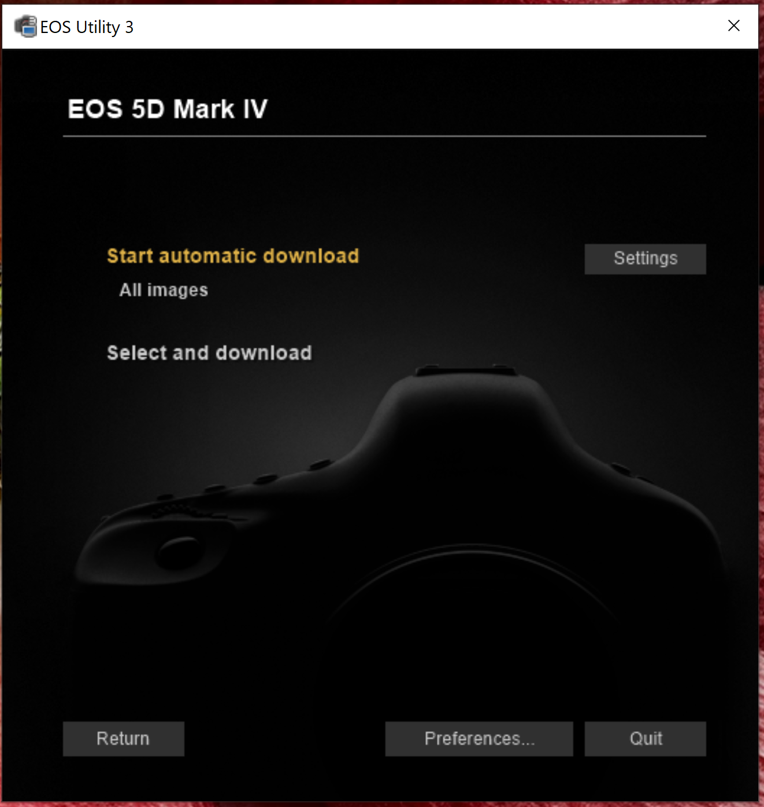

    - If you do “Start automatic download” open the “Settings” first and make sure you know which folder the images will be downloaded into.
- After images are all downloaded, which make take hours, back the up on another disk drive.
- Now you can close all the windows and turn off the power supply and disconnect the deck cable.
- To reformat and clear both flash and SD cards – there should be an option in the “Select and Download” window, maybe the lower left hand corner. Double check this.

Snappy command set

- Sleep
- Read Wake
- Deploy
- Resume
- Halt
- # Images
- Set sleep
- Read sleep
- Set delay
- Read delay
- Set timeout
- Read timeout
- Set batt
- Read batt
- Set SN
- Read SN
- Set clk
- Read clk
- Cam on
- Cam off
- Cam power?
- Left strb V?
- Right strb V?
- Chg Left strb
- Chg Right strb
- Left strb on
- Left strb off
- Right strb on
- Right strb off
- Trig left strb
- Trig right strb
- Trig far shut
- Trg near shut
- Snap far cam
- Snap near cam
- Get status

