October 2, 2018
Goal: to replace USB to Ethernet converters with USB extenders in all three camera housings.
DUALIE NF/SOLO tripod options:
Available ports: (2) 7/16
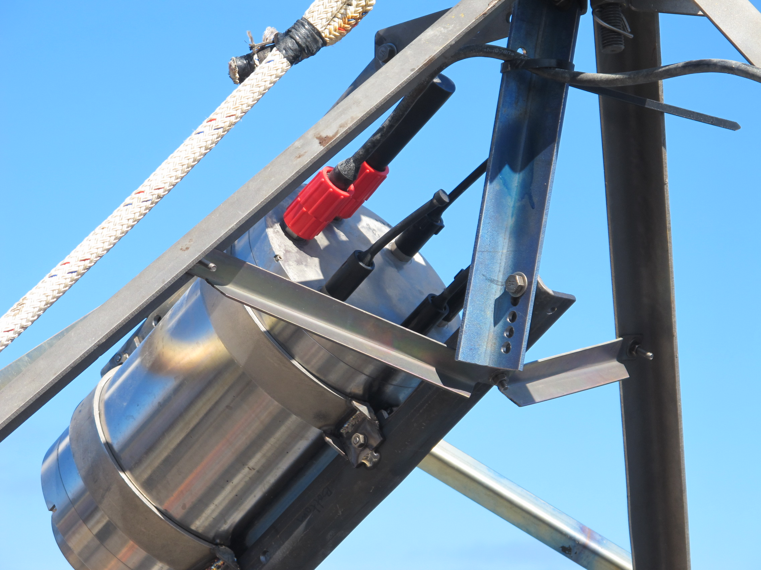
Best option is to add a MCBH8F Ti connector with Ethernet signals wired up in advance.

FF camera options:
Available ports: 1 ½”20 for MCBH10/12

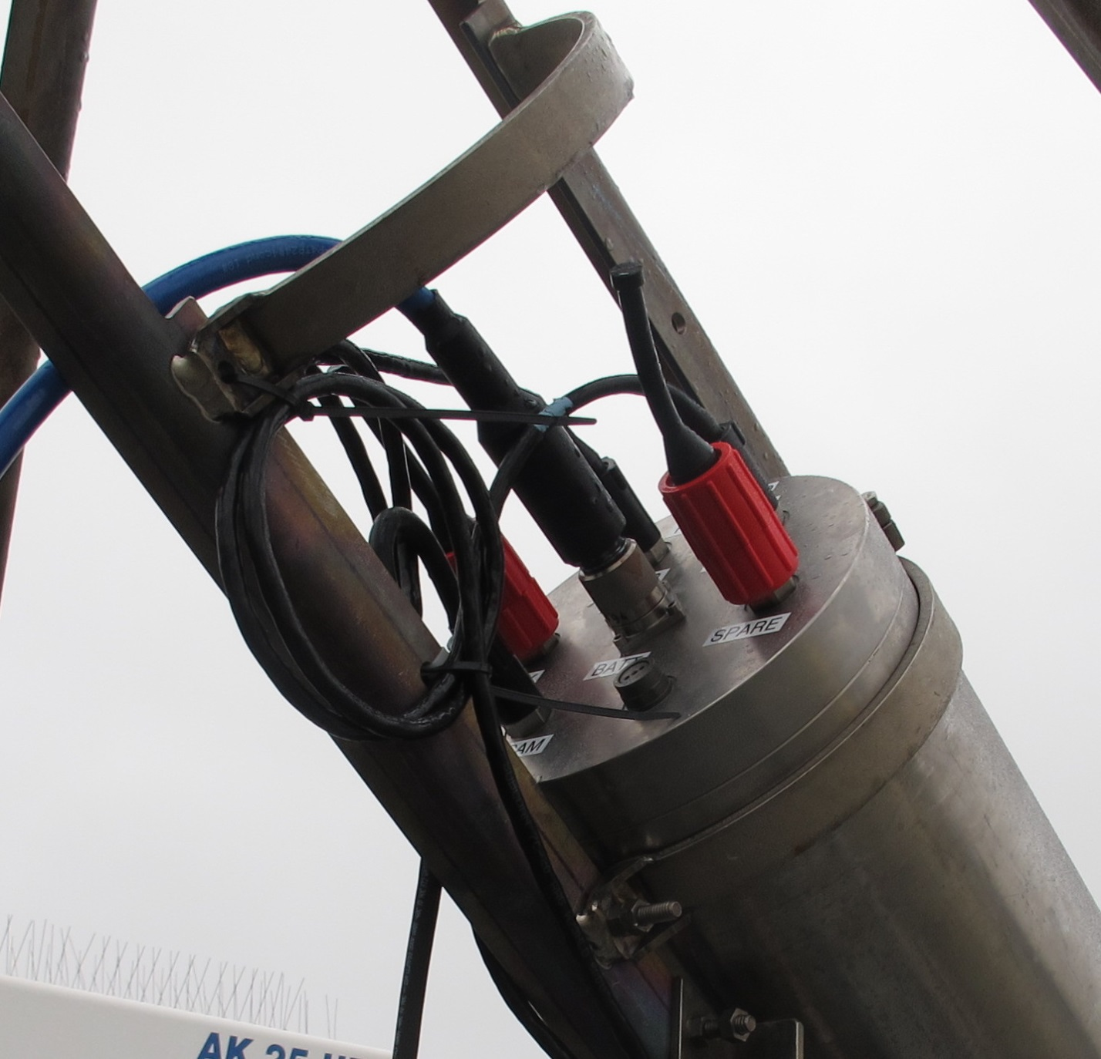
Option 1: add MCBH16F Ti prewired for Ethernet, still us deck cable for power.
Option 2: splice the 8 unused wires on MINK10 FCRL to CAT 5e cable.

NF:
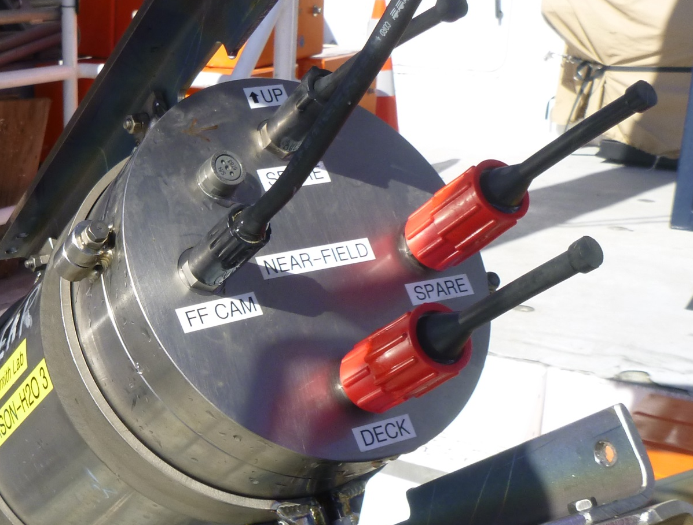
Available ports: (1) 1/2” 20 and (1) 7/16
Option 1: replace MCBH10/12 with MCBH16 prewired with Ethernet connection
Option 2: add MCBH8F Ethernet Ti connector.

Testing of USB extender
First test of Gefen USB 2.0 extender with cat6 cable on lab bench. I was able to download 3000 images in 34 minutes.
Second test: put subconn MCBH8F-MCIL8M inline with ~50 ft Cat5E cable. I was able to download 2000 pics in 37 min, so definitely slower but worked well. Sometimes I had to jiggle the cable around to get the initial connection to work.
Third test: used USB extender with deck cable (tactical black cable) and Ti subconn bulkhead to confirm function and connection was made instantly.

Installation:
- Phase 1: try to ugrade NF and SOLO camera housings
- Remove unused bulkhead connector
- Replace with pre-wired MCBH8F Ti connector
- Use RJ45 connectors and crimper to terminate the Cat5 cable inside the housing
- Connect the power cable to the +5V dedicated to the Anywhere USB, the wires should have the correct pins on them.
- Plug in deck cable – one side to camera housing endcap, the other side to the Gefen USB extender SENDER unit. The Sender unit should be connected to the laptop via a USB cable. MAKE SURE regular deck cable plugged in and now power it up through regular deck cable.
- You should see very fast blinking lights when a good connection is made.
- Once you are confident it is working reseal the camera housing.

