Acoustic communication between autonomous surface vessel and abyssal long time-series instrumentation

Authors

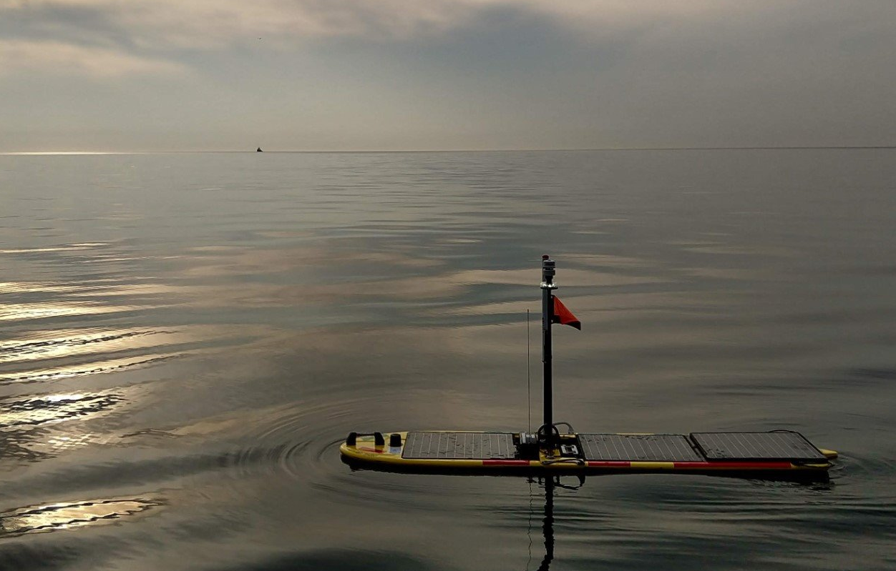

Abstract
For more than 30 years, scientists have been studying the seasonal pulses of sinking particulate organic matter at Station M - a location on the seafloor in the Northeast Pacific Ocean off the coast of California over the Califonia Current. An observatory consisting of sequencing sediment traps and a time-lapse camera system imaging the seafloor was first deployed in 1989 followed by significant additions to the instrumentation suite over the next 15 years. During this time, the time-series had been established as an important temporal source of data on benthic boundary layer and seafloor processes and their links to changing climate conditions. More recently, scientists and engineers at the Monterey Bay Aquarium Research Institute have made significant upgrades to all the observatory instrumentation. The primary objective behind the upgrades has been to reduce the cost of maintaining the observatory while simultaneously increasing both the reliability and the temporal sampling resolution of the measuring processes. These efforts have been successful in approximately halving the frequency of service trips to Station M and therefore significantly reducing the yearly operating costs of the time-series. The less frequent trips to Station M, however, introduced a potentially unfortunate side-effect of also significantly reducing the number of instrument status check-ups that MBARI researchers had come to rely upon

These upgrades have increased the operational duration of instruments, provided autonomy and fault-tolerance capabilities, and enabled remote control via acoustic communication with vessels on the surface. Acoustic communication has been utilized to precisely locate instruments, to acquire status updates and data samples, and to alter the operational profile for the deployment. More recently, operations at Sta. M have evolved to include periodic deployments of an Autonomous Surface Vessel (ASV) to the area. The ASV, a Wave Glider from Liquid Robotics, uses solar energy and surface wave action to provide power for both propulsion and onboard instrumentation including satellite communications. The Wave Glider deployments have enabled MBARI personnel to conduct the acoustic operations from shore and has dramatically reduced the cost of monitoring the observatory. This paper describes the evolution of both the instrumentation and operations at Sta.M, the science and engineering demands that pushed development of this generation of instrumentation, and the remote operations using the ASV.

is station was established in 1989 to study the inuence of seasonal
pulses of particulate organic matter reaching the seaoor from the highly productive
overlying waters of the California Current. Long time-series monitoring at StationM
began with sequencing sediment traps moored in the benthic boundary layer and a
time-lapse camera system taking hourly photographs of the seao

Station M

Description

Station M is the location of the eponymous Station M abyssal time-series study. It is an area of approximately XX square kilometers in the Northeast Pacific 220 km off the coast of central California. The ocean depth at Sta. M is approximately 4000 m with scant topographical variation. The focus of this study is monitoring the amount of sinking particulate matter reaching the seafloor and how it is consumed by the benthic animal communities. From these measurements, estimates can be derived of the amount of carbon is sequestered at extreme depths over time.

Measurements at Sta. M are made using an observatory consisting of a suite of unique instruments designed for long-term operation at 4000 m. Camera tripods. Sediment traps. Benthic Rover.

Next-gen Instrumentation

Science and Operational requirements driving design
Maintain the time-series while reducing the operating costs. Most of the cost is from visiting Sta.M with ship and crew. For more than 10 years, MBARI has been upgrading instrumentation with this goal in mind. Focusing on
- Modernize hardware (upgrade cameras, etc).
- Energy management to increase endurance. Objective of 12 months.
- Increase autonomy and fault-tolerance. Reduce impact of potential faults. Enable adaptive sampling.
- Enable remote Communication and Control from surface. Location, status updates, data samples, and mission modification for duty cycle and sample resolution.

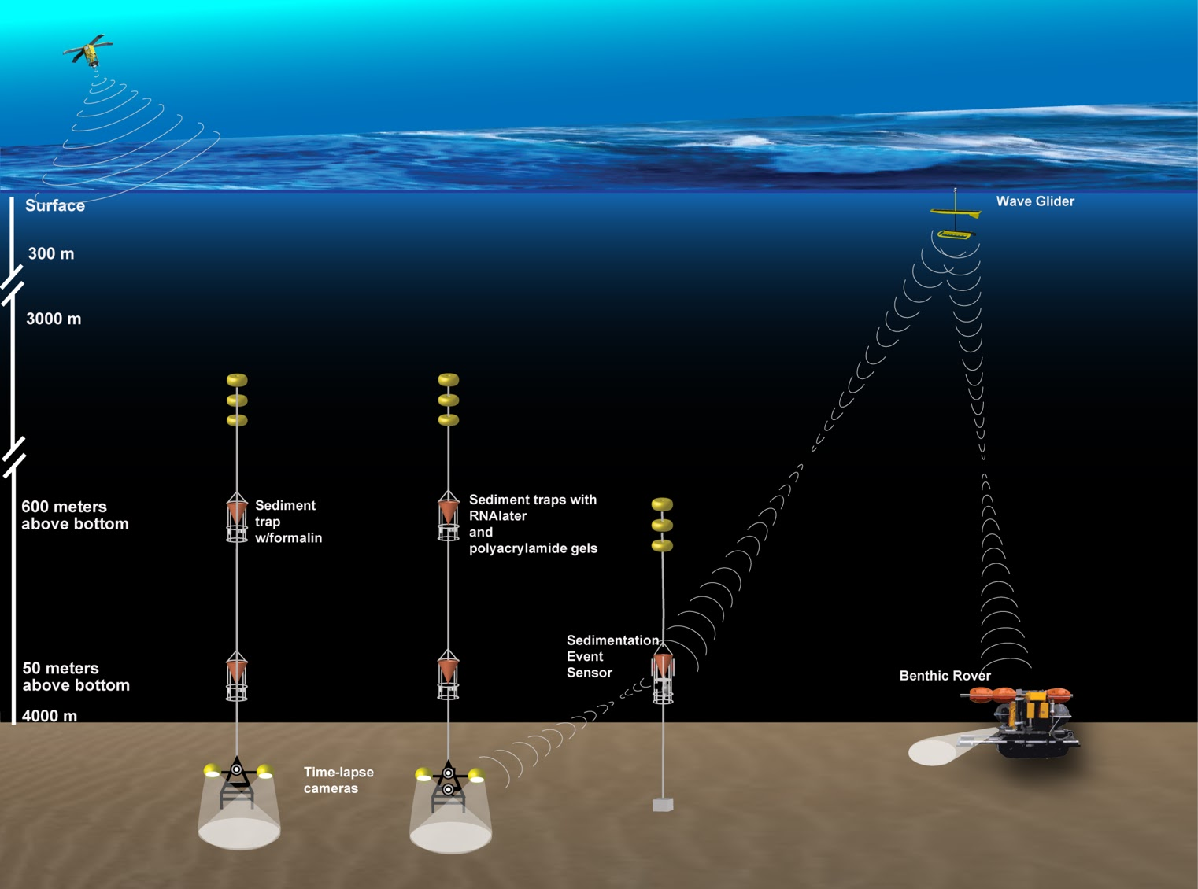

- Camera tripods - cameras, electronics, duo, power management

- Sediment traps - funnels, electronics, pumps

- Benthic Rover - respirometers, imaging, power management

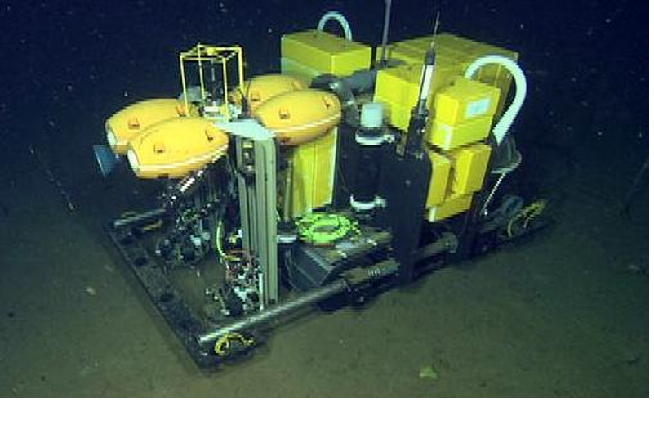

- SES – increase sampling resolution of sinking particulate matter.

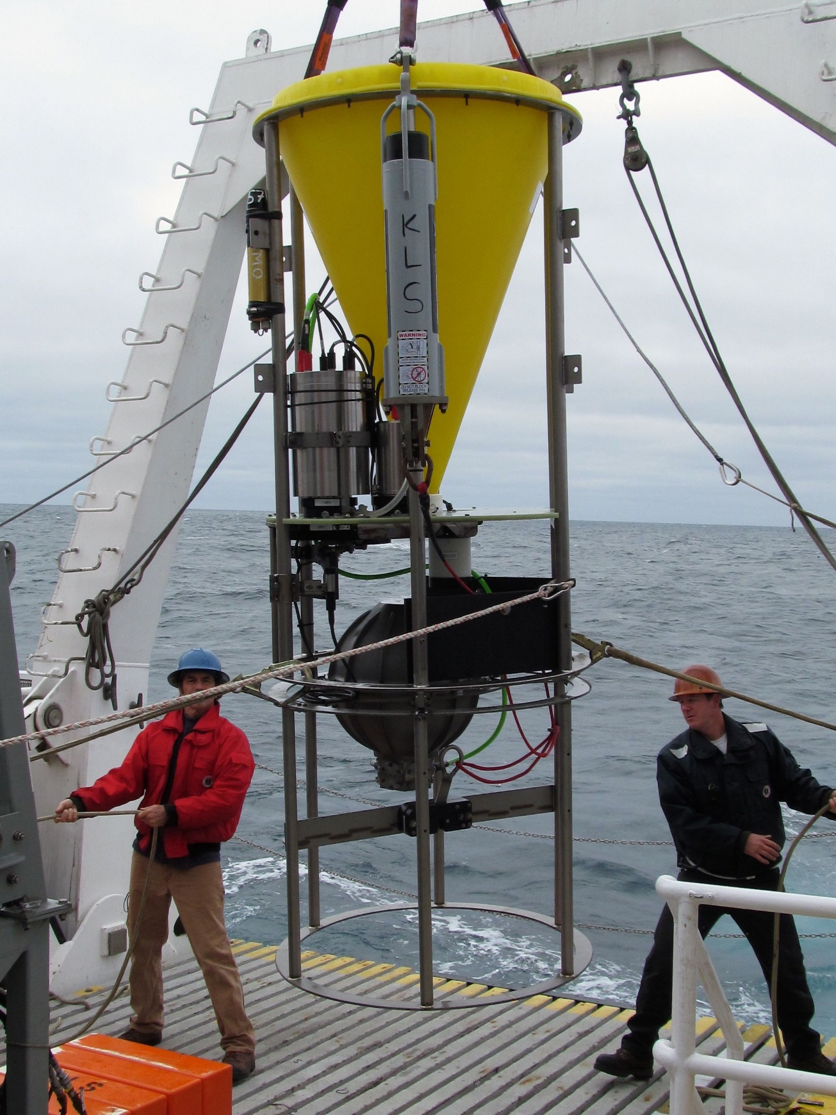

Results. One-year operations. Increased measurement reliability, coverage, and resolution. All while lowering yearly operational costs.

Autonomous Surface Vessel
ASV offers affordable platform to visit and take pulse of both observatory instruments and environment. Discover issues before annual servicing. Acoustically communicate with observatory.

Wave Glider
Wave Glider description.

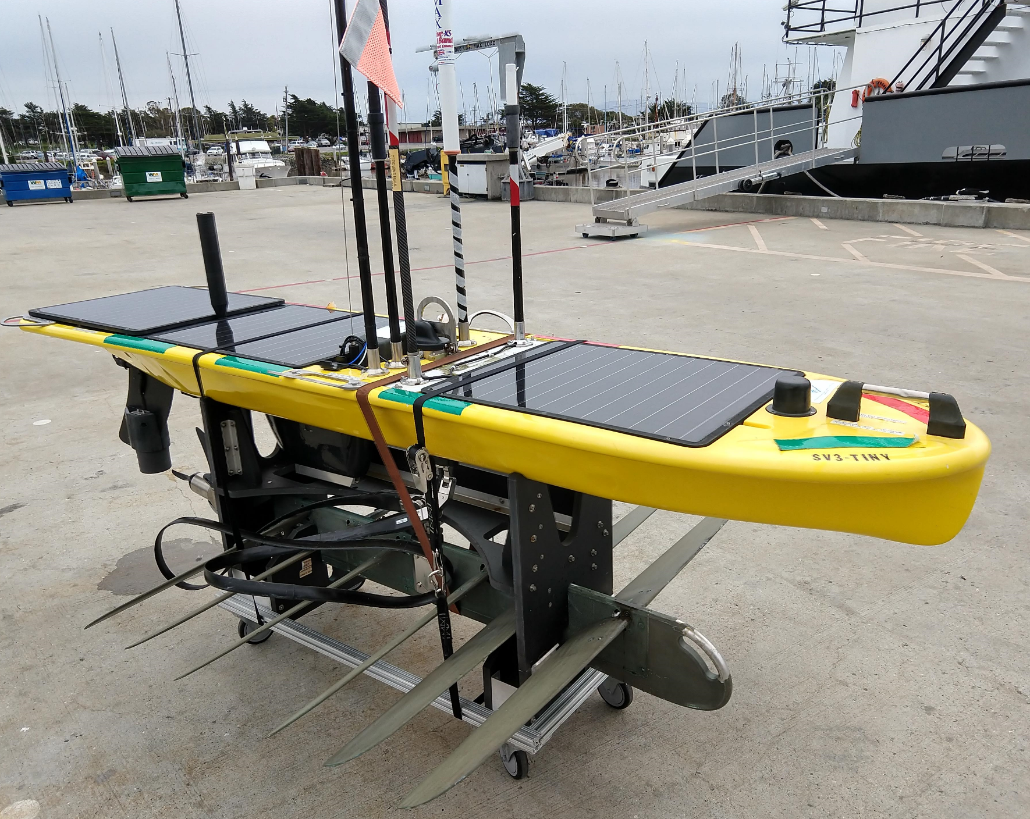

MBARI designed Hot Spot. Communications hub onboard the WG. Remote operation with acoustic communication to instruments. Effectively transfer R/V communication tasks to WG

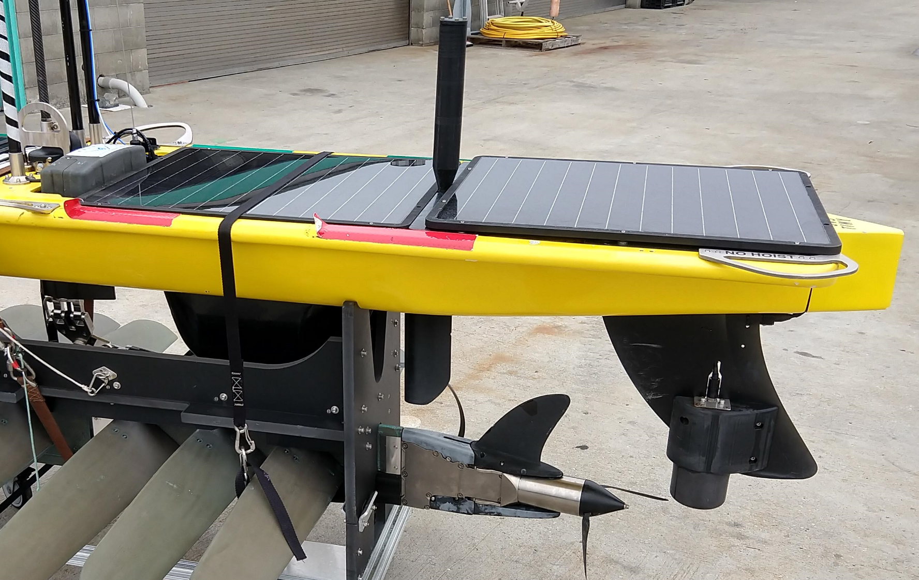

Remote Acoustic Comms and Control of Assets

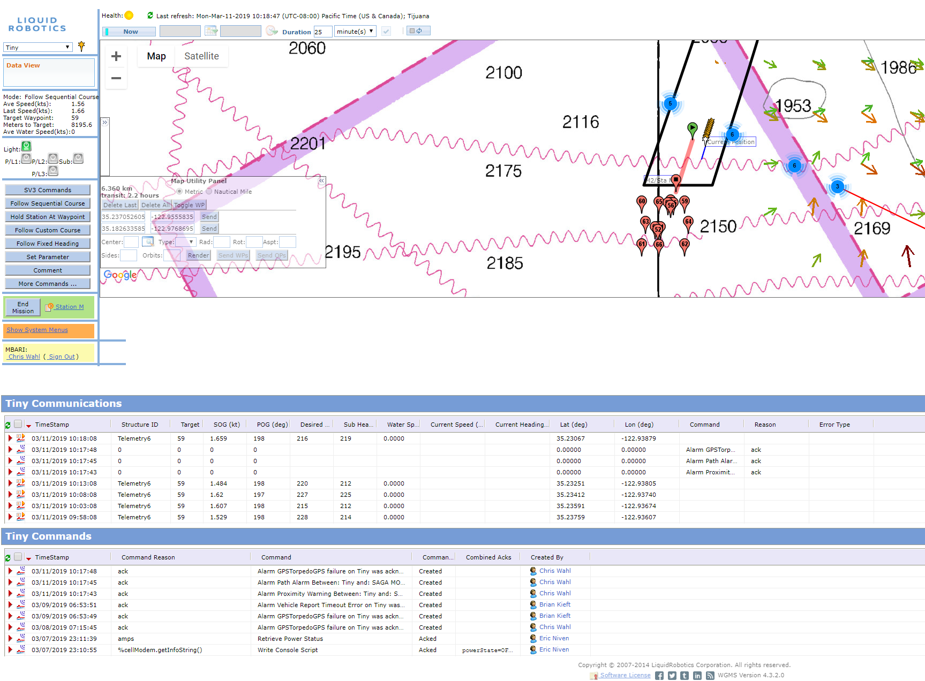

Results and Discussion

Results
Describe WG missions to Sta.M. Success and failures. See Wave Glider ProjectLibrary.

Issues and Challenges
Unreliable comms shore to WG. Hangups. Future upgrades to constellation will help.
Noisy acoustic comms. Depth, sea-state. Limited modem energy on seafloor units. Transducer limitations (directional vs. omni, LF/MF).

Future Plans
Reduce operator-in-the-loop tasks. Automate as much as possible while still operating efficiently wrt modem energy.
Upgrade modem hardware, electronics, transducers with objective of increasing the reliability and effectiveness of communication.
Greater observatory autonomy allows SES to detect and possibly change the sampling regime.

