Exploring climate impacts in the Sargasso Sea
The Sargasso Sea is one of the most nutrient-poor areas of the world ocean, delineated by the Gulf Stream on the west, the North Atlantic Current to the north, the Canary Current to the east, and the North Atlantic Equatorial Current on the south (Figure 17a). One of the most distinctive features of the Sargasso Sea is the brown alga, Sargassum, which forms floating patches on the surface and harbors a diverse assemblage of flora and fauna. MBARI ecologist Ken Smith was granted an unusual opportunity in February and again in August 2011 to sample this unique sea-surface community using the Schmidt Ocean Institute’s ship Lone Ranger, more than 30 years after he and others conducted extensive studies of the sea life there. The effects of climate change on the oceanic ecosystem and carbon cycling should be most evident in these nutrient-poor surface waters that are densely populated by the distinctive Sargassum community. A critical question was whether this community has changed over time. Another goal was to develop a long time-series monitoring observatory with funding from the Marine Science and Technology Foundation to measure the impact of changes in climate on organic carbon export (food supply) including Sargassum, to the deep-sea community as part of this very food-poor oceanic ecosystem.

Smith and his co-chief investigator Alana Sherman, and their team, established research stations along a 965-kilometer-long transect across the western portion of the Sargasso Sea between Bermuda and the Bahamas (Figure 26, inset) where Smith had conducted Sargassum community studies decades earlier. These stations were in open ocean areas where water depths ranged from 5,000 to 5,400 meters. At the final station on the southwest end of the transect, the Sargasso Deep-Sea Observatory (SDSO) was deposited on the seafloor at a depth of 5,400 meters. This station was situated generally south of the subtropical convergence zone in an area of very low primary productivity and presumed low food supply to the seafloor.

The floating Sargassum community is dominated by two brown algal species, Sargassum natans and Sargassum fluitans. The floating algal patches, ranging in size from a small plate to large rafts meters in diameter, serve as productive oases in otherwise food-poor surface waters, providing nutrients, attachment sites, and aggregation sites for a wide variety of species (Figure 27). More than 30 common species of animals ranging from flatworms to fishes and representing six different phyla live well-camouflaged amid the Sargassum. The total abundance of animals associated with Sargassum in 2011 showed little difference from the densities reported in the 1970s. However, the preliminary analyses show significant changes in abundance of individual species, with increasing numbers of crabs and other decapod crustaceans and decreasing numbers of fishes, such as the Sargassum fish, Histrio histrio. The next step is to compare these biological changes with surface water temperature and acidity increases over the past 40 years. Smith also used satellite imagery to provide a regional scale mapping of Sargassum and to show how the changes observed are related to the distribution and movement of Sargassum across the Sargasso Sea.

Data from the Sargasso Deep-Sea Observatory indicate that changes in climate influence the entire ocean to great depths. The deep-sea observatory deployed in the southern Sargasso Sea (Figure 28) in February 2011 consisted of sediment traps moored at 600 and 50 meters above the seafloor to collect sinking food particles and a time-lapse camera to take hourly images of seafloor-associated animals and events. This observatory is part of an effort to monitor carbon export and accumulation in the deep ocean and its impact on seafloor communities as changing climate impacts surface ocean productivity and ultimately the source of food for the entire ocean. Two similar observatories—one in the North Pacific and another in the eastern North Atlantic—provide data for comparative studies.

Based on data from the first six months, Smith saw a significant, unexpected seasonal pulse of particulate food to the seafloor, including fragments of Sargassum. In the time-lapse images of the seafloor during that first six-month deployment a strong “benthic storm” in February was surprising considering the great depth and the distance from any topographic features such as the continental margin, islands, or bathymetric irregularities. Smith’s team is attempting to relate this phenomenon to current-meter records available in the region. Smith and Sherman hope to keep this observatory on the seafloor for a long time by developing camera and sensing systems that can function over longer periods and require only annual maintenance. Such systems are planned for the deep-sea observatories in the Sargasso Sea and the North Pacific to continue monitoring the significant climate-related changes already observed, with the ultimate goal of gaining a broader global perspective and improved predictive capability.

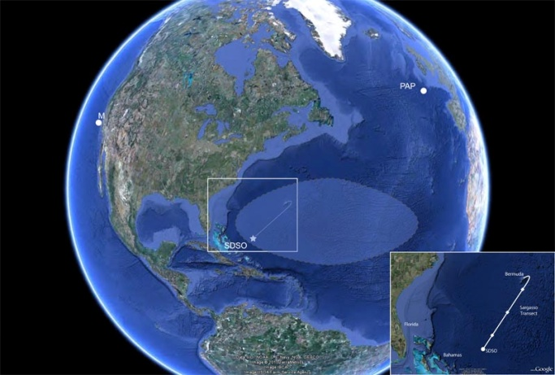
Figure 26: Google map showing Sargasso Sea and three existing deep-sea observatories. Inset shows Bermuda-Bahamas transect with four stations.
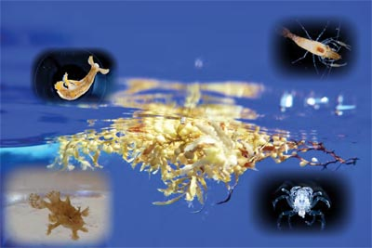
Figure 27: Sargassum patch floating on sea surface with close-ups of several of the most unique species (fish, crustaceans, nudibranchs).

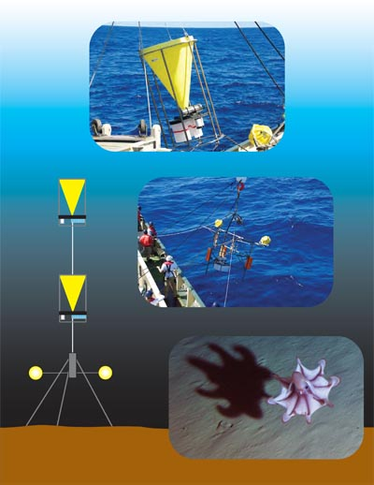
Figure 28. Sargasso Deep-Sea Observatory, diagram with pictures of a sediment trap, camera tripod, and a benthic image of a cirrate octopod.

Sargasso Sea Expedition
Project leads/managers: Ken Smith, Alana Sherman
Project team: Larry Bird, Jake Ellena, John Ferreira, Dale Graves, John Ryan, Susan von Thun
Collaborators: Dan Barshis and Judit Pungor, Hopkins Marine Station of Stanford University, Pacific Grove, California; Jeffrey Drazen, University of Hawaii, Manoa; Jim Gower and Stephanie King, Fisheries and Oceans Canada, Institute of Ocean Sciences, Vancouver; Mark Miller, California State University, Monterey Bay; Debbie Nail Meyer, Carlsbad, California; Kathleen Sealey, University of Miami, Florida

