SOI Cruise Plan/Itinerary:
Lone Ranger, Leg 7 (LR7-2012), Bermuda to Bahamas
1 to 15 February 2012
Chief Scientist: Ken Smith
Co-Chief Scientist: Alana Sherman

1. Purpose of cruise: A transect of four stations will be occupied along a transect beginning at #1 and going south to the Bahamas (Fig. 1; Table 1). This cruise includes three science projects which are each described below:
A. Pelagic Sargassum communities as indicators of surface ocean warming and increasing acidity: Sargassum is a brown alga that has a conspicuous presence in surface waters of the western North Atlantic. These floating patches of algae serve as the basis for entire communities of organisms ranging from bacteria and phytoplankton to attached and free-swimming faunal species, many of which are unique to this pelagic assemblage. This unique and ubiquitous community was extensively studied in the 1970’s and 1980’s before the impact of global warming was identified in the surface ocean. We suspect that this surface community will be significantly altered by warming surface waters. We will sample the Sargassum community and the surrounding surface waters along a transect of stations to measure the current species composition, abundance and biomass associated with pelagic Sargassum for comparison with previous records in the same region of the Sargasso Sea 25 to 35 years ago. This community was successfully sampled from Lone Ranger in February 2011 and now we will conduct an additional sampling in August 2011 to provide a seasonal perspective and complete the field program.
B. Climate, carbon cycling and deep-ocean ecosystems (Deep-sea observatory): Climate variation affects surface ocean processes and the production of organic carbon, which ultimately comprises the primary food supply to deep-sea ecosystems that occupy over 60% of the Earth’s surface. Recently, unprecedented time-series studies conducted over the past two decades in the eastern North Pacific and eastern North Atlantic at > 4000 m depth have revealed unexpectedly large changes in deep-ocean ecosystems significantly correlated to climate-driven changes in the surface ocean that will impact the global carbon cycle. Data from these two widely separated areas of the deep ocean have provided compelling evidence that changes in climate can readily influence deep-sea processes. However, the limited geographic coverage of these existing time-series studies stresses the importance of developing a more global effort to monitor deep-sea ecosystems under modern conditions of rapidly changing climate. The goal of this project is to establish a deep-sea observatory in the Western North Atlantic that is influenced by the growing intensity of seasonal storm systems off the southeastern continental margin of the US. This observatory would be similar to those already established in the eastern North Atlantic and eastern North Pacific so that data can be compared with regional, ocean basin and global scale climate indices. This deep-sea observatory was redeployed in August 2011 and will be recovered in February 2012. The current plan will be to redeploy the observatory in February 2012 for recovery in August 2012with no further deployment planned.
C. Kite deployments:

2. Sampling/Deployment plan:
A. Sargassum community sampling plan: Sargassum will be observed and collected along a transect of four stations (see attached map with transect of stations; Fig. 1) using small boat operations. Collections will be made from a small boat (Zodiac tender) using long-handled dip nets (0.5 mm mesh size). Snorkeling collections will also be made using nets and bottles as conditions permit.
B. Deep-sea observatory: The deep-sea observatory (Fig. 2) consists of a mast assembly tethered to the main mooring by a 30 m length of ½” line. The mooring consists of a series of eight syntactic foam flotation blocks each separated by 20 m lengths of ¾” line. Two sediment traps are mounted in the mooring string at 600 and 50 m above the time-lapse camera frame on the bottom. There are two acoustic releases in the camera frame holding the disposable ballast weight of ~500 lbs. The footprint of each mooring component is shown in Fig. 4. The camera frame is ~ 8 ft high while the sediment traps are ~ 5 ft high.

Recovery scenario: After arriving at Sta. #6, an acoustic command will be given from the ship that releases the anchor from the deep-sea observatory using dual Benthos acoustic releases. The entire observatory then floats to the surface in approximately 2.5 hours for recovery. Recovery is aided by the spar buoy with its large fluorescent flag, radio directional beacon (VHF channels 73-77, 156-157 MHz) and a strobe. Having a directional VHF receiver on the bridge is absolutely necessary. The ship will steam alongside the instrument on the port side and grapple the line between the first flotation block and the spar buoy. The line and spar buoy will be pulled aboard by hand. The line between the spar and first flotation block will be disconnected from the spar and the mooring line shackled to a pulling line fair-led over a series of blocks on the crane and bulwark to the capstan. The crane and capstan can then lift each component while stopping it off on the rail cleats. Two poles with snap hooks will be used to clip tag lines onto the frames of the two sediment traps and camera frame to handle the instruments as they are brought over the rail and onto the deck. This recovery scenario was successfully used on Lone Ranger (LR-6) cruise.

C. Kite deployments:

3. Daily itinerary: At each of the four stations, we will deploy the small zodiac to collect Sargassum community components both with dip nets and by free diving. The Sargassum community components will then be returned to the ship in 5-gal plastic buckets for sorting on the aft deck and in the laboratory. Spectral imaging from the satellite based MERIS optical sensor will be acquired in real-time aboard ship to help locate patches of Sargassum in the vicinity of each station.The kite team will launch their kites with attached cameras at each station to survey the surrounding area for Sargassum patches to support our sampling program as well as provide ground truth for the satellite imaging.
At the deep-sea observatory station, southern-most station on the transect (Fig. 1), the itinerary will follow the same sequence of events as outlined above. In addition, 48-hour period will be needed to recover, service and redeploy the deep-sea observatory during day-light hours. This turn-around period might require more time, depending on the condition of the observatory and the weather constraints for recovery/deployment operations.

4. Scientific personnel to be onboard:
Kenneth L. Smith, Jr. , MBARI, Chief Scientist, Principal investigator, Sargassum community and deep-sea observatory project
Alana D. Sherman, MBARI, co-Chief Scientist, lead science engineer, co-Principal investigator, Sargassum community and deep-sea observatory projects.
MBARI, marine technician (TBD)
Susan von Thun, science volunteer
Science volunteer #2, (MBARI selection)
Don Montague – Kite Assist team lead
Joe Brock – Kite Assist technician
Baltimore National Aquarium scientist – (SOI in coordination with Ken and Alana)
SOI Outreach specialist – SOI in coordination with Ken and Alana
SOI shoreside representative (in support of ship operations- TBD)

5. Hazardous materials
a. Ethanol – 25 gallons – Absorbent paper towels (see MSDS sheet attached)
b. Formalin (37% formaldehyde) – formalin spill kits (see MSDS sheet attached)
c. Lithium batteries (2) 3PD1516 custom CSDDD and two 3PD1517 custom CSCD battery packs (DOT certified) packed in a steel drum. – Fire fighting measures with Lith-X powder and Class D fire extinguisher (see MSDS sheet attached)
d. Gaseous Nitrogen – No materials needed for spill. Personal to vacate area incase of leak.

6. List of large science equipment
a. 500 lbs of disposable steel ballast weight (2)
b. Spar buoys (1) – to be recovered as part of deep-sea observatory
c. Syntactic flotation blocks 8 to be recovered as part of deep-sea observatory
d. Sediment traps (2) – to be recovered as part of deep-sea observatory
e. 20-ft shipping container/lab van
f. Time-lapse camera tripod – to be recovered as part of deep-sea observatory
g. Aquaria (8)

7. List of SOI provided science equipment
a. – 80ºC Freezer
b. – 20ºC freezer
c. Refrigerator
d. Dissecting microscope
e. Hazardous material van (on deck)
f. Fume hood

8. List of deck equipment required for the cruise (Crane, capstan, workboat, etc.)
  - Directional VHF receiver on the bridge
  - Capstan for pulling camera recovery line through a block on the crane
  - Tie down points welded to the deck to secure free vehicle equipment
  - 2 - 3" wide nylon ratchet straps and stainless steel ratchets or Samson 1/2" tie down lines
  - Rail and deck cleats for handling tag lines
  - Handling/tag lines - assorted lengths of 1/2'' Samson two-in-one braid
  - Assorted blocks for handling synthetic line (diameters from 1/2' to 1") including snatch blocks and trawl blocks.
  - Assorted rigging hardware including shackles (3/8", 1/2", 5/8", 3/4",1"), swivels and pear-rings for use on deck.
  - Recovery poles (4) – long telescoping poles for attaching snap hooks with tag lines to free-vehicle instruments for recovery.
  - Snap hooks (4) – a wide throat hook with an eye – weld square bar stock so that it slips inside the end of the recovery pole and can easily pull out.
  - Lightweight grappling hooks (4) –for acquiring line during mooring recovery
  - Eye on deck near capstan to fairlead pull-line
  - 100’ of ¾” working line to use as a pulling line through the crane to the capstan

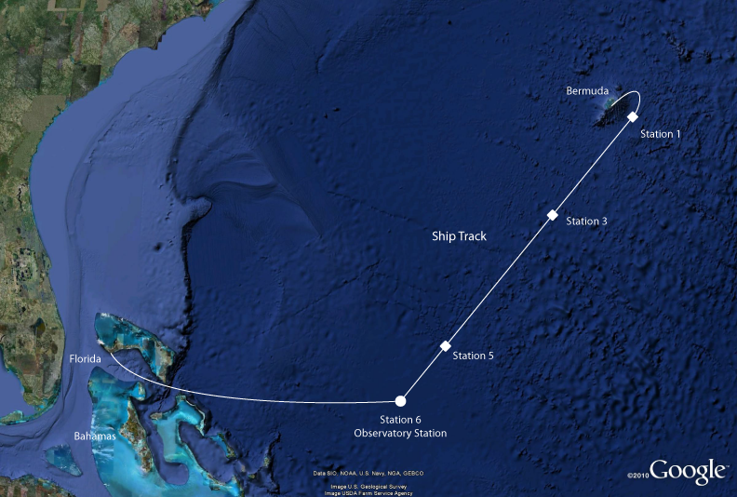
Figure 1. Proposed ship track. Diamonds represent stations of Sargassum sampling. The long time-series observatory will be recovered at the southwest end of the transect along with other sampling.

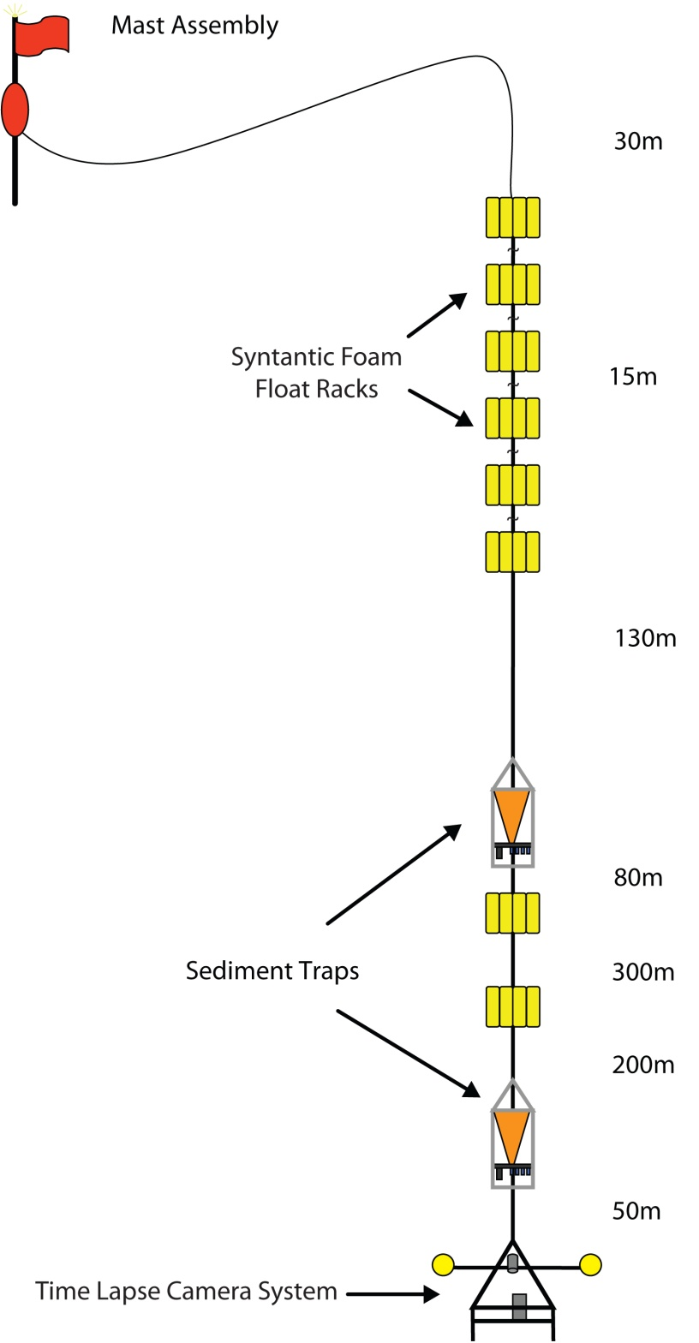
Figure 2. Diagram illustrating the deep sea observatory mooring.
Table 1 |  |  |  |  |  | Deployment/Sampling
Station | Latitude | Longitude | Depth (m) | Foreign EEZ |  | Sargassum Sampling | Deep Sea Observatory
1 | 31°53.4'N | 64°1.73'W | 4600 | Bermuda |  | ~4
3 | 29°36.5'N | 66°32.1'W | 5100 |  |  | ~4
5 | 26°44.5'N | 69°42.3'W | 5470 |  |  | ~4
6 | 25°30'N | 71°00'W | 5400 |  |  | ~4 | 1

