Discussion.
Of the many issues the problem of pelton design was (and still is) the most prominent. Although much is known about the design of pelton wheels this specific application presents several unique challenges. First, there is not a constant supply of fluid available to turn the wheel as there would be in a normal hydro electric pelton application and second, the scale of this system is greatly reduced as compared to other pelton systems used to generate electricity. Formation of the water jet was another challenge, only slightly less complex than the pelton design issue but no less important.
Initial stream coherence tests were discouraging to say the least. Due to a combination of several factors including but not limited to: turbulence, orifice deformation and interaction with the orifice walls, the coherence of the jets generated by the first steel and brass orifices decreased rapidly after the stream exited the nozzle. The initial orifices were fairly thick, meaning that the water had a significant amount of interaction with the orifice walls as compared to the sapphire orifice and the later generation steel orifice. The significance is this, the inner wall of the first steel orifice was not perfectly smooth, deformations in the orifice wall caused turbulence within the jet which resulted in a decrease in stream (jet) coherence upon exit. In the later generation steel and sapphire orifices, the water’s interaction with the wall was greatly reduced thereby reducing the loss of coherence due to interactions between the water and imperfections in the orifice wall. Still, this change was not enough to solve the coherence issue.
The problem of turbulence in the stream was a result for the most part of water entering the orifice from the
Turbulence in the stream was largely a result of deflection of water by the upstream shoulder of the orifice. As water entered the orifice it was deflected from a straight line path by the shoulder of the orifice. As a result a turbulent flow was induced in the stream.
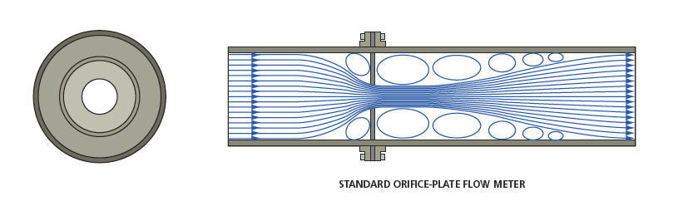
By chamfering the orifice inlet the turbulence in the fluid downstream from the orifice was significantly reduced, as a result flow through the orifice was increased. Flow was further increased by applying a radius to the inlet edge of the orifice.

Square edged (90^{O}) orifice entrances
-Table of loss (K) with relation to radius diameters. (Shames, mechanics of fluids, 287)
*check this, make sure it is radius diameters not the ratio of the opening and the radius diameter.
r/d | 0.02 | 0.04 | 0.06 | 0.10 | 0.15 and up
K (loss) | 0.28 | 0.24 | 0.15 | 0.09 | 0.04

It is clear from the table that as the diameter of the radius applied to the corner increases, the fluid flow through the orifice increases due to a reduced turbulence in the exit stream. With the inlet edges rounded improved exit stream coherence was achieved.
Even with the rounded corners, there were still problems with stream coherence. The most probable explanation for this that the fluid flowing through the orifice was still somewhat turbulent. The channel of the orifice was not sufficiently long and so the turbulence did not fully dissipate before exiting the orifice. For the purposes of this project though, the jet was maintained for long enough to strike the pelton wheel’s cups as a solid column.

