15 February 2013
BWH

AUV Operations Plan to Support ECOHAB Offshore Newport Beach March 2013
Preliminary Planning document
Monterey Bay Aquarium Research Institute (MBARI) http://www.mbari.org, is participating in a NOAA project offshore Newport Beach during March and early April 2013. Among other assets, MBARI will be operating two unmanned autonomous underwater vehicles (AUVs) offshore Newport Beach from March 12 through March 27th. This document is intended to describe a preliminary operations plan to relies heavily on help from people and facilities from Orange Coast College. In particular, Karen Prioleau, Robert Profeta and the boathouse in Newport Harbor will be key to our successful operations.
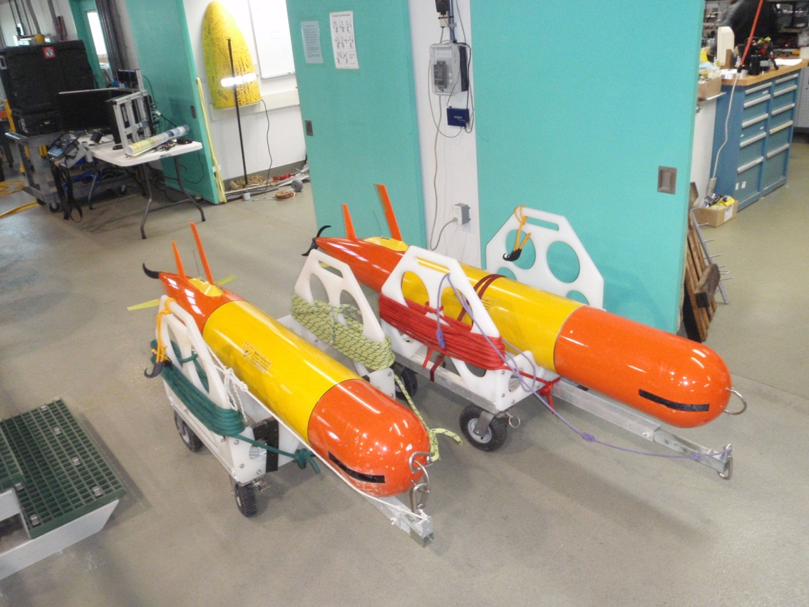We envision two people from MBARI arriving at the OCC Boathouse at 8 am on Monday morning March 11th driving a pickup and towing a 12’ enclosed trailer containing two AUVs, Figure 1 below. The AUVs are about 8 feet long, weigh 220 lbs and use lithium-ion
batteries. We’ll need a place to park the trailer for the duration of the experiment – through March 27th. Once the vehicles are unloaded from the trailer, they are easily moved on their wheeled carts and need to be stored either back in the trailer or inside a secure space overnight. We’ll need access to 110 vAC power to charge the batteries before deployment and once midway through the experiment. It would also be nice to have internet access, though cellular data is a backup option.
Both AUVs need to be deployed offshore either late on the 11th, or early on the 12th. Deployment involves placing both AUVs in the water at the dock and towing them to a launch point about 1 mile from the mouth of Newport Harbor. Our preferred technique would be to attach lifting straps to the AUV and lift it off its cart with an overhead gantry crane such as the one next door at the Boy Scout facility. Alternatively, several strong people could use the same lifting straps hooked to a beam that could be handled by three or four people. The vehicle would have to be set on a low dock with the tail hanging off the edge. Then, we could slide the vehicle back into the water. Once in the water a float is attached to the nose hook (Fig 2), and a propeller strap is installed to prevent the propeller from spinning during the tow offshore. The ideal tow boat for this task is a 17’ Boston Whaler because the low freeboard makes it easy to work over the side and the low mass closely matches the motion of the AUV in the water. We need to hire this Boston Whaler and an operator.
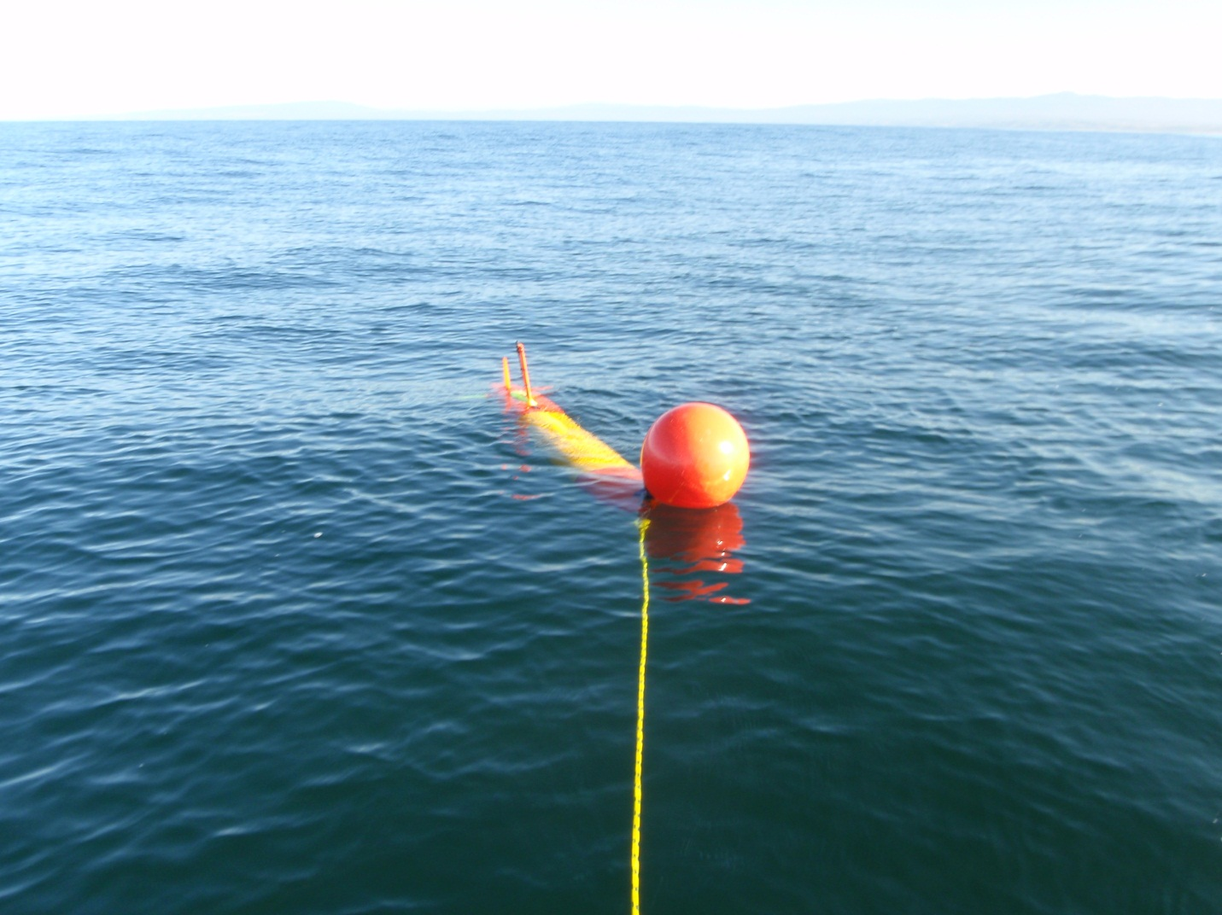
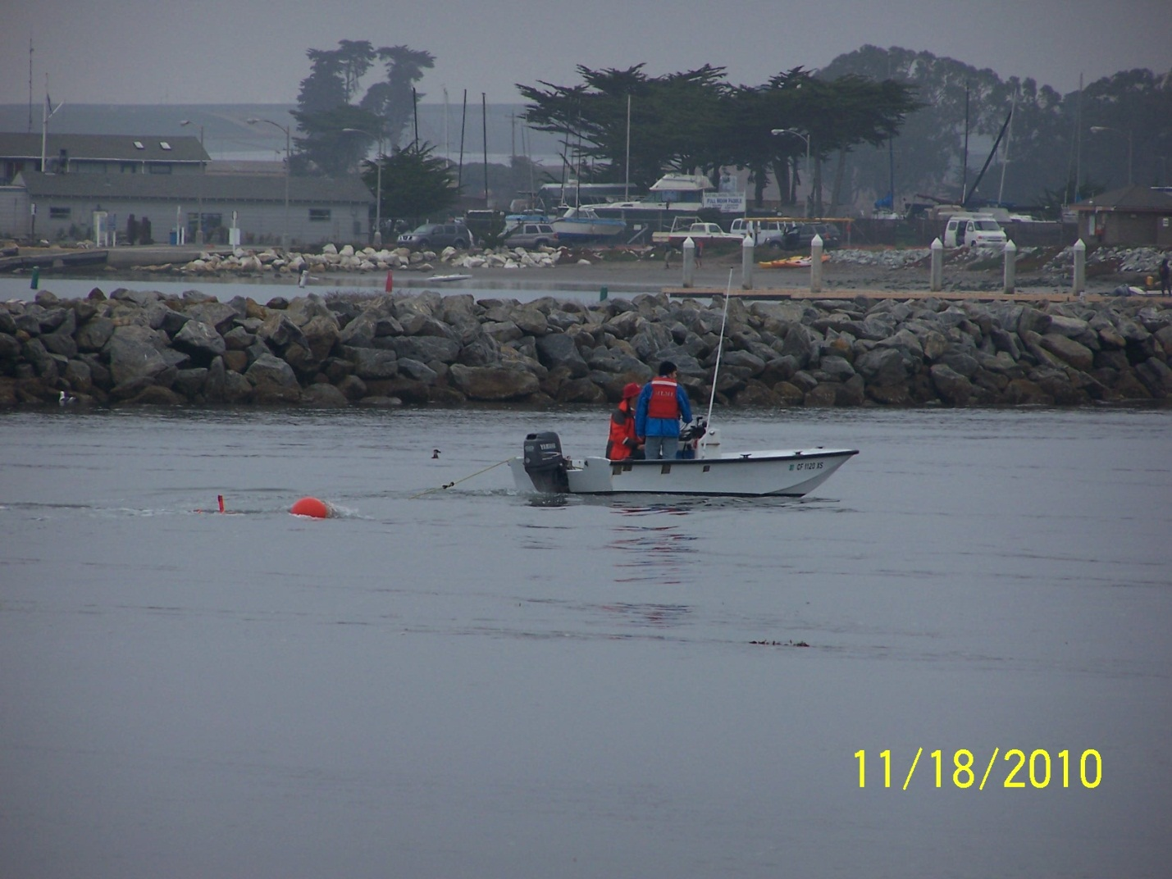
With a whaler we can tow two AUVs at once at a speed of 5 knots. Once clear of the harbor mouth and boat traffic the propeller strap, buoy and towline are removed and the AUVs are sent a message to dive from the surface and begin their pre-programmed mission.
We plan to recover individual vehicles on Tuesday, March 19th and Wednesday March 20th. The vehicles will be commanded to surface near the harbor mouth at a specific time. The recovery boat will rendezvous with the AUV and attach the towline, buoy and propeller strap and tow it back to the OCC boathouse. The AUV needs to be lifted out of the water with the crane, or strong people and placed back on their carts. The AUV will be rinsed off and loaded back in the trailer or a secure place inside the Boathouse where the rear fairing is removed to allow the installation of the battery charge cable. The batteries take about 24 hours to charge. We’ll need to re-launch the first AUV on early on March 20th before recovering the second AUV for charging and launching on March 21st. Both AUVs will be recovered on March 28th.
The AUVs will be operated by both the MBARI personnel working there in Newport and engineers up in Monterey. If there are any serious problems, which we don’t expect, the affected AUV would have to be recovered and repaired. There is also a chance the vehicle will not be able to make it to the rendezvous spot and have to be recovered from the operations area approximately 5 miles west of the harbor. Depending on the weather and time of day, the Boston Whaler may not be the most appropriate vessel so we may need access to the 29’ Crystaliner.
We will be available to talk about the experiment and technology and this can be done informally or in a more formal presentation format for a class or group.
Science Experiment Background
The spring 2013 ECOHAB experiment is the first of two planned collaborations between MBARI’s CANON Initiative and the NOAA ECOHAB project entitled, A Regional Comparison of Upwelling and Coastal Land Use Patterns on the Development of HAB Hotspots Along the California Coast. Institutions participating in the ECOHAB project are UCSC (lead R. Kudela), MBARI, MLML, CeNCOOS, USC, SCCWRP, JPL, and NOAA. This first experiment will take place in the San Pedro Bay region during March – April; the second experiment will take place in the Monterey Bay region during September – October (Figure 1). While sharing some Large scale variability, and perhaps some local environmental characteristics associated with ‘upwelling shadow’ dynamics, the two regions have significant differences in atmospheric and oceanic forcing, as well as human-impact channels (agricultural runoff, sewage). The contrasting oceanographic settings and anthropogenic influences form the basis of a comparative study to understand the environmental factors controlling the initiation, evolution, and toxicity of HABs – focusing primarily on Pseudo-nitzschia spp. that can cause domoic acid (DA) poisoning, and secondarily on Alexandrium catenella that can cause paralytic shellfish poisoning.
In both regions, a key hypothesis is that subsurface layers, “hidden” from near-surface observing strategies, are critical to HAB population dynamics and bloom development. Also in both regions, episodic upwelling is key to HAB ecology. In Monterey Bay, persistent “thin layers”, hosting dense populations of toxigenic Pseudo-nitzschia, have been documented (McManus et al., 2008). However, the prevalence and seasonality of such layers is unknown, and their ecology is poorly understood. On the San Pedro shelf, previous studies including one that employed two Environmental Sample Processors (ESPs) in spring 2010, indicate that subsurface layers of pseudo-nitzschia from the off-shelf deep chlorophyll maximum (DCM) seed bloom events on the shelf during upwelling events (Caron et al., 2011; Seegers et al., 2011). However, such seeding has never been directly observed, and the species composition and dynamics of the DCM on and off the shelf are not well understood.
Domain
Pseudo-nitzschia populations that bloom in San Pedro Bay are thought to come from along-coast transport from the NW. Although this aspect is important to understanding regional HAB ecology, its spatial domain is too large to cover adequately with the experiment observing assets. To effectively study HAB ecology in San Pedro Bay, we will concentrate efforts largely within waters on and near the southern San Pedro Shelf — where Pseudo-nitzschia blooms have been observed during spring, previous HAB ecological experiments have been conducted, and risks from shipping traffic are relatively low (Figure 2). Real-time data may motivate excursions toward the hypothesized source region of Pseudo-nitzschia populations further to the NW, but this focus will be secondary to operations on/near the southern San Pedro shelf.
Figure 1. Focal experiment domain and straw plan for deployment of some observing assets.
Shown in Figure 2 is a straw plan for the deployment strategy. Details follow this section; however, a brief explanation is noted here. The ESP locations and “standard” USC glider track are those used in the 2010 experiment. Because these ESP locations were effective in the spring 2010 study, they represent the approximate locations planned for the 2013 experiment. The R/V Rachel Carson section parallel to the ESP array (and to a glider section) represents one of the two modes of Carson operations; the other mode is Lagrangian observation of DCM populations. LRAUV (Tethys, Daphne) operations will include high-resolution mapping centered on ESP moorings, and possibly patch-tracking in collaboration with Dorado AUV operations. The R/V Yellowfin will conduct a survey of the Carson cross-shelf section prior to the intensive. During the intensive, on days when the Carson occupies the cross-shelf section, we propose that the Yellowfin conduct a complementary along-shelf section (distance offshore to be informed by near-real-time data), or targeted sampling based on near-real-time observations. On days when the Carson conducts Lagrangian DCM tracking and observation, we propose that the Yellowfin occupy the cross-shelf section.

