LRAUV Deployment plan for DAT Estimation test

Chief Scientists or Engineers
Brian Kieft, Software Engineer, MBARI
bkieft@mbari.org
+1-831-775-2070
M Jordan Stanway, Postdoctoral Fellow, MBARI
mjstanway@mbari.org
+1-831-775-1960

Vehicles

Daphne
- all operations

Other resources

Small Boat
- LRAUV launch & recovery operations

Acoustic Modem
- Standalone Benthos MF acoustic modem with battery pack and compass.
- Rigged to rise 10 meters altitude from an anchor, marked by a Norway float on the surface. Surface expression location is here: http://share.findmespot.com/shared/faces/viewspots.jsp?glId=0ZmngEMkPrkqqqoQ4JmuqyKh9ryqi84jW
- The modem location is: 36.8151, -121.8257

Preparation

Daphne
- docking long-nose configuration
  - DAT acoustic head and driving electronics installed
  - single SADM-1 acoustic baffle installed
  - docking connector assembly installed
  - PAR sensor tucked out of way (physical interference with SADM baffle)
- ISUS optional (for supplementary science)

Location
- On-shelf -- continuous bottom lock for comparison
- near MBARI -- minimal transit time
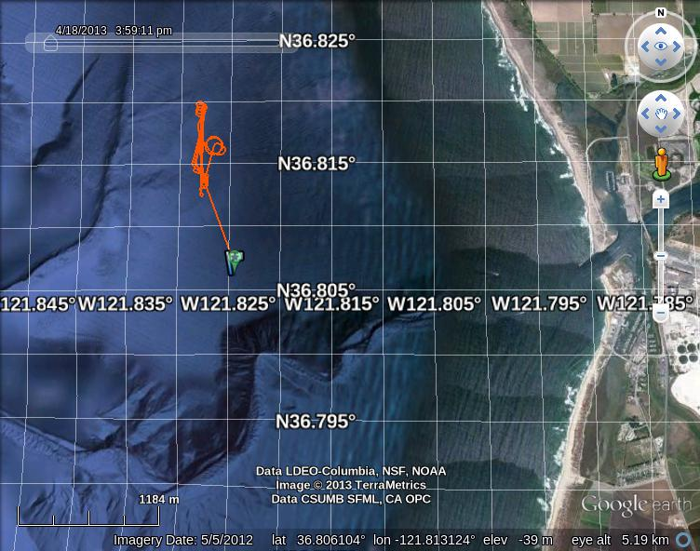

Mission

Deployment instructions
- Prep vehicle for cart launch and transit via boat and launch within 2km of 36.815, -121.826
- Run Maintenance/dat_on.xml and confirm AGC levels and range brought back to shore. Troubleshoot from shipboard DAT if not.
- Transit to deeper water for ballast and trim if necessary (36.81, -121.83)
- run Maintenance/ballast_and_trim.xml
  - Adjust buoyancy and mass parameters:
  - configset VerticalControl.buoyancyNeutral XXX cc persist
  - configset VerticalControl.massDefault Y.YYY cm persist
- run Engineering/DAT_line_with_circles.xml
- NOTE: simulations are showing the possibility of not enough mission time to complete the circles around the modem at the end of the mission. If this occurs, set MissionTimeout to 9 hours instead of 4 when running the mission. Additionally, the variable Repeat can be increased from 3/lap if operators would prefer the mission run longer during the night. Be sure to adjust the MissionTimeout as well if you increase the lap repeat number.
- Mission finished? Run again.

Post-processing and evaluation
Make sure range and bearing estimates are realistic -- observe AGC and LVL.
Estimate stationary acoustic modem position using ranges only.
Compare angular errors using phase outputs with and without general linear calibration applied.
Consider implementing a look-up table for post-processing angles in an even more general fashion.

Conclusion
Decide whether to send DAT and noes assembly to Benthos for precise calibration, or to drop efforts on DAT integration indefinitely.

