2014 LRAUV Configurations for CANON
- Daphne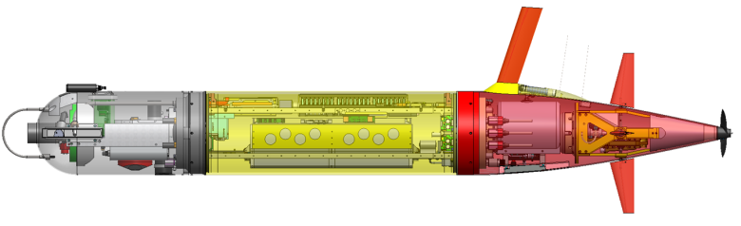
  - Mission: Circles Makai, or CPF using USBL collecting contextual bio/geo data. Position tracked by Tiny (WaveGlider), responds to a-comms command to continue mission
  - Instruments:
    - Linquest DVL Serial #013245, LCB B5 (5A)
    - Benthos DAT Serial # XXXX, LCB B6
    - Wetlabs Puck Serial # XXXX, LCB B3
    - NBOSI CTD Serial # XXXX, LCB B4
    - Turner Cyclops Rhodamine , Serial # XXXX ,LCB B0 (A/D)
    - Sparton Compass, Serial # XXXX , LCB B7
    - Aanderra Optode Serial # XXXX, not used
    - MBARI ISUS Serial # XXXX, LCB B1
    - MBARI SCIPI, Serial # XXXX, LCB B2
    - OPEN LCB: none
  - Comms
    - Freewave, Serial # XXXX LCB A2
    - NAL 9602, Serial # XXXX, LCB A1
    - Applied Acoustic transducer, Serial 2093573, standalone with 9v batteries, HPR3 Channel 6 (24.038 interrogate, 27.173 kHz reply)
    - Desert Star Argos, # 804, ID 136622, standalone battery powered
    - Telonics VHF beacon, Serial #678951A,159.65 MHz, Standalone battery powered
  - Notes:
- Tethys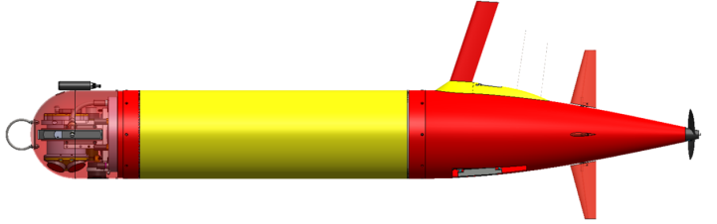
  - Mission: Patch tracking with rhodamine sensor, area recon, high resolution data upload (including ADCP?) through hotspot
  - Instruments:
    - Rowe ADCP/DVL Serial #013245, LCB B5 (5A)
    - Wetlabs Puck Serial # XXXX, LCB B3
    - Turner Cyclops Rhodamine, Serial # XXXXXX, LCB B0, using PAR port and wiring
    - NBOSI CTD Serial #XXXXX, LCB B4
    - PNI Compass (in Rowe), Serial #XXXXX, LCB B7
    - Aanderra 4830 Optode Serial # 240, LCB B2
    - MBARI ISUS Serial #XXXX , LCB B1
    - OPEN LCB: B6
  - Comms
    - CDMA radio, Serial #XXX LCB A2, IP 166.248.105.035, 831-710-7016
    - NAL 9602, Serial #XXX, IMEI 30023401186620, LCB A1
    - Benthos transponder, Serial # 49897, 26/29 kHz
    - Desert Star Argos, Serial # 1022, ID 136621
    - Telonics VHF beacon, Serial #678950A, 159.55 MHz
  - Notes:
- Makai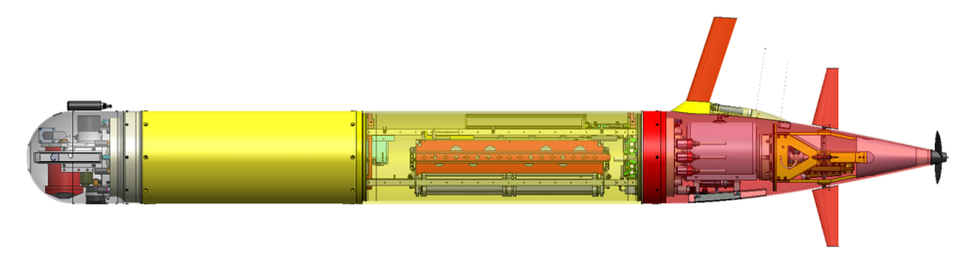
  - Mission: Sampler/ Patch center marker Vehicle, holding at density 1025.5, or temperature
  - Instruments
    - Linquest DVL Serial #,10089, LCB B5 (5A)
    - Benthos modem Serial #XXX, LCB B6
    - Wetlabs Puck Serial #XXX, LCB B3
    - NBOSI CTD Serial #XXX, LCB B4
    - Turner Cyclops Rhodamine, Serial #XXX, LCB B0
    - Sparton Compass, Serial #XXX LCB B7
    - Aanderra Optode Serial #XXX, LCB B2
    - OPEN LCB: B1
  - Comms
    - Cradlepoint radio, Serial #XXX LCB A2
    - NAL 9602, Serial #XXX, LCB A1
    - Benthos transponder Serial #XXX, 26/29 kHz, standalone battery
    - Desert Star Argos Serial # 939, Argos ID 136623, standalone battery
    - Telonics VHF beacon, Serial #XXX, XXX MHz, standalone battery
  - Notes: Using MB 2.0, old LCB backplane, new battery pack, new umbilical/charger box, though no shore-power

