2014 LRAUV Configurations for CANON
- Daphne 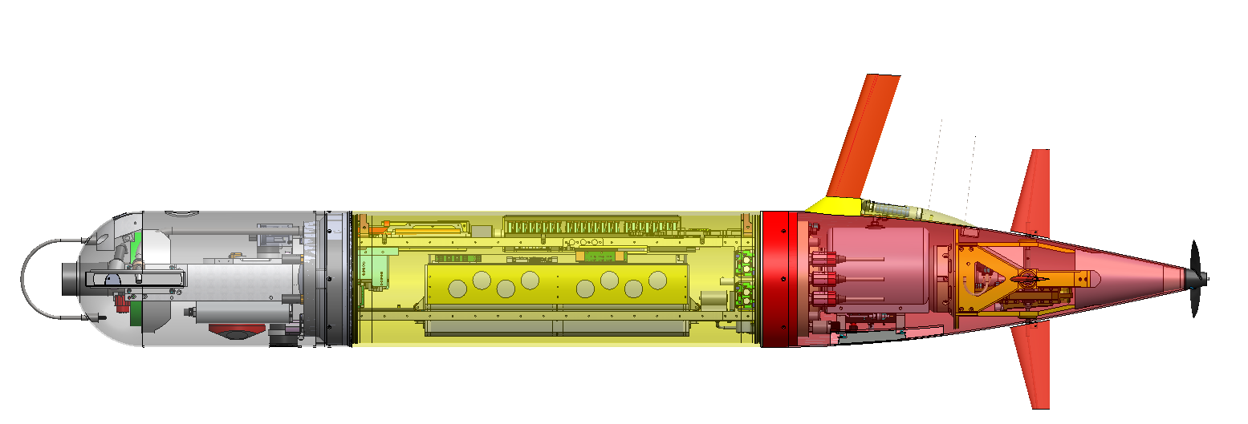
  - Mission: Circles Makai, or CPF using USBL collecting contextual bio/geo data. Position tracked by Tiny (WaveGlider), responds to a-comms command to continue mission
  - Instruments:
    - Linquest DVL Serial #013245, LCB B5 (5A)
    - Benthos DAT Serial # XXXX, LCB B6
    - Wetlabs Puck Serial # XXXX, LCB B3
    - NBOSI CTD Serial # XXXX, LCB B4
    - PAR , Serial # XXXX, LCB B0 (A/D), LCB A0
    - Sparton Compass, Serial # XXXX , LCB B7
    - Aanderra Optode Serial # XXXX LCB B2
    - MBARI ISUS Serial # XXXX, LCB B1
    - OPEN LCB: none
  - Comms
    - Freewave, Serial # XXXX LCB A2
    - NAL 9602, Serial # XXXX, LCB A1
    - Applied Acoustic transducer, Serial 2093573, standalone with 9v batteries, HPR3 Channel 6 (24.038 interrogate, 27.173 kHz reply) HPR3 Channel 6 (24.038 interrogate, 27.173 kHz reply)
    - Desert Star Argos, # 804, ID 136622 standalone battery powered
    - Telonic VHF beacon#678951A,159.65 MHz, Standalone battery powered

  - Notes:
- Tethys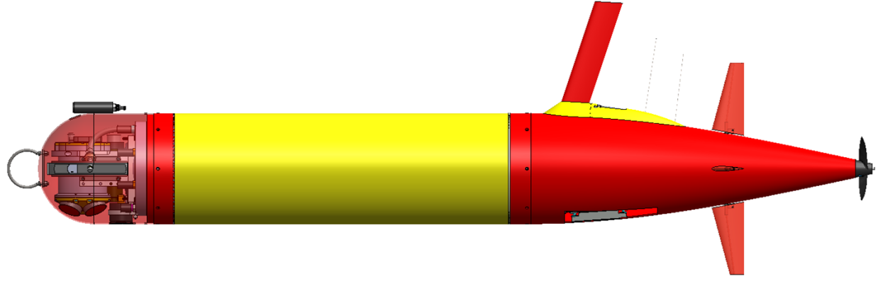
  - Mission: Patch tracking with rhodamine sensor, area recon, high resolution data upload through hotspot
  - Instruments:
    - Rowe ADCP/DVL Serial #013245, LCB B5 (5A)
    - Wetlabs Puck Serial # XXXX, LCB B3
    - Turner Cyclops Rhodamine, Serial # 2180551, LCB B0, using PAR port and wiring
    - NBOSI CTD Serial #XXXXX, LCB B4
    - PNI Compass (in Rowe), Serial #XXXXX, LCB B7
    - Aanderra Optode Serial # 241, LCB B2
    - MBARI ISUS Serial #XXXX , LCB B1
    - OPEN LCB: B6
  - Comms
    - CDMA radio, Serial #XXX LCB A2
    - NAL 9602, Serial #XXXLCB A1
    - Benthos transponder 26/29 kHz , Serial # 49897, 26/29 kHz
    - Desert Star Argos, Serial # 1022, ID 136621
    - Telonics VHF beacon, Serial #678950A, 159.55 MHz
  - Notes:
- Makai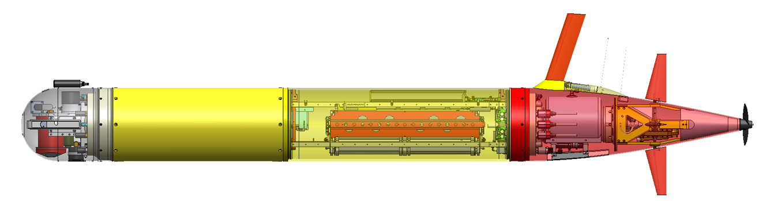
  - Mission: Sampler/ Patch center marker Vehicle, holding at density 1025.5, or temperature
  - Loads
    - Turner Cyclops Rhodamine, Serial #2180550, LCB B0
    - NBOSI CTD Serial #XXX, LCB B1
    - Sparton Compass, Serial #XXX LCB B2
    - NAL 9602, Serial #xxx1590, LCB B3
    - Wetlabs Puck Serial #1073, LCB B4
    - Aanderra Optode Serial #241, LCB B5
    - Cradlepoint radio, Serial #130489900096 LCB B6
    - ESP, LCB B7 (5A)
    - Keller Depth Sensor, Serial 51, A0
    - Linquest DVL Serial #,10089, A1 (5A)
    - Benthos modem Serial #XXX, LCB A2
    - Mass Shifter, LCB A3
    - Elevator, LCB A4
    - Rudder, LCB A5
    - Variable Buoyancy, LCB A6 (5A)
    - Thruster, LCB A7 (5A)
  - Comms
    - Benthos transponder Serial #54143, 26/29 kHz
    - Desert Star Argos Serial # 939, Argos ID 136623
    - Telonics VHF beacon, Serial #678952, XXX MHz
  - Notes: Using MB 2.0, old LCB backplane, new battery pack, new umbilical/charger box, though no shore-power

