CANON / ECOHAB summer 2015 experiment plan

Supply of nutrients to the photic zone by coastal upwelling is organized around upwelling centers. In the Monterey Bay region, upwelling centers at Point Año Nuevo and Point Sur dominate this organization (Figure Xa). Studies have shown that phytoplankton blooms in Monterey Bay, including blooms of diatom and dinoflagellate species that can cause harmful algal blooms (HABs), can be fed by nutrients from wind-driven upwelling originating at Point Año Nuevo or Point Sur, as well as upwelling from Monterey Canyon (Pennington and Chavez, 2000; Ryan et al. 2010, 2011, 2014a). Due to regional circulation, upwelling originating from Año Nuevo is a primary driver of phytoplankton ecology within Monterey Bay (Figure Xb). The dynamics and ecological processes resulting from the Point Año Nuevo upwelling will be the focus of CANON experiments during summer and fall 2015. The summer experiment will be in collaboration with a project of the NOAA Ecology and Oceanography of Harmful Algal Blooms (ECOHAB) program (Project 702105), which involves observational and numerical modeling teams from MBARI, UCSC, MLML, CeNCOOS, USC, SCCWRP and NASA/JPL. The overarching goal of the experiment is to examine the time-varying structure and dynamics of the Año Nuevo upwelling center and the phytoplankton blooms that form in response to its supply of nutrients.

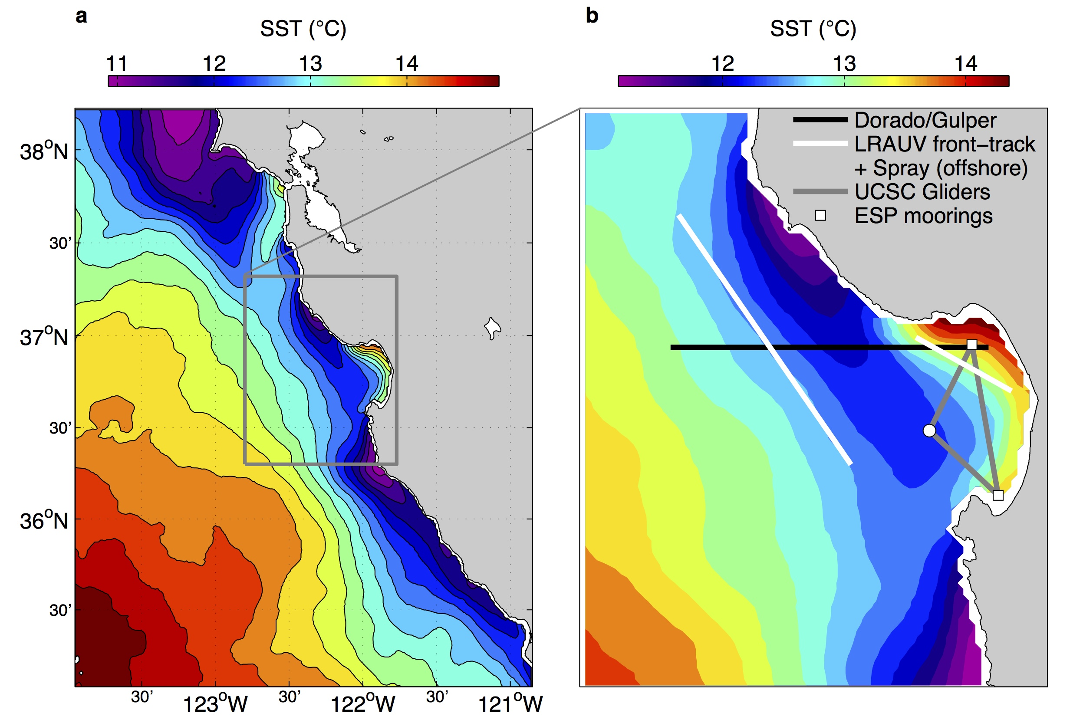

Figure X. Climatological mean sea surface temperature (SST) for summer (May-July). Greater regional context is provided in (a); details for asset planning are shown in (b). LRAUV lines represent frontal boundaries through which 4-D surveys will occur.

Zones of bloom response may be distinguished inshore and offshore of the Año Nuevo upwelling plume, and these zones have significantly different physical, chemical and biological influences. The zone offshore of the Año Nuevo upwelling plume is often seen in satellite ocean color imagery to transport phytoplankton populations southward from the north, and satellite SST suggests that outflow from the San Francisco Bay contributes to this transport pathway (Figure Xa). Blooms along this outer periphery are also subject to strong dispersion by offshore transport and intense stirring and mixing that characterize the transition zone between coastal upwelling and the California Current. In contrast, the zone inshore of the Año Nuevo upwelling plume, within Monterey Bay, is more retentive and allows resident phytoplankton populations to bloom in response episodic nutrient supply (Ryan et al., 2011, 2014b). Phytoplankton blooming both offshore and inshore of upwelling plumes depends upon the exchange between weakly stratified nutrient source water and adjacent environments that are more strongly stratified. This experiment aims to resolve these exchange processes and characterize and contrast biological communities and responses across the zones of upwelling influence.

Consistent with the previous CANON/ECOHAB experiment in Monterey Bay during fall 2013, this experiment will place persistent monitoring by ESPs in two bloom incubation zones of Monterey Bay (Figure Xb). ESPs deployment from mid-May to mid-June establishes a temporal framework for the experiment (Figure Y).

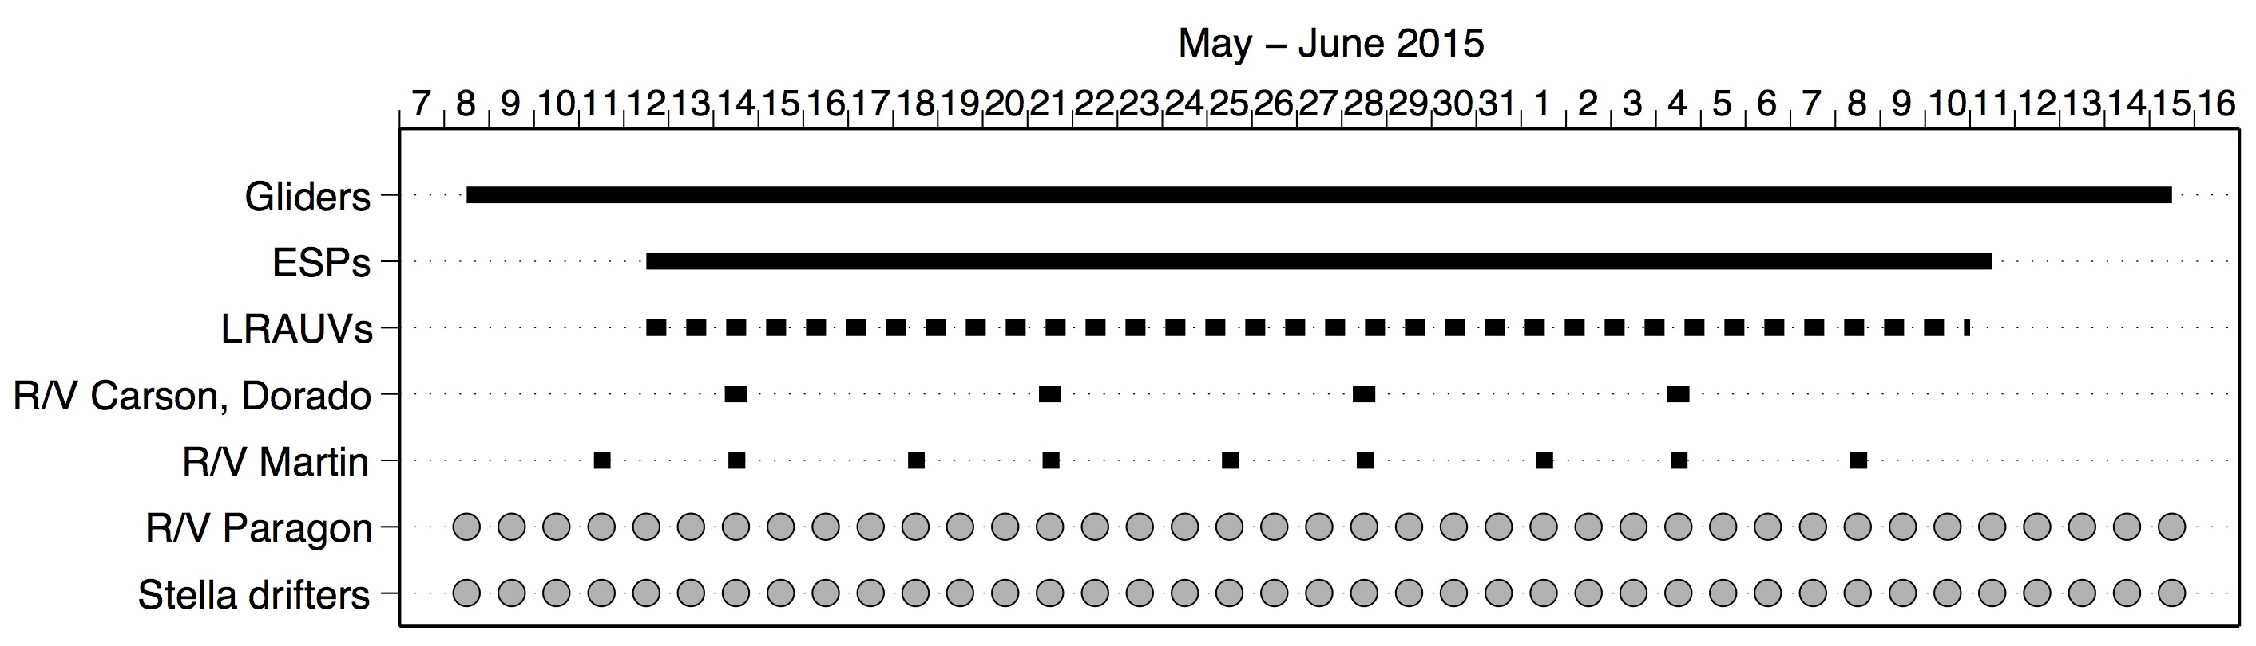

Figure Y. Schedule of asset deployments for summer 2015 CANON/ECOHAB experiment. Deployments of LRAUVs, Paragon and drifters will be adaptive in location and schedule.

Gliders will be used for persistent environmental characterization throughout the experiment, including NPS Spray gliders that will monitor offshore conditions along the outer periphery of upwelling filaments, UCSC gliders that will monitor Monterey Bay, and Wave Gliders that will observe at regional to frontal scales (Figure Xb). The endurance of LRAUVs will be applied for multiple purposes. First, three LRAUVs will be used in coordination such that two (Tethys, Daphne) provide context for the third (Makai with G3 ESP). Second, when conditions are appropriate the dynamics of the upwelling filament frontal zones will be resolved by LRAUVs running autonomous 4-D frontal tracking and mapping, a demonstrated capability (Zhang et al., in prep.). The white lines in Figure Xb identify the orientation of the front in the mean; frontal tracking uses real-time to detect and map across frontal zones. The frontal identification method (Zhang et al., 2012) has proven effective not only when weakly stratified upwelling filaments are present, but also during relaxation periods when weakly stratified offshore waters flow toward the coast (Zhang et al., in prep., b). If conditions are favorable, this frontal tracking mode will be applied using all three LRAUVs, to focus biological and chemical sampling within the frontal zones through which nutrient fluxes to the phytoplankton community are occurring. The R/V Carson will serve as a collaborative hub for the CANON ECOHAB team during weekly one-day (12 hour) cruises. Deployed from the Carson, the Dorado/Gulper AUV will provide weekly high-resolution mapping and targeted sampling across the bay, upwelling and offshore zones. The 20-Gulper mid-section will be important for sufficient sampling resolution across the region. With the relatively long Dorado section (60 km), we propose an inbound section timed to return Dorado to Moss Landing for tow-in (RHIB or Paragon) recovery the following morning. This mode of operation will allow dedication of most R/V Carson time to sampling the region between the Año Nuevo upwelling center and the northern bay. The R/V John Martin will be used for two purposes: (1) to sample around the southern bay and ESP while R/V Carson operations are focused further north, and (2) to fill in temporal coverage around the weekly Carson cruises.

