2015 LRAUV Configurations for CANON
- Daphne 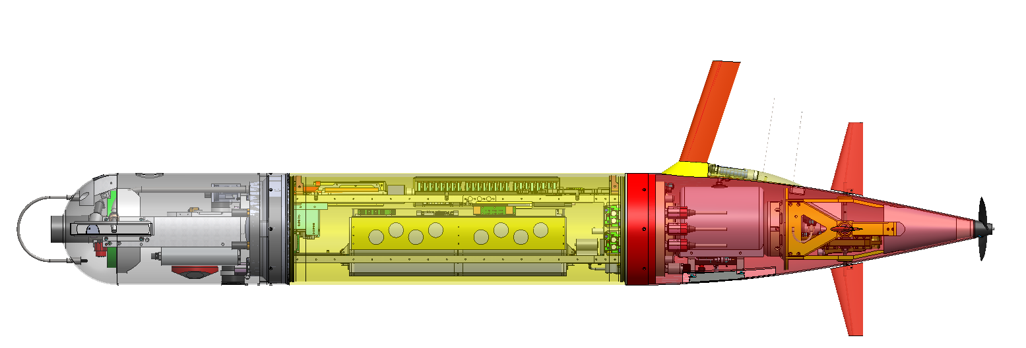
  - Mission: Circles drifting AUV using DAT while collecting contextual bio/geo data. Position tracked by Tiny (WaveGlider), responds to a-comms command to continue mission. Can also drift while being tracked by WaveGlider, but no other vehicles can circle
  - Instruments: C, T, DO, Chl, OBS, PAR, Nitrate
    - NBOSI CTD Serial # 212/292 LCB A4 36-232-5-
    - Wetlabs Puck Serial # 935, LCB A6 39-232-12-
    - PAR , Serial # 8455, LCB A0 50-0-0-A/D
    - Aanderra Optode Serial # 240 LCB A2 30-232-12
    - MBARI ISUS Serial # XXXX, LCB A1 19-232-Batt-Discrete
    - Linquest DVL Serial #013245, LCB A5 46-232-24V-4A
    - Sparton Compass, Serial # XXXX , LCB A7 34-TTL-3.3-
  - Comms
    - Cradlepoint Cell/WiFi # XXXX LCB B2 – 37-OFFBOARD-12V
    - NAL 9602, Serial # XXXX, LCB B1 35-232-5-
    - Applied Acoustic transducer, Serial 2093573, standalone with 9v batteries, HPR3 Channel 6 (24.038 interrogate, 27.173 kHz reply) HPR3 Channel 6 (24.038 interrogate, 27.173 kHz reply)
    - Desert Star Argos, # 804, ID 136622 standalone battery powered
    - Telonic VHF beacon#678951A,159.65 MHz, Standalone battery powered
    - Benthos DAT Serial #43987, LCB A6 45-232-24-4A
  - Notes:
    - Using MB 2.5, old LCB backplane, new battery pack

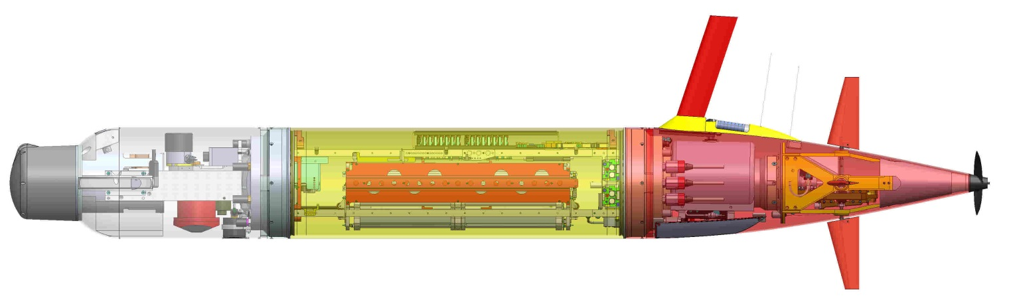
- Tethys
  - Mission: Carries CANON Sampler and can drift while being tracked by the WaveGlider and circled by Daphne
  - Instruments: C, T, Chl, OBS, PAR and CANON Sampler, DO, Vemco tag receiver
    - Wetlabs Puck Serial # 634, LCB B3 16-232-12, front port 2
    - NBOSI CTD Serial #159/199, LCB B4 22-232-5, , front port 3
    - Sparton Compass, Serial, LCB B7 20-TTL-3V, shares front port 7 with DVL
    - Aanderra Optode Serial # 14, LCB B2 23-232-12, , front port 6
    - Vemco fish tag receiver VR2C-69 kHzSerial # 450149 , share power with Puck (B3) Comms TTY/TX1/VRRT2/ J6, ISUS tray, front port 1
    - Linquest DVL Serial #,10089, B5 29-232-24-5V, shares front port 7 with compass
    - PAR #8454, LCB: B0 48-0-0-A/D, , front port 4
    - CANON Sampler LCB: B6 38/232/12 , front port 8
  - Comms
    - Cradlepoint radio (cell/WiFi), Serial #MM140253200389, LCB A2 51-Offb oard-12v
    - NAL 9602, Serial #300234011866620/D04VR3 LCB A1 13-232-5v
    - Benthos transponder 26/29 kHz , Serial # 49897, 26/29 kHz
    - Desert Star Argos, Serial # 1022, ID 136621
    - Telonics VHF beacon, Serial #678950A, 159.55 MHz
    - Benthos modem Serial #64093 PCB, LCB B1 83/232/24/5A, front port 5
    - MCV MUX #0003
  - Notes: Using MB 2.5, old LCB backplane, new battery pack, new

- Makai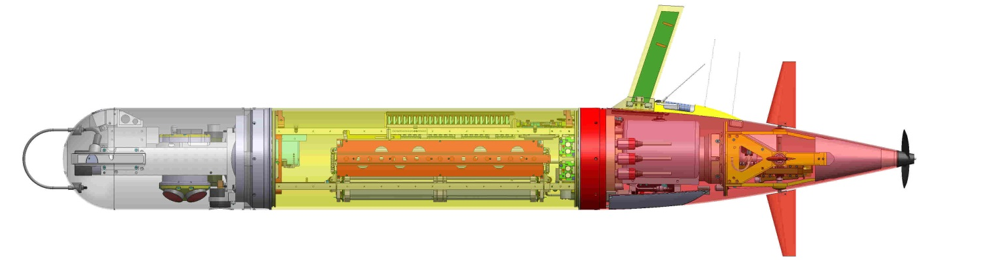
  - Mission: Can run front/patch tracking and be a drifter tracked by the Wave Glider
  - Instruments: CT, DO, Chl, OBS, PAR, Rowe Current Profiling
    - NBOSI CTD Serial #100/54 LCB B1 69-232-5-
    - PNI Compass (in Rowe), Serial #XXXXX #XXX LCB B2 74-TTL-3.3-
    - NAL 9602, 300234060751590, LCB B3 67-232-5-
    - Wetlabs Puck Serial #1073, LCB B4 70-232-12-
    - Aanderaa Optode Serial #241, LCB B5 71-232-12-
    - Keller Depth Sensor, Serial 51, A0 47-analog
    - Rowe ADCP/DVL Serial #013245, LCB A1 73-232-24-5A
    - PAR #8594, LCB B0 70 Analog
  - Comms
    - Benthos Acoustic Transponder Serial #49901, 26/29 kHz
    - Cradlepoint radio, Serial #130489900096 LCB B6 75--12-
    - Desert Star Argos Serial # 939, Argos ID 136623
    - Telonics VHF beacon, Serial #678952, 159.75 MHz
    - Benthos Acoustic modem, Serial #64093 PCB, LCB A2 72-232-24-
    - MCV mux serial number 005
  - Notes: Using MB 2.5, old LCB backplane, new battery pack, new
  - 970g trim weight in nose and 120g in tail at thruster motor

