Watchstanding Setup For

LRAUV and Waveglider


Revision: 0.1
Date: May 2015
Revision History
Rev 0.1 – 05/2015 | Initial Revision – B Kieft

Who’s On Watch?
This shared document is the “watchbill”. If you can’t access it, contact Brian or Brett to be added. On top of the watchstander, there is always an on call engineer. Either Jordan or Brian for the LRAUVs or Brian, Thom M, or Tom O for the Waveglider. This engineer can assist when you have a question. You can enter your name to sign up for a shift anytime:
https://docs.google.com/spreadsheets/d/12f-TYoBDVpOnU5p3KjH9cM1lPNxCVcrZLY_-nFVz0TA/edit?usp=sharing

Waveglider Command and Control Interface:
There is a general MBARI account under the name "Will Waterman". To log in go to http://mbari.wgms.com and log in using the credentials below
wgwaterman
mbari2015
Click on the piloting portal and check that the vehicle selected from the drop menu in the upper left corner is “Tiny”. That’s the name of the SV3. The white icon shows the current location of the Waveglider. Occasionally, alerts will come in from the Waveglider (denoted by a yellow or red circle at the top of the page where it says “Health”). When this occurs, an e-mail is sent to the following MBARI e-mail list: wgwaterman@listserver.mbari.org
Waypoints
A ship
Vehicle position
Vehicle name

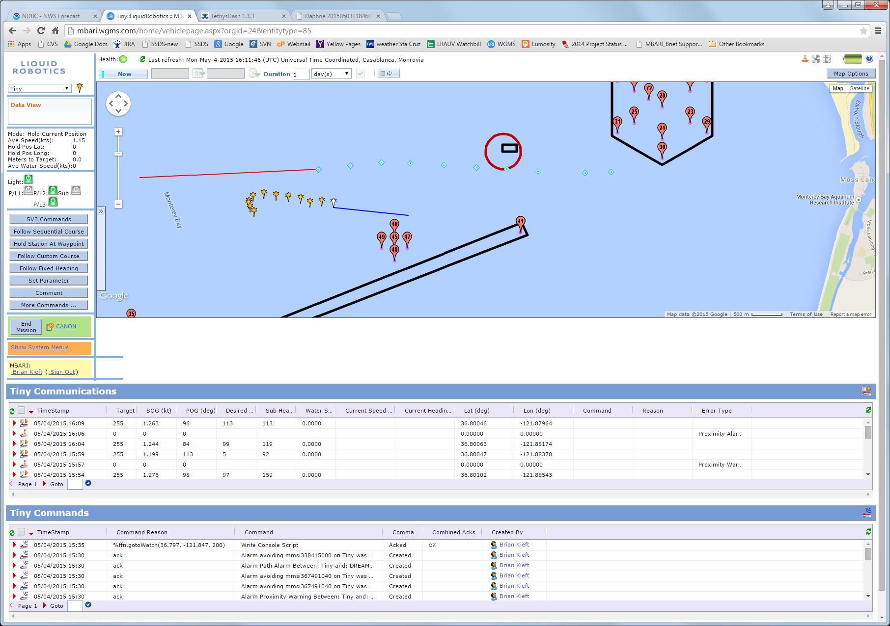

You’ll need to subscribe to this list to get the alert e-mails. If you’re not familiar with how to subscribe to an MBARI e-mail list, follow this link and click “subscribe” on the left hand side of the page to sign up for the list noted above. http://listserver.mbari.org/sympa/info/wgwaterman
Once you have e-mail flowing, it’s up to you as to how you’d like to receive the alert. I prefer using a text to my phone. You can set up your e-mail to forward them to your phone number (sms gateway).

Common SMS Gateways:
Carrier | Email to SMS gateway
Alltel | [insert 10-digit number] @message.alltel.com
AT&T | [insert 10-digit number] @txt.att.net
Boost Mobile | [insert 10-digit number] @myboostmobile.com
Sprint | [insert 10-digit number] @messaging.sprintpcs.com
T-Mobile | [insert 10-digit number] @tmomail.net
US Cellular | [insert 10-digit number] @email.uscc.net
Verizon | [insert 10-digit number] @vtext.com
Virgin Mobile | [insert 10-digit number] @vmobl.com

For the LRAUV(s):
Confirm that you can log into the dash at: http://okeanids.mbari.org/TethysDash/
Let me know if you have trouble logging in and we can create/update your account. Once logged in, activate your alert for vehicle daphne (vehicle selection is on the top left drop menu again) by clicking on the “notify” tab at the top of the page. You can select what you’d like to receive e-mail/texts for. A good place to start is what I have selected (search “Brian”).
Once you’ve selected a dialogue will ask to send a test message. Select yes and you should see one within a few minutes.
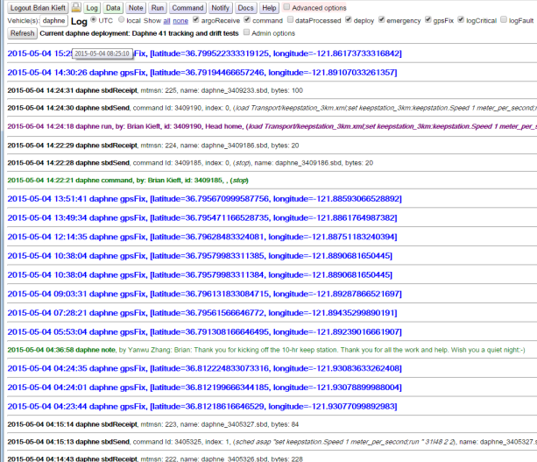
Make sure it shows you as logged in here

