Quick Guide to Transferring Data
From ISUS
Embedded in a Tethys Long Range AUV

02/05/2013

System Overview:
The ISUS is normally powered by a Load Control Board (LCB) with sensor data being read by the LRAUV application and stored locally on the ISUS. The ISUS local storage is a compact flash card with a maximum capacity of 2 Gb. Once the compact flash card is full, no data can be logged by the application or locally by the ISUS. Transferring files off the ISUS’ compact flash card may be necessary when the vehicle is sealed. This document describes: 1.) transferring data from the ISUS to a local computer, and 2.) transferring data from the ISUS to the LRAUV filesystem.

Necessary tools:
ISUS -> Computer:
- ISUS external power and comms cable
- 12V power supply
- A computer with a serial port and hyperterm

ISUS -> LRAUV filesystem:
- A physical connection to the LRAUV and computer with terminal

ISUS to Local Computer Transfer:
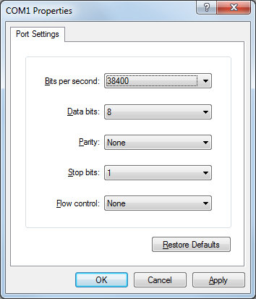
Connect the ISUS external power and comms cable to the J-F5 Aanderra DO connector on the front endbell of the LRAUV. Connect the serial connection to a computer and open HyperTerminal. Set up the port as shown in fig 1. The default baud rate for ISUS is 38400, but consult the vehicle.cfg file for the specific baud rate on an individual vehicle.
Fig 1.

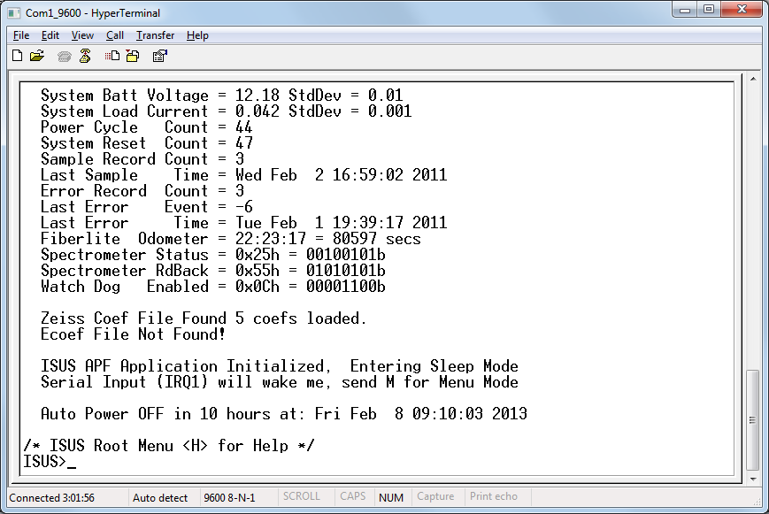
Apply 12V to the power connectors as labeled. This closes a relay on the external serial port and allows ISUS communication via the external serial port. You should see the ISUS boot messages scroll across the screen. Following the instructions, press ‘M’ for menu mode and you will receive an ISUS user prompt as shown in fig 2. Pressing ‘h’ as noted will give you command options for that specific menu.
Fig 2.

From the main menu, select ‘F’ for the “file menu”, then ‘D’ for the “download file” menu. Use Zmodem to transfer all files off the ISUS. This is option 4. When prompted to “Enter Common File Extension”, enter “LOG” (or any other extension you desire to transfer). See fig 3.
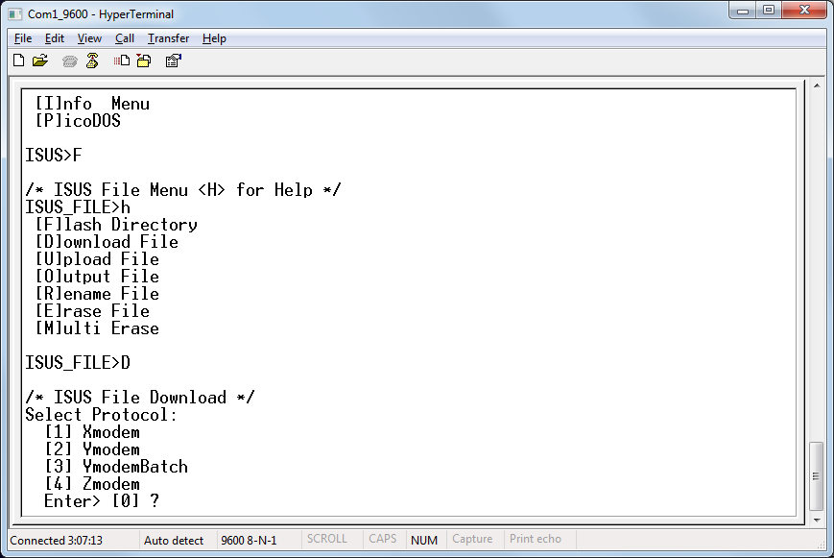
Fig 3.

The menu will then prompt for the desired baud rate. Select 115200 via option 5. The ISUS will wait 30 seconds before attempting the file transfer at the new baud rate. See fig 4.
While waiting, reconfigure HyperTerminal to run at 115200 baud:
disconnect, configure, and reconnect. See fig 5.
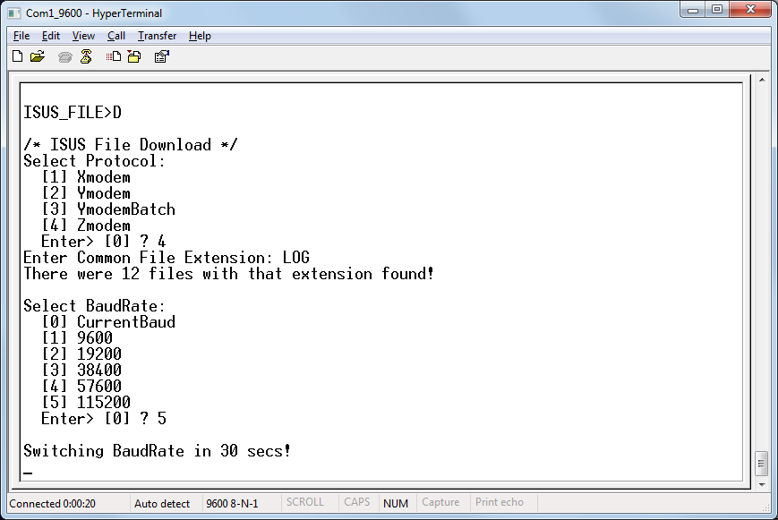
Fig 4.

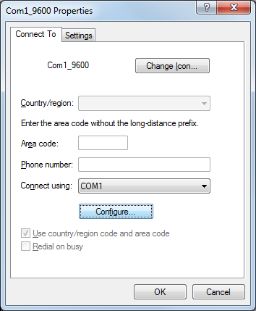
Fig 5.

When the ISUS begins the file transfer, HyperTerminal should automatically begin receiving via Zmodem. If it doesn’t, select:
Transfer -> Receive File -> Zmodem from the menu.

ISUS to LRAUV File System:
Coming soon…

