Project Description
A1. Instrument Location and Type
Instrument location: School of Marine & Atmospheric Sciences (SoMAS), Stony Brook University
Instrument type: An autonomous and modular in situ coastal Free Ocean Carbon Enrichment instrument

A2. Justification for submission as a Development proposal
Free Ocean CO₂ Enrichment (FOCE) is a technology facilitating studies of the consequences of ocean acidification (OA) for marine organisms and communities by enabling the precise control of CO₂ enrichment within in situ, semi-open, experimental enclosures. FOCE experiments examine the effects of OA under more natural settings than laboratory conditions, typically consisting of a series of semi-open enclosures placed on the seabed over a habitat or community of interest. Four such systems have been developed to test specific questions (see Table 1). However, the proposed FOCE system would differ from the previous FOCE systems in three specific ways: 1) It will be developed to operate in coastal environments (< 30 m deep), 2) possess the ability to adjust the flow rates so that different experimental enclosures would be able to be attached to the system and 3) it will be powered autonomouslyand therefore will not be restricted to areas where it can be powered via onshore electricity. This would be a significant step forward in FOCE technology. While many physical and chemical sensors (pH, pCO₂, DO, salinity, PAR) and instrumental components (pumps, current meters and CTD) are commercially available, combining them in an integrated system where sensors and components communicate to control flow pumps and gas injectors will require hardware and software development. In addition, electrical engineering expertise is required to fulfil power demands and operate autonomously. SoMAS instrument engineers, Stony Brook electrical engineers and Bill Kirkwood, the design engineer of the first two FOCE systems, have developed a conceptual design for the proposed system. The next transformative step in OA research requires in situ manipulative studies that incorporate multiple species interactions. However, conducting such experiments requires access to FOCE technology which can only be created via a team of instrument engineers, computer programmers, electrical power engineers and scientists. SoMAS is uniquely positioned to maximize the use of such technology. We have a history of conducting interdisciplinary research among our geological, chemical, biological and atmospheric faculty. Ocean acidification brings together faculty across those disciplines and beyond to address fundamental questions on the impact of OAon coastal processes.
The SoMAS Instrument Laboratory provides engineering services and technical support of scientific and oceanographic projects to clients at Stony Brook University and worldwide. Lab capabilities include electronic system design to the component level, PC board design, microcontroller and computer programming, real time web-based data displays, 4G Internet and satellite telemetry, welding, machine shop, pressure case design/fabrication, solar power systems, buoys, floating platforms, and mooring design and fabrication. All of which will be needed in the fabrication of the FOCE system. While all developmental projects involve risks in achieving the required specifications, the involvement of Bill Kirkwood and the incorporation of various elements of his shallow water protypes have mitigated much of the engineering and development risk. Given the engineering jump start that Kirkwood’s involvement in this project gives, we expect to be ready to field test a complete system in Yr. 3 and have only requested a 4 year project timeline.

B. Reseach Activities to be Enabled

Understanding the potential consequences of OA and other climate-related changes in ocean conditions for marine biological communities is a priority in ocean sciences (Rudd 2014, Mason et al. 2017). Ocean acidification - a shift in the carbonate chemistry of the oceans - is a direct result of the rapid rise in atmospheric CO₂ concentrations associated with human activities, particularly fossil fuel use (Canadell et al. 2007, Raupach et al. 2007, Ciais 2013, Le Quéré et al. 2016). It is estimated that the oceans have absorbed 29% of the CO₂ emitted to the atmosphere since the beginning of the industrial revolution (Le Quéré et al. 2016), resulting in a 0.1 decline of pH in the upper ocean mixed layer (Sabine et al. 2004, Bindoff et al. 2007, Rhein et al. 2013). This acidification impact is intensified on coastlines, where this change is overlaid on the complex and variable carbonate chemistry due to estuaries and biological activity (Feely et al. 2010, Wallace et al. 2014). Ocean acidification poses multiple challenges for marine organisms from molecular to ecosystem scales. Changes in ocean conditions can affect populations directly through shifts in the performance (physiology, behavior, survival, growth, reproduction) of individuals, which in turn may drive a cascade of direct and indirect consequences due to changes in the strength of interactions among species (e.g., competition, predation) (Louise Allan et al. 2013, Poore et al. 2013, Burnell et al. 2014). Laboratory experiments and field observations have documented effects of OA in a variety of taxa, particularly calcifying organisms. Ocean acidification can reduce survivorship, metamorphosis and calcification in marine organisms (Doney et al. 2009, Kleypas and Yates 2009, Erez et al. 2011, Kroeker et al. 2013), that support our most valuable fisheries. In the US, lobster, clams, scallops and oysters are among the most valuable fisheries and support well over $1 billion in landing (NMFS 2017). Additionally, shellfish aquaculture currently supports a billion dollar industry and is growing 1% per year (NMFS 2017). Impacts of OA on marine organisms, including economically important species, are often complex and life-stage dependent (Fabry et al. 2008, Iglesias-Rodriguez et al. 2008, Dupont et al. 2010, Hendriks et al. 2010). Furthermore, OA may have significant impacts when combined with other environmental changes such as hypoxia (Bograd et al. 2008, Nam et al. 2011) and warming (Queirós et al. 2015a, Rühl et al. 2017). Ocean acidification is very likely to cause major ecological, economic, and social impacts on coastal ecosystems. A growing number of studies suggest that there will be significant regional impacts on the livelihoods of coastal communities reliant on wild captures as a result of regional ecological impacts (Fernandes et al. 2017) especially those communities that have few alternative industries (Ekstrom et al. 2015). Such effects are expected to be seen worldwide including the US (Cooley and Doney 2009). Technologies and methods that enable experiments that advance current understanding of the consequences of OA in natural ecosystems over ecological to regional scales are a high priority in coastal ocean research.
It is critical to develop experimental approaches in OA research that: 1) scale up from single to multiple environmental drivers, 2) scale up from single species to communities and ecosystems, and 3) measure acclimation of species and capacities for adaptation to future conditions (Riebesell and Gattuso 2014). Addressing these challenges requires the development and emphasis of novel approaches that can measure the responses of species within intact assemblages or communities to multiple environmental changes, over fairly long time scales. Such ecological approaches are vital in addressing more far-reaching goals concerning the ecological and evolutionary responses of marine species and systems to escalating anthropogenic change in ocean conditions, and their implications for society. Building on the tremendous success of terrestrial CO₂ enrichment experiments through FACE (Free Air CO₂ Enrichment) sites around the globe (Nösberger et al. 2006), Gattuso et al. (2014) defined Free Ocean CO₂ Enrichment (FOCE), “as a technology facilitating studies of the consequences of OA for marine organisms and communities by enabling the precise control of CO₂ enrichment within in situ, semi-open, experimental enclosures.” FOCE experiments examine the effects of OA under more natural settings than laboratory conditions, typically consisting of a series of semi-open enclosures placed on the seabed over a habitat or community of interest. Specific elements (such as biological organisms or structures) can also be added into the enclosure. The surrounding ambient seawater flowing through each semi-open enclosure is manipulated to change the pH of the seawater, usually by the addition of CO₂ enriched seawater, which produce a desired pH offset in the enclosure water (Fig. 1). This offset is maintained for the duration of the experimental period in addition to natural variations in surrounding water carbonate chemistry. Enclosures are sufficiently sealed to permit control of water chemistry and prevent ingress of large mobile organisms.
Figure 1. Seawater pH in experimental (acidified) and control enclosures in comparison to ambient pH during a FOCE experiment. Large variation in acidified treatments was due to power failures causing the system to shut down (gaps in each line) and the pH to begin to revert to ambient conditions. (from Stark et al. 2018)
At present we lack an understanding of the likely long-term impacts of OA on benthic species, communities, and ecosystems and consequences for the ecosystem services they provide (Riebesell and Gattuso 2014). As summarized by Gattuso et al. (2014), FOCE studies are specifically designed to begin to address these needs. The primary aim of this approach is to move from understanding short-term, single organism responses to OA, to the community and ecosystem level, through the use of in situ experimental approaches involving natural benthic communities. FOCE experiments address some of the limitations of other approaches for in situ OA experiments, such as time-series analyses of communities changes resulting from changes in carbonate chemistry and in naturally high-CO₂ analogue studies such as CO₂ vents and seeps. FOCE enables the control of parameters that have been highlighted as potential shortcomings, or confounding variables in natural analogue studies, such as other uncontrolled environmental changes, large temporal variability (Kerrison et al. 2011), lack of experimental replication and no control over treatment conditions or reference sites, and immigration of organisms into the study areas (Gattuso et al. 2014). FOCE experiments also complement other approaches such as experiments performed in aquaria, mesocosms, or by using natural environmental pH gradients. Andersson et al. (2015) and Gattuso et al. (2014) compare the strengths and weaknesses of different experimental approaches, including FOCE studies, and suggest that a combination of approaches are required to understand the impacts of OA across a range of spatial and temporal scales.
The primary capability of FOCE is to provide realistic scenarios to test the impacts of future acidification on benthic communities that incorporate natural variation in ecosystem conditions. FOCE is thus a holistic experimental approach that can enable the detection of both the direct and indirect effects of OA on species and processes, potentially providing a more comprehensive assessment of the ‘real-world’ outcomes of future ocean conditions than other approaches. Environmental conditions such as temperature, oxygen, light and natural food concentrations are difficult to mimic even in the most controlled laboratory experiment. Thus, FOCE is an ideal approach to help address current gaps in understanding of OA impacts, including long-term effects and confounding effects of multi-stressors seen in natural settings (Riebesell & Gattuso, 2015). An important advantage of FOCE experiments is the possibility of long term studies, from months to years, with previous experiments ranging from 10 days to 8 months (Table 1). An offshore sub-surface version, dpFOCE, operated continuously for 17 months in engineering tests. The potential exists to run long experiments, particularly now that the technology has been tested and system design principles are well established. One of the most promising capabilities regarding FOCE is the incorporation of multiple environmental factors into experiments. Some factors would be difficult to manipulate, such as warming a large volume of water flowing through a FOCE system (in combination with enriched CO₂). Manipulating oxygen levels may be more achievable on the spatial and temporal scales of recent FOCE experiments. Investigating other factors such as contaminants may be achievable by deploying FOCE experiments in already polluted areas. The potential to conduct multi-factorial experiments in a FOCE setting provides an exciting opportunity for future research.

FOCE systems are amenable to a spectrum of research questions, spanning a range of life history phases of planktonic and benthic taxa and processes important in shaping natural communities. FOCE facilities can be used to address questions concerning the influence of OA on colonization, physiological performance, growth, survival, succession, mediation of predation and competition, community metabolism, nutrient cycling, and other processes in benthic communities. Previous FOCE experiments
have focused on a wide variety of scientific questions, with published results ranging from effects on coral growth and calcification (Georgiou et al. 2015), to seagrass productivity and changes in epibiotic communities (Cox et al. 2016), to urchin behavior (Barry et al. 2014). Most of these studies have been
Table 1: Location and habitat of each of the FOCE experiments to date.
Experiment | Location | Habitat | Depth (m) | Duration of experiment | Principal organisation
eFOCE -  European FOCE | Mediterranean, France | Seagrass | 12 | 4 months ambient, 4 months acidified | Laboratoire d’Océanographie de Villefranche
cpFOCE –  coral prototype FOCE | Heron Island, Great Barrier Reef, Australia | Coral reef flat | 1-4 | 6 weeks ambient, 6 months acidified | University of Queensland
dpFOCE –  deep FOCE | Monterey Bay Canyon, USA | Sediment | 890 | 17 months test, 32 days acidified | Monterey Bay Aquarium Research Institute
antFOCE –  Antarctic FOCE | Casey Station, Antarctica | Under-ice sediment and reef community | 14 | 4 weeks ambient, 8 weeks acidified | Australian Antarctic Division
swFOCE –  shallow water FOCE | Monterey Bay, USA | Sand | 13 | Test phase only | Monterey Bay Aquarium Research Institute

used to assess the response of individual species to OA under low pH and natural conditions (Kline et al. 2012, Barry et al. 2014, Georgiou et al. 2015, Cox et al. 2016).
FOCE experiments to date have been conducted completely independently, with no common goals or common scientific questions. A more coordinated multidisciplinary approach using FOCE instruments will enable greater comparability among different experiments. Important parallels between FOCE and the well-established FACE experiments may provide a guide to the development of specific sets of hypotheses that could be pursued in a more coordinated approach. Norby and Zak (2011) proposed a set of testable guiding hypotheses for FACE experiments which proved to be extremely valuable for extending insights in high atmosphere CO₂ effects from the scale of individual plants to ecological and ecosystem responses to address the critical need to gather insights across scales to evaluate feedbacks between the biosphere, atmosphere and climate. The envisioned projects that would be enabled by the development of the FOCE instrument include hypotheses-driven research within and across disciplines and scales including community structure and biodiversity, trophic interactions, competition/predation, resilience, acclimation and adaptation, net primary production and marine plant growth, calcification/dissolution, nutrient cycling, carbon cycling and ecosystem function, and processes such as bioturbation.
Climate change including OA can have direct and indirect effects on marine organisms (Andersson et al. 2015). Past studies have focused on the direct physiological responses of marine organisms, but very few experimental studies have quantified population level responses or incorporated indirect effects of environmental factors such as changes in trophic interactions. Results from FOCE studies will also be critical to improve parameterization ecosystem models. An important and novel approach will be to directly compare models parameterized from experiments on individual species vs. those parameterized with FOCE experiments, thus answering a fundamental problem in ecology of how physiological processes scale to population and ecosystem level. We would use mass-balance models currently being developed for estuarine ecosystems in the Northeast US. Projecting the potential effects of OA in ecosystems, and how we may shape management efforts to mitigate impacts requires predictive models of marine ecosystem structure and function that operate at systems level scales (Queirós et al. 2016). The building blocks of such models are mathematical representations of flows of matter and energy between ecosystem components, between biological systems and their environment, and their functional responses to environmental change such as OA and warming (Queirós et al. 2015a). Models enable predictions to be made from small scale processes, such as those associated with recycling of organic matter and nutrients on the seafloor (Laverock et al. 2013, Lessin et al. 2016, Rastelli et al. 2016), to large scale processes, such as productivity and bottom-up effects on marine food webs (Queirós et al. 2016). Model development is often limited by key aspects such as a mismatch between the scale and diversity of the focus of research, as well as the data type, data availability and scaling needs of model development (Riebesell and Gattuso 2014, Queirós et al. 2015b, Koenigstein et al. 2016). Laboratory studies, where the inherent complexity and variability of natural ecosystems is removed, are important in quantifying and describing mechanisms linked to OA that can be used to determine mathematical representations to be applied within models.
However, laboratory studies do not provide information about the interplay between the various processes through which OA impacts all levels of biological organization within a local community or ecosystem. Ecosystem-level studies of OA, therefore, remain largely absent. This is where the FOCE approach provides real value: it can generate the data required for the parameterization of models that incorporate changes in trophic interactions under acidified conditions. The manipulation of environmental conditions within a whole community/habitat setting offered by FOCE could allow detection of potential changes in the flows of energy and matter between different community components, as well as potential interactions between various community components, or processes. Thus, the FOCE approach can provide a more holistic, contrasting, yet complementary approach to other ongoing OA research efforts (Riebesell and Gattuso 2014).
The use of standardised FOCE methodologies across ecosystems, from tropical to polar regions (Table 1) supports the ability to derive regional responses and general principles about how OA modifies marine ecosystems. Such coordinated efforts would enable differentiation between general responses to OA and those impacts specific to local ecosystems. These two attributes conferred by a FOCE approach (community level manipulation and standardisation of information across ecosystems) provide clear advantages that will promote progress in developing ecosystem models that may help us forecast ecosystem-level impacts and support adaptive management solutions. As with FACE experiments (Norby and Zak 2011), models can be used to generate ecosystem level hypotheses that can be tested in a FOCE experiment. Results from FOCE can then feedback into ecosystem model development related to OA. FOCE experiments can facilitate the testing of hypotheses that contribute to the development of ecosystem models concerning the long-term responses of benthic ecosystems experiencing OA and associated or other environmental changes.

B1. Behavioral and physiological responses of benthic invertebrates to OA. N. Volkenborn – SoMAS (https://www.somas.stonybrook.edu/people/faculty/nils-volkenborn/), R. C. Aller – SoMAS (https://www.somas.stonybrook.edu/people/faculty/robert-aller/), Q. Zhu – SoMAS (https://www.somas.stonybrook.edu/people/faculty/qingzhi-zhu/), D. Hudson – Maritime Aquarium, S. Dupont – University of Gothenburg (https://bioenv.gu.se/english/staff?userId=xdupsa), J. Hall-Spencer – University of Plymouth (www.plymouth.ac.uk/staff/jasonhall-spencer): Long-term OA associated with the increase in atmospheric CO₂ is expected to superimpose upon other short-term dynamics (Melzner et al. 2013). Fore example diel-cycling hypercapnic hypoxia is a common phenomenon in coastal ecosystems (Hofmann et al. 2011, Baumann et al. 2015). Eutrophication can lead to an increase in the magnitude and frequency of diurnal oscillations between high pH - high O₂ conditions during daytime and low pH - low O₂ conditions during nighttime (Wallace et al. 2014). but How benthic organisms will cope with the expected increased severity of hypercapnia during diel-cycling hypoxia is currently unknown (Waldbusser and Salisbury 2014). The autonomous and modular in-situ coastal Free Ocean Carbon Enrichment (mcFOCE) instrument will allow exposing ecologically and economically important benthic invertebrates to contrasting magnitudes of natural co-variations in pH and O₂ with and without the additional change in carbonate chemistry associated with long-term OA to identify environmental thresholds that relate to non-lethal stress in key benthic species under future coastal ocean conditions. The rationale is that in coastal systems benthic organisms are frequently exposed to below-threshold conditions and the frequency and durations of non-lethal stress and the resilience of benthic organisms are critical aspects that will control population persistence in a changing costal ocean. Performance will be monitored in-situ using a suite of non-invasive sensors that allow measurements with high temporal resolution over extended periods. Heartbeat rates (bivalves and crustaceans), valve gaping (bivalves), and pumping and burrowing activity (infaunal bivalves and polychaetes) will be measured with infrared, Hall Effect, and porewater pressure sensors, respectively. By testing different species (calcifiers versus non calcifiers), different populations (acclimatized or not acclimatized to diel-cycling hypoxia), and different life stages (juveniles and adults) the in-situ measurements will provide critical data on species-, population-, and life-stage-specific resilience of benthic organisms to future coastal ocean dynamics. In addition, FOCE will allow to acclimatize key benthic species at different life stages in-situ to contrasting magnitudes of diel-cycling hypercapnia and hypoxia to determine acclimation and legacy effects on the ability to cope with environmental variability and severe stress. This work will provide unique insights into the adaptive capacities of ecologically and economically important benthic species in coastal ecosystems under current and future dynamic multi-stressor regimes. The insights will be useful to improve ecological risk assessments and conservation and management efforts in coastal ecosystems.
B2. Linking impacts of OA to complex marine microbial communities. J. Collier – SoMAS (https://www.somas.stonybrook.edu/people/faculty/jackie-collier/), R. Thacker – E&E (https://www.stonybrook.edu/commcms/ecoevo/people/faculty_pages/thacker.html), B. Peterson – SoMAS (https://www.somas.stonybrook.edu/people/faculty/bradley-peterson/): The mcFOCE system will provide unprecedented opportunities to investigate effects of pH on intact, natural microbial communities. Of particular interest to us is the characterization of pH effects on the microbiomes of marine plants and animals, such as seagrasses, macroalgae, corals, sponges, and bivalves, subjected to different pH treatments. The microbiomes of plants and animals are symbiotic assemblages increasingly recognized to play integral roles in host physiology and disease resistance (or susceptibility) (Lee and Hase 2014, Vandenkoornhuyse et al. 2015, Bengtsson et al. 2017, Ettinger et al. 2017, Fahimipour et al. 2017, Crump et al. 2018, McKenney et al. 2018). Research into marine microbiomes is just beginning to explore such relationships, and the experimental control provided by FOCE promises truly novel insight. A first priority for such experiments would be to investigate the relationship between eelgrass, Zostera marina, and the protist generally blamed as the causative agent of eelgrass wasting disease, Labyrinthula zosterae. L. zosterae is also found in/on healthy eelgrass and may represent an opportunistic pathogen. Sampling for these studies could likely be piggy-backed onto other experiments, providing greater context for the results and novel insight into increasing incidence of emerging marine diseases.
The FOCE facility would also provide opportunities to study effects of elevated CO₂ on sedimentary microbial communities. Changing seawater pH may strongly affect microbial communities and/or microbial activities in surficial sediments , specifically in the presence of bioturbating organisms that increase rates of benthic-pelagic coupling and thus facilitate the transport of acidified, CO₂-rich seawater to greater depths (see B1 above).
B3. Investigating the impacts of OA on bioerosion and species interactions. R. Thacker – E&E, A. Stubler – Occidental College (https://www.oxy.edu/faculty/amber-stubler), J. Carroll – Georgia Southern University (https://cosm.georgiasouthern.edu/biology/people/faculty/john-carroll/), B. Peterson – SoMAS: Bioeroding organisms are underappreciated components of functioning ecosystems, and the ecological and environmental drivers that affect bioerosion continue to be a research priority. Many bioeroding taxa, including boring sponges and euendolithic algae, generally benefit from increased temperatures and decreased water quality, while experiencing few negative physiological impacts from acidification levels projected for this century. This has profound implications for the future balance between bioerosion/accretion and habitat resilience in carbonate-based ecosystems. The mcFOCE instrument system will enable investigations to determine the impacts of OA on sponges and sponge-microbe interactions. Sponges such as Cliona celata are abundant in Long Island ecosystems, particularly in sheltered habitats (Nicol and Reisman 1976). C. celata is an excavating sponge that does not host the photosynthetic dinoflagellate Symbiodinium (which is hosted by most other species of Cliona), but does host a diverse microbiome (Alex and Antunes 2015). The mcFOCE will enable us to measure the impacts of decreased pH on C. celata growth rates, excavation rates, and microbial interactions. Since excavation by C. celata can have destructive effects on clam and oyster populations (Carver et al. 2010), we will also be able to measure these effects under conditions of OA, predicting future impacts on these important coastal fisheries.
B4. Nearshore marine sediments as buffers against OA: Seasonality of carbonate dissolution as a function of CO₂ boundary condition, sediment type, hydrodynamics and bioturbation. R. C. Aller – SoMAS, N. Volkenborn – SoMAS, Q. Zhu – SoMAS: In an acidifying ocean, increasing rates of carbonate dissolution and alkalinity fluxes from sediments to the overlying water constitute one of the major negative feedbacks in the climate system in which seawater CO₂ reacts with sedimentary carbonate, enhancing the ocean’s ability to absorb CO₂ from the atmosphere (Morse et al. 2006). For deep-sea sediments, this feedback is linked to thermohaline ocean turnover and will thus unfold on time scales of centuries to millennia (Archer et al. 1998). In contrast, coastal deposits, which harbor a significant portion of the global carbonate inventory (Woodroffe et al. 2017), are already impacted by OA and constitute a potentially major alkalinity source that is poorly constrained. The autonomous and modular in-situ coastal Free Ocean Carbon Enrichment (mcFOCE) instrument will allow us to systematically address fundamental knowledge gaps related to sedimentary carbonate mineral dissolution under changing acid-base boundary conditions in an acidifying coastal ocean. We propose to deploy the FOCE instrument at different sites and times of the year to determine season-specific rates of carbonate mineral dissolution as a function of manipulated CO₂ boundary condition (e.g., future), sediment type (calcareous versus siliciclastic sediments), temperature, organic matter inputs, dominant porewater transport mechanism (diffusion dominated muds versus advection dominated permeable sediments), and bioturbation intensity (bioirrigation; particle reworking). Alkalinity flux measurements (charge and titration balance based) and sediment sampling will be combined with in-situ carbonate mineral dissolution experiments in which carbonate dissolution probes (Green et al. 1992) will be buried within the sediment in FOCE enclosures to directly determine depth-dependent dissolution rates for different types of carbonate minerals (e.g., aragonite, hi-Mg calcite, lo-Mg calcite). This work will help to quantify biogeochemical feedbacks in nearshore sediments spanning a range of depositional conditions, evaluate the regional consequences of OA, and constrain carbonate budgets of the coastal ocean.
B5. Linking the impacts of OA on suspension feeding organisms. R. Cerrato – SoMAS (https://www.somas.stonybrook.edu/people/faculty/robert-cerrato/), B. Allam – SoMAS (https://www.somas.stonybrook.edu/people/faculty/bassem-allam/), N. Volkenborn – SOMAS, A. Knights – University of Plymouth (www.plymouth.ac.uk/staff/aknights): Multiple studies have underlined negative effects of acidification on benthic invertebrates, with a particular sensitivity of shelled mollusks (Talmage and Gobler 2011, Hettinger et al. 2013, Waldbusser and Salisbury 2014, Waldbusser et al. 2015a, Waldbusser et al. 2015b). The mechanisms underlying these alterations are unclear and may be induced by an altered energy budget to compensate for increasing demands to maintain homeostatic processes (Thomsen et al. 2010, Lardies et al. 2014). The maintenance of a suitable intracellular pH, the transport of substrate for biomineralization (in shelled organisms), and the synthesis of compensatory proteins, induce a surplus of energy consumption that may explain energy metabolism depression in several species exposed to elevated pCO₂. In support of this scenario, several studies have reported that marine invertebrates are more resilient to acidification when food supply is sufficiently abundant to balance this increased metabolic expenditure (Hettinger et al. 2013, Sanders et al. 2013, Thomsen et al. 2013). Nevertheless, the impact of acidification on food uptake in suspension-feeding invertebrates remains unexplored. We propose to use the FOCE system for the evaluation of heart beating (where applicable), respiration, filtration rate, and particle capture efficiency in key suspension-feeding invertebrate species under conditions of diel-cycling hypercapnia and hypoxia and to use these data to for improved parameterization of dynamic energy budget models under consideration of OA Investigations will contrast shelled species (bivalves and gastropods) with soft-bodied suspension-feeders (sponges) to assess the cost of shell maintenance under acidified conditions on basic physiological functions.
In parallel, the re-allocation of energy for maintaining ionic balances can be expected to be at the expense of other important physiological processes such as immunity. This aspect of physiological cost of resilience in marine invertebrates (beyond growth and survivorship) has been rarely evaluated. Previous studies, including some of our own work, highlighted the impact of acidification on immunity and more specifically on how this trade-off could affect animal resistance to microbial infections in acidified seawater (Asplund et al. 2014, Mackenzie et al. 2014, Li et al. 2015). In this context, we propose to use the mcFOCE system to expand our investigations and probe the impact of acidification on the immunity (cellular and humoral immune processes) and resistance of key invertebrate species (oysters, clams) to microbial infections in situ.
B6. In situ studies of diploid and triploid oyster strains under acidified conditions. B. Allam – SoMAS, N. Volkenborn – SoMAS, R. Cerrato – SoMAS: Research funding is being pursued currently to compare the performance of diploid and triploid strains of the American oyster Crassostrea virginica in order to understand how interactions among genotype, environment, diseases and energy budget affect growth and survival. Triploid oysters contain an extra set (3n) of chromosomes and are generally sterile. Evidence suggests that they grow faster, have better meat quality, and are less impacted by infectious diseases because assimilated energy does not have to be expended on reproductive processes. Side by side comparisons of multiple diploid and triploid strains, therefore, produce an interesting experimental system to examine the effects of channeling energy to different physiological compartments. Planned research centers around a coupled field and laboratory effort that would lead to a parameterized, validated bioenergetics model to better understand and predict physiological rates and scope for growth under differing environmental conditions. This research requires the collection of in situ physiological rates (respiration, filtration, assimilation, excretion) and current plans are to use short-term, low-tech, 1-hour static and 4-hour flow through chamber incubations. Access to the mcFOCE system would improve this effort in a variety of ways: 1) it would extend the measurement of physiological rates to ecologically relevant time periods (diel and longer) and allow acclimation, 2) it would increase measurement accuracy and precision by providing access to sensors that record high resolution heart rate, valve gaping, and pumping activity, and 3) it will allow the scope of the research to expand by incorporating OA effects.
B7. Assessing the ability of macrophytes to ameliorate OA for recruiting shellfish. B. Peterson – SoMAS, Gobler – SoMAS, A. Stubler – Occidental College, E. Cox (http://new.uno.edu/profile/faculty/erin_cox), J. Campbell – FIU, J. Fourqurean – FIU (https://marine.fiu.edu/faculty/james-fourqurean/), P. Macreadie – Deakin University (http://www.deakin.edu.au/about-deakin/people/peter-macreadie): Despite growing evidence that seagrasses modify local water chemistry enough to generate refugia from acidified waters (Unsworth et al. 2012), little quantitative information is available to ascertain how this buffering affects calcifying organisms living within seagrass meadows (Fig. 2) (Semesi et al. 2009). If we are to conserve and manage coastal ecosystems under future conditions, a broader understanding of the dynamic ecosystem services provided by seagrasses, specifically the interactions between biogenic habitat services and the multitude of taxa that rely on seagrasses, is essential. The central challenge now is to understand the links between OA and ecosystem functioning. We hypothesize that the draw-down of pCO₂ within the seagrass canopy will ameliorate the negative impacts of OA on both shellfish living within the seagrass beds and in adjacent habitats.
Figure 2. Conceptual model of the ameliorating effect of seagrass on shellfish
B8. Investigations of the effects of ocean acidification on seagrass-epiphyte relationships and seagrass seedling development. E. Cox – UNO, A. Stubler – Occidental College, B. Peterson – SoMAS, A. Alteri – UF (https://www.altierilab.org/): Seagrasses are foundational species that are in global decline (Waycott et al. 2009). Observations made along a handful of volcanic CO₂ vents indicate OA will result in long-term benefits for seagrass production and a loss of calcifying epibionts (Hall-Spencer et al. 2008, Takahashi et al. 2015). The understanding of OA effects on seagrass ecology, however, could benefit from more manipulative investigations done in diverse natural settings to describe the range in ecosystem response (Cox et al. 2016, Cox et al. 2017). The mcFOCE would allow the testing of OA effects on the seagrass-epiphyte relationship in the temperate northeastern USA where species assemblages and environmental conditions greatly differ from previous studies done in natural settings. In addition, few published studies on seagrass carbon gains in a high pCO₂ ocean considered effects on seeds and seedlings that have a different ecology and physiology than the plants (Hernán et al. 2016). Very recently, several species of marine Phytophthora species were discovered that can infect seeds of Zostera marina (eelgrass). Phytophthora infections have been shown to kill off seeds and damage seedling development (Govers et al. 2016). This finding is worrisome for the future health of meadows as Phytophthora-species show optimum survival around pH of 7 (Kong et al. 2009). If given the opportunity, the mcFOCE would allow for the investigation of acidification effects on seedling development and the presence of Phytophthora infections in control and acidified conditions.
B9. Understanding the interaction between ocean biology and atmospheric aerosols in an acidifying ocean with implications for climate. J. Y. Aller – SoMAS (https://www.somas.stonybrook.edu/people/faculty/josephine-aller/), D. Knopf – SoMAS (https://www.somas.stonybrook.edu/people/faculty/daniel-knopf/): Oceans are a major source of atmospheric particles as a result of waves breaking and bubbles bursting at the sea surface which generates sea spray aerosol (SSA) (Ault et al. 2013, Quinn et al. 2015, Cochran et al. 2017). The consequences of an acidifying ocean for the metabolic activities (Kujawinski 2011), chemical nature of organic compounds released by planktonic microorganisms (Bar-Zeev et al. 2012, Cunliffe et al. 2013, Quinn et al. 2015, Miyazaki et al. 2016, Wurl et al. 2017), and therefore the production and physicochemical characteristics of aerosol are significant for understanding their role in cloud formation and modeling their effect on climate (Fröhlich-Nowoisky et al. 2016). Controlled in situ OA experiments by FOCE instrumentation provides a unique opportunity to collect SSA, microlayer, and underlying water to infer the impact of future ocean conditions on atmospheric aerosol. The in situ FOCE approach is advantageous compared to the common use of small laboratory mesocosms (Bar-Zeev et al. 2012, Collins et al. 2013, Prather et al. 2013). Using FOCE bulk water, microlayer, and SSA will be sampled to monitor the effects of growth conditions on DOM production, on cell metabolism through quantitative profiling of metabolites or metabolomics (Hall 2006, Rivas-Ubach et al. 2016) using solid phase extraction (Koek et al. 2011, Mosier et al. 2013) and potential cloud formation using a high volume air sampler/cascade impactor (Alpert et al. 2011, Aller et al. 2017). To track how the DOM maps into SSA, we will experimentally look for particles which under mixed-phase and ice cloud conditions are efficient ice nucleating agents (INPs) (Knopf et al. 2011, Knopf et al. 2014, Wilson et al. 2015). A mechanistic understanding of the impact of changes the activities of planktonic microorganisms in a more acidic ocean on SSA in particular organic material with ice nucleating potential is essential for improving the treatment of aerosols and clouds in models and projections of climatic impacts.
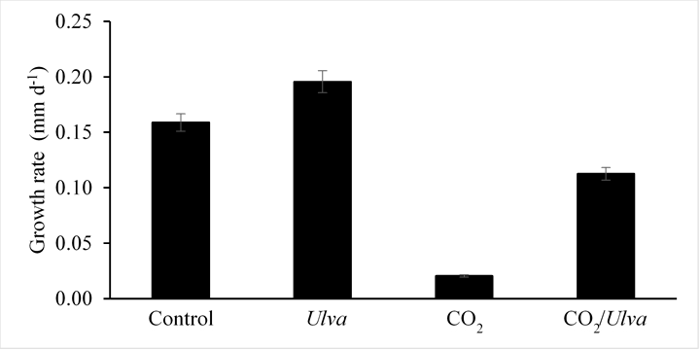
B10. Assessing macroalge amelorating impacts on caged aquaculture. C. Gobler – SoMAS (https://www.somas.stonybrook.edu/people/faculty/christopher-gobler/): Aquaculture is a billion dollar industry in the U.S., with domestic production dominated by calcifying bivalves and increasing by approximately 1% annually (NMFS 2017). While continued growth in bivalve aquaculture is expected, several serious hazards threaten to hamper recent advances including coastal OA. Seaweeds offer an opportunity to mitigate this risk for bivalve aquaculture. Recently, we have documented the ability of the macroalgae, Ulva, to alleviate the negative effects of OA on bivalves. We specifically conducted controlled laboratory experiments with North Atlantic populations of hard clams (Mercenaria mercenaria), eastern oysters (Crassostrea virginica), bay scallops (Argopecten irradians), and blue mussels (Mytilus edulis) grown with and without North Atlantic populations of the green macroalgae, Ulva, and exposed to high and low levels of pCO₂ (Young and Gobler 2018). While elevated pCO₂ levels (~1,700 µatm) resulted in depressed shell- and/or tissue-based growth rates of bivalves compared to control conditions, rates were significantly higher in the presence of Ulva in all experiments (Fig. 3). Saturation states for calcium carbonate (Ω) were significantly higher in the presence of Ulva under both ambient and elevated CO₂ delivery rates. Collectively, the results suggest that photosynthesis and nitrate assimilation by Ulva increased alkalinity, fostering a carbonate chemistry regime more suitable for optimal growth of calcifying bivalves. While these findings suggest that large natural and/or aquacultured collections of macroalgae in acidified environments could serve as a refuge for calcifying animals that may otherwise be negatively impacted by elevated pCO₂ levels and depressed Ω, field-based affirmation of these lab experiments is needed. This ability of macroalgae to buffer against OA for the benefit of bivalves has enormously important implications for aquaculture.
Figure 3. Growth of juvenile eastern oysters exposed to high CO₂ (1,700 ppm), the seaweed Ulva, or both. While high CO₂ depressed oyster growth, Ulva improved it under high and lzow CO₂ conditions (Young and Gobler, 2018).
This study will engage in targeted experiments to determine the seaweed species and densities that maximize the production of bivalves, while mitigating the effects of OA. Using FOCE we will perform experiments to determine the abilities of different macroalgal species within specific seasonal window and stocked at different densities to mitigate acidification. Kelp is a cold-temperature seaweed that grows November through May, a time of year when coastal acidification is less intense in estuaries (Wallace et al. 2014, Baumann and Smith 2017) but can be more intense at higher latitudes (Gledhill et al. 2008). Conversely, during summer, estuarine acidification intensifies (Wallace et al 2014; Baumann and Smith, 2017) and Gracilaria and Porphyra grow optimally. Hence, our experiments will focus on seaweed species and acidification conditions consistent with appropriate seasons.
Results from Prior NSF Support: PI Volkenborn has the following NSF support: NSF OCE-1757045
"Iron cycling in bioturbated sediments - Fluxes, diagenetic redistribution, and isotopic signatures" L
Wehrmann (PI), RC Aller, N Volkenborn (Co-PIs) $574,845, 04/01/18-03/31/21. Intellectual Merit: This
project determines the effects of bioturbation by infaunal organisms, bottom water oxygen concentrations, sedimentary organic carbon, and permeability on iron (Fe) cycling and isotopic redistribution in marine sediments to constrain the magnitude and dynamics of the benthic Fe source to the ocean. Broader Impacts: The project supports two doctoral and several undergraduate students. In collaboration with SBU’s Science and Technology Entry Program (STEP) a summer module entitled "Buried Alive," will be offered to historically underrepresented and economically disadvantaged high school students in which students set-up their own seafloor antfarms and record infaunal activities using tracer addition and time-lapse photography. Demonstrations of "seafloor slices" at the NY Marine Science Festival "Submerge" and at SBU’s earth celebration day "Earthstock" will be used for public outreach. The project supports two Early Career Scientists with no prior NSF research support.

C. Description of the Research Instrument Needs

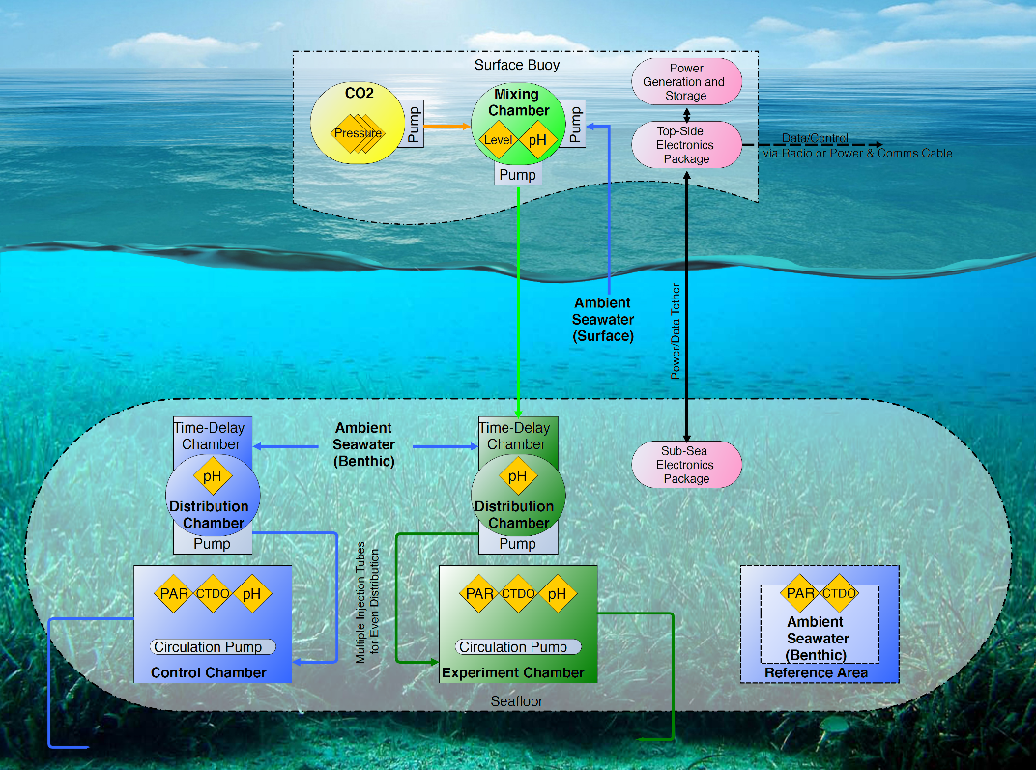
The conceptual design of the mcFOCE was determined after consultation with engineers, programmers and scientists. The system will be composed of a moored floating buoy (Fig. 4), that will draw in ambient water and house the CO₂ mixing chamber. The acidified water will be pumped to a subsurface chamber that will distribute CO₂ -enriched water to the experimental chambers. The surface mixing chamber, subsurface distribution chamber and the experimental chamber will have DuraFET total pH sensors that will communicate with each of other. The experimental chambers will also have PAR, CTD and pH sensors.
Figure 4. Conceptual design of the modular coastal FOCE.
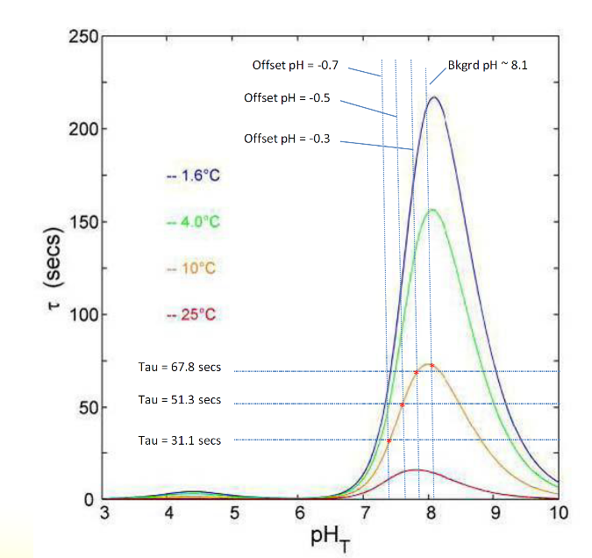
Figure 5. Curves from the Zeebe-Wolf Gladrow CO2 kinetic model showing e-folding time at various temperatures as a function of pH
A central objective of the proposed FOCE is the in situ control of OA by changing pH using the same process that is occurring in nature. This requires a system for CO₂ injection that acidifies sea waterand in turn injects it into the in situ FOCE structure delay loop, a water way that is designed to ensure the natural chemistry has
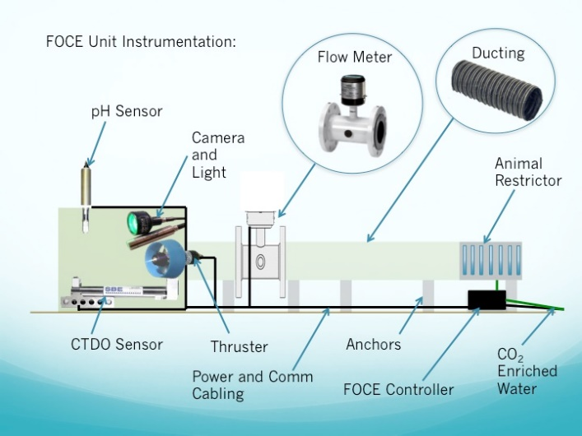
fully completed prior to being introduced to flora and fauna exposure at the core of all FOCE units. The net result of adding a defined quantity of CO₂ to seawater is to reduce the concentration of dissolved carbonate ions and increase the concentration of bicarbonate ions. Generally, the reaction between CO₂ and H₂O is slow and a function of temperature, pressure, pH, TCO₂. The reaction is non-linear with the reaction proceeding more rapidly at lower pH and higher temperatures. Experiments at MBARI were conducted to select a suitable model for control and it was found that the Zeebe and Wolf-Gladrow model of carbonate chemistry was the most accurate and therefore has become the core of this FOCE system design (Zeebe and Wolf-Gladrow 2001). The kinetics of carbonate chemistry are critical and must be addressed as this variable is site specific. The Zeebe and Wolf-Gladrow model provides curves that illustrate the e-folding time, tau ($τ$), for carbonate chemistry (Fig. 5). The requirement to monitor pH, as the primary variable, is core to the FOCE system and is accomplished in our system by use of high resolution pH sensors. pH values are entered as an error from desired pH as the primary input for control. The FOCE concept design includes an experimental chamber that is open on the bottom, allowing for natural benthic fluxes and biology (Fig. 6). The chamber is also open from at least one end allowing for external water to transfer through the experimental area and exhaust. The entry and exit do not impede the flow on natural detritus but, depending on the science experimental needs, may have fences or barriers as needed to exclude unwanted fauna. Similarly, the chamber has options for skirts to control burrowing animals from entry if needed. The mcFOCE system will have bi-directional flow to include natural hydrodynamic variations. A section of ducting is used to provide the necessary delay to create the e-folding time ($τ$) within the experimental chamber that allows the CO₂ reaction to reach equilibrium naturally. Because of variances in current that may occur the conceptual design includes a thruster to make this work properly. Given that the majority of science applications expressed by the major users require natural light, the experimental chambers will be constructed of acrylic which has superior optical properties and transmits the full spectrum of natural light. While polycarbonate is much easier to work with, it does not transmit the higher frequencies toward ultraviolet and over time tend to go opaque in the visible spectrum.
Figure 6. mcFOCE experimental chambers concept figure.

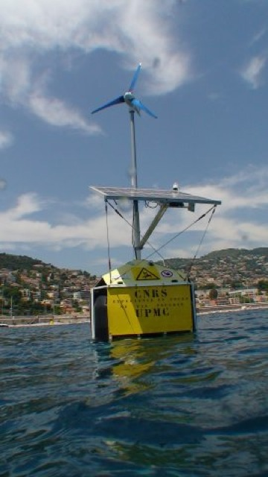
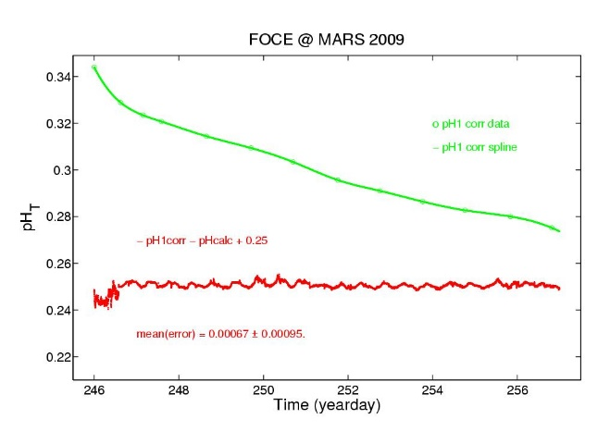
Primary to the mcFOCE system concept is modularity and the need to adapt to the variety of the environments and science requirements. Multiple use scenarios of FOCE experiment were discussed with the major users and it was apparent that not all experiments would have access to shore side connections (power, communications, CO₂ enriched seawater). Therefore, various types of electrical power availability have been considered: tether, battery, solar, wind and diesel. The power requirements are largely dependent on the number of replicate experimental enclosures, the size of the pumps required to deliver the pCO₂-enriched seawater, and the number of sensors and instruments connected to the system. It was determined that the power requirements can be fulfilled with a combination of solar and wind (with possible battery swaps at times of extreme power needs i.e. at low temperatures and maximum working depths and low solar and wind energy generation) (Fig. 7). The control system which will be housed in the surface buoy controls pH and flow, monitors the system and collects and archives the data. Various data handling methods were discussed from wireless connections, local storage, physical retrieval and potentially satellite links. It was determined that a dual wireless connection with local storage would provide the most robust combination for this system. The surface buoy will therefore include telemetry hardware to provide data and system status information to operators and other users.
Figure 7. Solar and wind powered buoy used to determine the potential power generation.
Figure 8. The mean error performance of the DuraFET 18S deployed by Kirkwood.

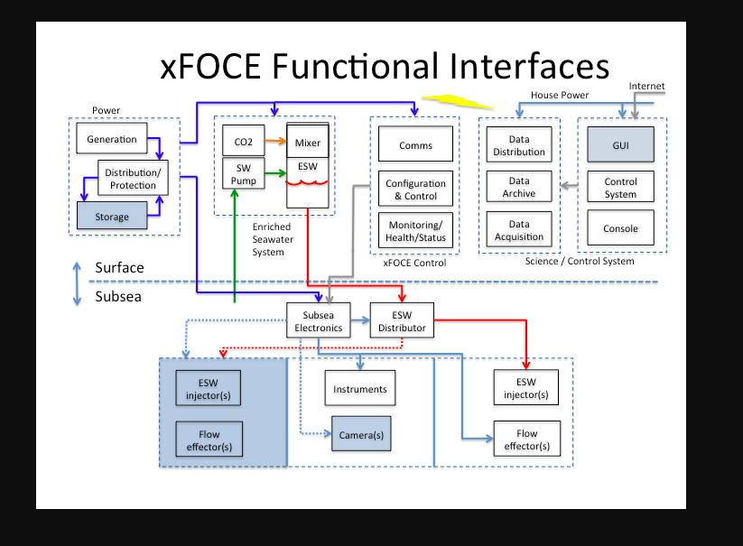
Feedback control will be achieved by using the enriched seawater source within the surface buoy and a control loop that monitors the pH in the enclosures and controls the enriched seawater dosing pump. There are several factors that affect the amount of CO₂ required for the experiment of choice: the size of the enclosure (cross section of the volume), the number of enclosures, the rate of seawater turnover within the enclosure, and the enrichment (pH offset) required. Once the amount of CO₂ required per unit is known, it is a simple calculation to determine how much CO₂ will be needed for the duration of the experiment. Underwater sensors for salinity, temperature and dissolved oxygen are required for each enclosure and are well known to the oceanographic community and have a reputation for reliability and robustness. Unfortunately, pH sensors are not as robust. Recent developments in ion-sensitive field-effect transistor (ISFET) sensors have improved the quality and stability of field pH measurements particularly for shallow water, longer term deployments. Therefore, this system will use the DuraFET 18S probe which digitizes the signal at the probe and has excellent performance (Fig. 8).
Figure 9. The mcFOCE functional interfaces necessary to operate the system.

The control system will communicate with the various sensors and control CO₂ injection, pump and thruster speed, and monitor FOCE system status relaying real-time data to the operators via wireless telemetry. A flow chart of the FOCE functional interfaces is provided (Fig. 9). To construct the proposed FOCE and to manage data and feedback control of pH and telemetry mechanical (Kirkwood),electrical (Parekh) and software engineering expertise (SoMAS Instrument Lab) will be critical and is available for the project.

D. Broader Impacts

Barely 50 years old, SUNY’s Stony Brook University (SBU) has amassed a remarkable record of research accomplishments and graduate education in the natural sciences, health sciences and engineering and is well-respected as a public research university, ranked in the top 1% of colleges and universities world-wide according to a recent London Times survey. Our historical emphasis on graduate education to produce future leaders in science, technology and engineering is evident. SBU is also nationally known for providing exceptional research and training opportunities for its undergraduates (1 of 10 nation-wide recognized by NSF). As an example, the PI and the co-PIs have 2-5 undergraduates working on projects in their labs every year and this is typical of SBU. Over the last decade, SBU’s undergraduate ranks have swelled with increasingly competitive freshman. The ethnic/cultural diversity of our student body is surpassed by a very few other major U.S. universities. More than half our undergraduates receive need-based financial aid (Pell Grant) and 37% receive merit-based awards, illustrating enrollment of under-represented minorities and economically disadvantaged high-achieving students.

To maintain vital research programs and advance science, engineering and education, public universities, such as SBU, must rely on programs like NSF’s MRI to acquire costly, cutting-edge instrumentation. No U.S. university currently has an autonomous FOCE system. The scope and number of potential scientific applications for this technology are rapidly expanding. The PIs have over a decade of experience in the field of OA. The development of a mcFOCE would revolutionize the ability of SBU to purse in situ OA experiments. Fourteen SBU faculty (representing marine, atmospheric, geosciences, ecology and evolution), six faculty from other US institutions (Occidental College, Georgia Southern University, University of Florida, Florida International University, University of New Orleans) and three from international institutions (University of Gothenburg, Plymouth University and INVEMAR) have committed to being major users of the mcFOCE. This group represents a diverse group of academic interest in in situ OA capability. The SBU faculty collectively advise 22 Ph.D. and 10 M.S. graduate students and have 32 undergraduates working in their research labs.

Development of a state-of-the-art modular coastal FOCE system at SBU will certainly accelerate transformative advances in broader areas of research related to environmental quality, climate change, oceanic-atmosphere interactions and aerosol production, marine diseases and coastal resilience. The proposed FOCE system will complement existing facilities (lab based OA systems), lead to a significant improvement of instrumentation now available for research, and will tremendously boost hands-on research-related education. SoMAS has demonstrated their commitment to connecting this technology to graduate education by providing graduate student funding and tuition as cost share to this project. It is the intention that a doctoral student be recruited to be involved in the development and testing and implementation of the instrument as their dissertation.

Peterson, Gobler and Volkenborn have demonstrated the integration of their research into primary and secondary education programs on Long Island (East Quogue Elementary, Hampton Bays Middle and High School, Westhampton High School, and Southampton High School). Peterson and Gobler have each taught OA modules to the marine science classes at Southampton and Westhampton High Schools, respectively. The natural consequence of the development of the mcFOCE will be the incorporation of the data from this instrument into future OA modules. While being constructed, the FOCE system could be an educational opportunity for the Southampton, Hampton Bays and Westhampton High School robotic teams to discuss the steps of integrating communication between various sensors and instruments. Peterson and Gobler are also co-PIs in the Shinnecock Bay Restoration Project (http://www.shinnecockbay.org/) that utilizes the enhancement of biotic filtration to improve water quality. The mcFOCE use within the hard clam sanctuaries or the restored oyster reefs would provide community outreach opportunities to the members and volunteers of ShiRP. As a result of ShiRP Peterson and Gobler are actively involved in shellfish restoration and aquaculture. The mcFOCE system has several aquaculture applications (see B10 above) that include investigating the impact of multi-culture on increasing shellfish survival and growth rates. The mcFOCE could also be used to predict the economic consequences of future acidification levels on aquaculture production. Peterson has reached out to the East Coast Shellfish Growers Association and Taylor Shellfish on the west coast to discuss possible uses of the mcFOCE system to address research needs of the aquaculture community.

In addition, the Stony Brook Southampton Marine Station, which will be the location of the mcFOCE when not deployed in the field, has more than 1,200 elementary and secondary school visitors each year as school groups that use the university education vessels and tour the facility. Seeing the system during a visit or observing the telemetered data when deployed on the large LCD display as you walk into the marine station will be educational moments. In addition, Peterson, Gobler and Volkenborn give multiple public presentations annually (SoMAS Friday night public talks, Moustache Brewery Science Talks, High School Science Research keynote speakers, community and local environmental group presentations).

E. Management Plan

Instrument operation - The newly constructed modular coastal Free Ocean Carbon Enrichment (mcFOCE) instrument will be maintained at the SoMAS Southampton Marine Station and deployed locally and regionally. Peterson, Gobler and Volkenborn will be the faculty supervisors of the system. They will oversee the use of the instrument and will be responsible during the award period and afterwards for day-to-day maintenance and operation of the instrument. Additional technical expertise during the award period will be provided by a full-time mcFOCE technician, Bill Kirkwood and SoMAS Instrument Lab personnel.
The mcFOCE will be available to all SBU faculty and their research groups as well as faculty at other institutions and non-academics under the university’s specialized services facility (SSF) program, which will be instituted after the 3-yr grant has expired. SSF policies and practices reflect standard federal regulatory costing principles, such as those contained in the Office of Management Budget (OMB) Circular A-21, “Cost Principles for Colleges and Universities”, and those required by the Cost Accounting Standards Board. In essence, these regulations state that user rates are structured to recover operating direct costs, which include applicable personnel salaries, fringe benefits, consumables, travel, and maintenance costs as well as administrative overhead. SSF are prohibited from turning a profit and the rate structure must be reassessed at least biannually. User’ rates structure will be based on days of usage and level of technical assistance required. Anticipated levels of assistance are: collaborative I (user + technician), collaborative II (user + technician + PI) and full service (technician and divers only). Cost and use data will be collected during the NSF-funded period in order to structure user fees after the grant terminates. Funds accumulated by this facility will be held in an FOCE facility account and used to offset operating and maintenance costs.
Training –FOCE is a emerging technology and therefore it will not be simply a plug-and-play operation. At each deployment site, effective use will require calibration before useful data emerge and not all deployment depths and experimental chamber sizes will be equally amenable. Training in the basic operation of the mcFOCE will be provided by the technician and faculty supervisors. The technician will be responsible for training new users in the basic operations and data processing. We also recognize that mastery of this system will require investment of the PI and co-PI’s time. For example, setting up individual user’s experiments in different benthic habitats, with different experimental chambers based on the researcher’s question under different environmental conditions will require supervision and training.
Scheduling – The faculty supervisors will form the use committee and will strive to make the mcFOCE scheduling as flexible, fair, dynamic,transparent, and efficient as possible to accommodate as many users as is reasonable. We will strive to minimize the mcFOCE’s idle time by working with the next major user during usage by others. Many experiments will be straightforward with predictable requirements, whereas others will be more challenging and less predictable. All potential investigators will be required to submit a brief outline describing his/her project objective and instrumentation needs. These requests will be evaluated by the use committee. The committee will meet with the investigator to determine feasibility, impact on the system and scheduling. The mcFOCE system will have a SoMAS-maintained webpage describing the instrumentation, its capabilities and recent applications. A scheduling calendar will be linked to this page and will be updated by the facility technician as additions, delays, and cancellations arise. This will facilitate scheduling research activities and requesting mcFOCE time.
Maintenance – Based on consultation with Bill Kirkwood, the creator of two prior (non-University) FOCE systems, and prior experience with various instrumentation used within the system, maintenance costs are expected to be less than $10K over the first three years of operation. Many of the instruments incorporated into the system have one-year factory warranties. We are not requesting support for a service contract in the second year of the grant. Routine maintenance, calibration, sensor replacement, alignment, etc will be carried out by the technician, PI Peterson, and assisted by graduate students as part of their education. In the event of instrument breakdown, diagnosis will be the responsibility of Peterson and the technician, in conjunction with factory support specialist. We estimate that the requested system will have a useful research and educational lifetime of no less than 15 years.
References Cited.
Alex, A., and A. Antunes. 2015. Pyrosequencing characterization of the microbiota from Atlantic intertidal marine sponges reveals high microbial diversity and the lack of co-occurrence patterns. PloS one 10:e0127455.
Aller, J. Y., J. C. Radway, W. P. Kilthau, D. W. Bothe, T. W. Wilson, R. D. Vaillancourt, P. K. Quinn, D. J. Coffman, B. J. Murray, and D. A. Knopf. 2017. Size-resolved characterization of the polysaccharidic and proteinaceous components of sea spray aerosol. Atmospheric Environment 154:331-347.
Alpert, P., J. Aller, and D. Knopf. 2011. Ice nucleation from aqueous NaCl droplets with and without marine diatoms. Atmospheric Chemistry and Physics 11:5539-5555.
Andersson, A. J., D. I. Kline, P. J. Edmunds, S. D. Archer, N. Bednaršek, R. C. Carpenter, M. Chadsey, P. Goldstein, A. G. Grottoli, and T. P. Hurst. 2015. Understanding ocean acidification impacts on organismal to ecological scales. Oceanography 28:16-27.
Archer, D., H. Kheshgi, and E. Maier‐Reimer. 1998. Dynamics of fossil fuel CO₂ neutralization by marine CaCO3. Global Biogeochemical Cycles 12:259-276.
Asplund, M. E., S. P. Baden, S. Russ, R. P. Ellis, N. Gong, and B. E. Hernroth. 2014. Ocean acidification and host–pathogen interactions: blue mussels, M ytilus edulis, encountering V ibrio tubiashii. Environmental microbiology 16:1029-1039.
Ault, A. P., R. C. Moffet, J. Baltrusaitis, D. B. Collins, M. J. Ruppel, L. A. Cuadra-Rodriguez, D. Zhao, T. L. Guasco, C. J. Ebben, and F. M. Geiger. 2013. Size-dependent changes in sea spray aerosol composition and properties with different seawater conditions. Environmental science & technology 47:5603-5612.
Bar-Zeev, E., I. Berman-Frank, O. Girshevitz, and T. Berman. 2012. Revised paradigm of aquatic biofilm formation facilitated by microgel transparent exopolymer particles. Proceedings of the national academy of sciences 109:9119-9124.
Barry, J. P., C. Lovera, K. R. Buck, E. T. Peltzer, J. R. Taylor, P. Walz, P. J. Whaling, and P. G. Brewer. 2014. Use of a Free Ocean CO₂ Enrichment (FOCE) system to evaluate the effects of ocean acidification on the foraging behavior of a deep-sea urchin. Environmental science & technology 48:9890-9897.
Baumann, H., and E. M. Smith. 2017. Quantifying metabolically driven pH and oxygen fluctuations in US nearshore habitats at diel to interannual time scales. Estuaries and Coasts:1-16.
Baumann, H., R. B. Wallace, T. Tagliaferri, and C. J. Gobler. 2015. Large natural pH, CO₂ and O₂ fluctuations in a temperate tidal salt marsh on diel, seasonal, and interannual time scales. Estuaries and Coasts 38:220-231.
Bengtsson, M. M., A. Bühler, A. Brauer, S. Dahlke, H. Schubert, and I. Blindow. 2017. Eelgrass leaf surface microbiomes are locally variable and highly correlated with epibiotic eukaryotes. Frontiers in microbiology 8:1312.
Bindoff, N., J. Willebrand, V. Artale, A. Cazenave, J. Gregory, S. Gulev, K. Hanawa, C. Le Quere, S. Levitus, and Y. Nojiri. 2007. Observations: oceanic climate and sea level. In:/Climate change 2007: The physical Science Basis. Contribution of Working Group I to the Fourth Assessment report of the Intergouvernmental Panel on Climate Change. Cambridge University Press, Cambridge, UK, and New York, USA., 2007:385-432.
Bograd, S. J., C. G. Castro, E. Di Lorenzo, D. M. Palacios, H. Bailey, W. Gilly, and F. P. Chavez. 2008. Oxygen declines and the shoaling of the hypoxic boundary in the California Current. Geophysical Research Letters 35.
Burnell, O. W., B. D. Russell, A. D. Irving, and S. D. Connell. 2014. Seagrass response to CO 2 contingent on epiphytic algae: indirect effects can overwhelm direct effects. Oecologia 176:871-882.
Canadell, J. G., C. Le Quéré, M. R. Raupach, C. B. Field, E. T. Buitenhuis, P. Ciais, T. J. Conway, N. P. Gillett, R. Houghton, and G. Marland. 2007. Contributions to accelerating atmospheric CO₂ growth from economic activity, carbon intensity, and efficiency of natural sinks. Proceedings of the national academy of sciences 104:18866-18870.
Carver, C. E., I. Thériault, and A. L. Mallet. 2010. Infection of cultured eastern oysters Crassostrea virginica by the boring sponge Cliona celata, with emphasis on sponge life history and mitigation strategies. Journal of Shellfish Research 29:905-915.
Ciais, P. 2013. Carbon and other biogeochemical cycles Climate Change 2013: The Physical Science Basis ed TF Stocker et al. Cambridge: Cambridge University Press.
Cochran, R. E., O. S. Ryder, V. H. Grassian, and K. A. Prather. 2017. Sea spray aerosol: The chemical link between the oceans, atmosphere, and climate. Accounts of chemical research 50:599-604.
Collins, D. B., A. P. Ault, R. C. Moffet, M. J. Ruppel, L. A. Cuadra‐Rodriguez, T. L. Guasco, C. E. Corrigan, B. E. Pedler, F. Azam, and L. I. Aluwihare. 2013. Impact of marine biogeochemistry on the chemical mixing state and cloud forming ability of nascent sea spray aerosol. Journal of Geophysical Research: Atmospheres 118:8553-8565.
Cooley, S. R., and S. C. Doney. 2009. Anticipating ocean acidification’s economic consequences for commercial fisheries. Environmental Research Letters 4:024007.
Cox, T., V. Díaz-Castañeda, S. Martin, S. Alliouane, P. Mahacek, A. Le Fur, J.-P. Gattuso, and F. Gazeau. 2017. Effects of in situ CO 2 enrichment on epibiont settlement on artificial substrata within a Posidonia oceanica meadow. Journal of Experimental Marine Biology and Ecology 497:197-211.
Cox, T. E., F. Gazeau, S. Alliouane, I. Hendriks, P. Mahacek, A. Le Fur, and J.-P. Gattuso. 2016. Effects of in situ CO 2 enrichment on structural characteristics, photosynthesis, and growth of the Mediterranean seagrass Posidonia oceanica. Biogeosciences 13:2179-2194.
Crump, B. C., J. M. Wojahn, F. Tomas, and R. S. Mueller. 2018. Metatranscriptomics and Amplicon Sequencing Reveal Mutualisms in Seagrass Microbiomes. Frontiers in microbiology 9:388.
Cunliffe, M., A. Engel, S. Frka, B. Gašparović, C. Guitart, J. C. Murrell, M. Salter, C. Stolle, R. Upstill-Goddard, and O. Wurl. 2013. Sea surface microlayers: A unified physicochemical and biological perspective of the air–ocean interface. Progress in Oceanography 109:104-116.
Doney, S. C., V. J. Fabry, R. A. Feely, and J. A. Kleypas. 2009. Ocean acidification: the other CO₂ problem. Annual Review of Marine Science 1:169-192.
Dupont, S., N. Dorey, and M. Thorndyke. 2010. What meta-analysis can tell us about vulnerability of marine biodiversity to ocean acidification? Estuarine, Coastal and Shelf Science 89:182-185.
Ekstrom, J. A., L. Suatoni, S. R. Cooley, L. H. Pendleton, G. G. Waldbusser, J. E. Cinner, J. Ritter, C. Langdon, R. Van Hooidonk, and D. Gledhill. 2015. Vulnerability and adaptation of US shellfisheries to ocean acidification. Nature Climate Change 5:207-214.
Erez, J., S. Reynaud, J. Silverman, K. Schneider, and D. Allemand. 2011. Coral calcification under ocean acidification and global change. Pages 151-176 Coral reefs: an ecosystem in transition. Springer.
Ettinger, C. L., S. E. Voerman, J. M. Lang, J. J. Stachowicz, and J. A. Eisen. 2017. Microbial communities in sediment from Zostera marina patches, but not the Z. marina leaf or root microbiomes, vary in relation to distance from patch edge. PeerJ 5:e3246.
Fabry, V. J., B. A. Seibel, R. A. Feely, and J. C. Orr. 2008. Impacts of ocean acidification on marine fauna and ecosystem processes. ICES Journal of Marine Science 65:414-432.
Fahimipour, A. K., M. R. Kardish, J. M. Lang, J. L. Green, J. A. Eisen, and J. J. Stachowicz. 2017. Global-scale structure of the eelgrass microbiome. Applied and environmental microbiology:AEM. 03391-03316.
Feely, R. A., S. R. Alin, J. Newton, C. L. Sabine, M. Warner, A. Devol, C. Krembs, and C. Maloy. 2010. The combined effects of ocean acidification, mixing, and respiration on pH and carbonate saturation in an urbanized estuary. Estuarine, Coastal and Shelf Science 88:442-449.
Fernandes, J. A., E. Papathanasopoulou, C. Hattam, A. M. Queirós, W. W. Cheung, A. Yool, Y. Artioli, E. C. Pope, K. J. Flynn, and G. Merino. 2017. Estimating the ecological, economic and social impacts of ocean acidification and warming on UK fisheries. Fish and Fisheries 18:389-411.
Fröhlich-Nowoisky, J., C. J. Kampf, B. Weber, J. A. Huffman, C. Pöhlker, M. O. Andreae, N. Lang-Yona, S. M. Burrows, S. S. Gunthe, and W. Elbert. 2016. Bioaerosols in the Earth system: Climate, health, and ecosystem interactions. Atmospheric Research 182:346-376.
Gattuso, J.-P., I. E. Hendriks, and P. G. Brewer. 2014. Free-ocean CO₂ enrichment (FOCE) systems: present status and future developments. Biogeosciences 11:4057-4075.
Georgiou, L., J. Falter, J. Trotter, D. I. Kline, M. Holcomb, S. G. Dove, O. Hoegh-Guldberg, and M. McCulloch. 2015. pH homeostasis during coral calcification in a free ocean CO₂ enrichment (FOCE) experiment, Heron Island reef flat, Great Barrier Reef. Proceedings of the national academy of sciences 112:13219-13224.
Gledhill, D. K., R. Wanninkhof, F. J. Millero, and M. Eakin. 2008. Ocean acidification of the greater Caribbean region 1996–2006. Journal of Geophysical Research: Oceans 113:C10031.
Govers, L. L., W. A. Man, J. P. Meffert, T. J. Bouma, P. C. van Rijswick, J. H. Heusinkveld, R. J. Orth, M. M. van Katwijk, and T. van der Heide. 2016. Marine Phytophthora species can hamper conservation and restoration of vegetated coastal ecosystems. Proc. R. Soc. B 283:20160812.
Green, M. A., R. C. Aller, and J. Y. Aller. 1992. Experimental evaluation of the influences of biogenic reworking on carbonate preservation in nearshore sediments. Marine Geology 107:175-181.
Hall-Spencer, J. M., R. Rodolfo-Metalpa, S. Martin, E. Ransome, M. Fine, S. M. Turner, S. J. Rowley, D. Tedesco, and M.-C. Buia. 2008. Volcanic carbon dioxide vents show ecosystem effects of ocean acidification. Nature 454:96-99.
Hall, R. D. 2006. Plant metabolomics: from holistic hope, to hype, to hot topic. New Phytologist 169:453-468.
Hendriks, I. E., C. M. Duarte, and M. Álvarez. 2010. Vulnerability of marine biodiversity to ocean acidification: a meta-analysis. Estuarine, Coastal and Shelf Science 86:157-164.
Hernán, G., L. Ramajo, L. Basso, A. Delgado, J. Terrados, C. M. Duarte, and F. Tomas. 2016. Seagrass (Posidonia oceanica) seedlings in a high-CO 2 world: from physiology to herbivory. Scientific Reports 6:38017.
Hettinger, A., E. Sanford, T. Hill, J. Hosfelt, A. Russell, and B. Gaylord. 2013. The influence of food supply on the response of Olympia oyster larvae to ocean acidification. Biogeosciences 10:6629-6638.
Hofmann, G. E., J. E. Smith, K. S. Johnson, U. Send, L. A. Levin, F. Micheli, A. Paytan, N. N. Price, B. Peterson, and Y. Takeshita. 2011. High-frequency dynamics of ocean pH: a multi-ecosystem comparison. PloS one 6:e28983.
Iglesias-Rodriguez, M. D., P. R. Halloran, R. E. Rickaby, I. R. Hall, E. Colmenero-Hidalgo, J. R. Gittins, D. R. Green, T. Tyrrell, S. J. Gibbs, and P. von Dassow. 2008. Phytoplankton calcification in a high-CO₂ world. science 320:336-340.
Kerrison, P., J. M. Hall-Spencer, D. J. Suggett, L. J. Hepburn, and M. Steinke. 2011. Assessment of pH variability at a coastal CO₂ vent for ocean acidification studies. Estuarine, Coastal and Shelf Science 94:129-137.
Kleypas, J. A., and K. K. Yates. 2009. Coral reefs and ocean acidification. Oceanography 22:108-117.
Kline, D. I., L. Teneva, K. Schneider, T. Miard, A. Chai, M. Marker, K. Headley, B. Opdyke, M. Nash, and M. Valetich. 2012. A short-term in situ CO 2 enrichment experiment on Heron Island (GBR). Scientific Reports 2:413.
Knopf, D., P. Alpert, B. Wang, and J. Aller. 2011. Stimulation of ice nucleation by marine diatoms. Nature Geoscience 4:88-90.
Knopf, D. A., P. A. Alpert, B. Wang, R. E. O'Brien, S. T. Kelly, A. Laskin, M. K. Gilles, and R. C. Moffet. 2014. Microspectroscopic imaging and characterization of individually identified ice nucleating particles from a case field study. Journal of Geophysical Research: Atmospheres 119:10365-10381.
Koek, M. M., R. H. Jellema, J. van der Greef, A. C. Tas, and T. Hankemeier. 2011. Quantitative metabolomics based on gas chromatography mass spectrometry: status and perspectives. Metabolomics 7:307-328.
Koenigstein, S., F. C. Mark, S. Gößling‐Reisemann, H. Reuter, and H. O. Poertner. 2016. Modelling climate change impacts on marine fish populations: process‐based integration of ocean warming, acidification and other environmental drivers. Fish and Fisheries 17:972-1004.
Kong, P., G. W. Moorman, J. D. Lea-Cox, D. S. Ross, P. A. Richardson, and C. Hong. 2009. Zoosporic tolerance to pH stress and its implications for Phytophthora species in aquatic ecosystems. Applied and environmental microbiology 75:4307-4314.
Kroeker, K. J., R. L. Kordas, R. Crim, I. E. Hendriks, L. Ramajo, G. S. Singh, C. M. Duarte, and J. P. Gattuso. 2013. Impacts of ocean acidification on marine organisms: quantifying sensitivities and interaction with warming. Global change biology 19:1884-1896.
Kujawinski, E. B. 2011. The impact of microbial metabolism on marine dissolved organic matter. Annual review of marine science 3:567-599.
Lardies, M. A., M. B. Arias, M. J. Poupin, P. H. Manríquez, R. Torres, C. A. Vargas, J. M. Navarro, and N. A. Lagos. 2014. Differential response to ocean acidification in physiological traits of Concholepas concholepas populations. Journal of Sea Research 90:127-134.
Laverock, B., V. Kitidis, K. Tait, J. Gilbert, A. Osborn, and S. Widdicombe. 2013. Bioturbation determines the response of benthic ammonia-oxidizing microorganisms to ocean acidification. Phil. Trans. R. Soc. B 368:20120441.
Le Quéré, C., R. Andrew, J. Canadell, S. Sitch, J. Korsbakken, G. Peters, A. Manning, T. Boden, P. Tans, and R. Houghton. 2016. Global Carbon Budget 2016, Earth Syst. Sci. Data, 8, 605–649.
Lee, W.-J., and K. Hase. 2014. Gut microbiota–generated metabolites in animal health and disease. Nature Chemical Biology 10:416-424.
Lessin, G., Y. Artioli, A. M. Queirós, S. Widdicombe, and J. C. Blackford. 2016. Modelling impacts and recovery in benthic communities exposed to localised high CO₂. Marine pollution bulletin 109:267-280.
Li, L., W. Lu, Y. Sui, Y. Wang, Y. Gul, and S. Dupont. 2015. Conflicting effects of predator cue and ocean acidification on the mussel Mytilus coruscus byssus production. Journal of Shellfish Research 34:393-400.
Louise Allan, E., P. William Froneman, J. V. Durgadoo, C. D. McQuaid, I. J. Ansorge, and N. B. Richoux. 2013. Critical indirect effects of climate change on sub‐A ntarctic ecosystem functioning. Ecology and Evolution 3:2994-3004.
Mackenzie, C. L., G. A. Ormondroyd, S. F. Curling, R. J. Ball, N. M. Whiteley, and S. K. Malham. 2014. Ocean warming, more than acidification, reduces shell strength in a commercial shellfish species during food limitation. PloS one 9:e86764.
Mason, J. G., M. A. Rudd, and L. B. Crowder. 2017. Ocean Research Priorities: Similarities and Differences among Scientists, Policymakers, and Fishermen in the United States. BioScience 67:418-428.
McKenney, E., K. Koelle, R. Dunn, and A. Yoder. 2018. The ecosystem services of animal microbiomes. Molecular ecology 27:2164-2172.
Melzner, F., J. Thomsen, W. Koeve, A. Oschlies, M. A. Gutowska, H. W. Bange, H. P. Hansen, and A. Körtzinger. 2013. Future ocean acidification will be amplified by hypoxia in coastal habitats. Marine Biology 160:1875-1888.
Miyazaki, Y., S. Coburn, K. Ono, D. T. Ho, R. B. Pierce, K. Kawamura, and R. Volkamer. 2016. Contribution of dissolved organic matter to submicron water-soluble organic aerosols in the marine boundary layer over the eastern equatorial Pacific. Atmospheric Chemistry and Physics 16:7695-7707.
Morse, J. W., A. J. Andersson, and F. T. Mackenzie. 2006. Initial responses of carbonate-rich shelf sediments to rising atmospheric pCO₂ and “ocean acidification”: Role of high Mg-calcites. Geochimica et Cosmochimica Acta 70:5814-5830.
Mosier, A. C., N. B. Justice, B. P. Bowen, R. Baran, B. C. Thomas, T. R. Northen, and J. F. Banfield. 2013. Metabolites associated with adaptation of microorganisms to an acidophilic, metal-rich environment identified by stable-isotope-enabled metabolomics. MBio 4:e00484-00412.
Nam, S., H. J. Kim, and U. Send. 2011. Amplification of hypoxic and acidic events by La Niña conditions on the continental shelf off California. Geophysical Research Letters 38:L22602.
Nicol, W. L., and H. M. Reisman. 1976. Ecology of the boring sponge (Cliona celata) at Gardiner’s Island, New York. Chesapeake Science 17:1-7.
NMFS. 2017. Fisheries of the United States, 2016.in N. Department of Commerce, editor.
Norby, R. J., and D. R. Zak. 2011. Ecological lessons from free-air CO₂ enrichment (FACE) experiments. Annual review of ecology, evolution, and systematics 42:181-203.
Nösberger, J., S. P. Long, R. J. Norby, M. Stitt, G. R. Hendrey, and H. Blum. 2006. Managed ecosystems and CO₂: case studies, processes, and perspectives. Springer Science & Business Media.
Poore, A. G., A. Graba-Landry, M. Favret, H. S. Brennand, M. Byrne, and S. A. Dworjanyn. 2013. Direct and indirect effects of ocean acidification and warming on a marine plant–herbivore interaction. Oecologia 173:1113-1124.
Prather, K. A., T. H. Bertram, V. H. Grassian, G. B. Deane, M. D. Stokes, P. J. DeMott, L. I. Aluwihare, B. P. Palenik, F. Azam, and J. H. Seinfeld. 2013. Bringing the ocean into the laboratory to probe the chemical complexity of sea spray aerosol. Proceedings of the national academy of sciences 110:7550-7555.
Queirós, A. M., J. A. Fernandes, S. Faulwetter, J. Nunes, S. P. Rastrick, N. Mieszkowska, Y. Artioli, A. Yool, P. Calosi, and C. Arvanitidis. 2015a. Scaling up experimental ocean acidification and warming research: from individuals to the ecosystem. Global change biology 21:130-143.
Queirós, A. M., K. B. Huebert, F. Keyl, J. A. Fernandes, W. Stolte, M. Maar, S. Kay, M. C. Jones, K. G. Hamon, and G. Hendriksen. 2016. Solutions for ecosystem‐level protection of ocean systems under climate change. Global change biology 22:3927-3936.
Queirós, A. M., N. Stephens, R. Cook, C. Ravaglioli, J. Nunes, S. Dashfield, C. Harris, G. H. Tilstone, J. Fishwick, and U. Braeckman. 2015b. Can benthic community structure be used to predict the process of bioturbation in real ecosystems? Progress in Oceanography 137:559-569.
Quinn, P. K., D. B. Collins, V. H. Grassian, K. A. Prather, and T. S. Bates. 2015. Chemistry and related properties of freshly emitted sea spray aerosol. Chemical reviews 115:4383-4399.
Rastelli, E., C. Corinaldesi, A. Dell'Anno, T. Amaro, S. Greco, M. L. Martire, L. Carugati, A. M. Queirós, S. Widdicombe, and R. Danovaro. 2016. CO₂ leakage from carbon dioxide capture and storage (CCS) systems affects organic matter cycling in surface marine sediments. Marine environmental research 122:158-168.
Raupach, M. R., G. Marland, P. Ciais, C. Le Quéré, J. G. Canadell, G. Klepper, and C. B. Field. 2007. Global and regional drivers of accelerating CO₂ emissions. Proceedings of the national academy of sciences 104:10288-10293.
Rhein, M., S.R. Rintoul, S. Aoki, E. Campos, D. Chambers, R.A. Feely, S. Gulev, G.C. Johnson, S.A. Josey, A. Kostianoy, C. Mauritzen, D. Roemmich, L.D. Talley and F. Wang, 2013: Observations: Ocean. In: Climate Change 2013: The Physical Science Basis. Contribution of Working Group I to the Fifth Assessment Report of the Intergovernmental Panel on Climate Change [Stocker, T.F., D. Qin, G.-K. Plattner, M. Tignor, S.K. Allen, J. Boschung, A. Nauels, Y. Xia, V. Bex and P.M. Midgley (eds.)]. Cambridge University Press, Cambridge, United Kingdom and New York, NY, USA, pp. 255–316,
Riebesell, U., and J.-P. Gattuso. 2014. Lessons learned from ocean acidification research. Nature Climate Change 5:12-14.
Rivas-Ubach, A., Y. Liu, J. Sardans, M. M. Tfaily, Y.-M. Kim, E. Bourrianne, L. Pasa-Tolic, J. Penuelas, and A. B. Guenther. 2016. Atmo-metabolomics: a new measurement approach for investigating aerosol composition and ecosystem functioning. in AGU Fall Meeting Abstracts.
Rudd, M. A. 2014. Scientists' perspectives on global ocean research priorities. Frontiers in Marine Science 1:36.
Rühl, S., P. Calosi, S. Faulwetter, K. Keklikoglou, S. Widdicombe, and A. M. Queirós. 2017. Long-term exposure to elevated pCO₂ more than warming modifies early-life shell growth in a temperate gastropod. ICES Journal of Marine Science 74:1113-1124.
Sabine, C. L., R. A. Feely, N. Gruber, R. M. Key, K. Lee, J. L. Bullister, R. Wanninkhof, C. Wong, D. W. Wallace, and B. Tilbrook. 2004. The oceanic sink for anthropogenic CO₂. Science 305:367-371.
Sanders, M. B., T. P. Bean, T. H. Hutchinson, and W. J. Le Quesne. 2013. Juvenile king scallop, Pecten maximus, is potentially tolerant to low levels of ocean acidification when food is unrestricted. PloS one 8:e74118.
Semesi, I. S., J. Kangwe, and M. Björk. 2009. Alterations in seawater pH and CO₂ affect calcification and photosynthesis in the tropical coralline alga, Hydrolithon sp.(Rhodophyta). Estuarine, Coastal and Shelf Science 84:337-341.
Takahashi, M., S. Noonan, K. Fabricius, and C. Collier. 2015. The effects of long-term in situ CO₂ enrichment on tropical seagrass communities at volcanic vents. ICES Journal of Marine Science 73:876-886.
Talmage, S. C., and C. J. Gobler. 2011. Effects of elevated temperature and carbon dioxide on the growth and survival of larvae and juveniles of three species of northwest Atlantic bivalves. PloS One 6:e26941.
Thomsen, J., I. Casties, C. Pansch, A. Körtzinger, and F. Melzner. 2013. Food availability outweighs ocean acidification effects in juvenile M ytilus edulis: laboratory and field experiments. Global change Biology 19:1017-1027.
Thomsen, J., M. Gutowska, J. Saphörster, A. Heinemann, K. Trübenbach, J. Fietzke, C. Hiebenthal, A. Eisenhauer, A. Körtzinger, and M. Wahl. 2010. Calcifying invertebrates succeed in a naturally CO₂ enriched coastal habitat but are threatened by high levels of future acidification. Biogeosciences (7:3879-3891.
Unsworth, R. K., C. J. Collier, G. M. Henderson, and L. J. McKenzie. 2012. Tropical seagrass meadows modify seawater carbon chemistry: implications for coral reefs impacted by ocean acidification. Environmental Research Letters 7:024026.
Vandenkoornhuyse, P., A. Quaiser, M. Duhamel, A. Le Van, and A. Dufresne. 2015. The importance of the microbiome of the plant holobiont. New Phytologist 206:1196-1206.
Waldbusser, G. G., B. Hales, C. J. Langdon, B. A. Haley, P. Schrader, E. L. Brunner, M. W. Gray, C. A. Miller, and I. Gimenez. 2015a. Saturation-state sensitivity of marine bivalve larvae to ocean acidification. Nature Climate Change 5:273.
Waldbusser, G. G., B. Hales, C. J. Langdon, B. A. Haley, P. Schrader, E. L. Brunner, M. W. Gray, C. A. Miller, I. Gimenez, and G. Hutchinson. 2015b. Ocean acidification has multiple modes of action on bivalve larvae. PloS one 10:e0128376.
Waldbusser, G. G., and J. E. Salisbury. 2014. Ocean acidification in the coastal zone from an organism's perspective: multiple system parameters, frequency domains, and habitats. Annual review of marine science 6:221-247.
Wallace, R. B., H. Baumann, J. S. Grear, R. C. Aller, and C. J. Gobler. 2014. Coastal ocean acidification: The other eutrophication problem. Estuarine, Coastal and Shelf Science 148:1-13.
Waycott, M., C. M. Duarte, T. J. Carruthers, R. J. Orth, W. C. Dennison, S. Olyarnik, A. Calladine, J. W. Fourqurean, K. L. Heck, and A. R. Hughes. 2009. Accelerating loss of seagrasses across the globe threatens coastal ecosystems. Proceedings of the national academy of sciences 106:12377-12381.
Wilson, T. W., L. A. Ladino, P. A. Alpert, M. N. Breckels, I. M. Brooks, J. Browse, S. M. Burrows, K. S. Carslaw, J. A. Huffman, and C. Judd. 2015. A marine biogenic source of atmospheric ice-nucleating particles. Nature 525:234-238.
Woodroffe, C. D., J. W. Farrell, F. R. Hall, and P. T. Harris. 2017. Calcium Carbonate Production and Contribution to Coastal Sediments. The First Global Integrated Marine Assessment: World Ocean Assessment 1. Cambridge, United Kingdom: Cambridge University Press (pp. 149-158).
Wurl, O., W. Ekau, W. M. Landing, and C. J. Zappa. 2017. Sea surface microlayer in a changing ocean–A perspective. Elementa Science of the Anthropocene 5:31.
Young, C. S., and C. J. Gobler. 2018. The ability of macroalgae to mitigate the negative effects of ocean acidification on four species of North Atlantic bivalve. Biogeosciences 15:6167-6183.
Zeebe, R. E., and D. Wolf-Gladrow. 2001. CO₂ in seawater: equilibrium, kinetics, isotopes. Elsevier Oceanography Book Series, 65, 346 pp, Amsterdam.

