Data Summary

Instrument:

Lagrangian Sediment Trap #1

Brief description of deployment:
LST-1 was deployed for a few hours from the Nathaniel B. Palmer during cruise NBP0902 as science event number ???? The LST drifted under a small tabular iceberg ~2 nmi long by ~0.75 nmi wide. The deployment was successful and the instrument was recovered with no damage.

Deployment date/time or start date/time of summary:

16Mar09 1044 UT

Recovery date/time or end date/time of summary:

16Mar09 1726 UT

Deployment location:
-61 57.2134, -50 57.7233

Recovery location if different from deployment location:
-61 56.863, -50 58.366

Participants:

Alana Sherman, Paul McGill, Ken Smith

Data summary prepared by:

Paul McGill

Data summary date and version:

10Apr09 v 1.1.0

Data products:

Depth Profile

The depth profile shows a rapid descent to about 510 m, where the pressure guillotine cut the descent weight loose, then a slower descent to the target depth of 600 m. After a small amount (14 m) of overshoot, the LST’s buoyancy engine maintained the target depth until the drop weight was acoustically commanded to drop from a distance of 1849 m (1 nmi). The ascent is slower than the descent because the descent weight is much heavier than the ascent weight, and the LST’s funnels present more hydrodynamic drag while ascending.

Conductivity

The conductivity changes very little during the drift phase of the deployment. There is a rapid decrease of almost 1 PSU during the ascent, with the great majority of the change taking place above 250 m depth. The LST surfaced into the wake of the iceberg, so this decrease in conductivity may be due to fresh water melting from the iceberg.

Temperature

The temperature during the drift phase was stable at about 0.4 deg C. During the ascent, however, the LST recorded a rapid temperature decrease, peaking at -1.4 deg C at a depth of 90 m. This is followed by an equally rapid increase up to 0 deg C.

Sonar Ranging

The sonar data show the most “hits” (i.e. echoes of the 12 kHz signal) during descent and ascent. Very few returns are seen during the drift phase from about 0 to 3 hrs MET. One set of returns is seen at 3 hrs MET, and they do begin weakly at 600 m, but the strongest echo in the set is much farther away at 1,150 m.

Drift Data

The LST drifted 0.48 nmi on a bearing of 317 deg during its deployment from 1044 UT until it was first spotted on the surface at 1620 UT. The VHF beacon was first heard at 1524 UT, so the LST drifted on the surface for almost an hour.

Images

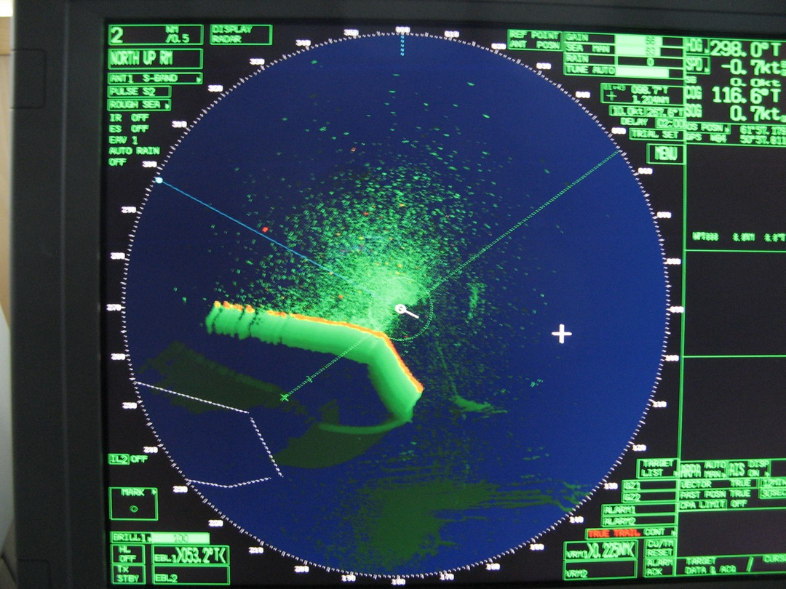

Radar image of the LST drop point at 1048 UT just after release, ~0.2 nmi NE of the iceberg. The iceberg is moving NE at about 0.6 kts.

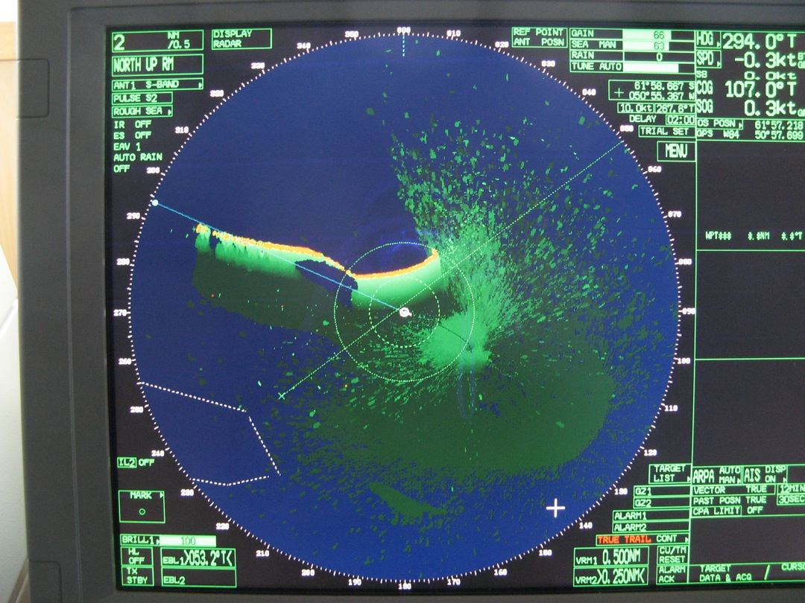

Radar image of the LST drop point at 1238 UT, almost two hours after release. The LST appears to have passed under the SE corner of the iceberg.

