Pulse width measured to the 1/2 intensity point, measuring the actual
light (not tube current).

50J 0.6ms
100J 1.0ms
200J 1.5ms

These are not precise, but simply measured off a scope using a photo
voltaic cell.

3/10/11
50J – 1 hz strobe
Charge current (@24vdc) will be approximately 5 amps peak during recharge.
The power supply will be running about 70% of the time at a 1 hz rate, so the "average" will be approximately 3.5 amps.

1 1 3831 Externally Powered Strobe $19,475.00 $19,475.00
6000 Meter Titanium Housing
316SS Connectors and hardware
50 watt-second, 1 sec recycle
Includes one 3831RH remote flash head
Includes flash head harness
2 1 3831RH Remote Flash Head $4,950.00 $4,950.00
Second flash head for item one, includes
upgrade to "tee" harness.
Order Total (US Dollars) $24,425.00
- 540J/image for one picture and one 100J flash
- Scale up for 400J flash, conservatively assuming 4x100 : 2160J/image
- SeaBattery:
  - 24 volts, 48 Amp-hr – assume 24 a-hr useable – 576 W-hr, 2073kJ
  - ~50 lbs wet
  - Good for 3838 images with 100J flash
  - 959 images with 400J
for the long term deployment, we derate the alkaline battery for low temp, high current drain (only 1 amp but it does effect the capacity) and long term self discharge ( one year). Thus I assume 7 amp-hours available from the pack.
In theory, we need 4.4 amp-hours for 1,000 pictures and a one year deployment .... a pretty safe match. I don't like to push assumptions about battery requirements for long term deployments. A one month deployment is a lot easier as the system quiescent current doesn't fact in very much. This represents almost 45% of the power requirement for that system over one year.
We have 100, 200, 300, 400 and 600 watt-second externally powered strobes available. If you go with the SeaBattery you should have enough energy to give you 1,000 images even at 600 w-s. There are two basic mechanical configurations:
1) Short housing (13" long) containing two photoflash capacitors (200 or 300 watt-seconds, only one capacitor for the 100w-s version)
2) Long Housing (22" long) containing four photoflash capacitors (400 and 600 watt-seconds)
The power differences are achieved with different capacitors. Note that the high powered strobes (300 & 600 w-s) use a custom capacitor that I only have a few of on hand, so delivery may be an issue.
Also .... the higher powered strobes (400 & 600 w-s) use two flash heads, and electrically are actually two independent strobes in one housing, providing electrical redundancy.
So ... if the longer length is ok, I would suggest the 400w-s strobe with two flash heads, using the "standard" capacitors. The SeaBattery will very easily supply enough energy. (I estimate that you would need approximately 14-amp-hours for the strobe and another 2 amp-hours for the camera for 1,000 pictures).
Like I said before ... between housing material, power source and strobe power there are many options! Our most "standard" product is the 200w-s self powered strobe using Ni-Cad batteries.

The electronics of this system would be modified to slow the recycle time (~30 sec) allowing the use of alkaline batteries which will be fine for this application.
Your deployment plan calls for 720 pictures over 30 days, which the system I am proposing will easily do.
Either way, 6 weeks will be very difficult to do. I would have to talk to my machine shops about expedited deliveries, and also get a better delivery from Impulse. I have most of the "specialty" parts in house, but might not be able to built all 6 systems without getting a run of PC boards done as well as other parts.
We should discuss housing options .... we could also go with 316SS for about the same cost as the aluminum.
With the self contained alkaline battery we specify 1,000 pictures over 1 year
Several of our systems use the DSP&L SeaBattery. The battery was customer supplied, but makes things much easier as they can easily provide the currents that our standard strobes require. Their capacity is such that power wasn't an issue. Not a bad way to go if you don't mind the size, weight and cost of the battery.
Yes we would use an externally powered strobe in that case, although we have done systems that can be either internally or externally powered!
The externally powered basic strobe is about $3K cheaper than the internally powered version
I have not had my hands on a D700 to assess the size issue. Power is also an issue, as the camera (probably) needs to accept external power and still run in a low quiescent current (i.e. sleep) mode. No all of them do. They also need to accept an external trigger without adding a battery handle (which some need). I know you had mentioned in the past that you liked the D700, if you think you'd like to go that way, I can investigate it.
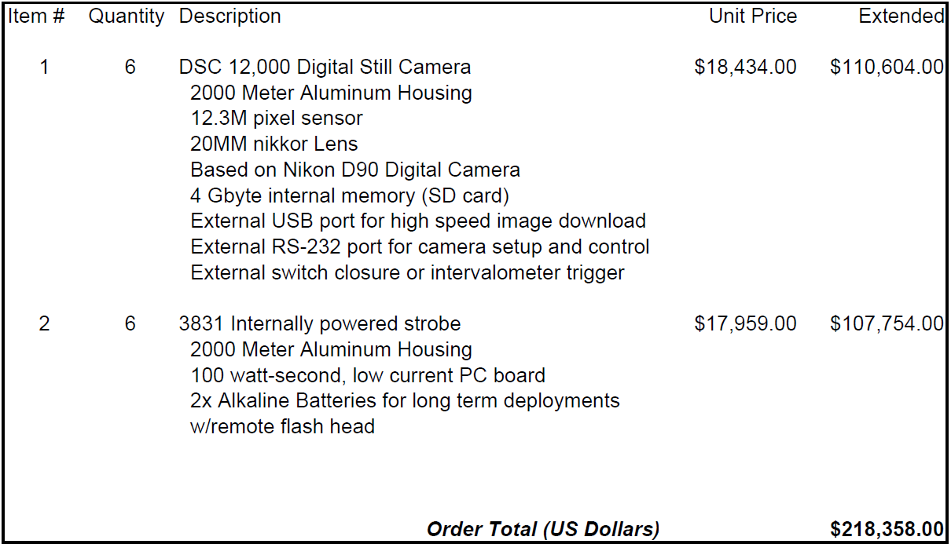
Our standard camera costs $25,260 in a titanium housing. This gives you the ball park. The domed port version would add ~$5,000, but I am not sure pressure-wise. We would need to investigate. To date, we have only used the dome on the 2,000 meter aluminum housing.

