Project Number: | 901006

Project Start: Jan. 1, | 2014 | Project Duration (in years): | 2 ¹

Please indicate what type of project is being proposed (mark only one).

 |  |  |  | X
Feasibility/Scoping  [Less than 100 days effort] |  |  | Development |  |  | Research |  |  | Infrastructure² |  |  | Education
 |  |  | Time Series |  |  | Institute Initiative

Project Manager: Brian Kieft
Principal Investigator: Charlie Paull

Project Title: Benthic Event Detectors (BEDs)

- ABSTRACT (new projects only)

- PROPOSAL

  - New Projects

  - Continuing Projects

If the proposed project includes multiple individual projects, please list each of these projects as a subheading in the proposal. For each subheading, please address the following:

Current status of project and results to date
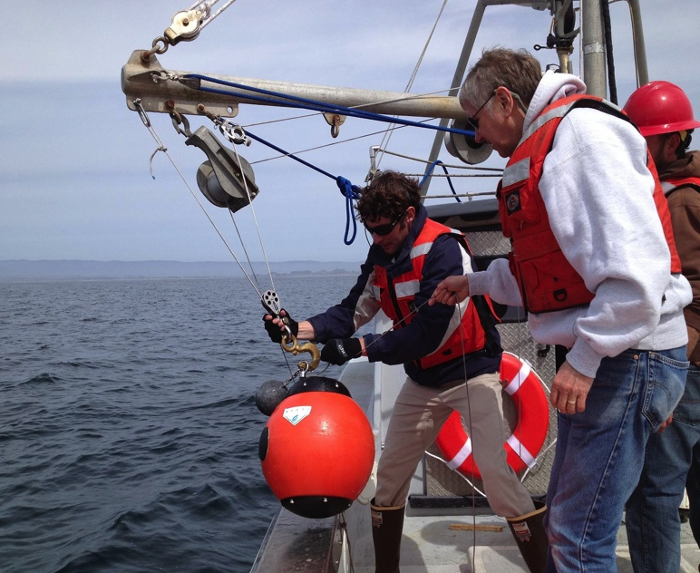
The BEDs project has been progressing according to plan so far in 2013. Two BED units were fabricated and ocean testing began in March. Field testing started with a tethered deployment off the R/V Paragon which tested communications and event detection (see figure 1). Further testing at deployment depths included an ROV dive in early April that recorded pressure and orientation data. In parallel, work was done to provide a more intuitive visualization of BED orientation on shore. An example of this visualization tool using data from a lab test conducted in April is shown here: \\Atlas\ProjectLibrary\901006.BEDS\BEDS.Data\2013_04_29_Bench_Orientation\video_clips\BEDS_2013_04_29_Video_X3D_orientation.mov
Fig. 1: BED being deployed on tether for communication tests.

Additionally, the data architecture is being set up to accommodate more BEDs and their associated data in 2014. This includes having the data readily available in STOQS (the Spatial Temporal Oceanographic Query System).

The BED design provides two methods of communication. The instrument contains a Homer beacon, which can be interrogated at any time to establish the position of the instrument and a modem that awakes on the hour that can be commanded to transmit the event and engineering data through the water column to a surface platform.
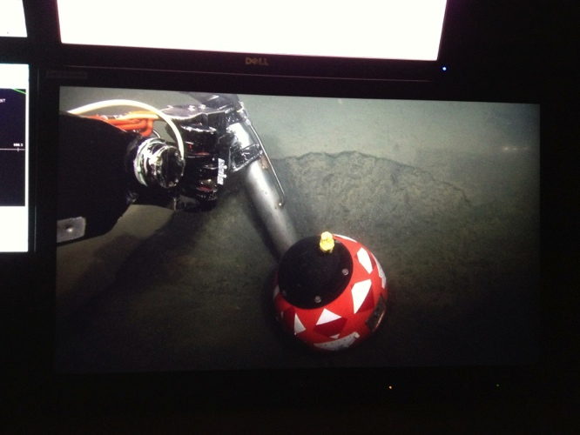
In April of 2013, a prototype BED was deployed in 300 m of water in the axis of the canyon. The position of this unit was surveyed in using both the homer beacon and the low frequency modem. The deployed BEDs initial position was confirmed and its health was determined by downloading engineering data using a modem that was hand lowered over-the-side from the R/V Paragon on five separate occasions prior to June 1. However, after the initial confirmations, five unsuccessful searches for the BED were conducted in June and early July. It was not until July 15th that the instrument was relocated using its Homer beacon, when the search pattern was opened up to look much further down canyon. The BED was found nearly 9 km down the canyon’s axial channel. Using the BED internal modem and over-the-side modem most of the critical event data was down loaded, while the R/V Sheila B held station over the site. The data showed that the BED was swept down canyon during a ~50 minute long event that occurred on June 1.
Fig. 2: BED deployed by ROV Ventana in a small depression at 300m.

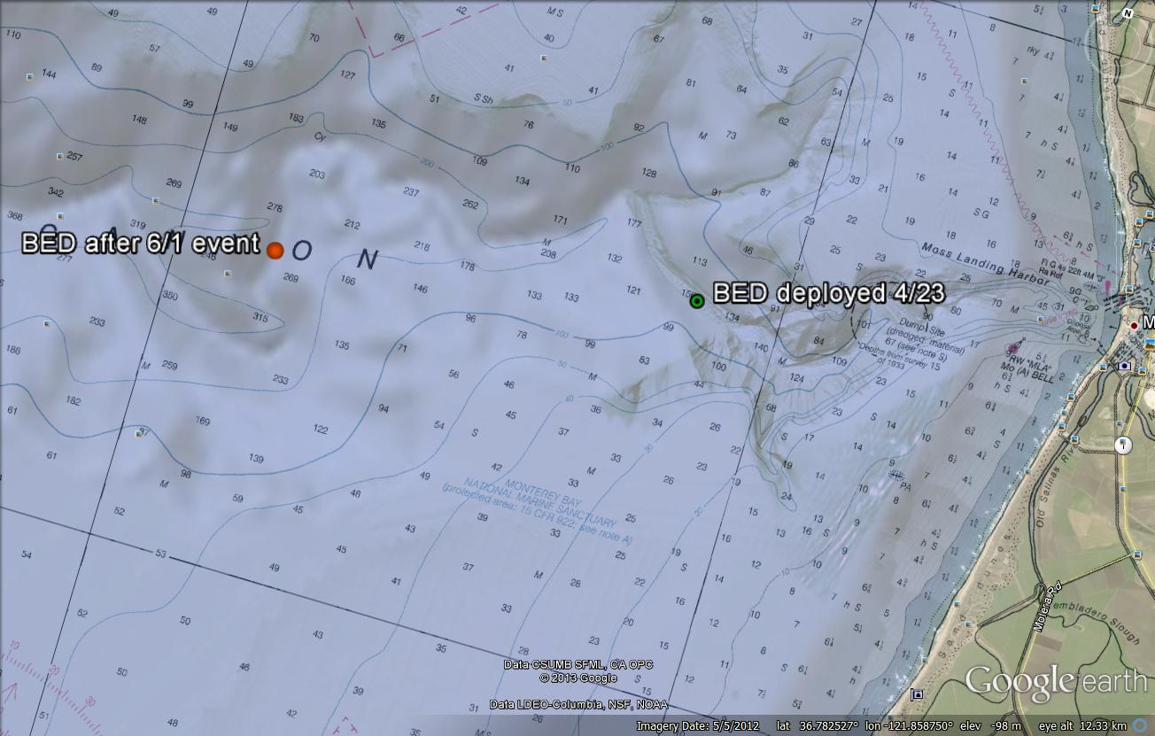
Fig. 3: Prototype BED unit deployment and post-event locations

A planned ROV dive on July 18 found the BED half-buried in 500 m water depths and Ventana was able to pull it out of the sediments and physically recover the instrument. By recovering the instrument the full data set is now available which includes contextual data that was too extensive to be downloaded through the modem while the R/V Sheila B maintained station above. The initial, novel, data set is still undergoing analysis. However, the data clearly shows that the motions of the BED sphere are successfully recorded within the instrument, accomplishing one of the BEDs’ project major design goals.

A second BED was then deployed on July 18th in 300 m water depth, where the previous deployment occurred in April. The intention is to have a BED in place that will allow tracking and locating techniques to be improved. An acoustic pole, useful for USBL tracking and general acoustic work, is being fabricated to fit the R/V Paragon. It is due to be finished by mid-summer 2013.

Our experiences demonstrate that we can locate and survey positions of the BEDs adequately from the R/V Carson, R/V Paragon, or other small vessel using their Homer beacons. The essential orientation data has also been successfully downloaded via the modem to the R/V Paragon. However, this takes a few hours on uninterrupted communications. Unfortunately, the R/V Carson and Ventana are both acoustically noisy, and while modem communications can be initiated, the connections are lost too frequently to make this an efficient way of downloading the event data from the BEDs.

Work has also been ongoing to integrate an acoustic modem onto the Wave Glider platform. A handful of integration issues have slowed this progress down. The SV2 Wave Glider was not specifically designed to handle high-energy payloads on the glider or in the tow-body. As such, we have had to do some further engineering of enclosures and higher voltage switching boards to accommodate an acoustic modem. Currently bench tests have been completed that have demonstrated full communication with a BED through an acoustic modem on the Wave Glider. The next step is to automate this process with scripts and finish mounting all the hardware in the tow-body. Sea tests are still planned for late summer and into the fall. A CDR in preparation for the 2014 canyon experiment is planned for December 2013.

Project Documentation:
System Development Lifecycle Document (including requirements):
\\atlas\ProjectLibrary\901006.BEDS\BEDS.Documents\Requirements\BEDs_SDLC_rev_2.0.doc

Project WBS/Schedule:
\\atlas\ProjectLibrary\901006.BEDS\BEDS.Documents\Project.Schedule\2013\BEDs_schedule_2013.mpp

Significant changes from previous project proposal

Coordinated Canyon Experiment:

An experiment is being planned to conduct a large multi-institution program with partners and partial support from the United Kingdom’s Natural Environment Research Council (NERC) and the United States Geological Survey (USGS) with the goal of directly documenting the passage of sediment density flows down through the axis of Monterey Canyon. The concept of this experiment is outlined in more detail in the Canyon Dynamics Project proposal (901023).

The vision of the entire experiment is to collect as much information on sediment transport events as possible by simultaneously deploying in the canyon our maximum instrumentation capability nominally during an 18-month period. The project involves a comprehensive monitoring of submarine sediment density flows from source-to-sink. This will be the first scientific application of the BEDs project and will serve as the excellent demonstration project for the BED project.

The array of other instruments and measurements that are being made simultaneously will provide a unique view of what happens within these sediment transport events and how they evolve. This array is planned to include: four traditional moorings carrying downward looking current meters and near bottom sediment traps will be distributed along the canyon axis from near the canyon's head (i.e., 300 m) out to ≥ 1,900 m water depths; a BIN placed on the canyon floor in ~1,850 m water depths set up to sample at a high temporal frequency (2 seconds to 1 minute); McLane Profiler deployed near the BIN; an array of ~10 STEDS spaced out between 300 m to >1,900 m water depths. An array of ~8+ BEDs, and ~4 acoustic monuments will be buried within the floor of the upper canyon (300 m – 750 m). Repeated AUV mapping of the canyon floor will be conducted with contingency plans for event-response cruises. Together these will provide an unparalleled context to understand the events in the canyon and the BED instruments are likely to be one of the most exciting components of this experiment.

Individual BEDs deployed associated with this project will document the timing and style of the movements they experience. However, each BED will only be observing what happens starting at their individual position. The instruments will be spaced at ~100 m depth increments from 100 m water depths down to 800 m water depths (the present depth limit for BEDs). By having up to 8 instruments distributed throughout this zone we can get a more synoptic view. For example, we currently do not know what initiates these events or event whether these events start at the canyon head and pass progressively down canyon, or conversely, propagate up-canyon though retrogressive failures in the canyon floor. The existence of the traditional moorings with downward looking ADCP (gear provided by the USGS) at 300 m and 800 will provide information on the water column as the BEDs pass underneath. Also when STEDs (provided by NERC) deployed within the same stretch of the canyon are triggered, they will alert us when an event has occurred and trigger event response efforts.

Publications based on the results of this project only

None (yet)

  - New and Continuing Projects: Plans for 2014

Research Activities

The major goal for 2014 is to be prepared for deploying an array of BEDs in October 2014 as part of the Coordinated Canyon Experiment. To prepare for this, we propose to conduct a proof-of-concept experiment in the early 2014. This experiment is designed to test two things: the ability to use the Wave Glider to download BEDs data and transfer it to shore, and to determine the effect that shape and density have on the BED’s transport down canyon. This test/experiment will involve deploying one BED in the upper canyon along with 4 Acoustic Monuments. Conducting this experiment will require developing data download software for the Wave Glider, obtaining real operating experience, and developing some algorithms necessary to conduct the Coordinated Canyon Experiment.

Once the instruments are deployed, the BED and monuments will be geolocated using the pole-mounted USBL on the Paragon. The Wave Glider will then be sent out to retrieve the data from the deployed BED and transmit the data back to shore. This functionality is crucial for the Coordinated Canyon Experiment, because data retrieval from a multiple BEDs will be so time consuming that it is impractical to do from a surface ship. Ultimately a means to geolocate homers from the Wave Glider will be developed (see Development Activities), however our top priority is data retrieval. Developing geolocation capabilities will occur later in the year or in a subsequent year.

This experiment will simultaneously be testing how the shape and density of the BED form affects the distance of transport. As of now the BED are spheres with a density of 1.55 gm/cm2, which was somewhat arbitrarily selected. The four acoustic monuments, which will be deployed immediately adjacent to the BED, will be of different exterior shapes (e.g., 2 spheres and 2 pyramids) and densities (e.g., 1.55 and 2 gm /cm2) with the intention of evaluating how these factors affect the total movement of BED size objects. Ultimately it is easy to select either different shaped housing or adjusting the densities that will be used during the Coordinated Canyon Experiment, but as of now, we do not have enough information to make an informed decision.

Engineering/technology development

- Advancing the Wave Glider as the primary mechanism to download data from the BEDs autonomously. This will require integrating a modem onto the Wave Glider, and developing software to communicate from the Wave Glider to the BED’s modem, and from the Wave Glider back to shore.
- Building 5 more BEDs in 2014. Currently the BEDS project has one instrument on the Canyon floor, another assembled instrument that was recovered from the canyon floor and the components and resources for assembling 4 new BED instruments. Thus adding 5 more in 2014 will make up to 8 BEDs available for the Coordinated Canyon Experiment, one or two for the winter experiment, and one or two spare units. The ship time and efforts to deploy and monitor the BEDS during the Coordinated Canyon Experiment will then be taken over by the Canyon Dynamics Project (901023) as that field experiment begins in October 1, 2014.
- Modest hardware and software upgrades to improve to the existing prototype. In particular, software upgrades will focus on improving the user interface.
- Advancing the Wave Glider as a mechanism to geolocate the BEDs. We will integrate an ROV Homer transducer head onto the wave glider to conduct geolocation with the homer alone (as opposed to using the modems).
- A technical paper describing the BED instrument will be written by the BEDS project team.

Work will also continue with the Wave Glider acoustic integration and further integration of the cesium clock. Construction of the five new BEDs will begin early in the year to accommodate the large coordinated canyon studies experiment listed above.

Field programs (detail ship requirements/deployments/diver requirements)

Our field programs and test plans require two days of Carson/Ventana time. These ship days will be requested in March, which leaves enough time to integrate the modem onto the Wave Glider and arrange for the fabrication of the 4 other acoustic monument housings. Additionally 12 R/V Paragon days are being requested. These days include Wave Glider launch and recovery as well as BED surveys.
Note that 15 days of Wave Glider time have been requested prior to October 1 in the Wave Glider proposal (901310).

Specific deliverables

- Capability to carryout data retrieval with Wave Glider
- 5 additional functional BEDs
- Participation in the fall 2014 coordinated canyon experiment.
- Data from prototype experiments
- Firmware revision 2.0, motherboard spin 2.0
Note: The team is aware that the potential exists for the Coordinated Canyon Experiment to be delayed due to a MARS cable extension. The project is planned such that a hiatus after fall 2014 would be possible if necessary with minimal effort to resume work at a later time.

Milestones (see personnel classification list)

2014 Project Start Date:  MM/DD/2014 | Milestone 1 | Milestone 2 | Milestone 3 | Milestone 4 | Milestone 5 | Total Resources for each resource category for all milestones listed here
Milestone Date | Q1 | Q2 | Q2 | Q3 | Q4
Milestone Description | Software and hardware upgrades completed | Monument and Bed experiment | 5 additional BEDs constructed | Further support of canyon testing | Coordinated canyon experiment deployment (see note above)
EE | 300 | 50 | 50 | 125 | 100 | 625 (325 DK, 300 AS)
SE | 500 | 50 | 200 | 275 | 300 | 1025 (525 BH, 500 BK, 200 MM)
ME | 50 |  | 180 | 75 | 50 | 355 (DG 178, LB 177)
EE Tech | 50 |  | 50 | 25 |  | 125 (TM)
SE Tech
ME Tech
Machine Shop |  |  | 200 |  |  | 200
Divers

Budget justification

CATEGORY | COST
Fabrication of 5 BEDs (includes 1 spare) | $70,000
Lab Supplies and hardware to support deployments | $3500
Software licensing including BSD ContactGeo | $2,100
Home Pro top side transducer (ROV-Homer) for wave glider | $11,000
Domestic Travel and conference fees to present at ASLO Conference (Brian Kieft) | $3,670

Project team

Brian Kieft (P.M), Charlie Paull (P.I), Larry Bird (ME), Dale Graves (ME), Bob Herlien (SE), Mike McCann (SE, data visualization), Denis Klimov (EE) or Alana Sherman (EE), Esther Sumner, Roberto Gwiazda, Bill Ussler.

Project lab space

We are currently using the west end of the center bench (including shelves, drawers, and bench top) in Lab 244 for fabrication effort. The deployment efforts will be staged out of the Canyon Dynamics (Lab B124).

Data availability outside project team, uniqueness

To our knowledge there are no devices that exist which can measure the movement of submarine sediments down submarine canyons. Development of the BED concept would enable other investigators worldwide to deploy comparable devices to monitor and measure sediment movement down submarine canyons. With a dataset more comprehensive that what can be obtained from Monterey Canyon, a more robust understanding of submarine canyon processes will be obtained. What we learn in Monterey Canyon can be extrapolated to other submarine canyon systems in the world for both the development of second generation monitoring systems and for interpreting observations and data from the canyon systems. Interest has already been expressed by two other outside parties who are interested in deploying BEDs in other locations.

Export Regulation
Does the project team anticipate any foreign collaborations or international travel? If so, please identify collaborators by name, institution, and country.

No

Does the project team plan or anticipate export controlled purchases, shipments, or transfers of items (e.g., research instruments, proprietary data, hand-carried tools or samples) outside the U.S. temporarily or permanently? If yes, please identify country or countries and indicate whether these items will remain under MBARI control while abroad or controlled by others. Will the items be exported to more than one country? Please include foreign collaborator information as described above.

No

Monterey Bay National Marine Sanctuary SESAs (General map)
Projects will need to indicate whether or not work will be conducted within one of the Monterey Bay National Marine Sanctuary's Ecologically Significant Areas (SESAs). An interactive map can be found on the Sanctuary's SIMoN webpages at http://sanctuarysimon.org/maps/sesa/. (Note: It may take a moment for the page to load, so please be patient.) To determine if your work will occur in a SESA, specific coordinates can be entered using the locator function (click on the red "target" button in the toolbar at the top of the map). If your work will be conducted in one of these areas, please indicate which area, by number.

NONE

Risk matrix (development and infrastructure projects only)

 | Technical Risk | Organizational Risk | Tech Transfer Risk | Labor Estimate Risk
High
Medium | X |  |  | X
Low |  | X | X

This date and number should remain the same for the duration of the project. If your project start date for 2014 is not January 1, please indicate the start date in the first cell of the milestone chart.
Development and infrastructure projects must complete the risk matrix (see item #5 at the end of the proposal form).
Not all projects will require all four titles to be filled in. Please indicate individuals only for those titles that are appropriate for your project.
This number should be the same number you entered on the resource requests for this particular resource.

