

Inspection report
Program Number: 901006
BEDS Benthic Even Detector
Author: Denis Klimov
Date: 5/9/2014

Hardware affected:
BEDS#3 (AS1 SN003 12/2013)
Cell Electrochem model CSC93DD part# 3B0036-XB, batch 2334026, SN 3027

Background.
BEDS#3 (AS1 SN003 12/2013) was built 12/6/2013 and deployed in December 2013 in Monterey Canyon at approximate depth of 290 meters. Initial environmental conditions inside of a housing were recorded by on-board sensor set at humidity 9%, temperature 8-9C, internal pressure 14.5 PSI
4/28/2014 an elevated humidity level was detected (85%; 9C; 14.8PSI) and decision was made to recover instrument as soon as possible.
5/1/2014 at about 11:00 another read of environmental sensors was performed (89%; 9C, 14.8 PSI).
5/1/2014 at about 16:00 BEDS instrument was recovered by means of ROV Tiburon and R/V Western Flyer, brought to Moss Landing and stored on site until next Monday.
5/5/2014 ~ 13:00, the instrument was opened for inspection.

Initial Inspection
Housing does not have any signs of damage. Pressure slightly elevated, large clamps were used to hold housing’s end plated until pressure released as a safety measure (no pressure read was performed right before opening). Subjectively, internal pressure was not more than 110% of atmospheric pressure.
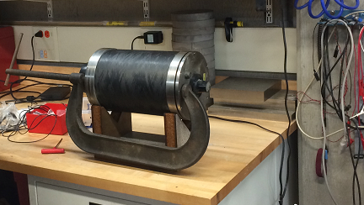
Once housing was open, presence of light-green liquid and chlorine smell became evident
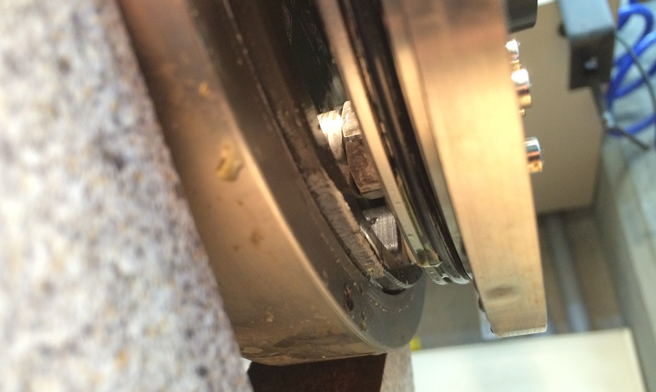

About 25-35mL of the light-green liquid was collected from the housing into polyethylene container.
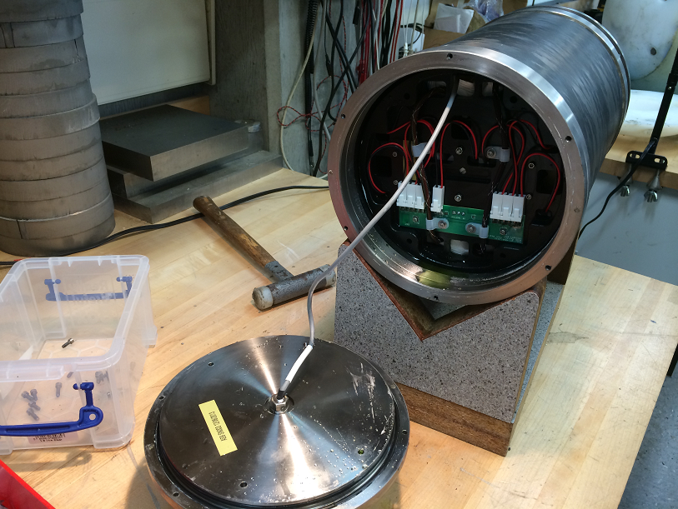

Housing does not have any signs of mechanical damage. Inside surface of the housing contaminated with light-green fluid.
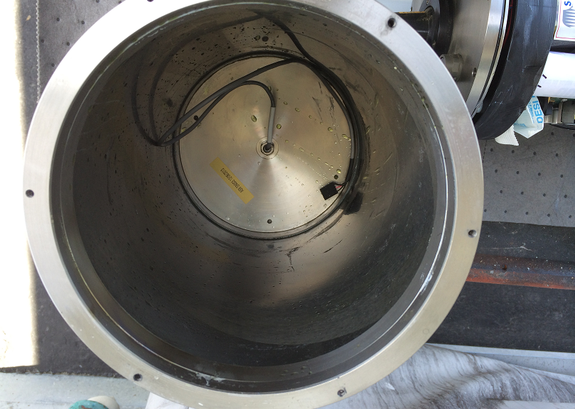

Left Black Delrin endplate holding battery sticks found missing about 1x3 cm section adjacent to Battery Stick marked L2 (means: stick “2”, oriented to the left end plate, assembly AS3-LEFT).
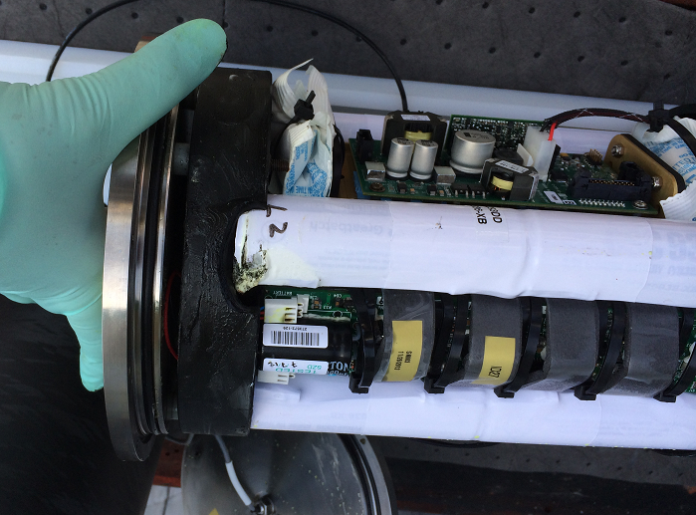

Edges of the missing section appeared “rounded” as if melted or chemically etched.
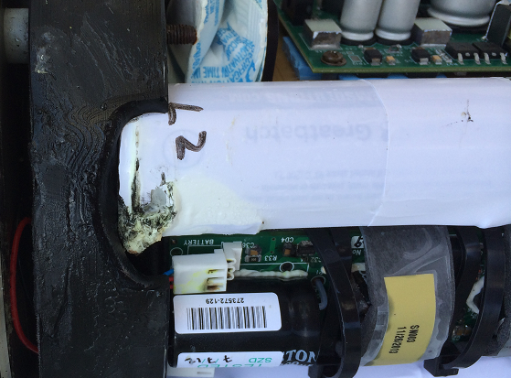

Internals of Electropack Assembly –AS1 look undisturbed aside of presence of light-green fluid on some surfaces, and some discoloration of metals: pressure sensor housing, solder on PCB boards and so on:
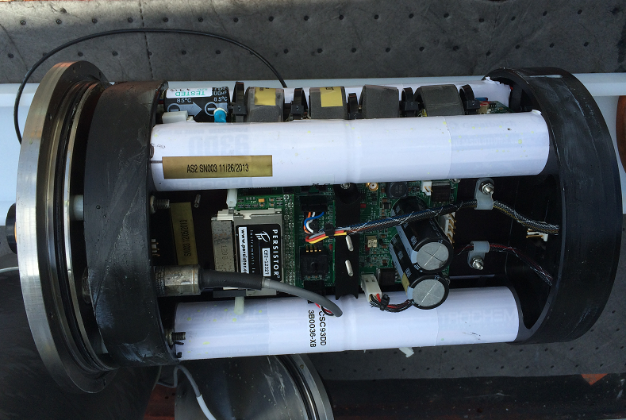
Battery pack board (10020895-BPB1) mounted on right end plate (10020895-AS3-RIGHT) has signs of corrosion near connectors J1-J2, but later tested to be fully functional
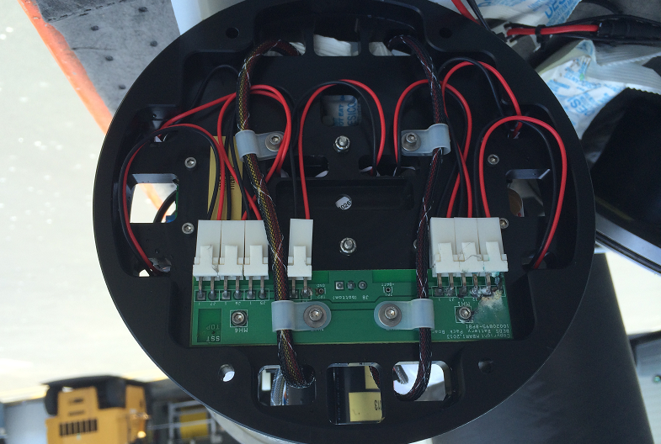

Battery pack board (10020895-BPB1) mounted on LEFT end plate (10020895-AS3-LEFT) is corroded near connectors J1-J2 with black-green deposits covering connectors pins; and later tested NOT to be functional. Damage to the board include dissolved traces between pins J1.1 and J2.2, and J1.1 and copper pour net name “+ BATT” on Top and BOTTOM layers.
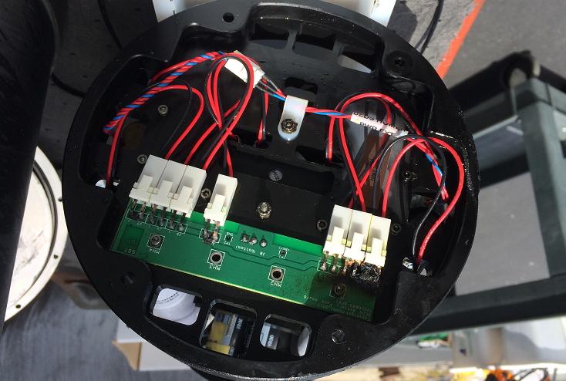

Black Delrin under the LEFT battery pack board is corroded with approximately 15x5x1mm mass missing, with discoloration and pitting in surrounding areas as if the electrolyte was trapped inside the channel under the PCB board enabling galvanic corrosion between energized connector pins.
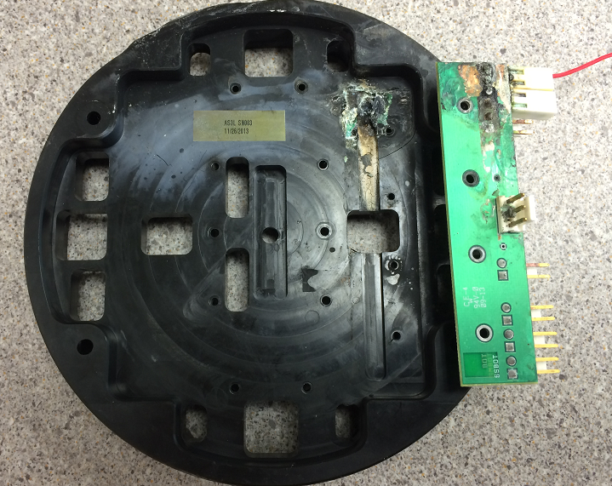

Fused Power Harnesses delivering power from each Battery Pack Board to Mother Board are intact and later tested to be functional.
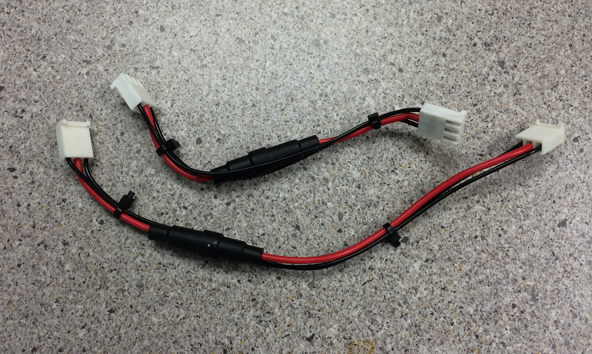

Inspection of battery sticks and cells. Table below indicates serial numbers of the cells installed in each slot as well as voltage of each cell measure at the time of the assembly and a the time of inspection after battery failure. Drawing below illustrates slots allocation in respective AS3- assembly.

Slot# | Model | Part# | Batch# | SN# | Voltage 11/26/2013 | Voltage 5/9/2014 | Note
Slot L1 | CSC93DD | 3B0036-XB | 2334026 | 3027 | 3.886 | 3.859 | positive wire missing; signs of corrosion under paper disk
Slot L2 | same | same | same | 7331 | 3.886 | 3.86 | failed cell; 2 pitted areas on the edge on positive side; electrolyte leaked out
Slot L3 | same | same | same | 7305 | 3.886 | 3.344
Slot L4 | same | same | same | 7306 | 3.885 | 3.85 | severe connector corrosion
Slot L5 | same | same | same | 7339 | 3.885 | 3.061
Slot L6 | same | same | same | 7340 | 3.885 | 3.739
Slot L7 | same | same | same | 7334 | 3.885 | 3.852
Slot R7 | same | same | same | 3026 | 3.885 | 3.856
Slot R6 | same | same | same | 7332 | 3.885 | 3.856 | other side of failed cell in slot L2
Slot R5 | same | same | same | 7325 | 3.885 | 3.856
Slot R4 | same | same | same | 7336 | 3.885 | 3.856
Slot R3 | same | same | same | 7335 | 3.886 | 3.856
Slot R2 | same | same | same | 3029 | 3.886 | 3.857
Slot R1 | same | same | same | 7327 | 3.886 | 3.856

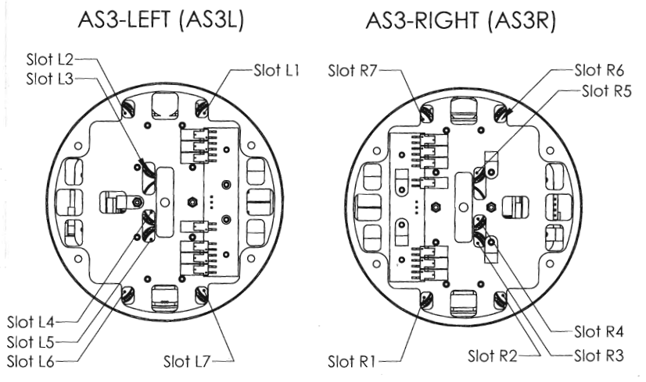

Conclusions of system-level inspection:
- Damage to the electrical system of the BEDS assembly is caused by a presence of corrosive liquid inside the housing.
- Source of the liquid:
  - Battery cell SN 7331 located in a Slot L2 of the LEFT half-pack
  - Possibly, presence of seawater inside of the housing
- LEFT half-pack failed due to corrosion of battery pack board traces. Channel milled under battery pack board negatively affected reliability allowing liquid to be trapped under the board and electrochemical corrosion to occur. Due to damage to the battery pack board, other cells in the same LEFT half-pack were affected (partially discharged beyond unaffected cells) as indicated by their voltage at the time of the inspection.
- RIGHT half-pack retained full functionality and continued supplying power to Mother Board.

Suggestions and improvements:

Batteries:
Slot

Battery and electrical:
- Pack configuration: Electrochem CSC93, 7s2p
- DC load discharge range: 27.5 to 17.5 VDC
- Pulse load discharge range: 17.5 to 13.5V at 4A peak

Configuration

