Arenal
Q1. What is an idea of a cost of your sensor? Since BEDS instruments are getting lost sometimes, the high cost could be prohibitive.
A: The cost for a normal system is about 12k euro. Changing the concept would initially bring higher cost, but for 2nd systems the cost would be again 12k.

Production transmitter electronics in a housing:
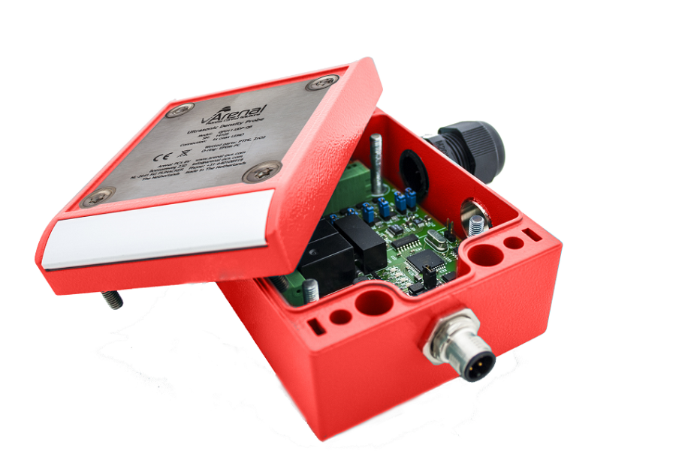

Design picture of our electronics stack. I think the total stack is 1,2”. You see two PCB’s 80x80 and one alu plate in between.
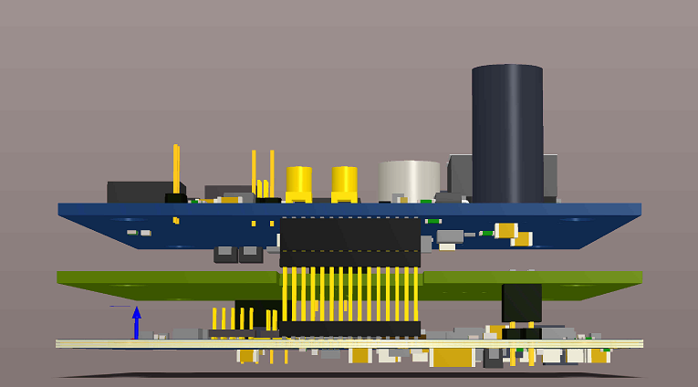

We do not have a marketing picture of this specific probe as we always embed them and we continuously redesign it. But I added a picture of the old probe (1 year). You can see the inner white part, which is ZrO2. The housing is PEEK and the back housing is POM. The length of this probe is 3”. We will need to determine the housing for your case as we have higher pressures and lower temperatures. We will discuss later.
M28x1,5 thread and two o-rings. In your case it will be potted by epoxy.
