Density meters review
http://www.control.com/thread/1026230991
corrosive and abrasive slurry

Ohmart/Vega is a good supplier of these devices. Thermo... now Fisher Scientific had TN Technologies devices. They all can provide excellent product. Ronan also is a good supplier.

Thermo Fisher Scientific is the manufacturer of what used to be Texas Nuclear and Kay-Ray. OhmartVega makes nuclear density gauges in the US.
Berthold sells nuclear gauges in the US.

I work for Berthold Technologies USA, LLC in Oak Ridge, TN. We provide nuclear density systems for slurry measurements on a regular basis - flyash slurries, limestone, gypsum, bauxite, etc. In many cases, we can provide an accurate solution with our low-activity sources that don't require shutter checks or leak tests, and that can be installed/serviced by plant technicians without special training. You can contact me at 865-483-1488 if you'd like more information. Our website is http://www.berthold-us.com

Radiometric density sensor Endress+Hauser FMG60
http://www.endress.com/en/Tailor-made-field-instrumentation/level/20148?highlight=FMG60

There are several suppliers of nuclear slurry density gauges that are available in the United States. The best of them, in my opinion, is Thermo (the old Texas Nuclear AND Kay-Ray brands), followed quickly by Ohmart-Vega (whose nuclear level gauges are better than Thermo's) and Berthold Systems.

Ultrasonic sensors are available for this application which are very easy to install & handle unlike nuclear ones.
Go to http://www.bestobell.com for further details.

In the mining industry, slurry density is commonly measured by using dual bubbler tubes and pressure transmitters. Very cheap, stable and accurate.

I worked in the mining industry for many years. My favourite Nuclear Density is from Ronan,
see http://www.ronanmeasurement.com Toronto based I think. I haven't used one for a couple of years but I see they claim that the source is now so weak in some cases you don't need a license. A far cry from the 2 Curie source I used 20 years ago (level application). I agree they are very reliable.

Digital fork densitometer
http://www.viscoanalyser.co.uk/solids2.html

Coriolis mass meters – true mass meter flow rate, for density, a volume also needed!
Coriolis meters are considered to be true mass meters since they tend to measure the mass rate of flow directly while other flowmeter technologies measure volumetric flow. Since mass does not change, no adjustments are needed for varying fluid characteristics. Hence, a Coriolis meter operates in linear fashion. These types of meters exist in variety of designs. The most common type of unit includes
- a U-shaped flow tube
- a sensor assembly
- an electronics unit
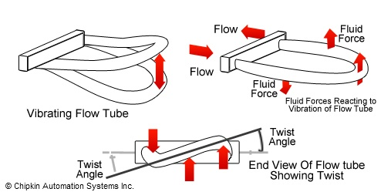

http://automationwiki.com/index.php?title=Mass_Flowmeters

Ultrasonic methods.

Ultrasonic Sonochemistry is the science of the behavior of propagation of ultrasonic waves, due to changes in the environment.
Which products are required for Ultrasonic Sonochemistry?
A complete setup for ultrasonic sonochemistry consist always of the following parts:
- Process Control Analyzer (PCA)
- 2x2 twisted pair cable from PCA to UDT
- Ultrasonic Density Transmitter (UDT)
- Coax cable from UDT to UDP
- Ultrasonic Density Probe (UDP)
- Teflon or POM sampling blocks
- Connected to eachother, the following words explain how it operates:
The PCA is a ProFace HMI based PLC/analyzer that retrieves measurement data from the connected transmitters in the field. This data is validated and calculated into client specific parameters, like density, mass flow, efficiency, or anything. The PCA visualizes these results and takes care for connectivity to other PLC’s.
While powering the PCA, the PCA powers the UDT. In the UDT, voltage pulses are created and send throught the coax cable to the UDP. The UDP is the Ultrasonic Density Probe and consist of a piezo-sensitive material, which reacts tot his pulse quite intensively by generating ultrasonic waves. These waves are transmit into the probe. On changes of acoustic impedances from material to other material, a part of the echo is reflected back to the piezo element. These ultrasonic waves are, like magic, convert into voltage signal, like a sine. The probe is made in such way that many reflections are formed and converted. These are measured and stored in the UDT. These results are averaged and the deviation coefficient is determined for further analysis.
Mentioned above, measuring the acoustic impedance of materials is one of the key important properties that we analyze. But also the speed of sound in the material is of main importance. By combining these measurement, the physical property of the material (or fluid) “density” is accurately determined. Furthermore, by measuring the attenuation or dampening of the signal, the concentration of suspended solids is determines as well.
These properties can be explaned in more detail in the following echo’s:
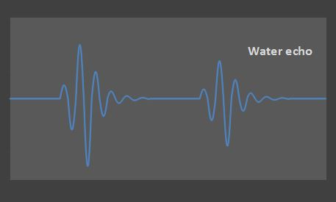
One of the echo’s that returns to the piezo, is the one from the reflector. In water, the echo looks as above. The shape of the echo is depending on the transducer type and the pulser settings.
At a certain moment, the echo returns to the piezo. The vibration of the wave is converted to a voltage amplitude and read by the transmitter. A little later a second echo returns at the transmitter, which is a reflection caused by the first echo. It is lower, because some energy is absorbed by the probe and the piezo element and the water.
Suppose that we insert the probe in salt water. The following graph is formed:
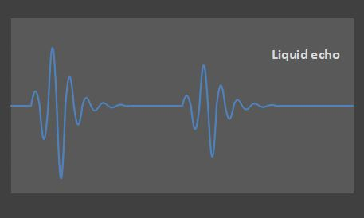
Applications: In addition to the applications on this website, Arenal is focussed on:
Slurry density monitoring to replace radioactive analyzers. Apllications can be found in mining, dredging, drilling. Below you see four pictures of a 1-1/2"wafer for monitoring slurry density, TTS (Total Suspended Solids) and TDS (Total Dissolved Solids). In case of larger pipe diameters, only density monitoring is offered. The electronics are embedded in a small waterproof junction box and this is encapsulated in a polyethylene housing to offer solutions for submersible applications. Multiple sensors can be added to the wafer, f.e. pressure and flow.
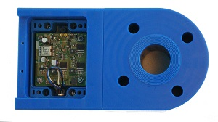

http://www.arenal-pcs.com/technology/ultrasonic-density.html

Submersible sensor
http://www.arenal-pcs.com/embodiment/submersible-probe-configurations.html

DENSITY ANALYZERS FOR SLURRIES

9690 Series Hybrid Sensor Technology Slurry Density Analyzer
The Rhosonics sensor of the Model 9690 Ultrasonic Density Analyzer employs only one, simple to install, flush mounted probe, which can be installed in a tank or in an existing pipeline, or supplied with our UFTC Full Bore Flow-Through cells, see picture.
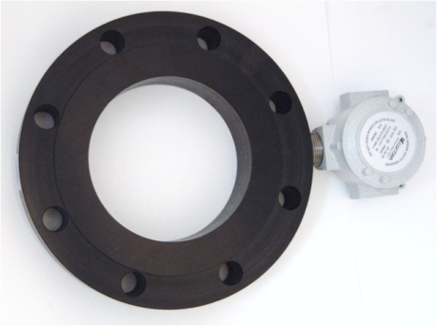

Australia
http://plapl.com.au/slurry-density-measurement.html

Request letters
We have the BEDS instruments which we deploy to the bottom of the underwater ocean canyon, to study motion of the sediment layer using on-board inertial sensors. BEDS is self-contained, autonomous instrument, with acoustic communication interface. It normally sits on the top of sediment layer, or can be self-buries to about 1-2 meters into sediment layer, depending on the density of the instrument relative to sediments density. Pressure rating of the instrument is 500m nominal, 700m absolute maximum rating. Most of the time BEDS instrument just sits on the bottom, and once the motion of "event" (sort of underwater avalanche) is detected, the instrument records inertial motion data at high rate. During single event, the instrument could move down the canyon, say from initial depth of 300 meters, to 380 meters, in say 20 minutes time, and then sits there until next event.
The sediments is a mix of sand and gravel with average density range about 1.0 - 2.2 kg/m3. Once the event starts, sediment layer liquefies into sort of slurry and start moving down the canyon.
We are interested to monitor the change of the density of the sediments around the instrument during those events with frequency of about 1-10 Hz.
Do you think your 9690 series could work for this?
Thanks!
Denis Klimov,
EE, R&D Engineering
Monterey Bay Aquarium Research Institute (MBARI)
7700 Sandholdt Rd
Moss Landing, CA 95039
Phone: 831-775-1914
Fax: 831-775-1608
email: klimov@mbari.org

measure density of marine sediments in situ?
Hello, I am looking for the sensor to measure density of marine sediments in situ at depths from 300 to 700 meters. Do you have something like this?
Denis Klimov
EE, R&D Engineering
Monterey Bay Aquarium Research Institute (MBARI)
7700 Sandholdt Rd
Moss Landing, CA 95039
Phone: 831-775-1914
Fax: 831-775-1608
email: klimov@mbari.org

In short, we have the BEDS instruments which we deploy to the bottom of the underwater ocean canyon, to study motion of the sediment layer using on-board inertial sensors. BEDS is self-contained, autonomous instrument, with acoustic communication interface - please refer to the PDF document attached with a short specs and description.
It normally sits on the top of sediment layer, or can be self-buries to about 1-2 meters into sediment layer, depending on the density of the instrument relative to sediments density. Pressure rating of the instrument is 500m nominal, 700m absolute maximum rating. Most of the time BEDS instrument just sits on the bottom, and once the motion of "event" (sort of underwater avalanche) is detected, the instrument records inertial motion data at high rate. During single event, the instrument could move down the canyon, say from initial depth of 300 meters, to 380 meters, in say 20 minutes time, and then sits there until next event. The sediments is a mix of sand and gravel with average density range about 1.0 - 2.2 kg/m3. Once the event starts, sediment layer liquefies into sort of slurry and start moving down the canyon.
We are interested to monitor the change of the density of the sediments *around* the instrument during those events with frequency of about 1-10 Hz.
Regarding technical implementation, we have a processor board inside the cylindrical pressure housing (see picture in the document attached), and so some electronics could be packaged there, while transducers be placed outside, on the surface of the sphere presumably and be connected by short cable and wet connectors. We have severe limitations on any parts protruding from the surface of the sphere as it would change the dynamics of instrument motion in sediment flow, or simple be broken by impact of the rock or something during motion. For this reason, Procon System sensor with a reflector sticking out from the sensor is problematic for our application:
http://www.proconsystems.com/product_brochures/9690productsheet-psi~rhosonics~.pdf
Denis Klimov

