Desktop IMU Motion Testing

Problem Statement
The Invensense ICM-20948 is a 9-DOF sensor with excellent sensor characteristics and a brochure that promises full sensor fusion [1]. The statistics are significantly better than the Invensense MPU-6050 used on the previous BEDS implementation [2]. However, is the ICM-20948 able to perform as expected in simple desktop testing? While a desktop test lacks the precision of a rate table test, it should uncover gross errors which would indicate against a preparing the BEDS daughter card.
Note that the full rate table plan is beyond this document.

Paper Comparison: New ICM-20948 vs Old MPU-6050
Both IMUs have the same range and sensitivity for the gyro and accelerometer. The base statistics for each unit are comparable with the new sensor being better than the old for most characteristics [4].
 | New  ICD-20948 | Old  MPU-6050 | Units | Notes
Gyro
Zero-rate output (ZRO) | +/- 5 | +/- 20 | dps
ZRO variation over temperature | +/- 0.05 | +/- 20 | dps
RMS noise (FS_SEL=0) | 0.015 | 0.005 | dps/ √Hz
Mechanical frequencies | 25-29 | X: 30-36  Y: 27-33  Z: 35-30 | kHz
Accel
Initial Tolerance | +/- 0.5 | +/- 3 | % full scale
Sensitivity change to temperature | +/- 0.026 | +/- 0.02 | % full scale /°C
Noise | 230 | 400 | ug/ √Hz

The ICM-20948 also has a magnetometer and uses an on-chip motion processor to calculate a quaternion which represents roll, pitch and Earth-fixed heading. As the old MPU-6050 did not have a magnetometer, its yaw output was represented the drifting gyro value.
The ICM-20948 uses lower power for each sensor but utilizing the on-board motion coprocessor eliminates the improvement. There are no direct comparison numbers for this.

Test Plan
The goal of testing is to verify the repeatability, algorithm settling time, and static measurements of the sensors [3,5]. The set of data to be collected consists of:
- Calibrated accelerometer, magnetometer, and gyro data.
- Rotation vector (RV) quaternion representing the fusion of accelerometer, magnetometer and gyro sensors. The Euler angles will also be computed in the output.
- Game rotation vector (GRV) quaternion representing the fusion of accelerometer and gyro sensors. The Euler angles will also be computed in the output.
These will be stored in a timestamped CSV file. Most of the testing will focus on the quaternion outputs, using the raw sensors only to look at time characteristics. Testing will be 50Hz or 225Hz as noted.

Test Equipment
As this is intended to be a basic validation, the equipment is straightforward:
- Butcher paper or craft mat that allows positions to be marked
- Spirit (bubble) level (cellphone not ok)
- Compass (cellphone ok)
- Power supply (15V)
- IMU and BEDS board mounted on lexan, serial connection outputting data via serial and power input (15V)
- Laptop recording data with python script

Outline of Tests
- Test basic functionality using fusion quaternion:
  - Move unit around to allow calibration (figure 8s in all 6 directions).
  - Perform 90-degree tilt around each positive axis: roll (x), pitch (y), and yaw (z). Use the spirit level or compass to verify rotation is close to 90 degrees. Record values from software.
  - Multiple turns 90-degree tilts in sequence such as RP-R (which results in -Y). Record values.
- Determine sensor fusion settling time
  - Move unit around to allow for calibration.
  - Quickly turn the unit 90 degrees roll, pitch, -roll, resulting in a yaw -90.
  - Plot raw accelerometer output vs quaternion-generated Euler angles to calculate fusion settling time in the algorithm.
  - Run this test with both 50 and 225Hz fusion output rate.
- Verify system repeatability
  - Outline the system on the test surface (pen on paper or tape) as precisely as possible
  - Move system around, slowly, replace and verify results.
    - Optional: plot raw accelerometer vs quaternion-generated Euler angles to determine settling time. Run this test with both 50 and 225Hz fusion output rate.
  - Move system around quickly (but within the dynamic limits). Replace to original position and verify results.
  - Run this test with both 50 and 225Hz fusion output rate.

Test Results
This table is an example of how the test results will be presented. Graphs will also be provided as needed.
 | Goal starting  (R, P, Y) | Measured starting  (R, P, Y) | Measured (R, P, Y) | Expected (R, P, Y) | Notes
Positive 90° roll around x axis | (0, 0, x) |  |  | (90, 0, x) | Yaw (heading) not critical for this test, should be the same before and after for RV.
Positive 90° pitch around y-axis | (0, 0, x) |  |  | (0, 90, x) | Yaw (heading) not critical for this test, should be the same before and after for RV.
Positive 90° turn around z-axis | (0, 0, 0) |  |  | (0, 0, 90) | Not likely to be valid for GRV.

Future Testing
Future testing will occur on the MBARI 3-axis linear motion table.

References
- Invensense. MPU-6000/MPU-6050 Product Specification. August 2013. https://www.invensense.com/products/motion-tracking/6-axis/mpu-6050/
- Invensense. ICM-20948 Datasheet. June 2017. https://www.invensense.com/products/motion-tracking/9-axis/icm-20948/
- Arden, Dale. Analysis of MEMS IMU Motion Table Testing. May 2007. http://cradpdf.drdc-rddc.gc.ca/PDFS/unc65/p527627.pdf In depth description of testing three IMU (accel + gyro) sensors including their results. The author uses a 2-axis rate table to measure sensor drift, bias, noise, scale factor, and misalignment.
- Chow, Raymond. Evaluating inertial measurement units. November 2011. https://www.edn.com/design/test-and-measurement/4389260/Evaluating-inertial-measurement-units Describes the kinds of errors and noise that are likely with MEMS IMU sensors and some of the standard ways to compensate for them. The ICD-20948 performs compensation and calibration for bias error and scale-factor error. Noise and bias stability are characteristic of the sensors should minimized in IMU selection.
- Smajlovic Dino and Roman Tkachev. Testing Approaches for Characterization and Selection of MEMS Inertial Sensors. May 2016. https://meptec.org/Resources/9%20-%20Smajlovic.pdf A useful resource for describing what tests exercise different sensor characteristics. This focuses on the individual sensors, not any fusion.

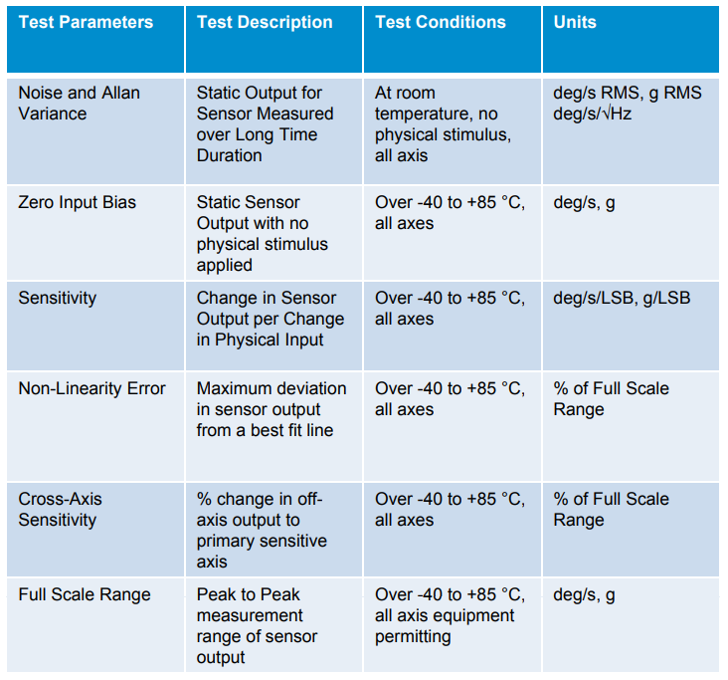
Figure 1: From Reference 5

