10-31-2018

Robert Herlien DBA Herlien Engineering Consultants

1910 Jacklyn Ct.
Royal Oaks, Ca. 95076

RE: Independent Contractor Agreement

Dear Mr. Herlien:

Enclosed, please find two signed originals of the Independent Contractor Agreement for your project with Dr. Charles Paull. Mr. Basilio Martinez, Comptroller & CFO, and Norm Steinberg, Director of Human Resources, have signed both originals. If this agreement meets with your approval, please sign both originals. Retain one copy for your records and return one original to:

Basilio Martinez, CFO

7700 Sandholdt Road
Moss Landing, CA 95039-9644

In addition, an MBARI purchase order #PO-XXXXX will be executed for this work. This authorizes payment to begin on this agreement after we receive the signed original. Please reference the Purchase Order number on your invoices for work performed under this agreement.

If you have any questions, please give me a call at (831)775-1886, or email at paull@mbari.org.

Sincerely,

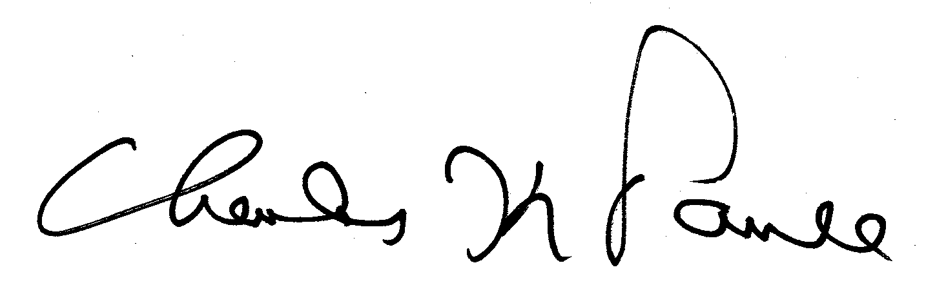

Dr. Charles Paull
Senior Scientist

Enclosures

