Project Highlights

Benthic Event Detectors (BEDs) 901006
The BEDs team has completed a series of tests and a first prototype deployment. On March 18, following a pressure, tank, and a harbor test, a BED unit was lowered from the R/V Paragon to 300m in the canyon. Communications testing was performed as well as geo-location from the surface vessel.
On April 12, the ROV Ventana dug a depression in the sea floor and deployed a BED there (see figure 1). This prototype deployment is planned to last until December 2013. Currently the R/V Paragon, equipped with an acoustic modem, is used to communicate with and transfer data from the BED. Work is progressing on using a Wave Glider equipped with an acoustic modem to transfer basic sediment debris flow event back to shore. An initial deployment of the Wave Glider with acoustic modem is planned for late June. The BEDs team is planning to participate in a collaborative canyon experiment in 2014 with multiple units deployed.

Images:

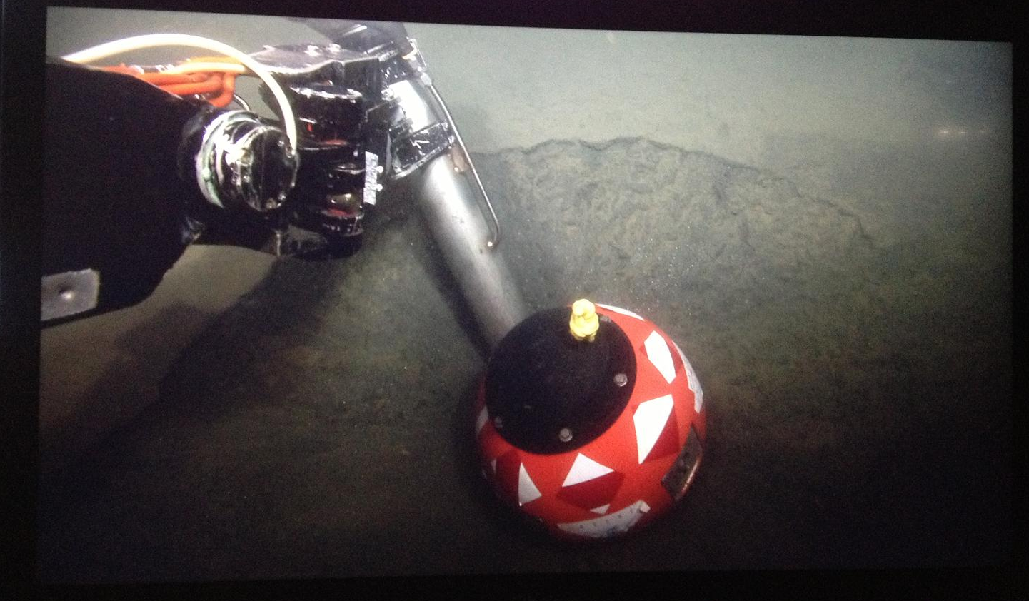

The R/V Paragon is being fitted with an acoustic pole (figure 2). The BEDs team will be using a iUSBL on the pole in combination with a GPS in order to geo-locate the BED units on the seafloor.

Figure 2 – Paragon pole design.

A realistic representation of the motion of the BED is an important part of the shore-side data processing. This animation shows video footage of the ROV Ventana moving the BED alongside the VRML animation of the motion recorded on the BED.

