Project Highlights

Benthic Event Detectors (BEDs) 901006

Just over one year has passed since the initial prototype deployment of a Benthic Event detector. Since that time, at least one BED has been constantly monitoring the canyon and a total of 3 benthic events have been detected. The two latest events were recorded by two individual instruments allowing for start and end time comparisons as well as a comparison of the motion.

In December of 2013, the project began work on refining the shape and density of the instruments in preparation for the coordinated canyon experiment scheduled for 2015. This refinement consisted of deploying two spherical beds with different densities each partnered with a monument of the same density but cubical shape. Following an event, the team will now be able to compare the motion and distances of the different shapes and densities to determine which are embedded in the debris flow. Nature cooperated and we experienced two events during this time. Final data from these events is still being recovered and analyzed in preparation for building more units.

As more data became available, it was apparent that downloading data from a boat was inefficient. In conjunction with the Waveglider Hotspot project, the BEDs team was able to use the waveglider to download event data for the first time. We expect this to save a large amount of time in the future as more instruments are deployed.

Additionally, Bob Herlien presented a poster “Benthic Event Detectors: a Novel Instrument for Characterizing Sediment Transport Events” at the 2014 Ocean Sciences Meeting in Honolulu. An electronic copy of the poster is available here:
http://www.eposters.net/pdfs/benthic-event-detectors-a-novel-instrument-for-characterizing-sediment-transport-events.pdf

Further work continues in data visualization including the addition of 3D motion overlaid on high resolution terrain. See fig 3.

Images:
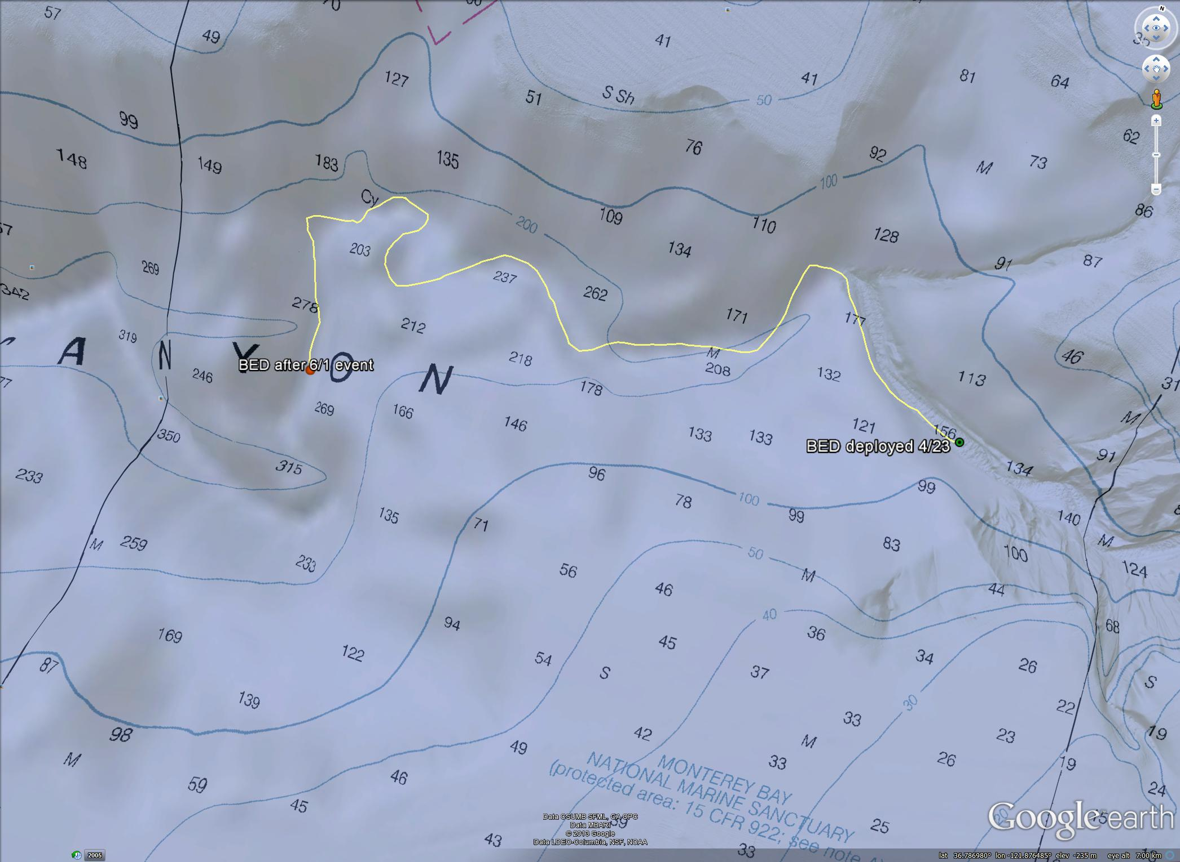
Figure 1 – The starting and ending locations of BED #1 before and after the June 1 event. The estimated path represented by the yellow line is 9 kilometers.

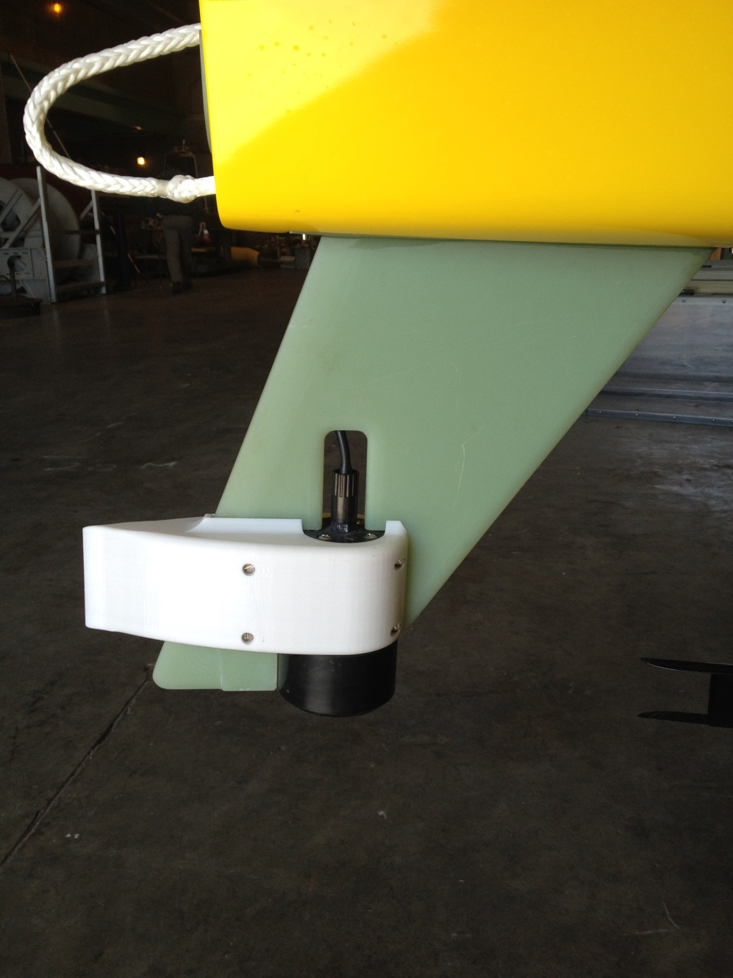

Figure 2 – The SV3 Waveglider equipped with a custom skeg that integrates a faired acoustic modem allows for humans to download benthic event data from their desks. Photo by Brian Kieft

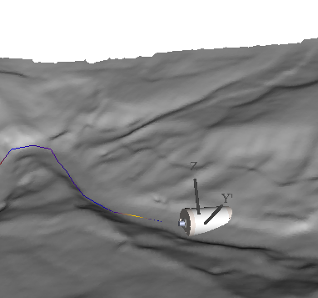
Figure 3 – Visualization of the motion of a BED over high resolution terrain background. By Mike McCann.

