Project Highlights

Benthic Event Detectors (BEDs) 901006
The BEDs team has implemented a primary design and has begun fabrication of six units to be deployed in April, 2013. The housings and circuit boards have been fabricated and integration and assembly has begun. Pressure testing, tank testing, and tethered testing from the R/V Paragon will precede the spring deployment.

Images:
Figure 1 – A model of the housing and internal components.

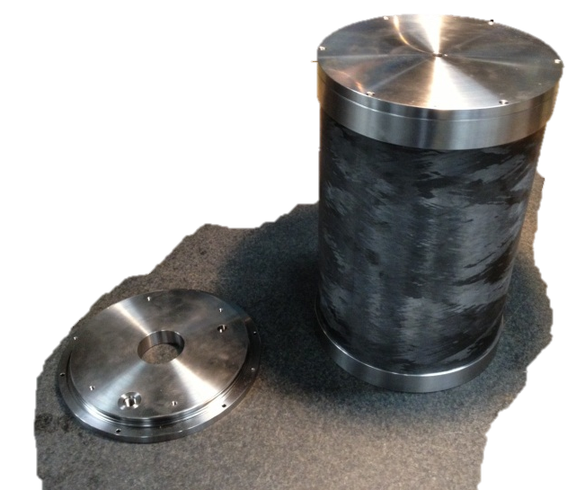
Figure 2 – A housing with end caps.

