Project Highlights

Benthic Event Detectors (BEDs) 901006
Following the April 12 deployment, prototype BED #1 continued to remain in contact acoustically from the seafloor until early June. On July 15 the BED was located nearly 9 kilometers down canyon in about 500 m water. A cruise was already planned for the Rachel Carson later that week and the team decided to attempt a recovery of BED #1 in order to collect all raw data. Despite challenging visibility, the ROV pilots were able to locate the unit and recover it. A new unit was deployed at the top of the canyon and, at the time of writing, is still awaiting an event. Data processing continues and an animation of the approximately 90 minute event has been put together. The team hopes to learn more about the frequency, duration, and magnitude of these sediment transport events prior to a large collaborative canyon experiment in 2015.

Images:

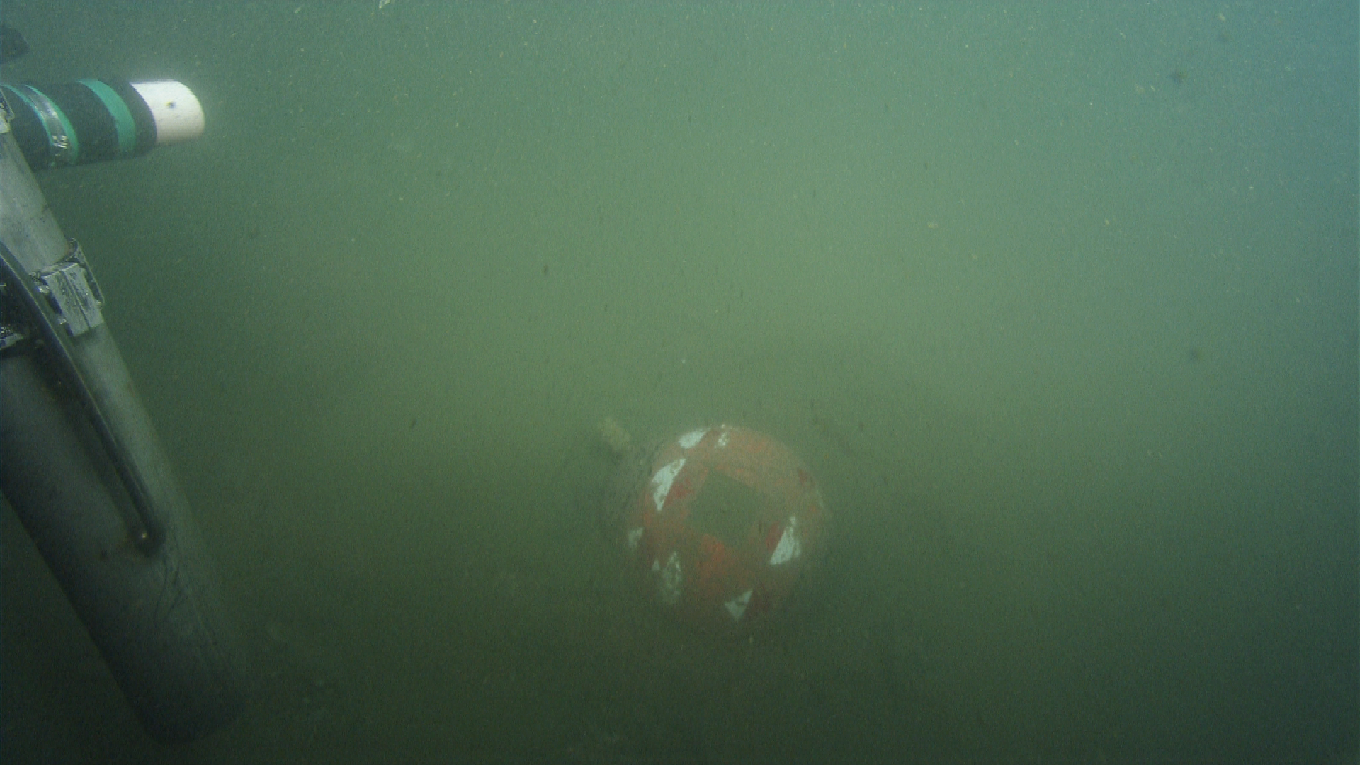

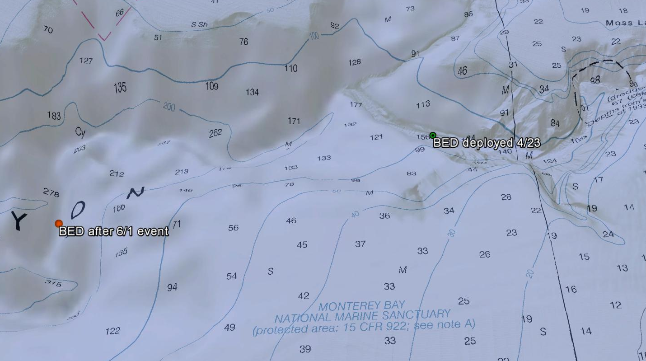
Figure 2 – The starting and ending locations of BED #1 before and after the June 1 event..

