Project Highlights

Benthic Event Detectors (BEDs) 901006
BEDs has conducted an engineering test using spherical BEDs of two different densities and cubical monuments of the same two densities. A comparison of three canyon events that have occurred since June of 2013 shows the different path lengths down the canyon (fig 3). Work has continued to refine data collection via the Waveglider SV3 Tiny and continues to be the primary planned data collection method for 2015. Mike McCann has developed data visualization tools that allow end users to view data in either an animated format laid over bathymetric data of the canyon or in a more traditional graphical view. With the combination of the two, users can zoom in on areas of interest during an event.
Finally, in early June 2014, MBARI hosted a workshop to refine plans for the Coordinated Canyon Experiment. The workshop participants were impressed with the functionality and capabilities of the BEDs: in particular they were enthusiastic that the BEDs offer the potential to investigate dense near-bed sediment layers that have hitherto been impossible to measure using conventional techniques e.g. flow measurements using ADCPs. As a result, the BEDs are likely to play a prominent role in the experiment.

Images:

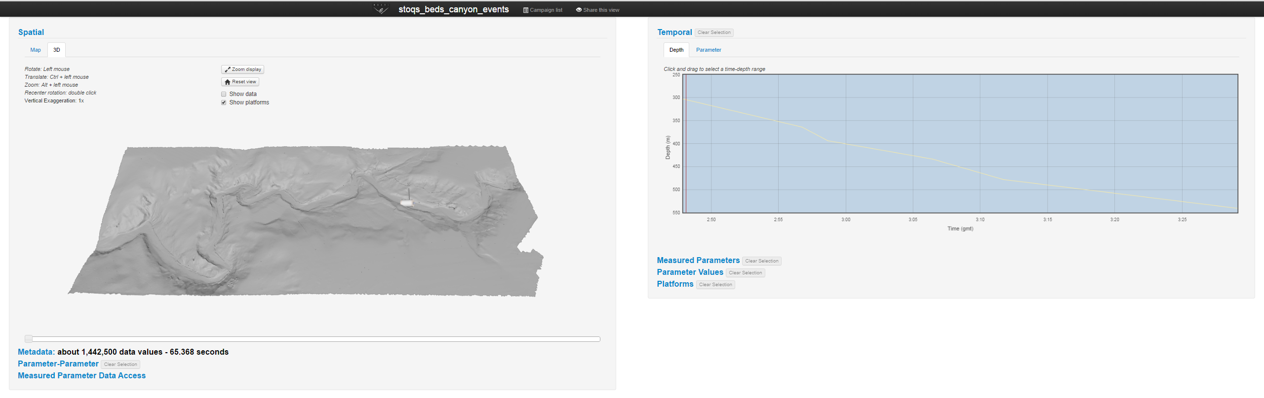

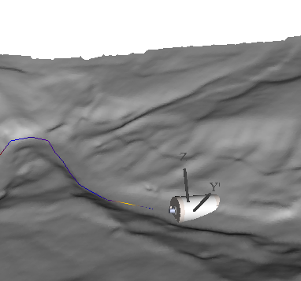
Figure 2 – A close-up of the 3D animation display from STOQS laid over bathymetry data.

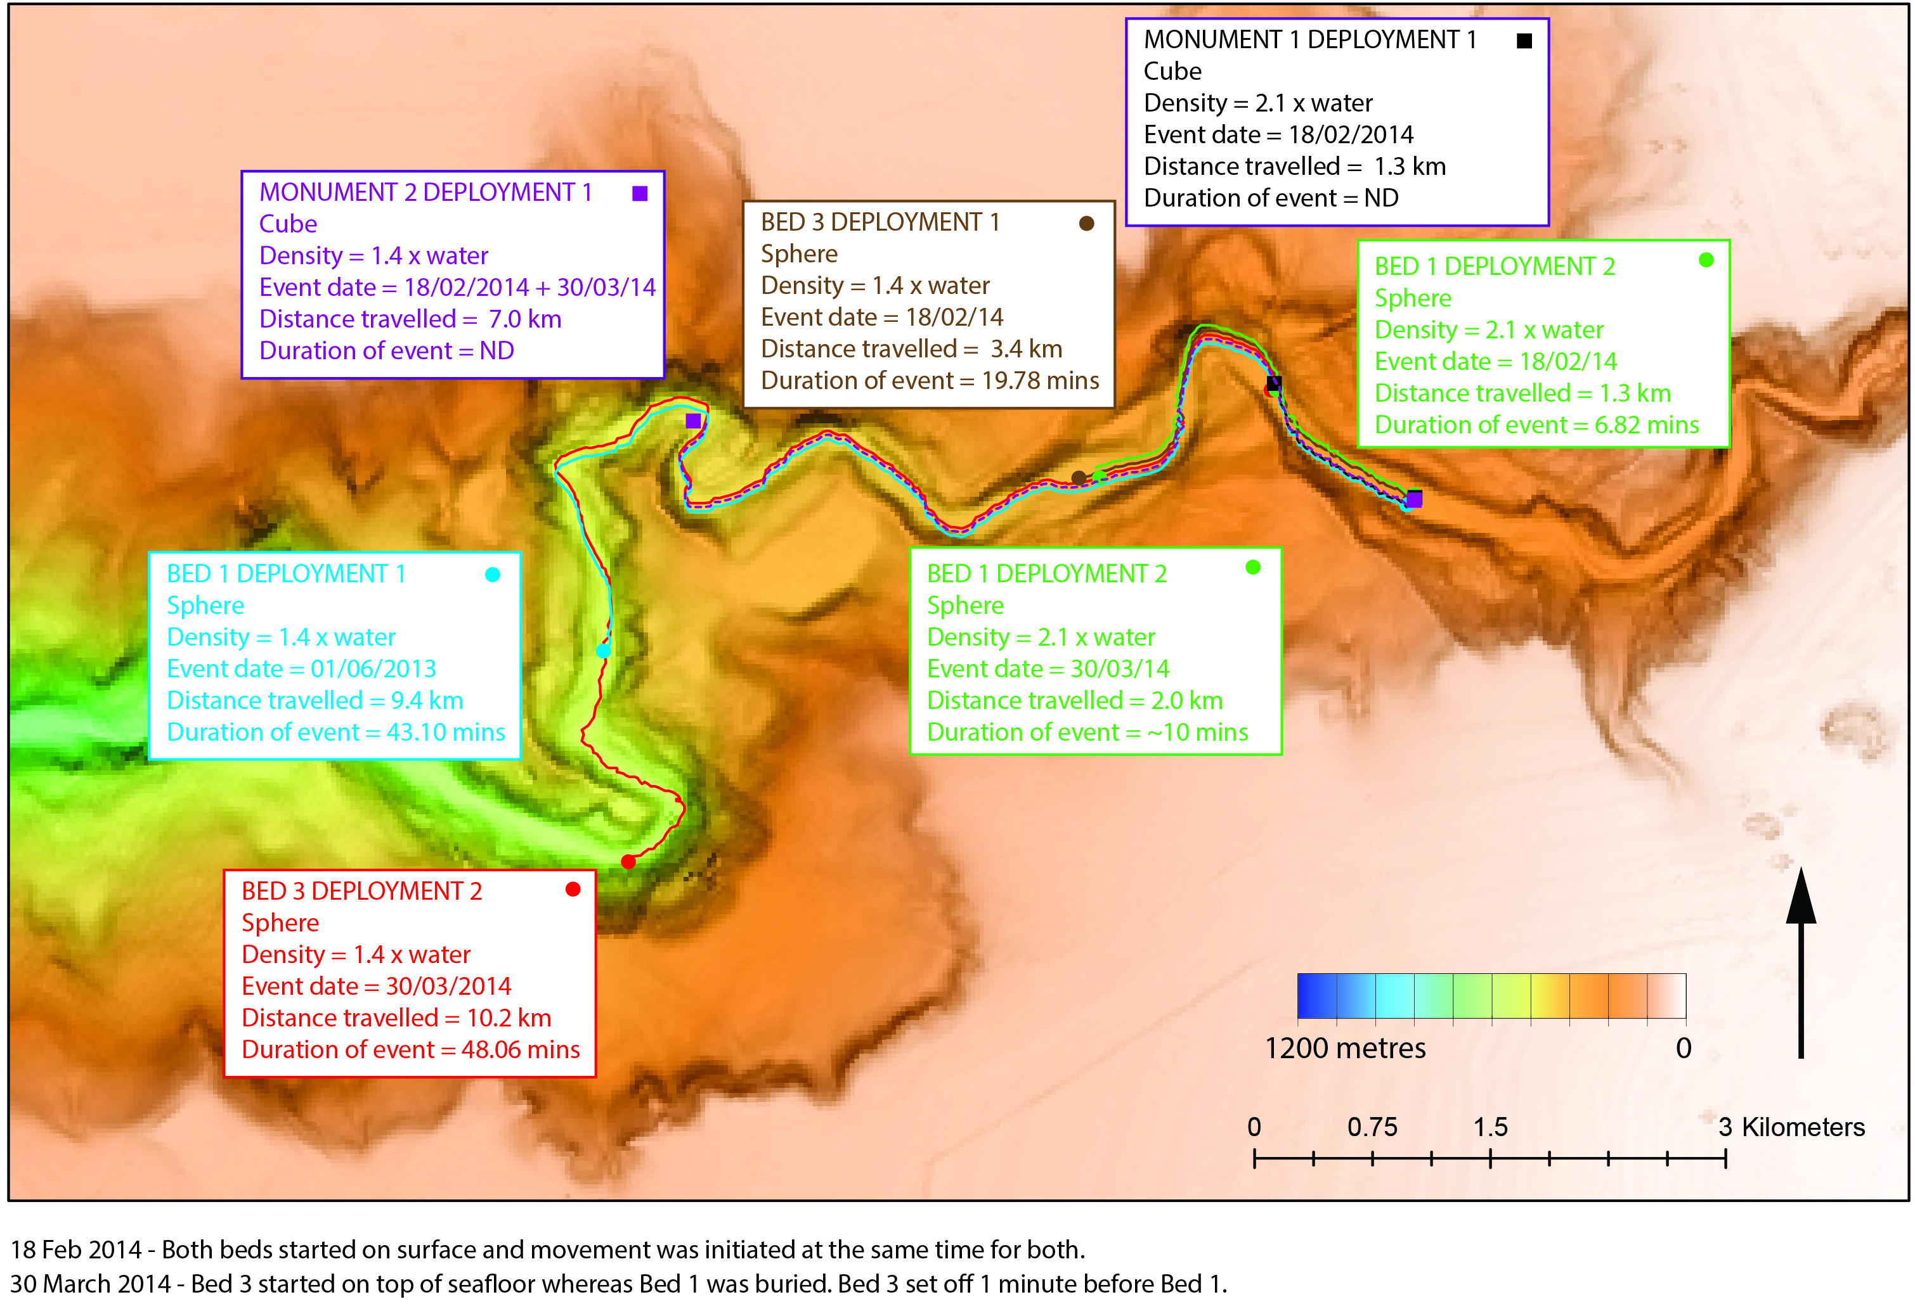
Figure 3 – A summary of canyon events to date.

