Science Plan for CANON 2012 experiments

Nitrogen biogeochemical dynamics along upwelling gradients in the California Current System

Background:
The sources and sinks of ammonium in the ocean are relatively well understood (Figure 1Bio). The primary source appears to be zooplankton excretion although direct decay of particulate nitrogen by bacteria is also at work. Bacteria then convert ammonium to nitrate in an energy-yielding process termed nitrification. This nitrification was thought to occur only in the dark, however recent evidence suggests that some nitrification is occurring in the euphotic zone. In the euphotic zone ammonium is also utilized by phytoplankton in their growth process. In general studies in coastal upwelling systems have focused on the impact of nitrate rather than ammonium on biological production. Ammonium has been studied primarily in relation to the remineralization process and been less studied in terms of its impact on biological productivity. Recent results from observations (Figure 2Bio) and models (Figure 3Bio and Figure 4Bio) have brought renewed attention to the role of ammonium in upwelling ecosystems. The purpose of CANON biogeochemistry and modeling team is to measure, budget and simulate the sources and sinks of ammonium in two different domains of the California Current System.

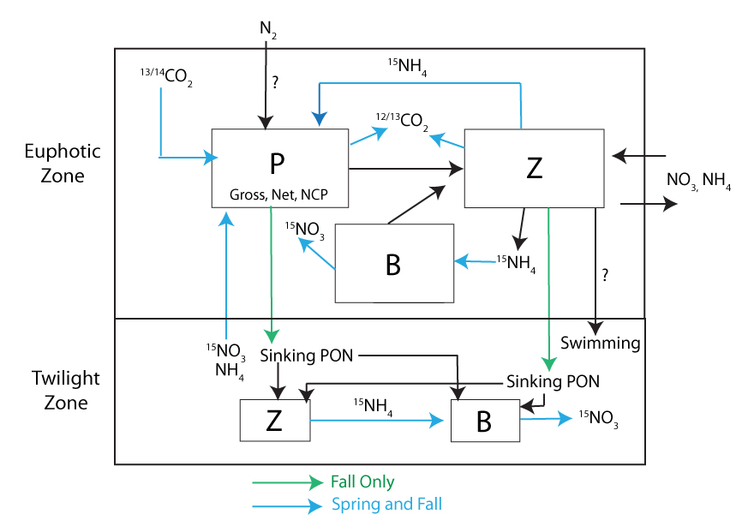
Figure 1Bio. Generalized schematic of the nitrogen pools and fluxes in the ocean color-coded to show proposed measurements via incubations during the Spring and Fall CANON experiments. B= Bacteria, P=Phytoplankton, Z=Zooplankton. The enzymes responsible for catalyzing the microbial and photosynthetic fluxes will be assayed using molecular techniques to measure gene expression (see Genomics section). Zooplankton abundance and distribution will be measured as described in the zooplankton section. The physical fluxes of water horizontally and vertically will be estimated as described in the oceanography section.

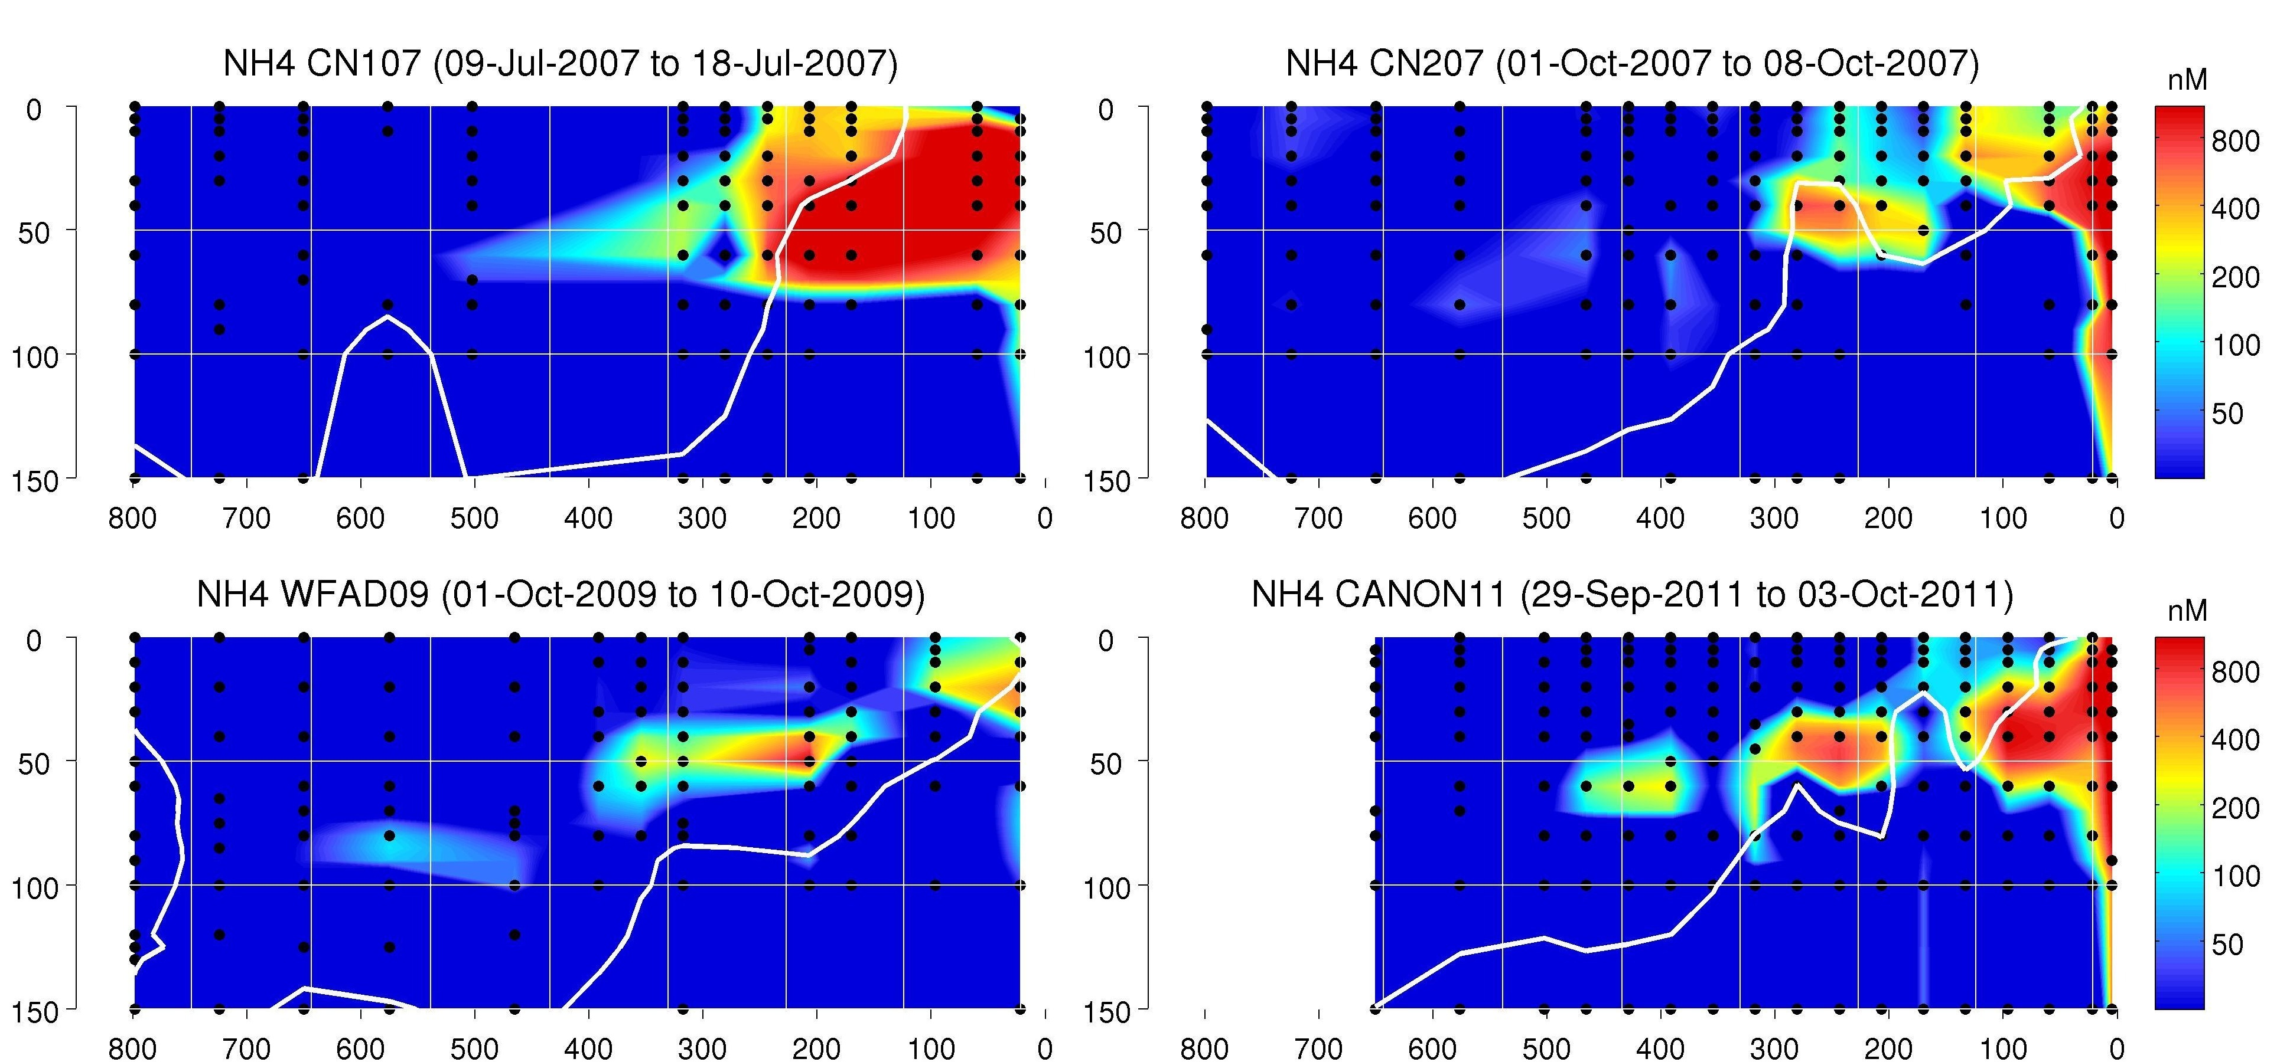

Figure 2Bio. Measurements of ammonium along four Line67 cruises.

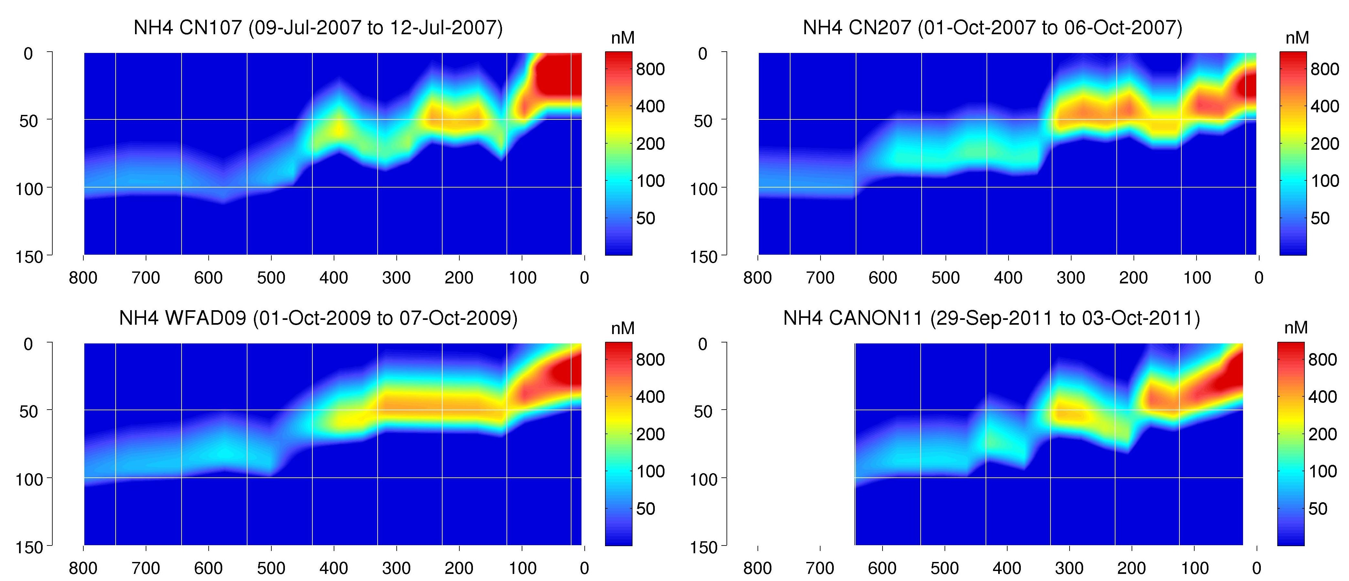
Figure 3Bio. Simple 1-D model simulation (see modeling section) of ammonium (using the fluxes in Figure 1Bio) for the same Line67 cruises as Figure 2Bio. The inputs are chlorophyll and surface irradiance from which the euphotic zone depth and light profile are estimated. The chlorophyll, depth and light drive the production of ammonium by zooplankton and its consumption by phytoplankton and bacteria.
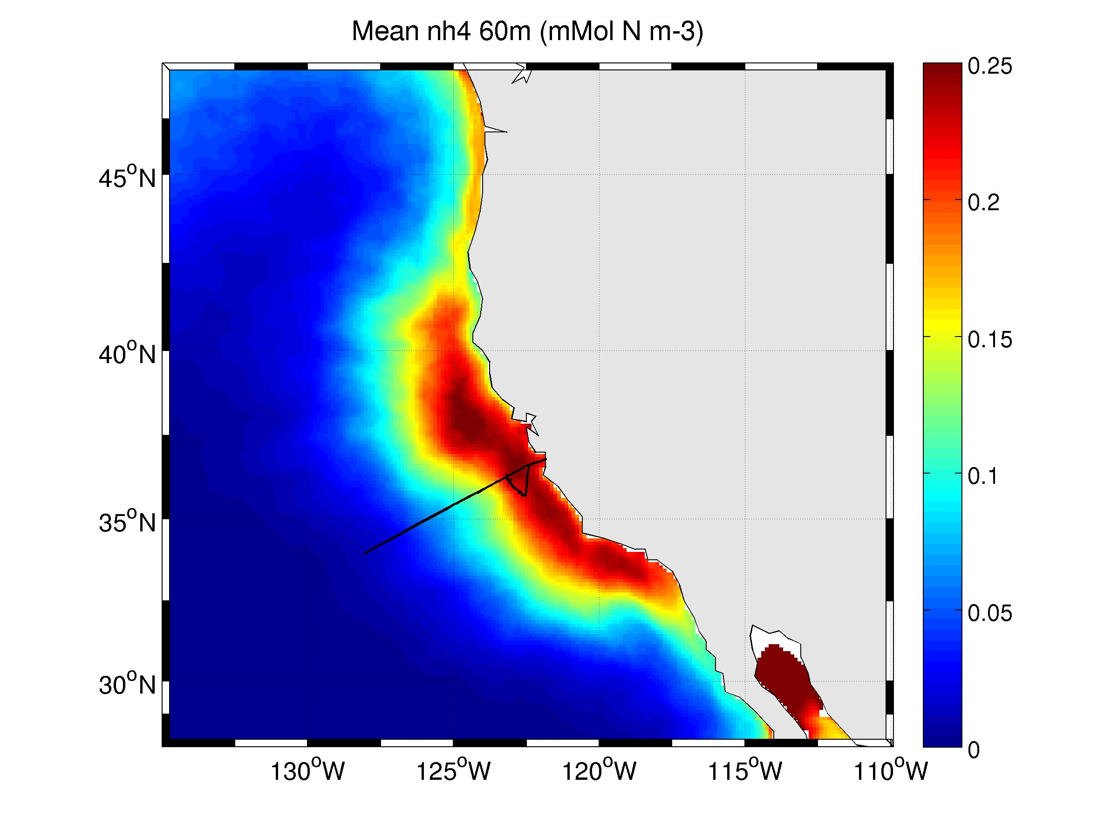
Figure 4Bio. Mean ammonium concentration at 60 meters from a multiyear three dimensional coupled physical-biogeochemical simulation with ROMS. Overlaid is the September 2010 CANON cruise along Line 67 and the ESP drifter.

Early studies of primary productivity in coastal upwelling ecosystems focused on processes evolving along an upwelling axis (Figure 5Bio). Drifters were deployed in the upwelling center and followed over time documenting changes in specific rates of carbon, nitrate and ammonium uptake. Satellite imagery and synoptic surveys have showed that the picture is much more complicated including lateral mixing across fronts and subduction of freshly upwelled water. The primary processes do not occur in an orderly fashion downstream and in addition other factors (e.g. iron) come in to play impacting rates and community structure.
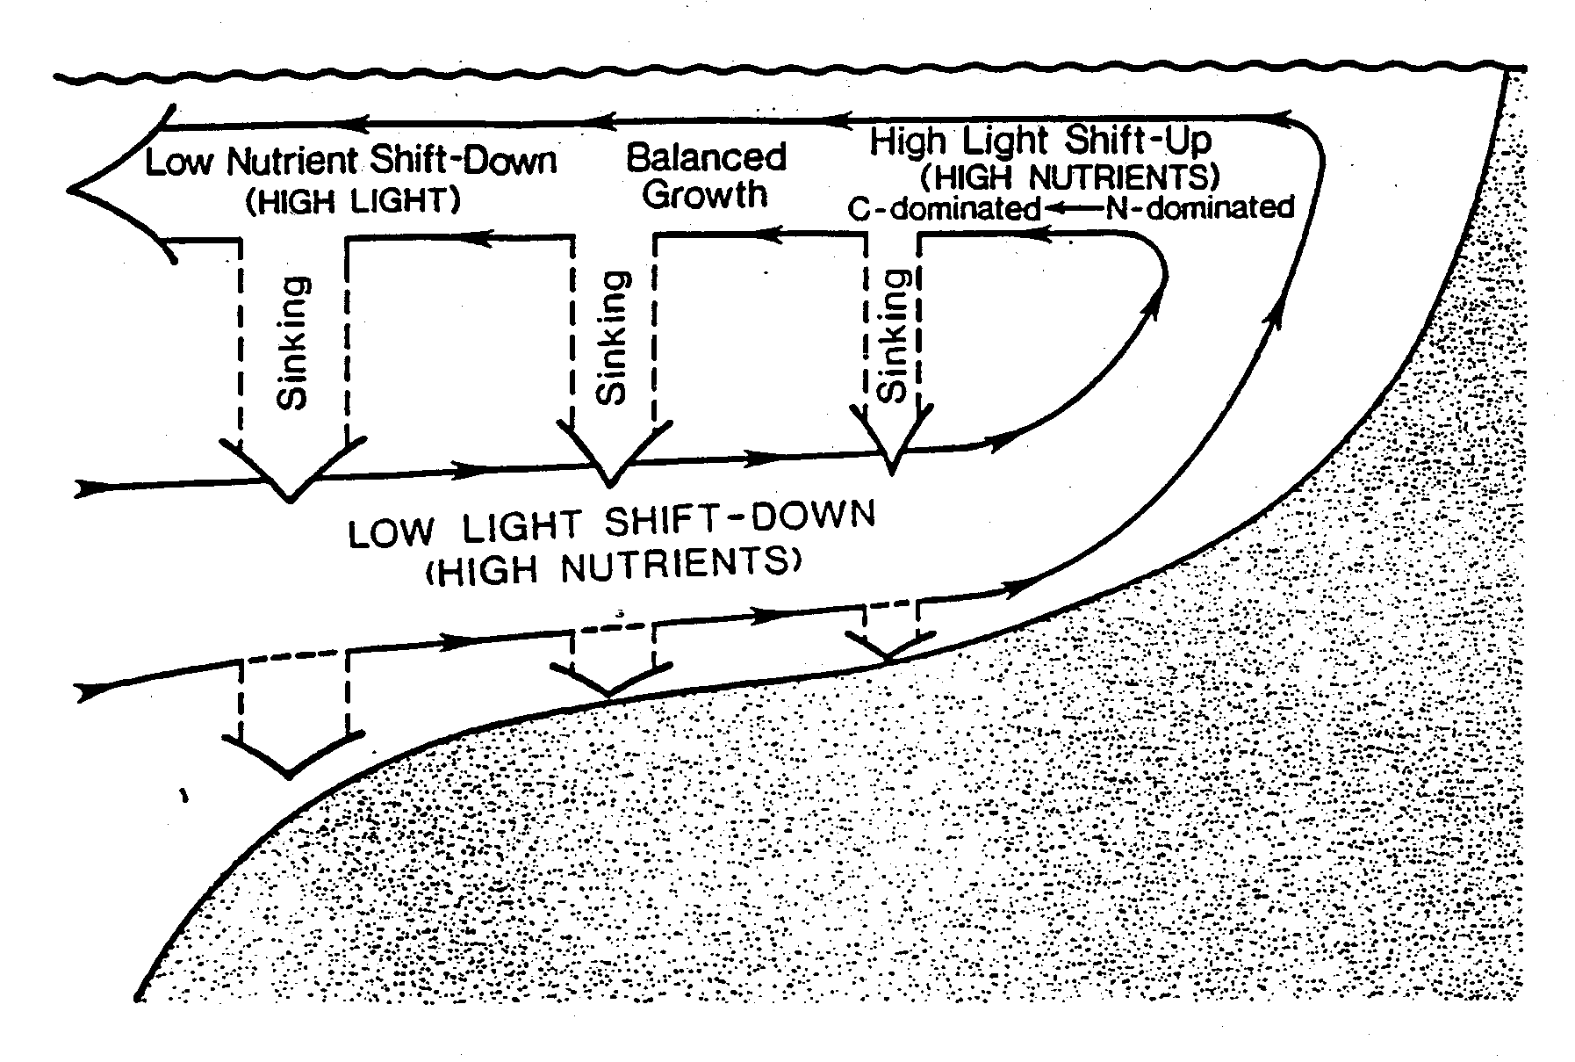
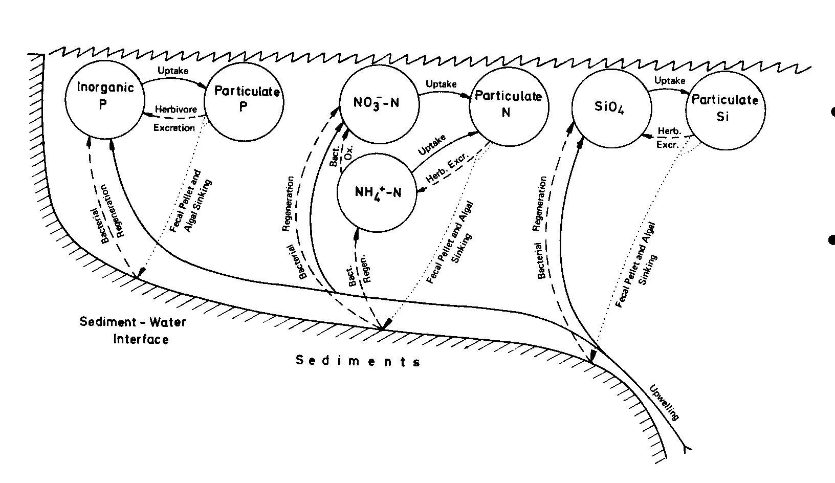
Figure 5Bio. Idealized changes in phytoplankton processes along an upwelling axis. (top) At the upwelling center nutrients are high, phytoplankton low and active (high specific uptake rates). As water ages chlorophyll and large phytoplankton accumulate and nutrients consumed. Once nutrients are consumed the bloom decays. The bottom panel shows macronutrient processes in a shelf upwelling system with the nitrogen cycle being of primary interest in this case. The particulate N pool subsumes B, P and Z in Figure 1Bio.

In addition during the 1960s and 70s coastal upwelling was viewed as a highly variable spatio-temporal process occurring over the mesoscale. The advent of satellites and larger-scale analysis led to the recognition that upwelling or more precisely the nutrient enrichment process was occurring over larger, regional spatial scales. The term eastern boundary upwelling emerged as a result, including coastal upwelling defined as that driven by Ekman transport, the later-recognized equally important upwelling driven by the curl of the wind stress and large-scale thermocline doming processes. In the shelf coastal upwelling system advective processes dominate and as you transition offshore vertical processes become more important. Based on many years of observations along CalCOFI Line 67 we have constructed the following conceptual model of ecological biomes in the California Current System from Monterey Bay to Hawaii (Figure 6Bio; the net surface flow along this entire transect is equatorward and can technically be considered the California Current). 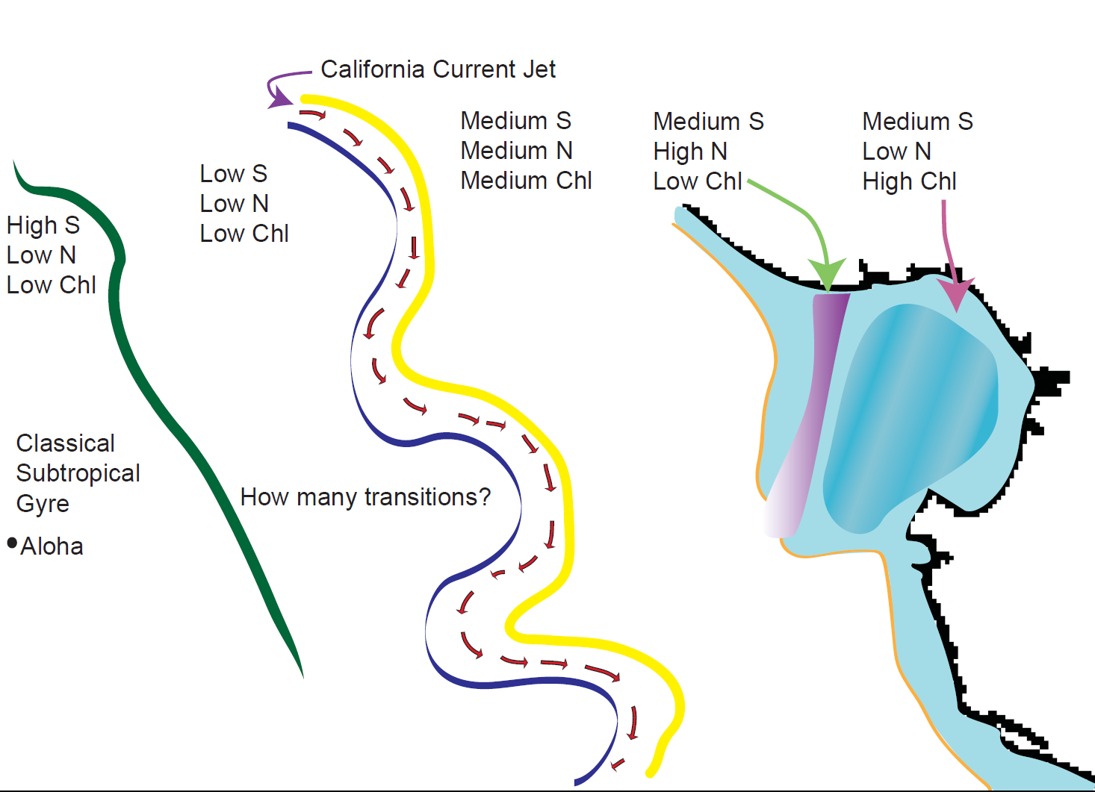
Figure 6Bio. Conceptual model of biomes in the California Current System. The Spring CANON 2012 experiment will be in the “blue” inshore region. The Fall experiment will be in between this inshore region and the California Current jet, the so-called Coastal Transition Zone (CTZ).

Biogeochemistry --- Science questions and purpose

The purpose is to measure and budget the sources and sinks of ammonium in two different environments of the California Current System.

- Ammonium sources. Model results suggest zooplankton excretion produces the ammonium maximum beneath the euphotic zone, but ammonium could also diffuse from continental shelf sediments. We will look for night time increases in near-surface ammonium due to zooplankton vertical migration to the surface at night. In fall aboard the Western Flyer we plan to extend these observations in time and through the euphotic zone and ammonium maximum.
- Ammonium sinks. Euphotic zone ammonium is taken up by phytoplankton as a nitrogen source, and we will measure rates of this ‘uptake’ with tracer incubations of ¹⁵NH4. Ammonium is also converted to nitrite then nitrate by bacteria, in an energy-yielding process called ‘nitrification’. This process occurs both in the ammonium maximum, beneath the euphotic zone, and in the euphotic zone itself. We will also measure rate of nitrification in the ¹⁵NH4 incubations.
- If we can measure the standing stock and losses (sinks) above, we can estimate the rate of ammonium supply (sources) by difference. In the spring experiment we will attempt this budgeting at the surface; in fall we will budget and model flux in the euphotic zone and ammonium maximum.
- Ammonium contribution to nitrogen budget. It is believed that phytoplankton use ammonium preferentially to nitrate, thus accounting for the low concentrations of ammonium observed in the euphotic zone. We will measure the relative rates of uptake of ammonium and nitrate uptake with the ¹⁵NH4 and ¹⁵NO3 incubations, and thereby partition primary production into that supported by ¹⁵NO3 (‘new production’) and that supported by ¹⁵NH4 (‘recycled production’).
- Contribution to primary production. Ammonium and nitrate together are the limiting macronutrients in Monterey Bay primary production, thus determining the amount of organic material available for export either to higher trophic levels (zooplankton, fish, whales) or to depth via the biological pump. We will compare the ¹⁵N-based production estimates above to independent estimates via ¹⁴C. In addition, a ¹³C method will be used to estimate daytime respiratory losses (‘net’ versus ‘total’ production), and a triple-oxygen-isotope method will estimate euphotic zone NCP (equivalent to NO3-supported new production and net production).

This focus on ammonium will enable a new dissection of the nitrogen and carbon cycles in two domains of the California Current System. In spring we will refine methods in Monterey Bay; in fall we will conduct and intensive experiment offshore in the CTZ. Below we detail specifics for the spring campaign.

Spring CANON12 – Studies in the shelf region:

The Spring focus is on the upwelling plume, the upwelling shadow in northern Monterey Bay and the front in between them. Figure 7Bio shows the mean sea surface temperature and fluorescence line height (a proxy for chlorophyll) for the May-June period with the proposed locations of AUV, glider and ship tracks. The list of assets and their dates is given below.

Deploy Spray, Wave and Webb gliders on May 21 for reconnaissance phase (see figure below for repeat transects), recover on June 7 or 8
Deploy LRAUV Daphne May 29 (Tuesday) with Turbulence Sensor for transect along 36.9N. Recover LRAUV Daphne May 31 (Thursday). Deploy LRAUV Tethys May 31.
Deploy LRAUV Daphne June 4th (Monday). Recover both LRAUVs no later than June 8th.
Deploy Dorado May, 29, 30, 31, June 1 (three evenings) with LIST and LIST Holo, make transect offshore along 36.9, collect water on the return transect in upwelling plume, front and shadow. Repeat June 5, 6, and maybe 7.

Deploy R/V Fulmar May 29, 30, 31, and maybe June 1 deploy drifters along 36.9 and collect water on the return transect in upwelling plume, front and shadow. Repeat June 5, 6, 7, and maybe 8. Drifters recovered daily unless clear that they will not exit region rapidly.

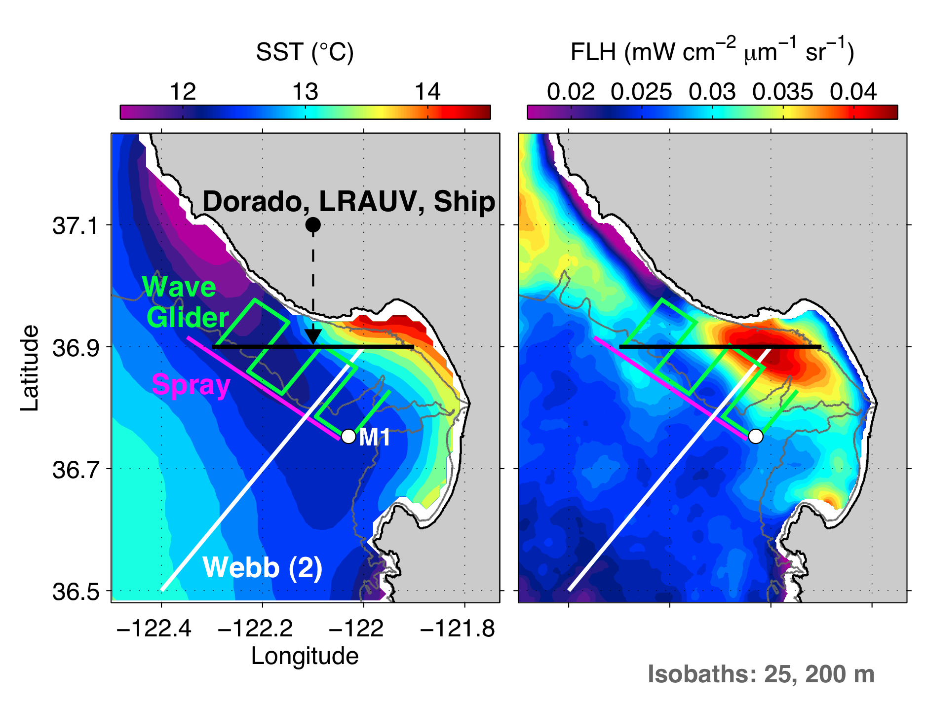

Figure 7Bio. Maps of the mean sea surface temperature and chlorophyll distributions during May/June with the proposed asset tracks. Also shown are the 25, 200 m isobaths.

The following section details water sample plans for biogeochemistry for Spring CANON.

Cruises and stations. Five replicate experiments are planned over the period 29May-7Jun 2012. The night prior to each experiment, the AUV Dorado will survey the 36.8 deg N transect line and determine station positions. The offshore station will be in the densest (cold+salt) surface water encountered on the transect, the inshore station will be in the lightest water encountered (not further inshore than Station M0), and the intermediate station will be halfway between. The AUV-Gulper will collect water samples from the surface at these stations to be analyzed as described below. The next morning, shipboard CTD casts to the bottom will be made at each station.

At each station, water from four set depths (0, 5, 10, 20 m) will be transferred to a series of incubation bottles, and different isotope tracers added. The samples will then be affixed to an in situ drifting array deployed at Station M0 within the upwelling shadow of Monterey Bay. While these waters do not replicate the exact conditions within each of the water types, incubation all water types under the same condition will the temperature and light variables, allowing us to better assess differences in N cycling.

- Samples will be obtained either by AUV Dorado or by CTD-Rosette using the R/V Fulmar within, inshore and offshore of the upwelling front.
  - Autonomy will be used to identify the location of the front.
  - Bottle data from the Dorado gulps will be used to establish sample acquisition boundaries.
    - Specifically, we will attempt to sample waters during the day with CTD-Rosette that match that the temperature and salinity profile of Dorado gulps taken the night prior.
      - Permitting us to interpret (some) data in a diel context.
  - Once target conditions within each water type are identified with uCTD, we will obtain water samples, via CTD-rosette, for the following analyses:
    - Cast 1: Depth profiles to bottom
      - Nutrients - SiO₄, PO₄, NO₃, NO₂, NH₄ (75 ml)
      - Chlorophyll (100 ml)
      - DIC (?)
      - POC (540 ml)
      - QP (25 – 250 ml)
      - Genetics (5000 ml)
      - NO₃ isotopes (150 ml)
      - Deck incubations to match gulps (????)
    - Cast 2: Samples for biogeochemical incubations will be obtained from four depths (0, 5, 10, 20 m) for the following experiments:
      - H¹⁴CO₃ primary productivity (280 ml)
      - H¹³CO₃ respiration/gross photosynthesis (620 ml)
      - ¹⁵NO₃ uptake and reduction (620 ml)
      - ¹⁵NH₄ uptake and oxidation (620 ml)
- AUV Dorado Gulps - We will be provided with 500 mls of sample from each of the ten gulps each morning.
  - Work up
    - Chlorophyll
    - Nutrients- SiO₄, PO₄, NO₃, NO₂, NH₄
    - QP
  - Incubation
    - One 280 ml sample will be used for quantification of a single biogeochemical process of interest?
    - These samples will be moved to fresh incubation bottles from the gulper and stored in a dark cooler until deployment on the array?
    - These samples will be immediately spiked with isotope tracer and incubated on deck/dock?

Drifting Array
      - CTD-rosette samples held over from each station will be stored by station in dark coolers (maximum 2 hour hold time?) until deployment on a drifting array.
      - Upon arrival at set deployment area (M0?) incubations will be spiked with the appropriate isotope tracer and affixed to the drifting array for deployment.
        - Deployment station
    - Protected from strong currents
    - Reasonable depth of photic zone (20 m may always be dark)
    - Near to shore/accessible in bad weather
  - Drifting array logisitics
    - Yellow poly loops tied and taped
      - Color code: bright – dark = surface to deep
    - Cable tie with loop placed tight around each bottle neck
    - Carabiner or cabletie each bottle to each poly loop on the tether.
      - All bottles for each station on a single array
        - Bottles per depth (12)
          - 9 x 620 ml (¹⁵NO₃, ¹⁵NH₄, H¹³CO₃)
          - 3 x 280 ml (H¹⁴CO₃)
- Array will be deployed over the side and allowed to drift for ca. 24 hours. We will add bottles by depth and deploy after each depth is affixed and before the next is, in order to prevent prolong exposure to high light.
- Following day, after acquisition of new samples following the above outline, the array will retrieved after deployment of the new one.
- Samples will either be held in dark cooler until processing on shore or processed at sea (time dependent).

Specific Methods: NOTE: SPIKES NEED TO BE WORKED OUT
- Nitrification/Ammonium uptake/Remineralization
  - Rinse and fill a 0.5 L polycarbonate bottle to brim (0.62 L actual).
  - Rinse and two (2) 60 ml HDPE bottles to shoulder (50 ml), cap and freeze (this is the time zero nitrate isotope measurement).
  - Spike 15NH₄-N as trace (less than 10% ambient NH₄).
  - Mix well by inversion and cap tightly
  - Incubate for 24 hours at in situ T and light (array).
  - Upon recovery, mix bottle by inversion
  - Remove 60 ml using a plastic syringe and filter through a 0.2 micron filter (Sterivex) into a 60ml HDPE bottle.
  - Repeat this with a second sample bottle.
  - Filter remaining volume (520 ml) onto GF/F.
  - Place GF/F into cryovial and freeze, along with 60 ml sample bottles at -20 ºC.
- Nitrate uptake/nitrate reduction
  - Rinse and fill a 0.5 L polycarbonate bottle to brim (620 ml actual).
  - Rinse and two (2) 60 ml HDPE bottles to shoulder (50 ml), cap and freeze (this is the time zero nitrate isotope measurement).
  - Spike K¹⁵NO₃ to a trace concentration (less than 10% ambient NO₃).
  - Mix well by inversion and cap tightly
  - Incubate for 24 hours at in situ T and light (array).
  - Upon recovery, mix bottle by inversion
  - Remove 60 ml using a plastic syringe and filter through a 0.2 micron filter (Sterivex) into a 60ml HDPE bottle.
  - Repeat this with a second sample bottle.
  - Filter remaining volume (520 ml) onto GF/F.
  - Place GF/F into cryovial and freeze, along with 60 ml sample bottles at -20 ºC.
- Respiration/Gross photosynthesis
  - Rinse and fill a 0.5 L polycarbonate bottle to brim (0.62 L actual).
  - Rinse one and fill bottles for the analysis of [DIC] and δ¹³C of DIC.
  - Spike H¹³CO₃ to a trace concentration (less than 10% ambient).
  - Mix well by inversion and cap tightly
  - Incubate for 24 hours at in situ T and light (array).
  - Upon recovery, mix bottle by inversion
  - Remove XX ml using a plastic syringe and filter through a 0.2 micron filter (Sterivex) into a 60ml HDPE bottle. (not sure on this)
  - Repeat this with a second sample bottle.
  - Filter remaining volume (520 ml) onto GF/F.
  - Place GF/F into cryovial and freeze, along with 60 ml sample bottles at -20 ºC.
- ¹⁴C primary production:

Analytical methods:
  - δ¹⁵N of NO₃⁻ -- Sigman et al., McIllvin & Casciotti
  - δ¹⁵N of NO₂⁻ -- Granger et al.
  - δ¹⁵N of NH4 – Lam et al., Peru ODZ
  - δ¹⁵N of POC/PON – EA/IRMS
  - Primary production – C14
  - Respiration - [DIC] and δ¹³C DIC, calculations
  - Macronutrients & Ammonium
  - Extraction and analysis of nucleic acids
  - Chlorophyll, QP, other BOG analyses.

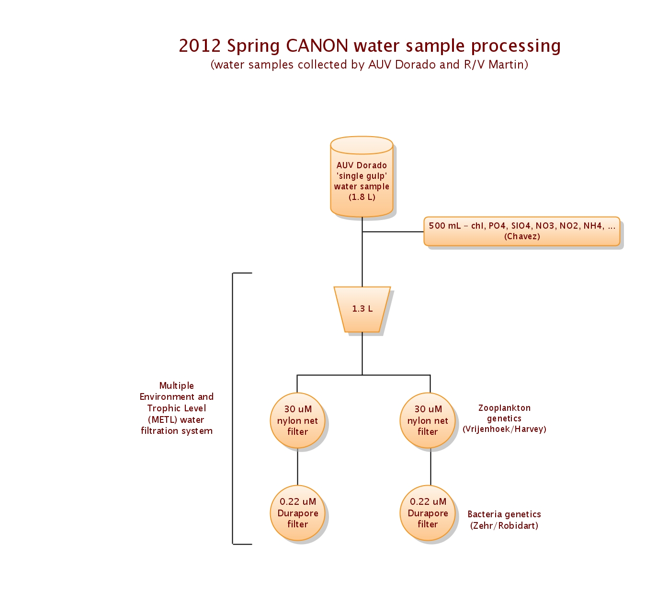Figure 8Bio. Water sample allocation for the DORADO Gulper samples

Fall CANON12 – Studies in the Coastal Transition Zone

Lagrangian Sediment Trap info here.
Judging from the CANON presentations, we would want to deploy the LSTs at ~60 m and > 100m depth to assure export flux. We will have to make a decision whether to put preservative in the sample cups. The collection duration would be best over a period of 2 to 3 days.
The current design has a series of four sample cups per collection funnel (4) so if we deploy for a period of two days, the sampling resolution can be 12 hours. This sequential sampler is deployed and recovered with free flushing so the discrete at-depth samples are not contaminated.

To measure the vertical flux of particulate carbon and nitrogen the Smith lab has developed an autonomous instrument that collects sinking particulate matter while floating at a depth below the euphotic zone. The Lagrangian Sediment Trap (LST) was designed around an existing neutrally buoyant SOLO float (Sounding Oceanographic Lagrangian Observer; Davis et al., 2001) and augmented by adding four sampling funnels and opening-closing cups to collect sinking particles at a pre-determined depths. Each collection funnel had a mouth opening of 0.08 m² for a total collection surface area of 0.32 m². Prior to each deployment, each LST sample cup (125 ml) is filled with filtered surface seawater. For short deployments (2-4 days, depending on ambient temperature) no preservative is added to the LST sample cups. The descent of the LST is done with a disposable weight of 7 kg. Four samples samples can be collected sequentially during each deployment. The period from surfacing to sample recovery is typically < 30 minutes. The capped sample cups and LST are returned to the ship and the samples kept cold until further processing.
During previous experiments cups have been subsampled for microscopy and bacterioplankton analyses of the freshly collected material. A low magnification stereomicroscope (6.5X to 50X) is used to examine and photograph the larger particulate matter in etched-glass grid petri dishes. The particulate matter in a small 5-ml subsample is examined and photographed with finer resolution using a high magnification compound microscope. Samples in water mounts are analyzed at either 100X, 200X or 400X in bright or phase contrast with a Zeiss Axioscop 50. Photographs are taken with a digital camera SPOT RT slider. Small subsamples are preserved in formalin for further microscopic analysis ashore. Mineral phases in these samples were determined by microscopic examination but sample size limitations precluded separate digestions for mineral content. In addition, a 50 ml subsample are taken for bacterioplankton analyses. The remaining sample is filtered onto quartz membrane filters, conspicuous swimmers are removed, and frozen at -80º C. In the laboratory the filters are dried at 60ºC for 24 hours and then weighed to determine total mass. Half of each filter is then analyzed for total carbon and nitrogen using a Control Equipment Corporation Elemental Analyzer (Model 240XA). The other half of each filter is moistened with 10% v/v HCL, held in a closed container for 24 hours and then placed in a 60º C drying oven for an additional 24 hours. The loss of mass measured after HCl treatment is considered inorganic carbon. The dried samples are then analyzed for carbon, and nitrogen using the elemental analyzer above with the resulting carbon concentrations assumed to be organic.
As above in previous experiment samples have been subsampled for cell counts and leucine incorporation rate determination. The leucine incorporation method (Kirchman et al., 1986) is one adapted to the microcentrifugation method (Smith and Azam, 1992). Triplicate 1.5 ml subsamples and a single TCA-killed control sample are prepared for each LST sample, 20 nM final concentration 3H-leucine added, and the samples incubated at 0ºC in water baths for 2-3 hours. Following incubations, the sample uptake is stopped by addition of TCA (5% final concentration), and following centrifugation and washes with 5% TCA, the pellets are dried with 80% ethanol. Small samples (1-1.5 ml) can be vortexed, and used to enumerate DAPI-stained bacterial cells following fixation in formalin using standard methods (Porter and Feig, 1980).
Samples can also be filtered on a Quartz Membrane Filter (QMF) and dried for determination of the organic carbon to ²³⁴Th activity ratio as a proxy for organic carbon export.

