CANON Experiment Plans – Spring

Science Motivation, Questions, Hypothesis

1-2 paragraphs (John Ryan with team) – Working questions below

- Can we detect increased levels of zooplankton (and ammonia?) at the edges of the upwelling plume?
- Can we measure diel changes in ammonia at the edges of the upwelling plume?
- Can we measure diel changes in nitrogen uptake by phytoplankton and nitrification by bacteria at the edges of the upwelling plume?
- Can we quantify nutrient fluxes from the upwelling plume into the high chlorophyll waters?
- What is the source of high ammonia in the upwelling plume?
- Does high ammonia in upwelling plume inhibit diatom growth?
- Can we have a genomics based question – methods?
- Others?

Pre-experiment analysis

What data is available, where is it, how do we access it, how do we process, analyze, visualize? Thom and John

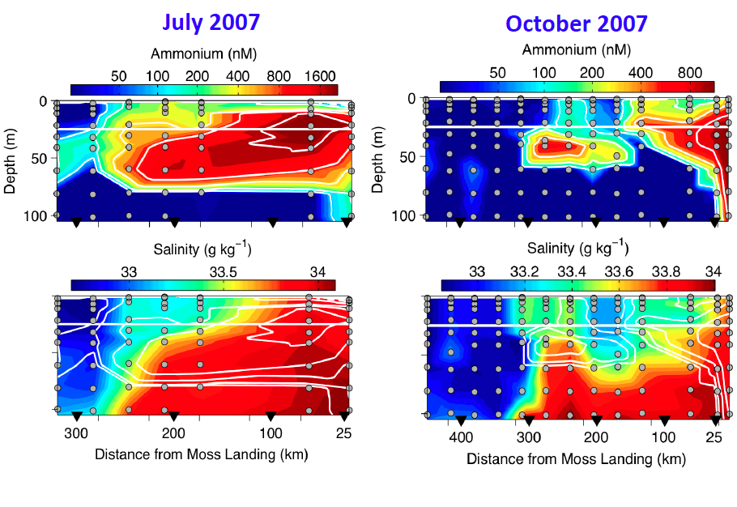

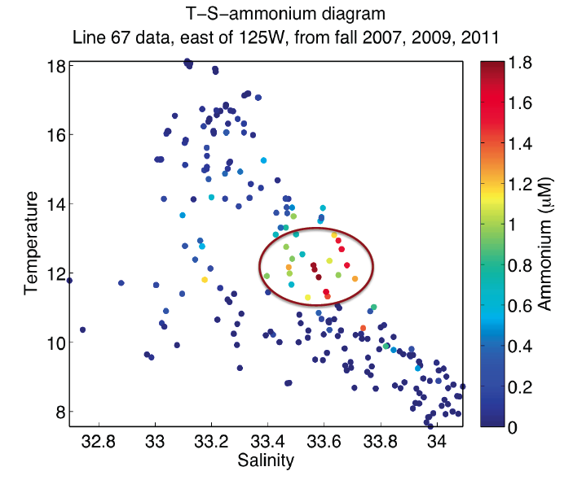
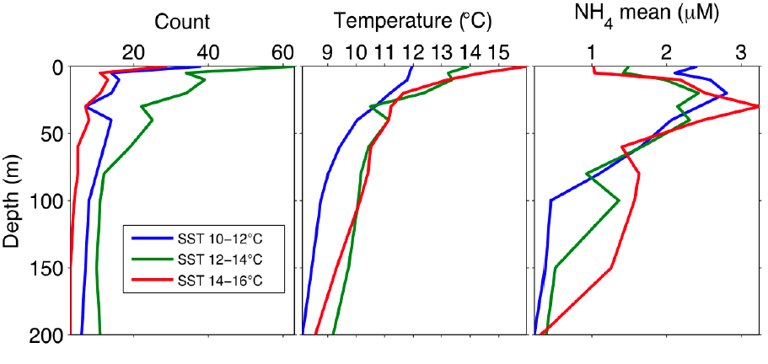

Pre-experiment planning

What are the assets, how do we deploy them, how do we know how long it takes for transects, how do we know where they are, what measurements do we make on water samples, do we have locations to store the data, do we have tools to extract, analyze the data, do we have tools to visualize the data?

Asset list
Spray, Wave and Webb gliders
LRAUV (Daphne with turbulence, Tethys with CTD package)
Dorado with LIST and LIST Holo, CTD package and gulpers
Small ship support with CTD and underway measurements
Drifters, moorings, satellites, HF radar, COAMPS, etc.

Preliminary plan (Francisco and John)

Deploy Spray, Wave and Webb gliders on May 21 for reconnaissance phase (see figure below for repeat transects), recover on June 7 or 8
Deploy LRAUV May 28-June 1 (Daphne with turbulence) for repeat transects along 36.9N (see figure below), on June 1 replace with Tethys , recover on June 7 or 8
Deploy Dorado May, 29, 30, 31, June 1 (three evenings) with LIST and LIST Holo, make transect offshore along 36.9, collect water on the return transect in upwelling plume, front and shadow. Repeat June 5, 6,7, and maybe 8.
Deploy small ship May 30, 31, June 1 deploy drifters along 36.9 and collect water on the return transect in upwelling plume, front and shadow. Repeat June 6,7, and maybe 8. Drifters recovered daily unless clear that they will not exit region rapidly.

Water sample analysis/other collections

Julio – please fill in
Alex Worden/Jon Zehr, other genomics folks please fill in
Biogeochemistry (Tim, Jason, Marguerite et al.) – Euphotic integrated rates of primary production (C14 and C-13), ammonia and nitrate uptake. Nitrification rates. Triple isotope samples. Chlorophyll, bacteria, flow cell cytometry ?, microscopy, etc.
Zooplankton – Steve H., Haibin and Julio please fill in.
Other?

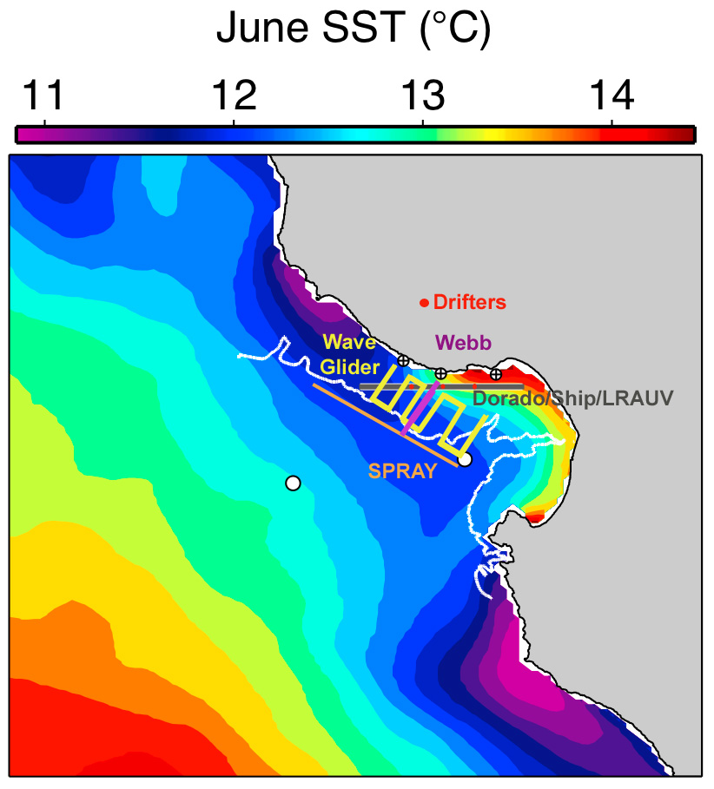

Figure. Preliminary plan for the deployment of assets. Thom, we need a simple table with asset speeds, dive depths, dive angles. We then need a simple tool to estimate transect times.

Reconnaissance phase

How do we access information, process the data, visualize, how do we use the information to make decisions, adapt the preliminary plan, what is the decision process, how do we transmit the information to the operators, etc.?

Experiment phase

How do we access information, process the data, visualize, how do we use the information to make decisions, adapt the preliminary plan, what is the decision process, how do we transmit the information to the operators, etc.?

Post experiment phase

How do we archive information, what kind of products should be produced immediately, what is the plan for data analysis and visualization, what are the lessons learned, etc.

